Procedures for Publishing EAD documents in the Virginia Heritage Database
March 2008
Tracking Database

The use of the VH Tracking Database is strongly recommended. Using an existing EADID may result in the loss of a file in the VH database. To access the VH tracking database go to http://mcgregor.lib.virginia.edu/vhp/enter.html

1. Password for tracking database is viva (username) viva (password)

2. Enter information for the: 1) institution EAD number; 2) accession number [or call number or other identification number] for your collection; 3) title of collection, 4) encoded from (may leave as no selection); 5) number of pages (may be 0); and 6) encoded by. Many of these elements were required during the original VHP grant project.

3. Enter a start date to track the length of the encoding process.

4. Submit record. When the document has been encoded and published, complete tracking database entry by submitting a completed date in appropriate field.

You are ready to encode!

Encoding finding aids

Encode finding aid using the clip library procedures http://www.lib.virginia.edu/small/vhp/download/notetab.doc

Instructions for uploading and publishing files

The administrative login page is located at: http://ead.lib.virginia.edu/vivaead/upload

1. When you log in, you should have a blue screen with (in the center) a text box with a "browse" button to the right of it. To the right of that, it should say [your institution] (e.g.”Library of Virginia”) followed by an “upload file” button.

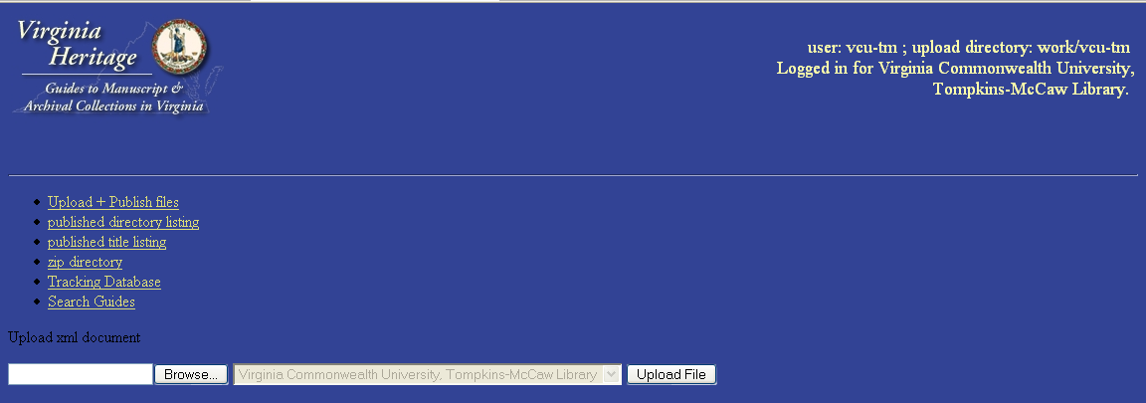
2. Click on “browse” to locate your file. When you select it, you'll return to the publish page.

3. Then click “upload file” and file will be parsed.

4. If it does not parse, you will see an error message similar to the ones below. Go back to NoteTab to correct EAD errors. Follow steps 2 and 3 until your document parses successfully.

Quality assurance warnings are those places where your encoding does not match the VIVA Best Practices Guidelines. You should go back to steps 2 and 3 to correct these problems. Consult the VIVA Best Practice Guidelines at http://www.lib.virginia.edu/small/vhp/admin.html for further details)

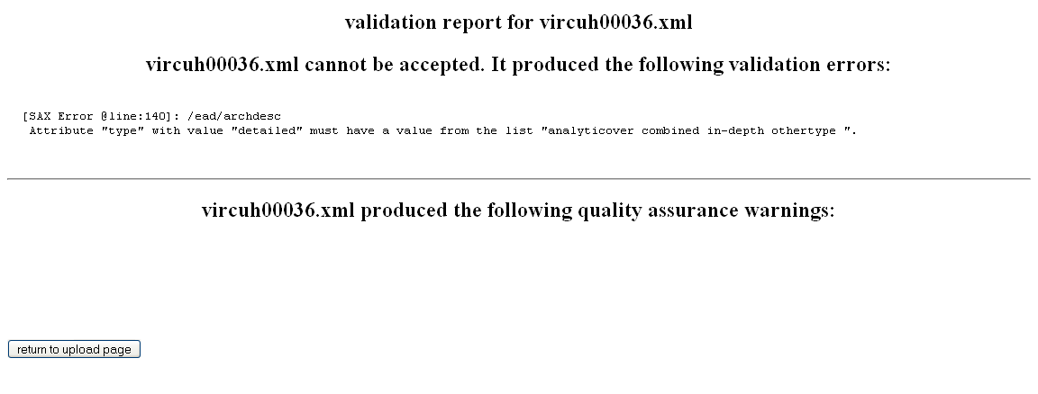

5. When your document parses successfully, you will see the box below. Click on continue to publish. That will bring up a view of your published guide rendered by the VIVA Virginia Heritage Style Sheet

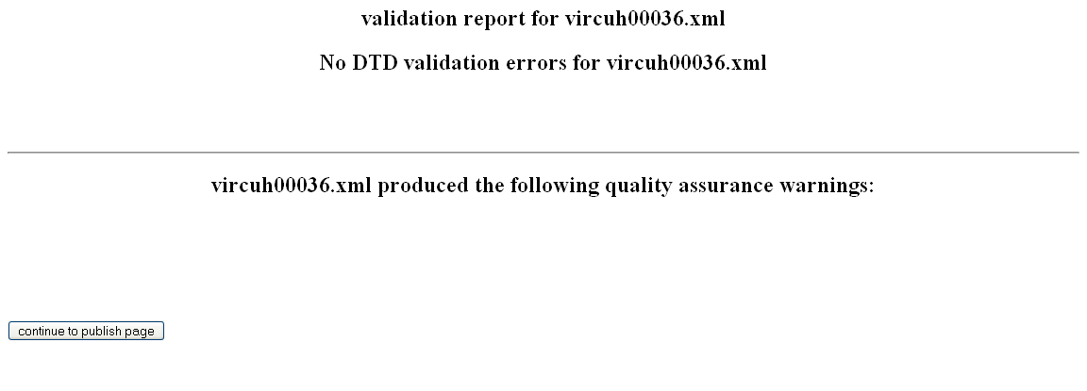

- Scroll to the bottom of the document. If you did not address the quality assurance warnings above you will see suggested style corrections in the red box labeled VIVA Q&A (based on VIVA Best Practices Guidelines, see Guidelines at http://www.lib.virginia.edu/small/vhp/admin.html ). Click "cancel" and go back to NoteTab to make changes in EAD document. Then go through upload steps again.

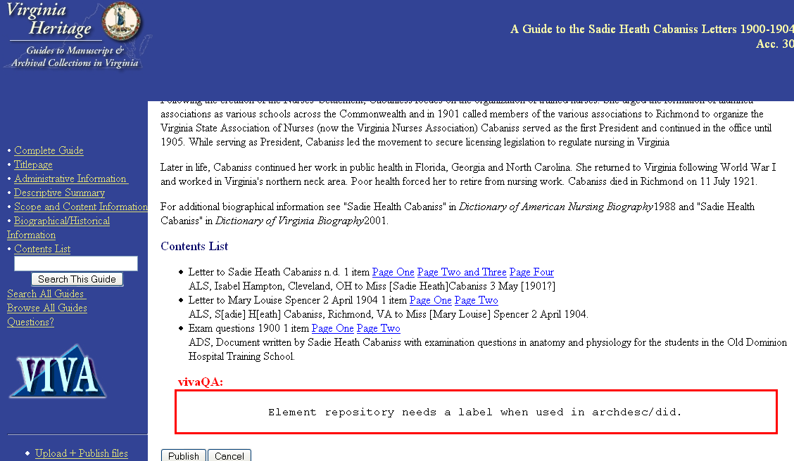

7. If the red box is empty, click “publish” and your work is done!

General recommendations and notes

1. You may use the back button to navigate between unpublished EAD guides and the administrative login page. Once you publish a guide, use URL http://ead.lib.virginia.edu/vivaead/upload (or bookmark of the URL) to return to the administrative login page.

2. If you need to download a published EAD file for revision, click on either the “published directory listing” (in EADID order) or the “published title directory” (in alphabetical order by collection title) and follow the instructions in the gray box on the web page. See below.

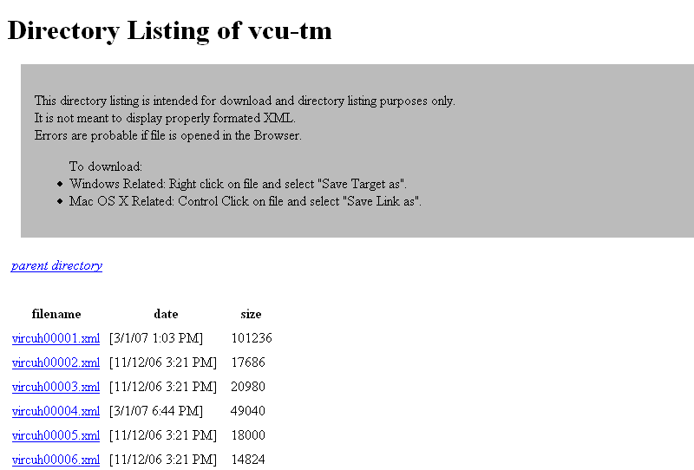

3. If you are republishing a EAD guide originally encoded EAD 1.0, you will need to add a repository label to the <archdesc> repository element. The tagging will appear as follows: <repository label=“Repository”>your repository name here</repository>

4. EAD files are indexed daily. If you need to call up a new file immediately, you will have to enter the published URL directly until the file is indexed.

5. If you're adding links to guides in your catalog records (MARC 856 field), the pattern of the URL should be:

http://ead.lib.virginia.edu/vivaead/published/[followed by your VIVA repository code and the EADID and ending with the html extension.

Example from a UVA guide: http://ead.lib.virginia.edu/vivaead/published/uva-sc/viu12345.html

Example from a LVA guide: http://ead.lib.virginia.edu/vivaead/published/lva/vi12345.html

