## DAV REPORT

**(22ADE01)**

**On**

**Food delivery cost and profitability analysis**

**Submitted in partial fulfilment for the completion of**

**BE-IV Semester**

**in**

**INFORMATION TECHNOLOGY**

**By**

**160122737127 - S. Srujan Reddy**

**160122737132 – V. Ashish**

**160122737135 – Y. Arun Reddy**

**Under the guidance of**

**Dr. N Sudhakar Yadav Sir**

**Assistant Professor,**

**Dept. of IT**



**DEPARTMENT OF INFORMATION TECHNOLOGY**

**CHAITANYA BHARATHI INSTITUTE OF TECHNOLOGY**

***(Autonomous)***

**(Affiliated to Osmania University; Accredited by NBA(AICTE) and NAAC(UGC), ISO Certified 9001:2015)**

**GANDIPET, HYDERABAD – 500075**

**Website:** [**www.cbit.ac.in**](http://www.cbit.ac.in)

**2023-2024**



**CERTIFICATE**

This isto certify that the project work entitled “**FOOD DELIVERY COST AND PROFITABILITY ANALYSIS**” submitted to **CHAITANYA BHARATHI INSTITUTE OF TECHNOLOGY,** in partial fulfilment of the requirements for the award of the completion of DAV project (22ADE01) IV semester of B. E in Information Technology, during the academic year 2023-2024, is a record of original work done by **S. SRUJAN REDDY, V. ASHISH, Y. ARUN REDDY** during the period of study in Department of IT, CBIT, HYDERABAD, under our supervision and guidance.

**Project Guide**

**Dr. N. Sudhakar Yadav**

Asst. Professor, Dept. of IT,

CBIT, Hyderabad.

## INTRODUCTION

The purpose of the food delivery cost and profitability analysis is multifaceted. Primarily, it aims to provide stakeholders, such as food delivery companies or restaurant owners, with a comprehensive understanding of the financial dynamics involved in operating a food delivery service.

1. **Cost Evaluation:** The analysis delves into the intricate details of the costs associated with food delivery, including but not limited to:

- Food procurement and preparation costs.

- Delivery expenses, such as fuel, vehicle maintenance, and driver wages.

- Overhead costs related to facilities, equipment, and administrative expenses.

2. **Revenue Assessment:** Beyond costs, the analysis scrutinies the revenue streams generated through food delivery services. This involves examining:

- Revenue from delivery fees, service charges, and markup on food prices.

- Potential for upselling or cross-selling additional items.

- Customer retention and lifetime value analysis.

3. **Profitability Insights:** By juxtaposing costs against revenue, the analysis aims to uncover the profitability of food delivery operations. This entails:

- Calculating profit margins and return on investment (ROI).

- Identifying areas where profitability is strong and areas where it may be lacking.

- Benchmarking performance against industry standards or competitors.

4. **Operational Optimisation:** In addition to assessing current performance, the analysis seeks to identify opportunities for improving efficiency and profitability. This might involve:

- Streamlining delivery routes to reduce fuel and time costs.

- Negotiating better terms with suppliers to lower food procurement expenses.

- Implementing technology solutions to automate processes and enhance customer experience.

5. **Strategic Decision-Making:** Ultimately, the analysis equips decision-makers with actionable insights to make informed strategic decisions. This could include:

- Expanding or refining the food delivery service offerings.

- Adjusting pricing strategies to maximise revenue and profitability.

- Investing in initiatives to enhance operational efficiency or customer satisfaction.

By conducting a thorough cost and profitability analysis, stakeholders can gain clarity on the financial health of their food delivery operations and devise strategies to drive sustainable growth and profitability.

**Methodology**

The methodology section of the food delivery cost and profitability analysis outlines the approach taken to gather data, conduct the analysis, and draw conclusions. Here's a breakdown of how the methodology might be structured:

1. **Data Collection:** Describe the sources of data used in the analysis. This may include:

- Financial records from the food delivery company or participating restaurants.

- Industry reports and market research data on food delivery trends and benchmarks.

- Surveys or interviews with key stakeholders, such as drivers, customers, and restaurant owners.

2. **Cost Identification:** Explain how costs were identified and categorised. This involves:

- Breaking down costs into different categories, such as food costs, delivery expenses, and overhead.

- Allocating indirect costs to specific activities or cost centre using appropriate methodologies.

3. **Revenue Analysis:** Detail the methods used to analyse revenue streams. This may involve:

- Calculating revenue from delivery fees, service charges, and food sales.

- Estimating potential revenue growth through customer acquisition or retention strategies.

4. **Profitability Metrics:** Specify the metrics used to assess profitability. This could include:

- Calculating profit margins, return on investment (ROI), and other key financial ratios.

- Comparing profitability metrics to industry benchmarks or historical performance.

5. **Data Analysis Techniques:** Describe the statistical or analytical techniques employed to analyse the data. This might include:

- Descriptive statistics to summarise key variables and trends.

- Regression analysis to identify factors influencing profitability.

- Sensitivity analysis to assess the impact of different assumptions or scenarios on profitability.

6. **Assumptions and Limitations:** Acknowledge any assumptions made during the analysis and limitations of the data or methodology. This helps to ensure transparency and reliability of the findings.

7. **Validation:** Discuss how the validity and reliability of the analysis were ensured. This may involve:

- Cross-checking data from multiple sources to verify accuracy.

- Peer review or consultation with subject matter experts to validate assumptions and conclusions.

8. **Ethical Considerations**: Address any ethical considerations related to data collection and analysis, such as privacy concerns or conflicts of interest.

By providing a clear and transparent methodology, stakeholders can understand the rigor and validity of the analysis and have confidence in the findings and recommendations presented in the report.

**IMPLEMENTATION**

Dataset Link: <https://github.com/VAshish07243/DAV-Project-01/blob/f7f4326f476593f94cdb4ec933e5ede3dc00883e/(CSV)DAV-Project-01.csv>

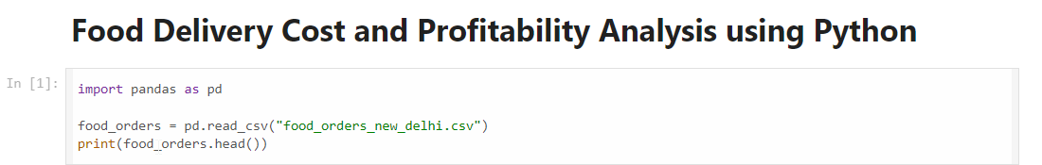

Output:

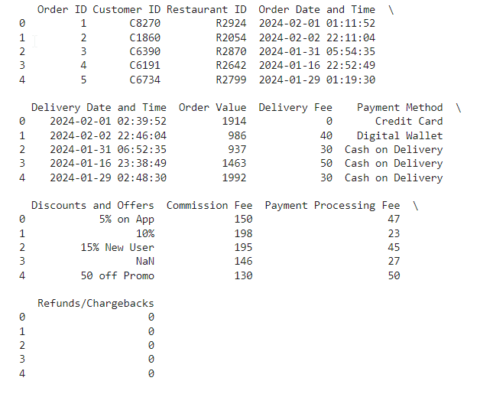

**The data is now ready with the following adjustments:**

Order Date and Time and Delivery Date and Time columns have been converted to datetime format. A new column, Discount Amount, has been calculated based on the Discounts and Offers column. This was achieved by extracting percentage discounts or fixed amounts and applying them to the order value. Discount Percentage has been added to represent the discount rate or fixed amount discount directly.

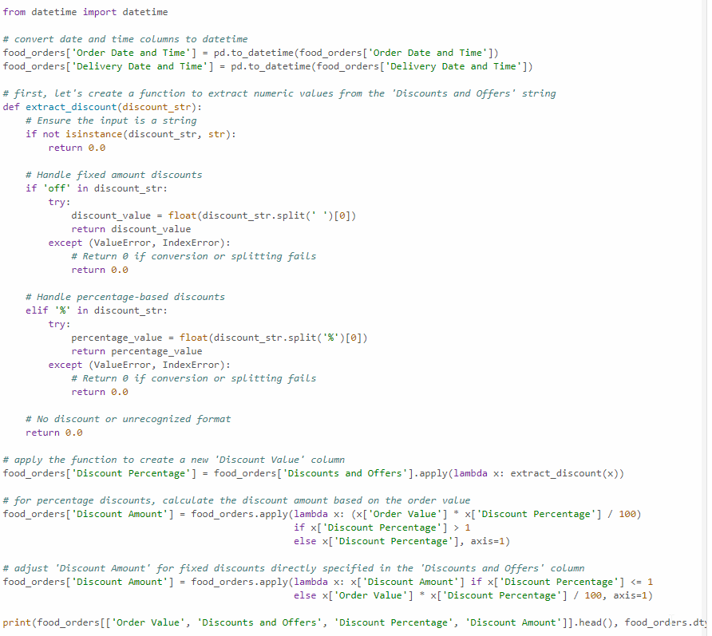

Output:

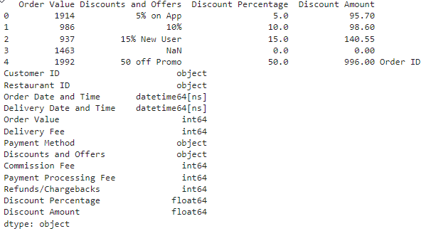

# **Cost and Profitability Analysis**

For the cost analysis, we’ll consider the following costs associated with each order: Delivery Fee: The fee charged for delivering the order. Payment Processing Fee: The fee for processing the payment. Discount Amount: The discount provided on the order. We’ll calculate the total cost for the platform per order and then aggregate this data to understand the overall cost structure.

The revenue for the platform is mainly derived from the Commission Fee. We’ll calculate the net profit by subtracting the total costs (including discounts) from the revenue generated through commission fees.

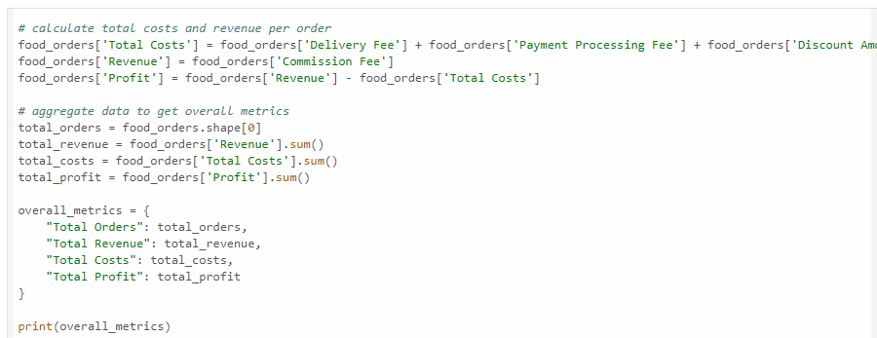

**Based on the analysis, here are the overall metrics for the food delivery operations:**

Total Orders: 1,000

Total Revenue (from Commission Fees): 126,990 INR

Total Costs: 232,709.85 INR (including delivery fees, payment processing fees, and discounts)

Total Profit: -105,719.85 INR

The analysis indicates that the total costs associated with the food delivery operations exceed the total revenue generated from commission fees, resulting in a net loss. It suggests that the current commission rates, delivery fees, and discount strategies might not be sustainable for profitability.

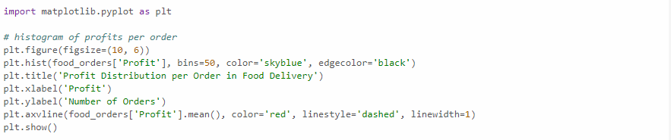

## 

The histogram shows a wide distribution of profit per order, with a noticeable number of orders resulting in a loss (profits below 0).

The red dashed line indicates the average profit, which is in the negative territory, highlighting the overall loss-making situation.

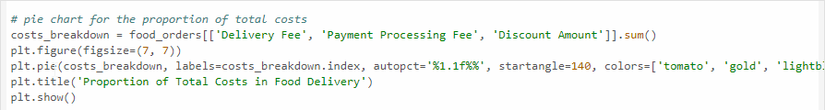

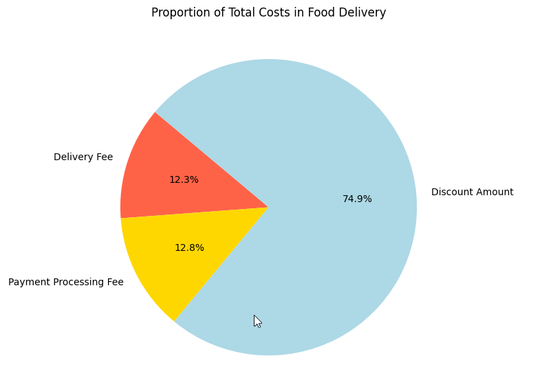

The pie chart illustrates the breakdown of total costs into delivery fees, payment processing fees, and discount amounts.

Discounts constitute a significant portion of the costs, suggesting that promotional strategies might be heavily impacting overall profitability.

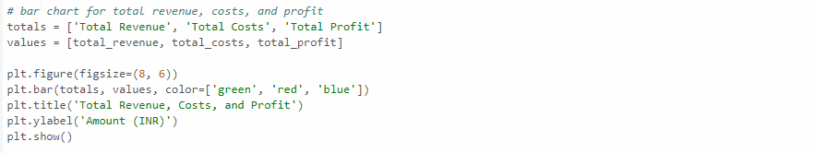

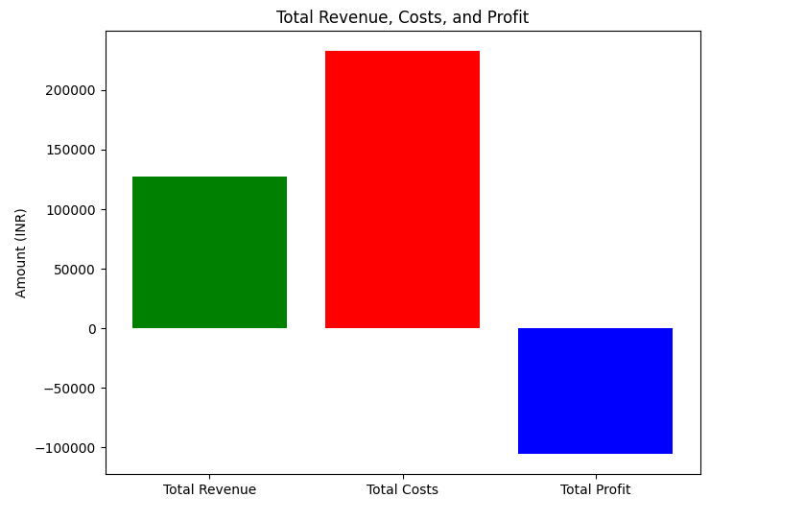

The bar chart compares total revenue, total costs, and total profit.

It visually represents the gap between revenue and costs, clearly showing that the costs surpass the revenue, leading to a total loss.

# **A New Strategy for Profits**

From the analysis so far we understood that the discounts on food orders are resulting in huge losses. Now, we need to find a new strategy for profitability. We need to find a sweet spot for offering discounts and charging commissions. To find a sweet spot for commission and discount percentages, we can analyse the characteristics of profitable orders more deeply.

Specifically, we need to look for:

* A new average commission percentage based on profitable orders.
* A new average discount percentage for profitable orders, that could serve as a guideline for what level of discount still allows for profitability.

Given these new averages, we can suggest adjustments that might not only make individual orders profitable but also apply broadly across all orders to improve overall profitability.

Let’s calculate:

The average commission percentage for profitable orders. The average discount percentage for profitable orders.

# 

. 

Based on the analysis of profitable orders, we find a new set of averages that could represent a “sweet spot” for commission and discount percentages:

* New Average Commission Percentage: 30.51%
* New Average Discount Percentage: 5.87%

The average commission percentage for profitable orders is significantly higher than the overall average across all orders. It suggests that a higher commission rate on orders might be a key factor in achieving profitability. The average discount percentage for profitable orders is notably lower than the overall average, indicating that lower discounts might contribute to profitability without significantly deterring order volume.

Based on this analysis, a strategy that aims for a commission rate closer to 30% and a discount rate around 6% could potentially improve profitability across the board.

## Market Overview

## The market view section of the food delivery cost and profitability analysis provides a comprehensive overview of the food delivery industry, including trends, competitors, and customer preferences. Here's how it might be structured:

## 1. Industry Landscape:

## - Describe the current state of the food delivery industry, including its size, growth rate, and key players.

## - Highlight recent trends and developments shaping the industry, such as the rise of third-party delivery platforms, the impact of technology on delivery logistics, and changes in consumer behaviour.

## 2. Competitive Analysis:

## - Identify major competitors in the food delivery market, including both traditional restaurants with in-house delivery services and third-party delivery platforms.

## - Assess the competitive landscape in terms of market share, geographic coverage, service offerings, and pricing strategies.

## - Analyse the strengths, weaknesses, opportunities, and threats (SWOT analysis) of key competitors to understand their positioning and competitive advantage.

## 3. Customer Segmentation:

## - Segment the target market based on demographic factors (e.g., age, income, location), psychographic characteristics (e.g., lifestyle, preferences), and behavioural patterns (e.g., frequency of orders, order size).

## - Analyse customer preferences and expectations regarding food delivery services, including factors influencing their choice of restaurants, delivery speed, quality of food, and pricing sensitivity.

## 4. Regulatory Environment:

## - Discuss relevant regulations and policies governing the food delivery industry, such as food safety standards, labor laws affecting delivery personnel, and licensing requirements for restaurants and delivery platforms.

## - Evaluate the potential impact of regulatory changes or proposed legislation on the operation and profitability of food delivery services.

## 5. Market Opportunities and Challenges:

## - Identify opportunities for growth and expansion within the food delivery market, such as underserved geographic areas, emerging consumer trends, or partnerships with complementary businesses.

## - Highlight challenges and obstacles facing food delivery companies, such as increasing competition, rising costs, logistical complexities, and customer retention issues.

## 6. Future Outlook:

## - Provide insights into the future direction of the food delivery industry, including anticipated trends, opportunities, and challenges.

## Cost Analysis

Cost analysis in the context of a food delivery cost and profitability analysis involves examining the various costs associated with operating a food delivery service. Here's how it can be explained:

**1. Cost Components:**

• Food Costs: The expenses incurred in procuring ingredients and preparing food items for delivery. This includes the cost of raw materials, labor, and overhead related to food preparation.

•Delivery Expenses: Costs associated with the delivery process, such as fuel or electricity for delivery vehicles, maintenance and repair costs, insurance, and wages for delivery personnel.

•Overhead Costs: Indirect expenses not directly attributable to specific delivery orders but necessary for the overall operation of the food delivery service. This may include rent or lease payments for facilities, utilities, administrative salaries, marketing expenses, and technology costs.

**2. Cost Allocation:**

• Allocating costs to specific activities or cost centre to accurately assess their impact on the profitability of food delivery services. This may involve allocating overhead costs based on usage or activity-based costing methods.

• Differentiating between fixed costs (e.g., rent, salaries) and variable costs (e.g., food ingredients, delivery expenses) to understand the cost structure and identify opportunities for cost optimisation.

**3. Cost Drivers:**

•Identifying the key factors driving costs in the food delivery process. For example, fluctuations in food prices, fuel prices, or labor costs can significantly impact overall expenses.

• Analysing the sensitivity of costs to changes in external factors and assessing the potential risks associated with cost volatility.

**4. Cost Efficiency**:

•Evaluating the efficiency of cost management practices and operational processes in the food delivery service. This may involve benchmarking costs against industry standards or best practices and identifying areas for improvement.

•Implementing cost-saving measures, such as optimising delivery routes to minimise fuel consumption, negotiating better terms with suppliers to lower food procurement costs, or investing in technology solutions to streamline operations and reduce overhead.

**5. Cost Control:**

• Establishing mechanisms to monitor and control costs on an ongoing basis. This may include implementing budgetary controls, variance analysis, and performance metrics to track actual costs against budgeted or target costs.

•Developing contingency plans to mitigate cost overruns or unexpected expenses and ensure the financial sustainability of the food delivery service.

By conducting a thorough cost analysis, stakeholders can gain insights into the cost structure of food delivery operations, identify opportunities for cost optimisation, and make informed decisions to improve profitability and competitiveness in the market.

## Profitability Analysis

Profitability analysis in the context of a food delivery cost and profitability analysis involves assessing the financial performance of food delivery services to determine their ability to generate profit:

**1. Revenue Sources:**

- Identify and quantify the various sources of revenue generated by the food delivery service. This may include delivery fees, service charges, markup on food prices, and any other ancillary revenue streams.

- Analyse the contribution of each revenue source to the overall revenue and assess its growth potential.

**2. Cost of Goods Sold (COGS):**

- Calculate the cost of goods sold, which includes the direct costs associated with providing the food delivery service. This typically includes the cost of food ingredients, packaging materials, and any other directly attributable costs.

- Determine the gross profit margin by subtracting the COGS from total revenue.

**3. Operating Expenses:**

- Identify and categorise operating expenses incurred in running the food delivery service. This includes delivery expenses, overhead costs, marketing expenses, administrative costs, and any other indirect costs.

- Calculate the operating profit margin by subtracting operating expenses from gross profit.

**4. Net Profitability:**

- Deduct additional expenses such as taxes, interest, depreciation, and amortisation to calculate the net profit margin.

- Evaluate the net profit margin as a percentage of total revenue to assess the overall profitability of the food delivery service.

**5. Key Performance Indicators (KPIs):**

- Track key performance indicators such as profit margin, return on investment (ROI), and return on assets (ROA) to measure the financial health and performance of the food delivery service.

- Compare KPIs against industry benchmarks or historical performance to identify areas of strength and areas for improvement.

**6. Break-even Analysis:**

- Conduct a break-even analysis to determine the level of sales volume required to cover all fixed and variable costs and achieve profitability.

- Assess the sensitivity of profitability to changes in key variables such as sales volume, pricing, and cost structure.

**7. Profitability Drivers:**

- Identify the drivers of profitability within the food delivery service, such as order volume, average order value, delivery efficiency, and cost management practices.

- Develop strategies to maximise profitability by optimising these drivers and addressing potential areas of weakness.

By conducting a comprehensive profitability analysis, stakeholders can gain insights into the financial performance of food delivery services, identify opportunities for improvement, and make informed decisions to enhance profitability and sustainable growth.

## Recommendations

Based on the analysis conducted, here are some recommendations for improving profitability and optimising operations in the food delivery service:

**1. Delivery Efficiency Optimisation:**

- Implement route optimisation software to streamline delivery routes, minimise travel time, and reduce fuel costs.

- Utilise real-time tracking systems to monitor delivery personnel and ensure timely and accurate deliveries.

- Explore the use of electric or hybrid vehicles to reduce fuel expenses and minimise environmental impact.

**2. Cost Management Strategies:**

- Negotiate bulk purchasing agreements with suppliers to lower food procurement costs and improve profit margins.

- Implement inventory management systems to minimise food waste and optimise inventory levels.

- Conduct regular audits of overhead expenses to identify areas for cost reduction and operational efficiency improvements.

**3. Dynamic Pricing Model:**

- Adopt a dynamic pricing strategy based on demand, time of day, and delivery distance to maximise revenue and profitability.

- Offer incentives such as discounts or promotions during off-peak hours to incentives orders and increase order volume.

**4. Customer Retention Initiatives:**

- Enhance the customer experience by providing personalised recommendations, order tracking, and responsive customer support.

- Implement a loyalty program to reward repeat customers and encourage customer retention.

- Solicit feedback from customers and use insights to continuously improve service quality and satisfaction levels.

**Conclusion**

In conclusion, the analysis of the food delivery cost and profitability provides valuable insights into the financial dynamics of the service. Key findings include:

**1. Cost Structure:** The analysis revealed that food procurement costs, delivery expenses, and overhead are significant components of the overall cost structure. Identifying and managing these costs effectively is crucial for improving profitability.

**2. Revenue Streams:** The service generates revenue from delivery fees, service charges, and markup on food prices. However, there is potential to diversify revenue streams and explore additional sources of income.

**3. Profitability Challenges:** While the service demonstrates profitability potential, there are challenges such as high competition, rising costs, and operational inefficiencies that need to be addressed to maximise profitability.

**4. Operational Opportunities:** Recommendations for optimising operations include improving delivery efficiency, implementing cost management strategies, adopting dynamic pricing models, enhancing customer retention initiatives, investing in technology, and exploring strategic partnerships and expansion opportunities.

In summary, by implementing the recommendations outlined in the analysis, the food delivery service can improve profitability, enhance operational efficiency, and maintain a competitive edge in the market.