

**Manual of Thermansys**

*\*Notice: The name of the folders where you have saved your data must be in Latin characters.*

*\*\*Notice: If the progress bar gets stuck, close the secondary window (E.g., IR Lock-in periods Calculator) and open it again.*

* **IR Lock-in with periods**

1. Click on “IR Lock-in period” button in order to open the IR Lock-in Calculator.

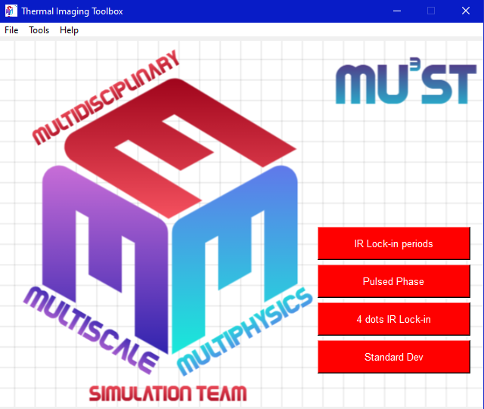

1. First, select your data/image directory as shown below. (File → Select Image Directory).

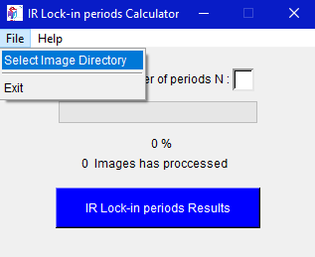

1. Then, type the number of periods in input box. (Please, be careful that you are not type a string or a negative number.)

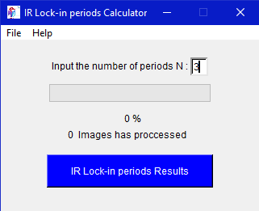

1. Click the main blue button “IR Lock-in periods Results” to run the algorithm.
2. Once the process is complete you can check the results in the results directory (IR Lock-in periods Results) and the corresponding report (IR Lock-in periods Report_).

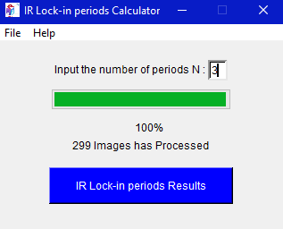

* **Pulsed Phase**

1. Click on “Pulsed Phase” button in order to open the Pulsed Phase Calculator.



1. First, select your data/image directory as shown below. (File → Select Image Directory).

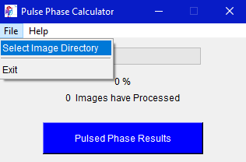

1. Then, Click the main blue button “Pulsed Phase Results” to run the algorithm.
2. Once the process is complete you can check the results in the results directory (Pulsed Phase Results) and the corresponding report (Pulsed Phase Report_).

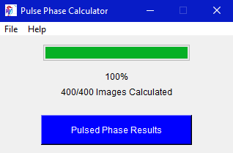

* **IR Lock-in 4 dots**

1. Click on “4 dots IR Lock-in” button in order to open the 4 dots IR Lock-in Calculator.



1. First, select your S1 image, S2 image, S3 and S4 as shown below. (File → Select Image S1, Select Image S2, Select Image S3, Select Image S4).

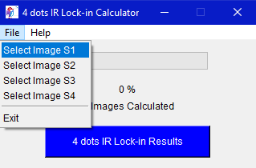

1. Then, Click the main blue button “4 dots IR Lock-in Results” to run the algorithm.
2. Once the process is complete you can check the results in the results directory (IR Lock-In 4-dots Results) and the corresponding report (IR Lock-in 4 dots Report_).

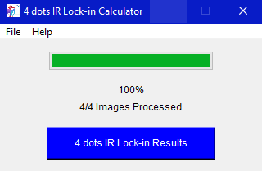

* **Standard Deviation**

1. Click on “Standard Dev” button in order to open the 4 dots IR Lock-in Calculator.



1. First, select your data/image directory as shown below. (File → Select Image Directory).

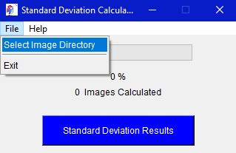

1. Then, Click the main blue button “Standard Deviation Results” to run the algorithm.
2. Once the process is complete you can check the results in the results directory (Standard Deviation Results) and the corresponding report (Standard Deviation Report_).

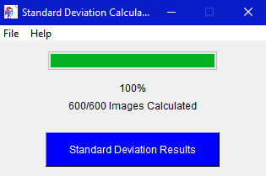

* **Menu bar**
* **Tools.**

1. From menu bar you can click on “Tools” and select “Crop Image”. This feature is quite useful if you want to cut an entire data set into specific coordinates for better resolution.

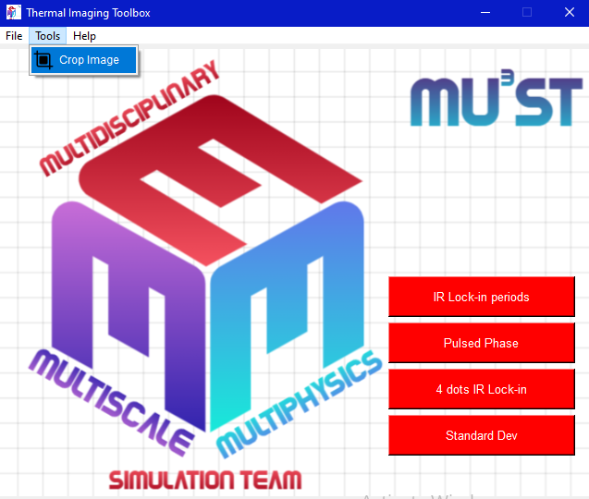

1. First, select an image where you want to select the coordinates (File → Select Image Directory for Coordinates). The coordinates you choose will be applied to the dataset you select next.

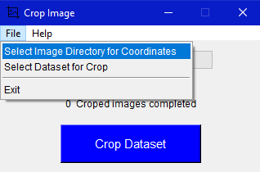

1. Then, select the data set where you want to apply the coordinates for crop (File → Select Dataset for Crop)

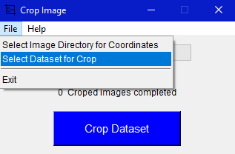

1. Click the main blue button “Crop Dataset” to run the algorithm. When you click the button a second window will appear showing the image you selected.

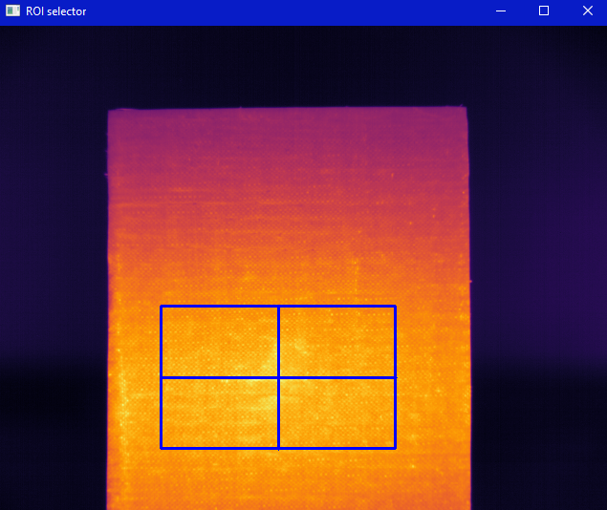

1. Click and drag to select the area you are interested in and press “Enter”. Next, a window will appear displaying the area you have selected.

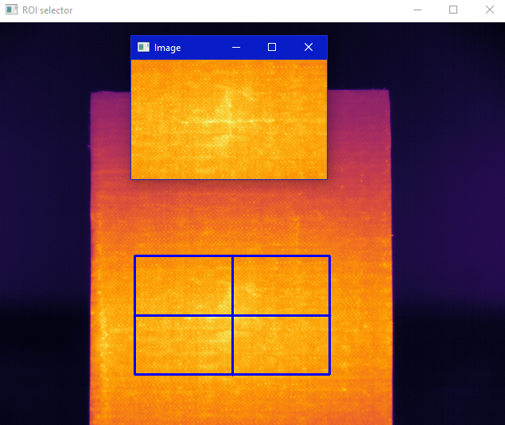

1. Close both of these windows (“Image”, “ROI selector”) by clicking the top right red windows button to continue the algorithm.



1. Once the process is complete you can check the new cropped dataset in the results directory (Cropped Dataset) and the corresponding report (Crop-tool Report_).