HORIZON ENTERPRISE IMS
Module Requirements Template
Module: [Maintenance]
Submitted by: [Richa]
Date: [14-Jul-2026]

COLOUR GUIDE
GREEN — Example value from MAINTENANCE CALL Reporting— replace for your module | BLUE — Empty slot — add your own rows here | AMBER — Instruction — read once, ignore after

HOW TO USE THIS TEMPLATE
1. Save a copy — rename to MRD_[ModuleName].docx before editing.
2. Replace every green value with your module's equivalent (SP names, RB codes, field names, routes, etc.).
3. Add your own rows in the blue slots at the bottom of each table.
4. In Section 2, delete the placeholder box and paste your design screenshot (Insert → Pictures).
5. Send completed document to the development team BEFORE coding starts.
6. Dev team signs off by stamping "Dev Confirmed" on each section.

1. Module Overview
Replace every green value below with your module's equivalent.
Module Name: Maintenance
Module Code: “MNT”
Purpose: to update open call status/Reporting for assets item.
Primary Users: Procurement / Maintenance Team
Listing Route: /Assets- MAINTENANCE CALL REPORTING
New Form Route: / Assets - MAINTENANCE CALL REPORTING /refresh
Nav Menu Label: MAINTENANCE CALL REPORTING

2. Screen Design
Delete the placeholder box below and paste your design screenshot (Insert → Pictures). Add a second image for the listing view if applicable.
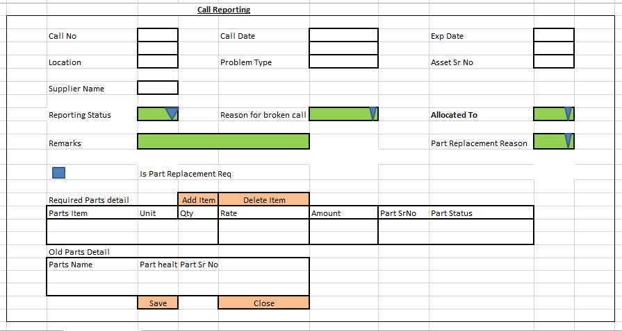

Note- do not copy color /back color from design.
This is a popup form which will be display from dashboard as a popup dialogue form (this form has no list side or any add/edit mode)

Screen notes / layout description:
Describe each visible area: panels, tabs, special controls, conditionally visible sections.
► Header panel — callno (textarea), calldate (textarea),expdate (date), location (textarea),problemtype (textarea),assetsrno (textarea),suppliername (textarea),
reportingstatusid (dropdown),reasonforbrokencallid(dropdown),allocatedtoid (dropdown),partreplacementreasonid (dropdown),
ispartreplacementreq (checkbox),remarks (textarea)

With RB Name(rb_mnt_clrpt)

3. Header Fields
One row per field shown in the Header Panel. Control types: Textbox | Date | Dropdown | Textarea | Checkbox.

Field Label | Field ID (ColName) | Control Type | Required | Is Read Only | Source SP / Cascade Note
Call No | callno | textarea | No | Yes
Call Date | calldate | TextArea | No | Yes
Expected Date | expdate | TextArea | No | Yes
Location | location | TextArea | No | Yes
Problem Type | problemtype | TextArea | No | Yes
Asset Sr No | assetsrno | TextArea | No | Yes
Supplier Name | suppliername | TextArea | No | Yes
Reporting Status | reportingstatusid | Dropdown | No | No | vw_callstatus - No parameters  ObjType = 3
Reason For Broken Call | reasonforbrokencallid | Dropdown | No | No | vw_brokencallreason- No parameters  ObjType = 3
Allocated To | allocatedtoid | Dropdown | No | No | fn_gen_fetchallocateduser  @prmcompanyid int,  @prmdivisionid integer,  @prmlocationid integer,  @prmdeptid integer
Part Replacement Reason | partreplacementreasonid | Dropdown | No | No | vw_partreplacementreason- No parameters  ObjType = 3
Is Part Replacement Req? | ispartreplacementreq | CheckBox | No | No
Remarks | remarks | TextArea | No | No
(add here) | (add here) | (add here) | (add here) |  | (add here)

Cascade resets:
- When Change reportingstatusid - Clear grid data on selection changed and reload grid RB.

- If reportingstatusid value= 1 then
- Clear RB grid data for RB - rb_mnt_clrptnwprtdtl, rb_mnt_clrptolprtdtl and make it readonly
- If reportingstatusid value= 2 or 3 then
- Clear RB grid data for RB - rb_mnt_clrptnwprtdtl, rb_mnt_clrptolprtdtl and make it editable

4. Grid RB Details
1.
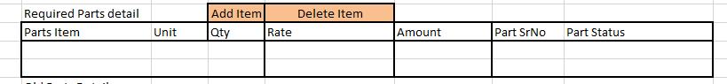

Grid Data load using RB(rb_mnt_clrptnwprtdtl)
List every column in the Item Grid (EntryGrid). Source = "API (RB detail metadata)" or "Hardcoded" if static.

Column Label | Key (ColName) | Control Type | Editable | Source
Sr. No. | SrNo | Number | No | API — rb_mnt_clrptnwprtdtl metadata
Item Code | ItemCode | Textbox | Yes | API — rb_mnt_clrptnwprtdtl metadata
Item Name | ItemName | Textbox | No | API — rb_mnt_clrptnwprtdtl metadata
Quantity | Qty | Number | Yes | API — rb_mnt_clrptnwprtdtl metadata
Unit | Unit | Dropdown | No | API — rb_mnt_clrptnwprtdtl metadata
Rate | Rate | Number | Yes | API — rb_mnt_clrptnwprtdtl metadata
Amount | Amount | Number | No | API — auto-calculated: Qty × Rate
Remarks | Remarks | Textarea | Yes | API — rb_mnt_clrptnwprtdtl metadata
(add here) | (add here) | (add here) | (add here) | (add here)
(add here) | (add here) | (add here) | (add here) | (add here)

2.
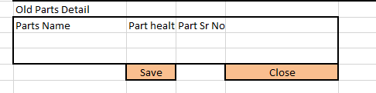

Grid Data load using RB(rb_mnt_clrptolprtdtl)
List every column in the Item Grid (EntryGrid). Source = "API (RB detail metadata)" or "Hardcoded" if static.

Column Label | Key (ColName) | Control Type | Editable | Source
Sr. No. | SrNo | Number | No | API — rb_mnt_clrptolprtdtl metadata
Item Code | ItemCode | Textbox | Yes | API — rb_mnt_clrptolprtdtl metadata
Item Name | ItemName | Textbox | No | API — rb_mnt_clrptolprtdtl metadata
Quantity | Qty | Number | Yes | API — rb_mnt_clrptolprtdtl metadata
Unit | Unit | Dropdown | No | API — rb_mnt_clrptolprtdtl metadata
Rate | Rate | Number | Yes | API — rb_mnt_clrptolprtdtl metadata
Amount | Amount | Number | No | API — auto-calculated: Qty × Rate
Remarks | Remarks | Textarea | Yes | API — rb_mnt_clrptolprtdtl metadata
(add here) | (add here) | (add here) | (add here) | (add here)
(add here) | (add here) | (add here) | (add here) | (add here)

5. API Reference
List every stored procedure / function called. ObjType 2 = Function, 1 = Procedure. Source: backend DBA.

SP / Function Name | ObjType | Purpose | Key Parameters | Returns
Fn_Fetch_RBDetailByRBCode | 2 | Fetch RB column metadata (header + detail) | prmRBCode | Table[0]: RBID + column definitions
Fn_tbl_FetchUserWsDivision | 2 | Division dropdown options | prmYearID, prmLoginID | Table: division list
fn_tbl_rb_mnt_clrptnwprtsel | 2 | TO load data in Required parts item selection popup | @prmmasterid int,  @prmdivisonid int,  @prmcompanyid int,  @prmloginid int,  @prmyearid int
fn_tbl_rb_mnt_clrptolprtsel | 2 | TO load data in Old parts item selection popup | @prmmasterid int,  @prmdivisonid int,  @prmcompanyid int,  @prmloginid int,  @prmyearid int
(add here) | (add here) | (add here) | (add here) | (add here)
(add here) | (add here) | (add here) | (add here) | (add here)

Save endpoint (REST POST):
Endpoint path - - API/ MntCallReporting / Post_RB_mnt_clrpt_Save

Payload keys: prmStrMstJSON | prmStrOldPartsDetail | prmStrNewPartsDetail

5.1 RB Structure Detail

SP / Function Name | RB Name | Purpose
Master Data RB | rb_mnt_clrpt | Load Master Controls in form
Required Parts Detail Grid | rb_mnt_clrptnwprtdtl | Load RB structure in Required parts detail grid
Old Parts Detail Grid | rb_mnt_clrptolprtdtl | Load RB structure in old parts detail grid
Required Parts Item Selection Popup | rb_mnt_clrptnwprtsel | Load RB Structure in Item selection Popup
Old Parts Item Selection Popup | rb_mnt_clrptolprtsel | Load RB Structure in Item selection Popup
RB Save API | API/ MntCallReporting / Post_RB_mnt_clrpt_Save
List side Data fill | -
Load /Fetch Data on Dialogue Open –Master data | fn_tbl_rb_mnt_clrpt
Load /Fetch Data on Dialogue Open –Required parts detail Grid data | fn_tbl_rb_mnt_clrptnwprtdtl
Load /Fetch Data on Dialogue Open –Old {Parts Detail Grid data | fn_tbl_rb_mnt_clrptolprtdtl

6. Business Rules
Every rule the developer must implement. Add or remove lines for your module.

1. (add here)

7. Constants (constants.js)
All values for the constants.js file. RB codes and SP names come from the backend DBA. Mark CONFIRM = Yes if value is uncertain.

Constant Name | Value | CONFIRM? | Notes
RB_MASTER | rb_mnt_clrpt | No | Master board code — header column metadata
RB_DETAIL (Required Parts Detail Grid) | rb_mnt_clrptnwprtdtl | No | Detail board code — grid column metadata
RB_Detail (Old Parts Detail) | rb_mnt_clrptolprtdtl
FORM_TAG | rb_mnt_clrpt | No | Short module tag used in save payload
TRAN_BOOK | MNTFLU | No | Transaction book name for item picker SP
CONFIG_YEAR_ID | 2 | CONFIRM | Year ID passed to configuration SPs
DIVISION_YEAR_ID | 2 | CONFIRM | Year ID passed to division fetch SP
SUPPLIER_PARTY_TYPE | - | No | Party type filter for supplier picker
LIST_OBJ_TYPE | 2 | No | OBJ_TYPE.FUNCTION — for listing SP call
SP_ LIST | - | CONFIRM | Function to load listing page data
LIST_DIVISION_ID | 15 | CONFIRM | Default division ID for listing data fetch
SAVE_ENDPOINT | API/ MntCallReporting / Post_RB_mnt_clrpt_Save | No | REST gateway save path
STORAGE_HEADER_META | piHeaderMeta | No | localStorage key for cached header RB metadata

— END OF TEMPLATE —

