HORIZON ENTERPRISE IMS
Module Requirements Template
Module: [Purchase]
Submitted by: [Richa]
Date: [03-jul-2026]

COLOUR GUIDE
GREEN — Example value from Purchase Inquiry — replace for your module | BLUE — Empty slot — add your own rows here | AMBER — Instruction — read once, ignore after

HOW TO USE THIS TEMPLATE
1. Save a copy — rename to MRD_[ModuleName].docx before editing.
2. Replace every green value with your module's equivalent (SP names, RB codes, field names, routes, etc.).
3. Add your own rows in the blue slots at the bottom of each table.
4. In Section 2, delete the placeholder box and paste your design screenshot (Insert → Pictures).
5. Send completed document to the development team BEFORE coding starts.
6. Dev team signs off by stamping "Dev Confirmed" on each section.

1. Module Overview
Replace every green value below with your module's equivalent.
Module Name: Purchase
Module Code: “RC”
Purpose: To generate PURCHASE RATE CONTRACT for Purchase item.
Primary Users: Procurement / Account Team
Listing Route: /Purchase-PURCHASE RATE CONTRACT (NEW)
New Form Route: / Purchase -PURCHASE RATE CONTRACT (NEW) /new
Edit Route: / Purchase -PURCHASE RATE CONTRACT (NEW) /:id
Nav Menu Label: PURCHASE RATE CONTRACT (NEW)

2. Screen Design
Delete the placeholder box below and paste your design screenshot (Insert → Pictures). Add a second image for the listing view if applicable.

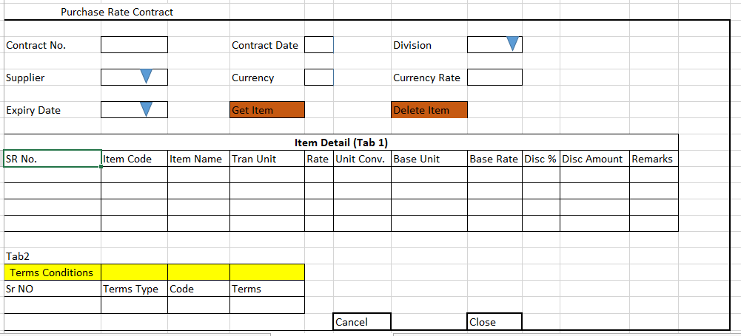

Screen notes / layout description:
Describe each visible area: panels, tabs, special controls, conditionally visible sections.
► Header panel — trancode (auto), trandate (Date), divisionid
(Dropdown), supplierid (cascades from to Division - Dropdown), currencyid
(TextArea), currencyrate (TextArea), expirydate (DATE), remarks(TextArea)
With RB Name – (rb_purratecontmst)

► Item Grid (Tab1) — EntryGrid (Contract Item Detail) with columns rb_purratecontdet metadata (dynamic). Buttons: Add New | Select Item.
Terms & Condition (Tab 2) — EntryGrid (Terms & Condition Detail) with columns rb_purrateconttncdet metadata (dynamic). Buttons: Add New | Select Item.

3. Header Fields
One row per field shown in the Header Panel. Control types: Textbox | Date | Dropdown | Textarea | Checkbox.

FieldID(colname) | Field Label | Control Type | Required | Is ReadOnly | Is Lock  On Edit | Source SP / Cascade Note
trancode | Contract No | TextAera | No | Yes | Yes | Auto-generated on save
trandate | Contract Date | Date | Yes | No | Yes | Default: today's date
divisionid | Division | Dropdown | Yes | No | Yes | fn_tbl_fetchuserwsdivision(@prmuserid , @prmcompanyid , @prmyearid)
supplierid | Supplier | Dropdown | Yes | No | Yes | Fn_tbl_FetchCustomerSupplierTranWs4Web (  @prmdivisionid numeric(18,0),  @prmloginid numeric(18,0),  @prmyearid int,  @prmpartytype varchar(5)  )
currencyid | Currency | Date | Yes | Yes | Yes | Auto fill from supplier Selection
currencyrate | Currency rate | TextArea | yes | Yes | Yes | Auto fill from supplier Selection
expirydate | Expiry Date | Date | Yes | No | Yes
remarks | Remarks | TextArea | No | No | No

Cascade resets:
► When divisionid changes → clear Grid Data(rb_purratecontdet) Refresh and reload its options.

Validations for masters:

- expirydate can not be small then current date.

- expirydate can not be small then contract date.

4. Grid / Entry Columns (Tab 1) with RB -rb_purratecontdet
List every column in the Item Grid (EntryGrid). Source = "API (RB detail metadata)" or "Hardcoded" if static.

Column Label | Key (ColName) | Control Type | Editable | Source
Sr. No. | SrNo | Number | No | API — rb_purratecontdet metadata
Item Code | ItemCode | Textbox | Yes | API — rb_purratecontdet metadata
Item Name | ItemName | Textbox | No | API — rb_purratecontdet metadata
Quantity | Qty | Number | Yes | API — rb_purratecontdet metadata
Unit | Unit | Dropdown | No | API — rb_purratecontdet metadata
Rate | Rate | Number | Yes | API — rb_purratecontdet metadata
Amount | Amount | Number | No | API — auto-calculated: Qty × Rate
Remarks | Remarks | Textarea | Yes | API —rb_purratecontdet metadata
(add here) | (add here) | (add here) | (add here) | (add here)
(add here) | (add here) | (add here) | (add here) | (add here)

4. Grid / Entry Columns (Tab 2) With RB - rb_purrateconttncdet
List every column in the Item Grid (EntryGrid). Source = "API (RB detail metadata)" or "Hardcoded" if static.

Column Label | Key (ColName) | Control Type | Editable | Source
Sr. No. | SrNo | Number | No | API — rb_purrateconttncdet metadata
Item Code | ItemCode | Textbox | Yes | API — rb_purrateconttncdet metadata
Item Name | ItemName | Textbox | No | API — rb_purrateconttncdet metadata
Quantity | Qty | Number | Yes | API — rb_purrateconttncdet metadata
Unit | Unit | Dropdown | No | API — rb_purrateconttncdet metadata
Rate | Rate | Number | Yes | API — rb_purrateconttncdet metadata
Amount | Amount | Number | No | API — auto-calculated: Qty × Rate
Remarks | Remarks | Textarea | Yes | API —rb_purrateconttncdet metadata
(add here) | (add here) | (add here) | (add here) | (add here)
(add here) | (add here) | (add here) | (add here) | (add here)

5. API Reference
List every stored procedure / function called. ObjType 2 = Function, 1 = Procedure. Source: backend DBA.

SP / Function Name | ObjType | Purpose | Key Parameters | Returns
Fn_Fetch_RBDetailByRBCode | 2 | Fetch RB column metadata (header + detail) | prmRBCode | Table[0]: RBID + column definitions
Fn_tbl_FetchUserWsDivision | 2 | Division dropdown options | prmYearID, prmLoginID | Table: division list
fn_tbl_rb_purratecontitem | 2 | Item Selection —  Tab1 | fn_tbl_rb_purratecontitem(  @prmdivisionid numeric(18,0),  @prmyearid int,  @prmloginid numeric(18,0),  @prmtrandate date,  @prmconfigid numeric(18,0),  @prmsupplierid numeric(18,0),  @prmlocationid numeric(18,0),  @prmtranbook varchar(20),  @prmfrmoption int  ) | Table: item rows
fn_tbl_rb_purrateconttncsel | 2 | Terms &Condition Selection-Tab2s | [fn_tbl_rb_purrateconttncsel]  (  @prmdivisionid integer,  @prmtrandate date,  @prmloginid integer,  @prmconfigid integer,  @prmcontractmstid integer  )
(add here) | (add here) | (add here) | (add here) | (add here)
(add here) | (add here) | (add here) | (add here) | (add here)

Save endpoint (REST POST):
Endpoint path/API/ PurRateContractSave / Post_RB_PurRateContMst_Save
Payload keys: prmStrMstJSON | prmStrDetJSON | prmTermsNCondDetJSon

5.1 RB Structure Detail

SP / Function Name | RB Name | Purpose
Master Data RB | rb_purratecontmst | Load Master Controls in form
Item Detail (Tab1) | rb_purratecontdet | Load Item grid in form
Terms & Condition Detail(Tab2) | rb_purrateconttncdet | Load data in Terms grid
Purchase Item Selection (Popup) for Tab 1 | rb_purratecontitem | To load Purchase Item selection popup RB data for Tab1
Terms & Condition selection popup | rb_purrateconttncsel | To load Terms selection popup RB data for Tab2
RB Save API | /API/PurRateContractSave / Post_RB_PurRateContMst_Save
List side Data fill | fn_tbl_rb_purratecontmst_list | [fn_tbl_rb_purratecontmst_list]  (  @prmcompanyid int,  @prmdivisionid int,  @prmyearid int,  @prmfromdate date,  @prmtodate date,  @prmloginid int  )
Purchase Item Detail (Popup) | fn_tbl_rb_purratecontitem | fn_tbl_rb_purratecontitem(  @prmdivisionid numeric(18,0),  @prmyearid int,  @prmloginid numeric(18,0),  @prmtrandate date,  @prmconfigid numeric(18,0),  @prmsupplierid numeric(18,0),  @prmlocationid numeric(18,0),  @prmtranbook varchar(20),  @prmfrmoption int  )
Terms Selection Detail(popup) | fn_tbl_rb_purrateconttncsel | [fn_tbl_rb_purrateconttncsel]  (  @prmdivisionid integer,  @prmtrandate date,  @prmloginid integer,  @prmconfigid integer,  @prmcontractmstid integer  )
Edit Mode - Master | fn_tbl_rb_purratecontmst | fill data on edit in master controls
Edit mode – Item Detail(Tab1) | fn_tbl_rb_purratecontdet | fill data on edit in Item Grid
Edit Mode – Terms & Condition(Tab2) | fn_tbl_rb_purrateconttncdet | Fill Terms & Condition data on edit.

6. Business Rules
Every rule the developer must implement. Add or remove lines for your module.

1. (add here)

7. Constants (constants.js)
All values for the constants.js file. RB codes and SP names come from the backend DBA. Mark CONFIRM = Yes if value is uncertain.

Constant Name | Value | CONFIRM? | Notes
RB_MASTER | rb_purratecontmst | No | Master board code — header column metadata
RB_DETAIL | rb_purratecontdet | No | Detail board code — grid column metadata
FORM_TAG | rb_purratecontmst | No | Short module tag used in save payload
TRAN_BOOK | RC | No | Transaction book name for item picker SP
CONFIG_YEAR_ID | 2 | CONFIRM | Year ID passed to configuration SPs
DIVISION_YEAR_ID | 2 | CONFIRM | Year ID passed to division fetch SP
SUPPLIER_PARTY_TYPE | S | No | Party type filter for supplier picker
LIST_OBJ_TYPE | 2 | No | OBJ_TYPE.FUNCTION — for listing SP call
SP_ LIST | fn_tbl_rb_purratecontmst_list | CONFIRM | Function to load listing page data
LIST_DIVISION_ID | 15 | CONFIRM | Default division ID for listing data fetch
SAVE_ENDPOINT | / API/ PurRateContractSave / Post_RB_PurRateContMst_Save | No | REST gateway save path
STORAGE_HEADER_META | piHeaderMeta | No | localStorage key for cached header RB metadata

— END OF TEMPLATE —

