HORIZON ENTERPRISE IMS
Module Requirements Template
Module: [Maintenance]
Submitted by: [Richa]
Date: [14-Jul-2026]

COLOUR GUIDE
GREEN — Example value from Maintenance DashBoard— replace for your module | BLUE — Empty slot — add your own rows here | AMBER — Instruction — read once, ignore after

HOW TO USE THIS TEMPLATE
1. Save a copy — rename to MRD_[ModuleName].docx before editing.
2. Replace every green value with your module's equivalent (SP names, RB codes, field names, routes, etc.).
3. Add your own rows in the blue slots at the bottom of each table.
4. In Section 2, delete the placeholder box and paste your design screenshot (Insert → Pictures).
5. Send completed document to the development team BEFORE coding starts.
6. Dev team signs off by stamping "Dev Confirmed" on each section.

1. Module Overview
Replace every green value below with your module's equivalent.
Module Name: Maintenance
Module Code: “MNT”
Purpose: to track complaint call against assets item.
Primary Users: Procurement / Maintenance Team
Listing Route: /Assets- MAINTENANCE DASHBOARD
New Form Route: / Assets - MAINTENANCE DASHBOARD /refresh
Nav Menu Label: MAINTENANCE DASHBOARD

2. Screen Design
Delete the placeholder box below and paste your design screenshot (Insert → Pictures). Add a second image for the listing view if applicable.

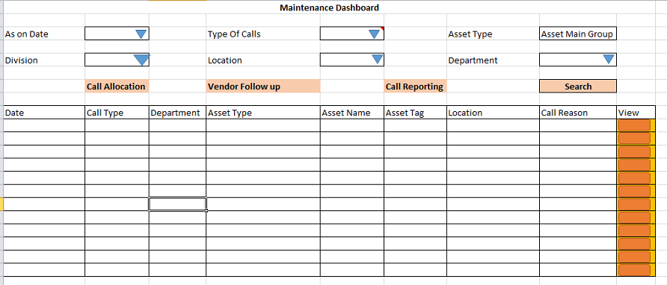

Screen notes / layout description:
Describe each visible area: panels, tabs, special controls, conditionally visible sections.
► Header panel — as on date (System Date(today date + 1 month)), divisionid (Drop down), locationid (dropdown – cascade in case of change divisionid), deptid (cascade in case of change locationid Drop down), Types of call (dropdown), Asset type (dropdown)

► Item Grid tab — EntryGrid with columns rb_mntdashboard metadata (dynamic). Buttons: Add New | Select Item.

3. Header Fields
One row per field shown in the Header Panel. Control types: Textbox | Date | Dropdown | Textarea | Checkbox.

Field Label | Field ID (ColName) | Control Type | Required | Source SP / Cascade Note
As on date | asondate | Date | Yes | Default: (today's date + 1 month)
Division | divisionid | Dropdown | Yes | fn_tbl_fetchuserwsdivision(@prmuserid , @prmcompanyid , @prmyearid)
Location | locationid | Dropdown | Yes | Cascade on change of division - fn_gen_fetchlocationmaster(@prmcompanyid , @prmloginid , @prmlocationtype)
Department | deptid | Dropdown | Yes | Cascade on change of division - fn_gen_fetchdepartmentmaster  (@prmcompanyid , @prmloginid)
Type of calls | typeofcalls | Dropdown | Yes | Vw_MntCallgentype – no parameters
Assets Type | assetstype | dropdown |  | fn_tbl_fetchassetsitemmaingroup(@prmdivisionid integer,  @prmloginid integer,  @prmdeptid integer,  @prmcalltypeid int)
(add here) | (add here) | (add here) | (add here) | (add here)

Cascade resets:
► When DivisionID changes → clear locationid, assetstype, Grid Data(rb_mntdashboard) Refresh and reload its options.

► When locationid changes → clear departmentid, Grid Data(rb_mntdashboard) Refresh and reload its options.

4. Grid / Entry Columns (Tab 1)
List every column in the Item Grid (EntryGrid). Source = "API (RB detail metadata)" or "Hardcoded" if static.

Column Label | Key (ColName) | Control Type | Editable | Source
Sr. No. | SrNo | Number | No | API — rb_mntdashboard metadata
Item Code | itemcode | Textbox | Yes | API — rb_mntdashboard metadata
Item Name | itemname | Textbox | Yes | API — rb_mntdashboard metadata
Batch Srno | batchsrno | textbox | Yes | API — rb_mntdashboard metadata
Complaint Type | complainttypeid | Dropdown | Yes | API — rb_mntdashboard metadata
Severity Type | severitytype | dropdown | Yes | API — auto-calculated: Qty × Rate
Location | fromlocationid | dropdown | Yes | API — rb_mntdashboard metadata
Department | fromdeptid | dropdown | Yes | API — rb_mntdashboard metadata
(add here) | (add here) | (add here) | (add here) | (add here)
(add here) | (add here) | (add here) | (add here) | (add here)

5. API Reference
List every stored procedure / function called. ObjType 2 = Function, 1 = Procedure. Source: backend DBA.

SP / Function Name | ObjType | Purpose | Key Parameters | Returns
Fn_Fetch_RBDetailByRBCode | 2 | Fetch RB column metadata (header + detail) | prmRBCode | Table[0]: RBID + column definitions
Fn_tbl_FetchUserWsDivision | 2 | Division dropdown options | prmYearID, prmLoginID | Table: division list
fn_tbl_rb_mntdashboard |  | Fetch data for dashboard grid | @prmcompanyid int,  @prmyearid int,  @prmloginid int,  @prmsessionid int,  @prmasondate date,  @prmdivisionid integer,  @prmlocationid integer,  @prmdeptid integer,  @prmcalltype varchar(5),  @prmmaingroupid integer,  @prmmasterid int
(add here) | (add here) | (add here) | (add here) | (add here)
(add here) | (add here) | (add here) | (add here) | (add here)

Save endpoint (REST POST):
Endpoint path - -

Payload keys: prmStrMstJSON | prmStrDetJSON

5.1 RB Structure Detail

SP / Function Name | RB Name | Purpose
Master Data RB | - | Load Master Controls in form
Item Detail Grid | rb_mntdashboard | Load Item grid in form
Search data | fn_tbl_rb_mntdashboard(  @prmcompanyid int,  @prmyearid int,  @prmloginid int,  @prmsessionid int,  @prmasondate date,  @prmdivisionid integer,  @prmlocationid integer,  @prmdeptid integer,  @prmcalltype varchar(5),  @prmmaingroupid integer,  @prmmasterid int) | To load Maintenance DashBoard data in (rb_mntdashboard )RB grid on click of search button
RB Save API | -
List side Data fill | -
Edit Mode – Master | -
Edit mode – Item Detail | -

6. Business Rules
Every rule the developer must implement. Add or remove lines for your module.

1. (add here)

7. Constants (constants.js)
All values for the constants.js file. RB codes and SP names come from the backend DBA. Mark CONFIRM = Yes if value is uncertain.

Constant Name | Value | CONFIRM? | Notes
RB_MASTER | - | No | Master board code — header column metadata
RB_DETAIL | rb_mntdashboard | No | Detail board code — grid column metadata
FORM_TAG | - | No | Short module tag used in save payload
TRAN_BOOK | MNTDB | No | Transaction book name for item picker SP
CONFIG_YEAR_ID | 2 | CONFIRM | Year ID passed to configuration SPs
DIVISION_YEAR_ID | 2 | CONFIRM | Year ID passed to division fetch SP
SUPPLIER_PARTY_TYPE | - | No | Party type filter for supplier picker
LIST_OBJ_TYPE | 2 | No | OBJ_TYPE.FUNCTION — for listing SP call
SP_ LIST | - | CONFIRM | Function to load listing page data
LIST_DIVISION_ID | 15 | CONFIRM | Default division ID for listing data fetch
SAVE_ENDPOINT | - | No | REST gateway save path
STORAGE_HEADER_META | piHeaderMeta | No | localStorage key for cached header RB metadata

— END OF TEMPLATE —

