HORIZON ENTERPRISE IMS
Module Requirements Template
Module: [Maintenance]
Submitted by: [Aditya]
Date: [24-08-2026]

COLOUR GUIDE
GREEN — Example value from Purchase Inquiry — replace for your module | BLUE — Empty slot — add your own rows here | AMBER — Instruction — read once, ignore after

HOW TO USE THIS TEMPLATE
1. Save a copy — rename to MRD_[ModuleName].docx before editing.
2. Replace every green value with your module's equivalent (SP names, RB codes, field names, routes, etc.).
3. Add your own rows in the blue slots at the bottom of each table.
4. In Section 2, delete the placeholder box and paste your design screenshot (Insert → Pictures).
5. Send completed document to the development team BEFORE coding starts.
6. Dev team signs off by stamping "Dev Confirmed" on each section.

1. Module Overview
Replace every green value below with your module's equivalent.
Module Name: Assets
Module Code: “MNT”
Purpose: To define parts item details of Asset Item.
Primary Users: Procurement / Account Team
Listing Route: /Assets- Assets BOM Master
New Form Route: / Assets - Assets BOM Master /new
Edit Route: / Assets - Assets BOM Master/:id
Naw Menu Label: Assets BOM Master

2. Screen Design
Delete the placeholder box below and paste your design screenshot (Insert → Pictures). Add a second image for the listing view if applicable.

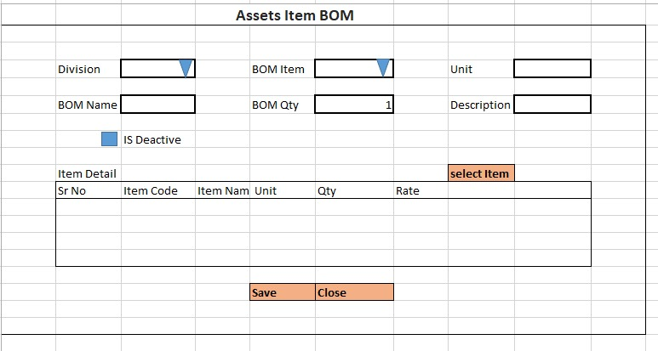

Screen notes / layout description:
Describe each visible area: panels, tabs, special controls, conditionally visible sections.
► Header panel --- Division (Drop Down). Bom Item (Drop Down). Unit (Text Box). BOM Name (Text Box). BOM Qty (Text Box). Description (Text Box). Is Deactive(Check Box).
With RB Name – (rb_astbommaster)

► Item Grid — EntryGrid (Contract Item Detail) with columns rb_astbomdet metadata (dynamic). Buttons: Add New | Select Item.

3. Header Fields
One row per field shown in the Header Panel. Control types: Textbox | Date | Dropdown | Textarea | Checkbox.

FieldID(colname) | Field Label | Control Type | Required | Is ReadOnly | Is Lock  On Edit | Source SP / Cascade Note
divisionid | Division | Drop Down | Yes | No | Yes | fn_tbl_fetchuserwsdivision  (  @prmuserid numeric(18,0),  @prmcompanyid int,  @prmyearid numeric(18,0)  )
bomitemid | bom item | Drop Down | Yes | No | NO | fn_tbl_bomitem_fetch(@prmuserid numeric(18,0),  @prmdivisionid int,  @prmyearid numeric(18,0))
unit | Unit | Text Box | No | Yes | Yes | Auto fill from BOm item selection
bomname | bom name | Text Boc | Yes | No | No
bomqty | bom qty | Text Box | Yes | No | Yes
description | Description | Text Box | No | No | No
isdeactive | Isdeactive | Check box | No | No | No

Cascade resets:
► When divisionid changes → clear Grid Data(rb_astbomdet) Refresh and reload its options.

4. Grid / Entry Columns
List every column in the Item Grid (EntryGrid). Source = "API (RB detail metadata)" or "Hardcoded" if static.

Column Label | Key (ColName) | Control Type | Editable | Source
item code | Itemcode | Textbox | Yes | API — rb_astbomdet metadata
item name | Itemname | Textbox | No | API — rb_astbomdetmetadata
Quantity | Qty | Number | Yes | API — rb_astbomdetmetadata
Unit | Unit | Dropdown | No | API — rb_astbomdetmetadata
Rate | Rate | Number | Yes | API — rb_astbomdetmetadata
(add here) | (add here) | (add here) | (add here) | (add here)
(add here) | (add here) | (add here) | (add here) | (add here)

5. API Reference
List every stored procedure / function called. ObjType 2 = Function, 1 = Procedure. Source: backend DBA.

SP / Function Name | ObjType | Purpose | Key Parameters | Returns
Fn_Fetch_RBDetailByRBCode | 2 | Fetch RB column metadata (header + detail) | prmRBCode | Table[0]: RBID + column definitions
Fn_tbl_FetchUserWsDivision | 2 | Division dropdown options | prmYearID, prmLoginID | Table: division list
fn_tbl_rb_astbommselonly | 2 | Item Selection — | @prmdivisonid int,  @prmcompanyid int,  @prmloginid int,  @prmyearid int | Table: item rows
(add here) | (add here) | (add here) | (add here) | (add here)
(add here) | (add here) | (add here) | (add here) | (add here)

Save endpoint (REST POST):
Endpoint path API/AstBomMaster/Post_RB_AstBomMaster_Save
Payload keys: prmStrMstJSON | prmStrItemDetail

5.1 RB Structure Detail

SP / Function Name | RB Name | Purpose
Master Data RB | rb_astbommaster | Load Master Controls in form
Item Detail (Tab1) | rb_astbomdet | Load Item grid in form
Assets Item Selection (Popup) | rb_astbommselonly | To load Assets Item selection popup RB data for Tab1
RB Save API | API/AstBomMaster/Post_RB_AstBomMaster_Save
List side Data fill | fn_tbl_rb_astbommaster_list | fn_tbl_rb_astbommaster_list (  @prmcompanyid int,  @prmdivisionid int,  @prmyearid int,  @prmfromdate date,  @prmtodate date,  @prmloginid int  )
Assets Item Detail (Popup) | fn_tbl_rb_astbommselonly | fn_tbl_rb_astbommselonly (@prmdivisonid int,  @prmcompanyid int,  @prmloginid int,  @prmyearid int)
Edit Mode – Master | fn_tbl_rb_astbommaster | fill data on edit in master controls
Edit mode – Item Detail | fn_tbl_rb_astbomdet | fill data on edit in Item Grid

6. Business Rules
Every rule the developer must implement. Add or remove lines for your module.

1. (add here)

7. Constants (constants.js)
All values for the constants.js file. RB codes and SP names come from the backend DBA. Mark CONFIRM = Yes if value is uncertain.

Constant Name | Value | CONFIRM? | Notes
RB_MASTER | rb_astbommaster | No | Master board code — header column metadata
RB_DETAIL | rb_astbomdet | No | Detail board code — grid column metadata
FORM_TAG | rb_astbommaster | No | Short module tag used in save payload
TRAN_BOOK | ABOM | No | Transaction book name for item picker SP
CONFIG_YEAR_ID | 2 | CONFIRM | Year ID passed to configuration SPs
DIVISION_YEAR_ID | 2 | CONFIRM | Year ID passed to division fetch SP
SUPPLIER_PARTY_TYPE | S | No | Party type filter for supplier picker
LIST_OBJ_TYPE | 2 | No | OBJ_TYPE.FUNCTION — for listing SP call
SP_ LIST | fn_tbl_rb_astbommaster_list | CONFIRM | Function to load listing page data
LIST_DIVISION_ID | 15 | CONFIRM | Default division ID for listing data fetch
SAVE_ENDPOINT | API/AstBomMaster/Post_RB_AstBomMaster_Save | No | REST gateway save path
STORAGE_HEADER_META | piHeaderMeta | No | localStorage key for cached header RB metadata

— END OF TEMPLATE —

