HORIZON ENTERPRISE IMS
Module Requirements Template
Module: [Admin]
Submitted by: [Om]
Date: [18-Jun-2026]

COLOUR GUIDE
GREEN — Example value from Item Master — replace for your module | BLUE — Empty slot — add your own rows here | AMBER — Instruction — read once, ignore after

HOW TO USE THIS TEMPLATE
1. Save a copy — rename to MRD_[ModuleName].docx before editing.
2. Replace every green value with your module's equivalent (SP names, RB codes, field names, routes, etc.).
3. Add your own rows in the blue slots at the bottom of each table.
4. In Section 2, delete the placeholder box and paste your design screenshot (Insert → Pictures).
5. Send completed document to the development team BEFORE coding starts.
6. Dev team signs off by stamping "Dev Confirmed" on each section.

1. Module Overview
Replace every green value below with your module's equivalent.
Module Name: Item Master
Module Code: “IM”
Purpose: Create Items For All Transactions.
Primary Users: Production / Admin Team
Listing Route: / Admin/Item/ – Item Master
New Form Route: /Admin/Item/ - Item Master /new
Edit Route: /Admin/Item/ - Item Master /:id
Nav Menu Label: Item Master

2. Screen Design
Delete the placeholder box below and paste your design screenshot (Insert → Pictures). Add a second image for the listing view if applicable.

. 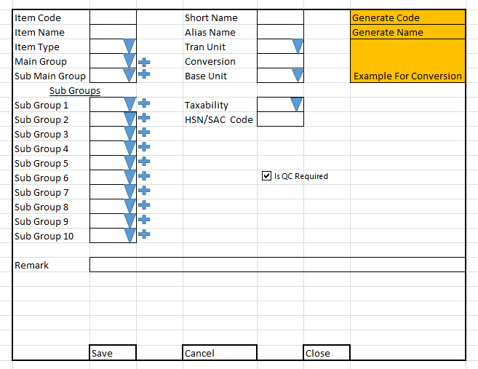

Screen notes / layout description:
Describe each visible area: panels, tabs, special controls, conditionally visible sections.
► Header panel — Item Code. (auto), Item Name (TextBox), Short Name (Textbox), Alias Name (TextBox),Generate Code(Button For Generate Itemcode Automatically),Generate Name (Button For Generate ItemName Automatically),Item Type(Dropdown),Main Group (Dropdown),Sub Main Group (Dropdown), Sub Group1(Dropdown), Sub Group2(Dropdown), Sub Group3(Dropdown), Sub Group4(Dropdown), Sub Group5(Dropdown), Sub Group6(Dropdown), Sub Group7(Dropdown), Sub Group8(Dropdown), Sub Group9(Dropdown), Sub Group10(Dropdown),
Texability (Dropdown), Remarks(TextBox),Tran Unit(Dropdown),Conversion (TextBox),Base Unit(Dropdown),HSN / SAC Code (TextBox),Example For Conversion(Button For Check the Conversion for Base To Tran),IS QC Required(CheckBox)

3. Form Fields
One row per field shown in the Form Panel. Control types: Textbox | Date | Dropdown | Textarea | Checkbox.

Field Label | Field ID (ColName) | Control Type | Required | Is ReadOnly | Is Lock  On Edit | Source SP / Cascade Note
Item code | Itemcode | Textbox | Yes | Yes | Yes | Auto-generated on save
Item Name | ItemName | Textbox | Yes | No | Yes
Item Type | ItemTypeID | Dropdown | Yes | No | Yes | Fn_tbl_Fetch_ItemType  No Parameter
Main Group | MainGroupID | Dropdown | Yes | No | Yes | Fn_tbl_Fetch_MainGroup  No Parameter
Sub Main Group | SubMainGroupID | Dropdown | Yes | No | Yes | Fn_tbl_Fetch_SubGroup  No Parameter
Sub Group 1 | SubGroupID 1 | Dropdown | Yes | No | Yes | Fn_tbl_Fetch_SubGroup  No Parameter
Sub Group 2 | SubGroupID 2 | Dropdown | Yes | No | Yes | Fn_tbl_Fetch_SubGroup  No Parameter
Sub Group 3 | SubGroupID 3 | Dropdown | Yes | No | Yes | Fn_tbl_Fetch_SubGroup  No Parameter
Sub Group 4 | SubGroupID 4 | Dropdown | Yes | No | Yes | Fn_tbl_Fetch_SubGroup  No Parameter
Sub Group 5 | SubGroupID 5 | Dropdown | Yes | No | Yes | Fn_tbl_Fetch_SubGroup  No Parameter
Sub Group 6 | SubGroupID 6 | Dropdown | Yes | No | Yes | Fn_tbl_Fetch_SubGroup  No Parameter
Sub Group 7 | SubGroupID 7 | Dropdown | Yes | No | Yes | Fn_tbl_Fetch_SubGroup  No Parameter
Sub Group 8 | SubGroupID 8 | Dropdown | Yes | No | Yes | Fn_tbl_Fetch_SubGroup  No Parameter
Sub Group 9 | SubGroupID 9 | Dropdown | Yes | No | Yes | Fn_tbl_Fetch_SubGroup  No Parameter
Sub Group 10 | SubGroupID 10 | Dropdown | Yes | No | Yes | Fn_tbl_Fetch_SubGroup  No Parameter
Texability | TaxId | Dropdown | Yes | No | Yes | Fn_tbl_Fetch_Texability  No Parameter
Remarks | Remarks | TextArea | Yes | No | Yes | --
Short Name | ShortName | Text Box | Yes | No | Yes | ----
AliasName | AliasName | TextBox | Yes | No | No | ----
Generate Code |  | Button | Yes | No | NO
Generate Name |  | Button | Yes | No | No
(add here) | (add here) | (add here) | (add here) |  |  | (add here)

Cascade resets:
► When DivisionID changes → clear SeverityType (Severity Type) , AssetName (Act_Ass_ItemMaster),SrNo
(Act_Ass_ItemDetailLedger) Refresh and reload its options.
- When change Asset Name clear Part Item Section(Part Name, SrNo,Remarks) Refresh and reload its options.
Save endpoint (REST POST):
Endpoint path: /API/RB_PurItemMst / Post_RB_PurItemMst_Save
Payload keys: prmStrMstJSON | prmStrDetJSON

5.1 RB Structure Detail

SP / Function Name | RB Name | Purpose
Master Data RB | RB_PurItemMst | Load Master Controls in form
RB Save API | /API/RB_PurItemMst / Post_RB_PurItemMst_Save
List side Data fill | Fn_tbl_Mnt_ItemMst_List | Load data on list side
Edit Mode - Master | fn_tbl_RB_PurItemMst | fill data on edit in master controls

6. Business Rules
Every rule the developer must implement. Add or remove lines for your module.
1. Division cascade — When DivisionID changes, clear Inquiry Type (ConfigID) and reload its options via fn_tbl_ddl_Pur_Configuration.
4. Three-phase metadata load — Phase 1 (mount): header RB + divisions in parallel. Phase 2: detail RB. Phase 3 (lazy, on first Add New / Select Item): grid columns.
6. Temp row IDs — New rows get negative temp IDs (nextTempId--) to avoid collisions with real DB IDs on save.
7. isNewRoute detection — /purchase-Inward/new → IDNumber = 0 in save payload. /purchase- Inward /:id → IDNumber = numeric id.
8. Edit mode gate — All inputs disabled until user clicks the ActionBar Add/Edit button. Prevents accidental edits on load.

9. (add here)

7. Constants (constants.js)
All values for the constants.js file. RB codes and SP names come from the backend DBA. Mark CONFIRM = Yes if value is uncertain.

Constant Name | Value | CONFIRM? | Notes
RB_MASTER | RB_PurItemMst | No | Master board code — header column metadata
FORM_TAG | RB_PurItemMst | No | Short module tag used in save payload
TRAN_BOOK | CR | No | Transaction book name for item picker SP
CONFIG_YEAR_ID | 2 | CONFIRM | Year ID passed to configuration SPs
DIVISION_YEAR_ID | 2 | CONFIRM | Year ID passed to division fetch SP
LIST_OBJ_TYPE | 2 | No | OBJ_TYPE.FUNCTION — for listing SP call
SP_LIST | Fn_tbl_Mnt_ItemMst_List | CONFIRM | Function to load listing page data
LIST_DIVISION_ID | 15 | CONFIRM | Default division ID for listing data fetch
SAVE_ENDPOINT | /API/RB_PurItemMst / Post_RB_PurItemMst_Save | No | REST gateway save path
STORAGE_HEADER_META | piHeaderMeta | No | localStorage key for cached header RB metadata

— END OF TEMPLATE —

