HORIZON ENTERPRISE IMS
Module Requirements Template
Module: [Admin]
Submitted by: [Om]
Date: [19-Jun-2026]

COLOUR GUIDE
GREEN — Example value from Group — replace for your module | BLUE — Empty slot — add your own rows here | AMBER — Instruction — read once, ignore after

HOW TO USE THIS TEMPLATE
1. Save a copy — rename to MRD_[ModuleName].docx before editing.
2. Replace every green value with your module's equivalent (SP names, RB codes, field names, routes, etc.).
3. Add your own rows in the blue slots at the bottom of each table.
4. In Section 2, delete the placeholder box and paste your design screenshot (Insert → Pictures).
5. Send completed document to the development team BEFORE coding starts.
6. Dev team signs off by stamping "Dev Confirmed" on each section.

1. Module Overview
Replace every green value below with your module's equivalent.
Module Name: User Group
Module Code: “GRP”
Purpose: Create Group For User.
Primary Users: Procurement / Maintenance Team
Listing Route: / Admin/File/ – User Group
New Form Route: / Admin/File/ - User Group /new
Edit Route: : / Admin/File/ User Group/:id
Nav Menu Label: User Group

2. Screen Design
Delete the placeholder box below and paste your design screenshot (Insert → Pictures). Add a second image for the listing view if applicable.

. 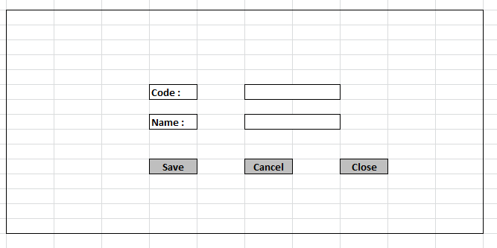

Screen notes / layout description:
Describe each visible area: panels, tabs, special controls, conditionally visible sections.
► Header panel – Code(Text Box),Name (Text Box)

3. Form Fields
One row per field shown in the Form Panel. Control types: Textbox | Date | Dropdown | Textarea | Checkbox.

Field Label | Field ID (ColName) | Control Type | Required | Is ReadOnly | Is Lock  On Edit | Source SP / Cascade Note
Code | GroupCode | Textbox | No | Yes | Yes
Name | GroupName | TextBox | Yes | No | Yes
(add here) | (add here) | (add here) | (add here) |  |  | (add here)
(add here) | (add here) | (add here) | (add here) |  |  | (add here)

Cascade resets:
► When Code changes → clear Group Name (Name)
Save endpoint (REST POST):
Endpoint path: /API/GenUserGroupMst /Post_RB_GenUserGroupMst_Save
Payload keys: prmStrMstJSON | prmStrDetJSON

5.1 RB Structure Detail

SP / Function Name | RB Name | Purpose
Master Data RB | RB_GenUserGroupMst | Load Master Controls in form
RB Save API | /API/GenUserGroupMst /Post_RB_GenUserGroupMst_Save
List side Data fill | Fn_tbl_Gen_GroupMaster_List | Load data on list side
Edit Mode - Master | fn_tbl_RB_GenUserGroupMst | fill data on edit in master controls

6. Business Rules
Every rule the developer must implement. Add or remove lines for your module.
1. (add here)

7. Constants (constants.js)
All values for the constants.js file. RB codes and SP names come from the backend DBA. Mark CONFIRM = Yes if value is uncertain.

Constant Name | Value | CONFIRM? | Notes
RB_MASTER | RB_GenUserGroupMst | No | Master board code — header column metadata
FORM_TAG | RB_GenUserGroupMst | No | Short module tag used in save payload
TRAN_BOOK | GRP | No | Transaction book name for item picker SP
CONFIG_YEAR_ID | 2 | CONFIRM | Year ID passed to configuration SPs
DIVISION_YEAR_ID | 2 | CONFIRM | Year ID passed to division fetch SP
LIST_OBJ_TYPE | 2 | No | OBJ_TYPE.FUNCTION — for listing SP call
SP_LIST | Fn_tbl_Gen_GroupMaster_List | CONFIRM | Function to load listing page data
LIST_DIVISION_ID | Fn_tbl_FetchUserWsDivision | CONFIRM | Default division ID for listing data fetch
SAVE_ENDPOINT | /API/GenUserGroupMst /Post_RB_GenUserGroupMst_Save | No | REST gateway save path
STORAGE_HEADER_META | piHeaderMeta | No | localStorage key for cached header RB metadata

— END OF TEMPLATE —

