HORIZON ENTERPRISE IMS
Module Requirements Template
Module: [Admin]
Submitted by: [Om]
Date: [19-Jun-2026]

COLOUR GUIDE
GREEN — Example value from User — replace for your module | BLUE — Empty slot — add your own rows here | AMBER — Instruction — read once, ignore after

HOW TO USE THIS TEMPLATE
1. Save a copy — rename to MRD_[ModuleName].docx before editing.
2. Replace every green value with your module's equivalent (SP names, RB codes, field names, routes, etc.).
3. Add your own rows in the blue slots at the bottom of each table.
4. In Section 2, delete the placeholder box and paste your design screenshot (Insert → Pictures).
5. Send completed document to the development team BEFORE coding starts.
6. Dev team signs off by stamping "Dev Confirmed" on each section.

1. Module Overview
Replace every green value below with your module's equivalent.
Module Name: User Master
Module Code: “UM”
Purpose: Create User For Access The System.
Primary Users: All / Management Team
Listing Route: / Admin/Files – User
New Form Route/ Admin/Files – User /new
Edit Route: / Admin/Files – User /:id
Nav Menu Label: User Master

2. Screen Design
Delete the placeholder box below and paste your design screenshot (Insert → Pictures). Add a second image for the listing view if applicable.

. 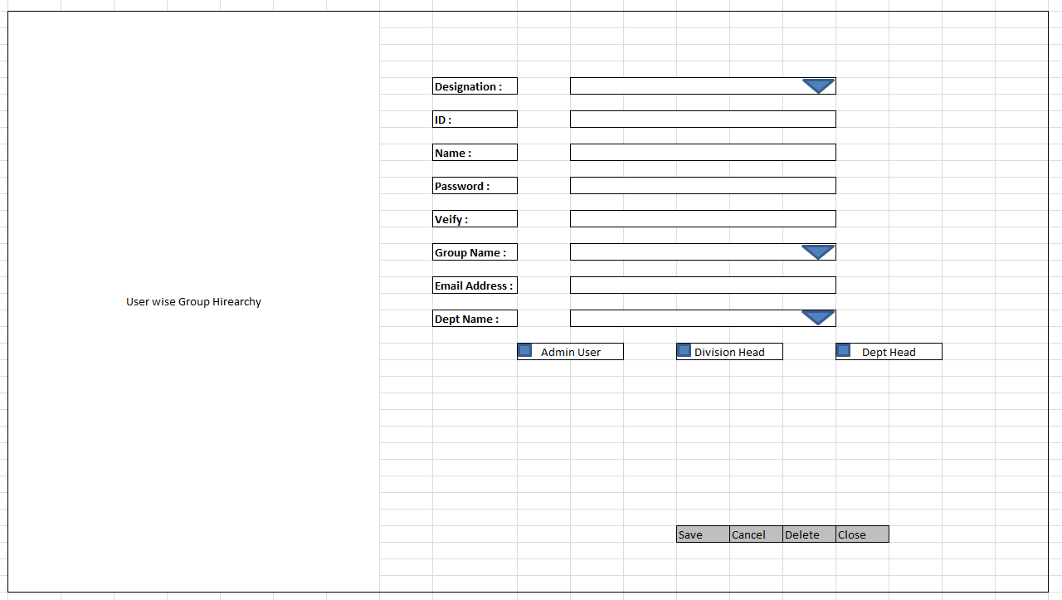

Screen notes / layout description:
Describe each visible area: panels, tabs, special controls, conditionally visible sections.
► Header panel — Designation (Dropdown), ID(TextArea), User Name (TextArea), Password(TextArea When Enter Password it will be save AS Encrypted mode and in front side show *),Verify (TextEdit Same Functionality In Password),GroupName(Dropdown),Email Address (Text Box),Department (Dropdown),
Right side Panel is for User wise Group wise Hierarchy.

3. Form Fields
One row per field shown in the Form Panel. Control types: Textbox | Date | Dropdown | Textarea | Checkbox.

Field Label | Field ID (ColName) | Control Type | Required | Is ReadOnly | Is Lock  On Edit | Source SP / Cascade Note
Designation | DesgID | Dropdown | Yes | NO | Yes | Fn_tbl_Fetch_Designation  No Parameter
ID | UserID | Text Box | Yes | No | Yes
Name | UserName | Text Box | Yes | No | Yes
Password | PWD | Text Box | Yes | No | Yes
Verify | PWD | Text Box | Yes | No | Yes
Group Name | GroupID | Dropdown | Yes | No | Yes | Fn_tbl_Fetch_GroupMst  No Parameter
Email Address | Email | Text Box | Yes | No | No
Department | DeptID | Dropdown | Yes | No | Yes | Fn_tbl_Fetch_Department  No Parameter
(add here) | (add here) | (add here) | (add here) |  |  | (add here)
(add here) | (add here) | (add here) | (add here) |  |  | (add here)

Cascade resets:
► When Designation changes → clear UserID(ID),UserName(Name),Group,Department
Refresh and reload its options.
Save endpoint (REST POST):
Endpoint path: /API/RB_GenUserMst /Post_RB_GenUserMst_Save
Payload keys: prmStrMstJSON | prmStrDetJSON

5.1 RB Structure Detail

SP / Function Name | RB Name | Purpose
Master Data RB | RB_GenUserMst | Load Master Controls in form
RB Save API | /API/RB_GenUserMst / Post_RB_GenUserMst_Save
List side Data fill |  | Load data on list side
Edit Mode - Master | fn_tbl_RB_GenUserMst | fill data on edit in master controls

6. Business Rules
Every rule the developer must implement. Add or remove lines for your module.
1. (add here)

7. Constants (constants.js)
All values for the constants.js file. RB codes and SP names come from the backend DBA. Mark CONFIRM = Yes if value is uncertain.

Constant Name | Value | CONFIRM? | Notes
RB_MASTER | RB_GenUserMst | No | Master board code — header column metadata
FORM_TAG | RB_GenUserMst | No | Short module tag used in save payload
TRAN_BOOK | UM | No | Transaction book name for item picker SP
CONFIG_YEAR_ID | 2 | CONFIRM | Year ID passed to configuration SPs
DIVISION_YEAR_ID | 2 | CONFIRM | Year ID passed to division fetch SP
LIST_OBJ_TYPE | 2 | No | OBJ_TYPE.FUNCTION — for listing SP call
SP_LIST |  | CONFIRM | Function to load listing page data
LIST_DIVISION_ID | Fn_tbl_FetchUserWsDivision | CONFIRM | Default division ID for listing data fetch
SAVE_ENDPOINT | /API/RB_GenUserMst / Post_RB_GenUserMst_Save | No | REST gateway save path
STORAGE_HEADER_META | piHeaderMeta | No | localStorage key for cached header RB metadata

— END OF TEMPLATE —

