HORIZON ENTERPRISE IMS
Module Requirements Template
Module: [Admin]
Submitted by: [Om]
Date: [24-Jun-2026]

COLOUR GUIDE
GREEN — Example value from Asset Item Master— replace for your module | BLUE — Empty slot — add your own rows here | AMBER — Instruction — read once, ignore after

HOW TO USE THIS TEMPLATE
1. Save a copy — rename to MRD_[ModuleName].docx before editing.
2. Replace every green value with your module's equivalent (SP names, RB codes, field names, routes, etc.).
3. Add your own rows in the blue slots at the bottom of each table.
4. In Section 2, delete the placeholder box and paste your design screenshot (Insert → Pictures).
5. Send completed document to the development team BEFORE coding starts.
6. Dev team signs off by stamping "Dev Confirmed" on each section.

1. Module Overview
Replace every green value below with your module's equivalent.
Module Name Account Item Opening Excel
Module Code: “AIME”
Purpose: Create Asset Item opening from Excel.
Primary Users: Management Team
Listing Route: /Account/Master/Asset – Asset Item Opening Excel
New Form Route/Account/Master/Asset – Asset Item Opening Excel /new
Edit Route: /Account/Master/Asset – Asset Item Opening Excel /:id
Nav Menu Label Asset Item opening from excel

2. Screen Design
Delete the placeholder box below and paste your design screenshot (Insert → Pictures). Add a second image for the listing view if applicable.

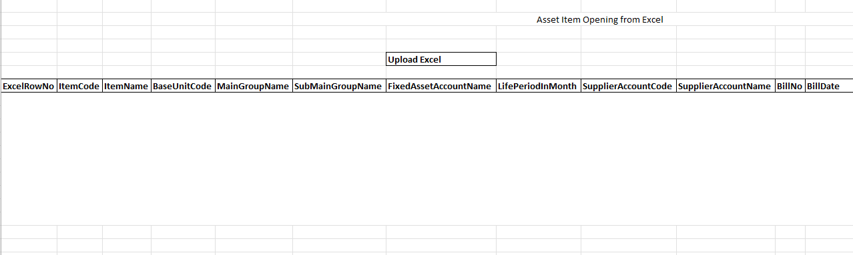.

3. Form Fields
One row per field shown in the Form Panel. Control types: Textbox | Date | Dropdown | Textarea | Checkbox.

Field Label | Field ID (ColName) | Control Type | Required | Is ReadOnly | Is Lock  On Edit | Source SP / Cascade Note
Item Code | ItemCode | Textbox | Yes | No | Yes
Item Name | ItemName | Text Box | Yes | No | Yes
Base Unit Code | BaseUnitCode | Textbox | Yes | No | Yes
Main Group Name | MainGroupName | Textbox | Yes | No | Yes
Sub Main Group Name | SubMainGroupName | Textbox | Yes | No | Yes
Fixed Asset Account Name | FixedAssetAccountName | Textbox | Yes | No | Yes
Life Period In Month | LifePeriodInMonth | Textbox | Yes | No | Yes
Supplier Account Code | SupplierAccountCode | Textbox | Yes | No | Yes
Supplier Account Name | SupplierAccountName | Textbox | Yes | No | Yes
Bill No | BillNo | Textbox | Yes | No | Yes
Bill Date | BillDate | Textbox | Yes | No | Yes
Inst Date | InstDate | Textbox | Yes | No | Yes
Purchase Qty | PurchaseQty | Textbox | Yes | No | Yes
Purchase Amount | PurchaseAmount | Textbox | Yes | No | Yes
SR NO | SRNO | Textbox | Yes | No | Yes
Opening Amount | OpeningAmount | Textbox | Yes | No | Yes
Acm Depreciation Amount | AcmDepreciationAmount | Textbox | Yes | No | Yes
Acm Depreciation Account Name | AcmDepreciationAccountName | Textbox | Yes | No | Yes
Depreciation Account Name | DepreciationAccountName | Textbox | Yes | No | Yes
Depreciation Amount B4 Life | DepreciationAmountB4Life | Textbox | Yes | No | Yes
Depreciation Days B4 Life | DepreciationDaysB4Life | Textbox | Yes | No | Yes
Division Name | DivisionName | Textbox | Yes | No | Yes
Location Name | LocationName | Textbox | Yes | No | Yes
(add here) | (add here) | (add here) | (add here) |  |  | (add here)
(add here) | (add here) | (add here) | (add here) |  |  | (add here)

Cascade resets:
► When upload excel button click then clear the gird which store past data.
Save endpoint (REST POST):
Endpoint path: /API/ assetitmopnexl /Post_RB_assetitmopnexl_Save
Payload keys: prmStrDetJSON |

5.1 RB Structure Detail

SP / Function Name | RB Name | Purpose
Detail Data RB | rb_assetitmopnexl | Load Master Controls in form
RB Save API | /API/ AstItemMst /Post_RB_AstItemMst_Save

6. Business Rules
Every rule the developer must implement. Add or remove lines for your module.
1. (add here)

7. Constants (constants.js)
All values for the constants.js file. RB codes and SP names come from the backend DBA. Mark CONFIRM = Yes if value is uncertain.

Constant Name | Value | CONFIRM? | Notes
RB_MASTER | Rb_assetitmopnexl | No | Master board code — header column metadata
FORM_TAG | Rb_assetitmopnexl | No | Short module tag used in save payload
TRAN_BOOK | AIO | No | Transaction book name for item picker SP
CONFIG_YEAR_ID | 2 | CONFIRM | Year ID passed to configuration SPs
DIVISION_YEAR_ID | 2 | CONFIRM | Year ID passed to division fetch SP
LIST_OBJ_TYPE | 2 | No | OBJ_TYPE.FUNCTION — for listing SP call
LIST_DIVISION_ID | Fn_tbl_FetchUserwsDivision | CONFIRM | Default division ID for listing data fetch
SAVE_ENDPOINT | /API/ AstItemMst /Post_RB_AstItemMst_Save | No | REST gateway save path
STORAGE_HEADER_META | piHeaderMeta | No | localStorage key for cached header RB metadata

— END OF TEMPLATE —

