HORIZON ENTERPRISE IMS
Module Requirements Template
Module: [Assets]
Submitted by: [Richa]
Date: [23-Jun-2026]

COLOUR GUIDE
GREEN — Example value from Purchase Inquiry — replace for your module | BLUE — Empty slot — add your own rows here | AMBER — Instruction — read once, ignore after

HOW TO USE THIS TEMPLATE
1. Save a copy — rename to MRD_[ModuleName].docx before editing.
2. Replace every green value with your module's equivalent (SP names, RB codes, field names, routes, etc.).
3. Add your own rows in the blue slots at the bottom of each table.
4. In Section 2, delete the placeholder box and paste your design screenshot (Insert → Pictures).
5. Send completed document to the development team BEFORE coding starts.
6. Dev team signs off by stamping "Dev Confirmed" on each section.

1. Module Overview
Replace every green value below with your module's equivalent.
Module Name: Assets
Module Code: “AIS”
Purpose: Issue Assets/other item to employee .
Primary Users: Procurement / Account Team
Listing Route: /Assets- Assets Employee Issue
New Form Route: / Assets - ASSETS ISSUE TO EMPLOYEES/new
Edit Route: / Assets - ASSETS ISSUE TO EMPLOYEES/:id
Nav Menu Label: ASSETS ISSUE TO EMPLOYEES

2. Screen Design
Delete the placeholder box below and paste your design screenshot (Insert → Pictures). Add a second image for the listing view if applicable.

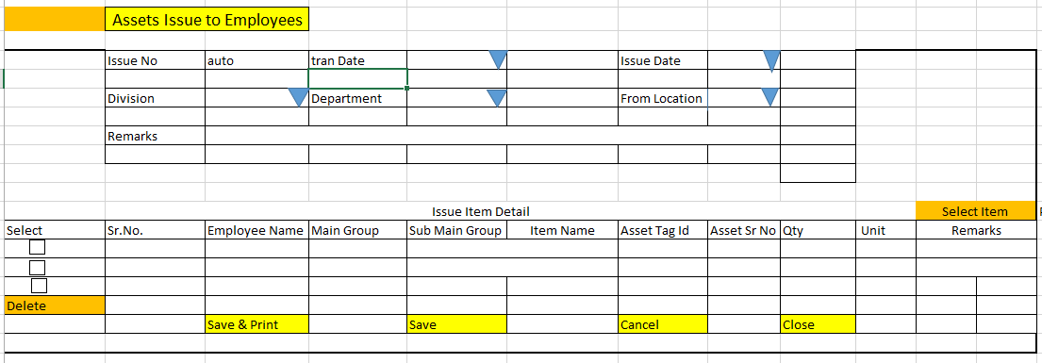

Screen notes / layout description:
Describe each visible area: panels, tabs, special controls, conditionally visible sections.
► Header panel — trancode(auto), trandate (Date), issuedate(Date), fromdivisionid (Dropdown), fromlocationid(cascades from From Division), fromdeptid(Dropdown), configid(Dropdown)
With RB Name – (rb_astbulempissmst)
► Item Grid tab — EntryGrid with columns rb_astbulempissdet metadata (dynamic). Buttons: Add New | Select Item.

3. Header Fields
One row per field shown in the Header Panel. Control types: Textbox | Date | Dropdown | Textarea | Checkbox.

Field Label | Field ID (ColName) | Control Type | Required | Is ReadOnly | Is Lock  On Edit | Source SP / Cascade Note
Tran Code | trancode | Textbox | No | Yes | Yes | Auto-generated on save
Tran Date | trandate | Date | Yes | No | Yes | Default: today's date
Issue Date | issuedate | Date | Yes | No | Yes | Default: today's date
From Division | fromdivisionid | Dropdown | Yes | No | Yes | fn_tbl_fetchuserwsfromdivision  (  @prmuserid numeric(18,0),  @prmcompanyid int,  @prmyearid numeric(18,0)  )
From Location | fromlocationid | Dropdown | No | No | No | Cascade on change of to division - fn_gen_fetchfromlocationmaster  (@prmcompanyid int,  @prmloginid numeric(18,0),  @prmlocationtype varchar(200))
Config | configid | Dropdown |  |  |  | fn_tbl_ddl_assetissueconfiguration (  "@PrmCompanyId":0,"@PrmDivisionId":1,"@PrmYearId":0 ,"@PrmUserId":0 ,"@PrmFormTag":"ASTIS","@PrmRefTYpe":"BIS" ,"@prmRef_MstID":0,"@prmRef_DetID":0  )
FrmType | frmtype | Hardcode |  |  |  | BIS – Assets Bulk Issue to employees
IssueTypeID | issuetypeid | 2 |  |  |  | - -Hardcode
(add here) | (add here) | (add here) | (add here) |  |  | (add here)

Cascade resets:
► When FromDivisionID changes → clear From Location ,Grid Data(rb_astbulempissdet) Refresh and reload its options.
► When From Location changes → clear Employee ,Grid Data(rb_astbulempissdet) Refresh and reload its options.
- When change Location clear Data(rb_astbulempissdet) Refresh and reload its options.

4. Grid / Entry Columns (Tab 1)
List every column in the Item Grid (EntryGrid). Source = "API (RB detail metadata)" or "Hardcoded" if static.

Column Label | Key (ColName) | Control Type | Editable | Source
Sr. No. | SrNo | Number | No | API — rb_astbulempissdet metadata
Item Code | ItemCode | Textbox | Yes | API — rb_astbulempissdet metadata
Item Name | ItemName | Textbox | No | API — rb_astbulempissdet metadata
Quantity | Qty | Number | Yes | API — rb_astbulempissdet metadata
Unit | Unit | Dropdown | No | API — rb_astbulempissdet metadata
Rate | Rate | Number | Yes | API — rb_astbulempissdet metadata
Amount | Amount | Number | No | API — auto-calculated: Qty × Rate
Remarks | Remarks | Textarea | Yes | API — rb_astbulempissdet metadata
(add here) | (add here) | (add here) | (add here) | (add here)
(add here) | (add here) | (add here) | (add here) | (add here)

5. API Reference
List every stored procedure / function called. ObjType 2 = Function, 1 = Procedure. Source: backend DBA.

SP / Function Name | ObjType | Purpose | Key Parameters | Returns
Fn_Fetch_RBDetailByRBCode | 2 | Fetch RB column metadata (header + detail) | prmRBCode | Table[0]: RBID + column definitions
Fn_tbl_FetchUserWsDivision | 2 | Division dropdown options | prmYearID, prmLoginID | Table: division list
fn_tbl_rb_astbulempisseonly | 2 | Item Selection — | @prmcompanyid integer,  @prmloginid integer,  @prmyearid int,  @prmtrandate date,  @prmfromdivisionid integer,  @prmtodivisionid integer,  @prmfromlocationid integer,  @prmtolocationid integer,  @prmfromdeptid integer,  @prmtodeptid integer,  @prmfromempuserid integer,  @prmtoempuserid integer,  @prmfromworkingclientid integer,  @prmtoworkingclientid integer,  @prmfromvendorid integer,  @prmtovendorid integer,  @prmconfigid integer,  @prmissuetypeid int,  @prmmaingroupid int, --  @prmsubmaingroupid int,  @prmsearchtext varchar(255),  @prmotherstr varchar(255),  @prmjson nvarchar(max) | Table: item rows
(add here) | (add here) | (add here) | (add here) | (add here)
(add here) | (add here) | (add here) | (add here) | (add here)

Save endpoint (REST POST):
Endpoint path/API/ AstBulEmpIssMst / Post_RB_AstBulEmpIssMst_Save

Payload keys: prmStrMstJSON | prmStrDetJSON

5.1 RB Structure Detail

SP / Function Name | RB Name | Purpose
Master Data RB | rb_astbulempissmst | Load Master Controls in form
Item Detail Grid | rb_astbulempissdet | Load Item grid in form
Assets Item Detail (Popup) | rb_astbulempisseonly | To load Assets Item selection popup RB data
RB Save API | / API/ AstBulEmpIssMst / Post_RB_AstBulEmpIssMst_Save
List side Data fill | fn_tbl_rb_astbulempissmst_list | [fn_tbl_rb_astbulempissmst_list]  (  @prmcompanyid integer,  @prmloginid integer,  @prmyearid integer,  @prmfromdate date,  @prmtodate date,  @prmfromdivisionid integer,  @prmfromempuserid integer  )
Assets Item Detail (Popup) | fn_tbl_rb_astbulempisseonly | (  @prmcompanyid integer,  @prmloginid integer,  @prmyearid int,  @prmtrandate date,  @prmfromdivisionid integer,  @prmtodivisionid integer,  @prmfromlocationid integer,  @prmtolocationid integer,  @prmfromdeptid integer,  @prmtodeptid integer,  @prmfromempuserid integer,  @prmtoempuserid integer,  @prmfromworkingclientid integer,  @prmtoworkingclientid integer,  @prmfromvendorid integer,  @prmtovendorid integer,  @prmconfigid integer,  @prmissuetypeid int,  @prmmaingroupid int, --  @prmsubmaingroupid int,  @prmsearchtext varchar(255),  @prmotherstr varchar(255),  @prmjson nvarchar(max)  )
Edit Mode - Master | fn_tbl_Rb_astbulempissmst | fill data on edit in master controls
Edit mode – Item Detail | fn_tbl_Rb_astbulempissdet | fill data on edit in Item Grid

6. Business Rules
Every rule the developer must implement. Add or remove lines for your module.

1. (add here)

7. Constants (constants.js)
All values for the constants.js file. RB codes and SP names come from the backend DBA. Mark CONFIRM = Yes if value is uncertain.

Constant Name | Value | CONFIRM? | Notes
RB_MASTER | rb_astbulempissmst | No | Master board code — header column metadata
RB_DETAIL | rb_astbulempissdet | No | Detail board code — grid column metadata
FORM_TAG | rb_astbulempissmst | No | Short module tag used in save payload
TRAN_BOOK | BIS | No | Transaction book name for item picker SP
CONFIG_YEAR_ID | 2 | CONFIRM | Year ID passed to configuration SPs
DIVISION_YEAR_ID | 2 | CONFIRM | Year ID passed to division fetch SP
SUPPLIER_PARTY_TYPE | S | No | Party type filter for supplier picker
LIST_OBJ_TYPE | 2 | No | OBJ_TYPE.FUNCTION — for listing SP call
SP_ LIST | fn_tbl_rb_astbulempissmst_list | CONFIRM | [fn_tbl_rb_astbulempissmst_list]  (  @prmcompanyid integer,  @prmloginid integer,  @prmyearid integer,  @prmfromdate date,  @prmtodate date,  @prmfromdivisionid integer,  @prmfromempuserid integer  )
LIST_DIVISION_ID | 0 | CONFIRM | Default division ID for listing data fetch
SAVE_ENDPOINT | / API/ AstBulEmpIssMst / Post_RB_AstBulEmpIssMst_Save | No | REST gateway save path
STORAGE_HEADER_META | piHeaderMeta | No | localStorage key for cached header RB metadata

— END OF TEMPLATE —

