HORIZON ENTERPRISE IMS
Module Requirements Template
Module: [Maintenance]
Submitted by: [Richa]
Date: [03-jul-2026]

COLOUR GUIDE
GREEN — Example value from Purchase Inquiry — replace for your module | BLUE — Empty slot — add your own rows here | AMBER — Instruction — read once, ignore after

HOW TO USE THIS TEMPLATE
1. Save a copy — rename to MRD_[ModuleName].docx before editing.
2. Replace every green value with your module's equivalent (SP names, RB codes, field names, routes, etc.).
3. Add your own rows in the blue slots at the bottom of each table.
4. In Section 2, delete the placeholder box and paste your design screenshot (Insert → Pictures).
5. Send completed document to the development team BEFORE coding starts.
6. Dev team signs off by stamping "Dev Confirmed" on each section.

1. Module Overview
Replace every green value below with your module's equivalent.
Module Name: Assets
Module Code: “MC”
Purpose: To generate maintenance contract for assets item.
Primary Users: Procurement / Account Team
Listing Route: /Assets- MAINTENANCE CONTRACT (NEW)
New Form Route: / Assets - MAINTENANCE CONTRACT (NEW) /new
Edit Route: / Assets - MAINTENANCE CONTRACT (NEW) /:id
Nav Menu Label: MAINTENANCE CONTRACT (NEW)

2. Screen Design
Delete the placeholder box below and paste your design screenshot (Insert → Pictures). Add a second image for the listing view if applicable.

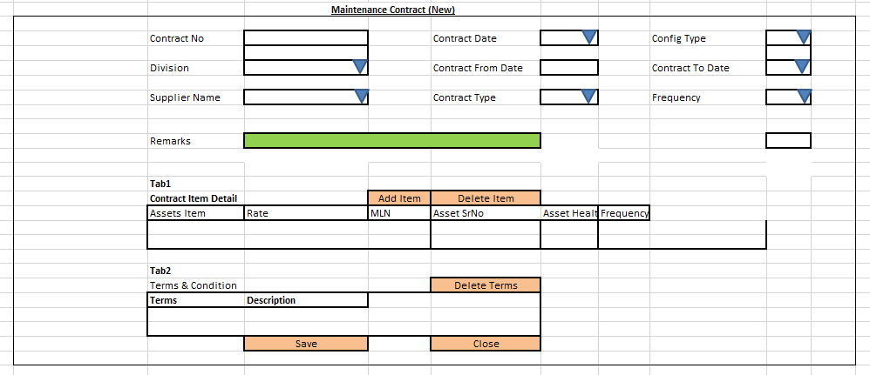

Screen notes / layout description:
Describe each visible area: panels, tabs, special controls, conditionally visible sections.
► Header panel — contractno(auto), contractdate(Date), issuedate(Date), divisionid
(Dropdown), configtypeid(cascades from to Division - Dropdown), contractfromdate
(Date), contracttodate(DATE) supplierid(cascade from division Dropdown), contracttypeid
(Dropdown), frequencyid (Dropdown), remarks(TextArea)
With RB Name – (rb_mntamcnewmst)

► Item Grid tab1 — EntryGrid (Contract Item Detail) with columns rb_mntamcnewdet metadata (dynamic). Buttons: Add New | Select Item.
- Tab2 – Terms & Condition Detail with columns rb_mntamcnewtncdet metadata (dynamic). Buttons: Add New | Select Item.

3. Header Fields
One row per field shown in the Header Panel. Control types: Textbox | Date | Dropdown | Textarea | Checkbox.

FieldID(colname) | Field Label | Control Type | Required | Is ReadOnly | Is Lock  On Edit | Source SP / Cascade Note
contractno | Contract No | TextAera | No | Yes | Yes | Auto-generated on save
contractdate | Contract Date | Date | Yes | No | Yes | Default: today's date
divisionid | Division | Dropdown | Yes | No | Yes | fn_tbl_fetchuserwsdivision(@prmuserid , @prmcompanyid , @prmyearid)
configtypeid | Config Type | Dropdown | Yes | No | Yes | fn_tbl_ddl_maintenanceconfiguration(  @prmcompanyid numeric(18,0),  @prmdivisionid numeric(18,0),  @prmyearid numeric(18,0),  @prmuserid numeric(18,0),  @prmformtag varchar(10)= " MNTCLT",  @prmreftype varchar(5)=“PMN”,  @prmref_mstid as numeric(18,0),  @prmref_detid as numeric(18,0)  )
contractfromdate | Contract From Date | Date | Yes | No | Yes
contracttodate | Contract To Date | Date | yes | No | Yes
supplierid | Supplier | Dropdown | Yes | No | Yes | fn_tbl_fetchcustomersuppliertranws4web  (  @prmdivisionid numeric(18,0),  @prmloginid numeric(18,0),  @prmyearid int,  @prmpartytype varchar(5) = ‘S’  )
contracttypeid | Contract Type | Dropdown | Yes | No | Yes | vw_mnt_contracttype – objtype = 3
frequencyid | Frequency | Dropdown | Yes | No | Yes | vw_gen_frequencytype – objtype = 3
remarks | Remarks | TextArea

Cascade resets:
► When divisionid changes → clear Grid Data(rb_mntamcnewdet) Refresh and reload its options.

Validations for masters:

- Contracttodate can not be small then current date.

4. Grid / Entry Columns (Tab 1)
List every column in the Item Grid (EntryGrid). Source = "API (RB detail metadata)" or "Hardcoded" if static.

Column Label | Key (ColName) | Control Type | Editable | Source
Sr. No. | SrNo | Number | No | API — rb_mntamcnewdet metadata
Item Code | ItemCode | Textbox | Yes | API — rb_mntamcnewdet metadata
Item Name | ItemName | Textbox | No | API — rb_mntamcnewdet metadata
Quantity | Qty | Number | Yes | API — rb_mntamcnewdet metadata
Unit | Unit | Dropdown | No | API — rb_mntamcnewdet metadata
Rate | Rate | Number | Yes | API — rb_mntamcnewdet metadata
Amount | Amount | Number | No | API — auto-calculated: Qty × Rate
Remarks | Remarks | Textarea | Yes | API —rb_mntamcnewdet metadata
(add here) | (add here) | (add here) | (add here) | (add here)
(add here) | (add here) | (add here) | (add here) | (add here)

4. Grid / Entry Columns (Tab 2)
List every column in the Item Grid (EntryGrid). Source = "API (RB detail metadata)" or "Hardcoded" if static.

Column Label | Key (ColName) | Control Type | Editable | Source
Sr. No. | SrNo | Number | No | API — rb_mntamcnewtncdet metadata
Item Code | ItemCode | Textbox | Yes | API — rb_mntamcnewtncdet metadata
Item Name | ItemName | Textbox | No | API — rb_mntamcnewtncdet metadata
Quantity | Qty | Number | Yes | API — rb_mntamcnewtncdet metadata
Unit | Unit | Dropdown | No | API — rb_mntamcnewtncdet metadata
Rate | Rate | Number | Yes | API — rb_mntamcnewtncdet metadata
Amount | Amount | Number | No | API — auto-calculated: Qty × Rate
Remarks | Remarks | Textarea | Yes | API —rb_mntamcnewtncdet metadata
(add here) | (add here) | (add here) | (add here) | (add here)
(add here) | (add here) | (add here) | (add here) | (add here)

5. API Reference
List every stored procedure / function called. ObjType 2 = Function, 1 = Procedure. Source: backend DBA.

SP / Function Name | ObjType | Purpose | Key Parameters | Returns
Fn_Fetch_RBDetailByRBCode | 2 | Fetch RB column metadata (header + detail) | prmRBCode | Table[0]: RBID + column definitions
Fn_tbl_FetchUserWsDivision | 2 | Division dropdown options | prmYearID, prmLoginID | Table: division list
fn_tbl_rb_mntamcnewselonly | 2 | Item Selection — | @prmdivisonid int,  @prmcompanyid int,  @prmloginid int,  @prmyearid int | Table: item rows
(add here) | (add here) | (add here) | (add here) | (add here)
(add here) | (add here) | (add here) | (add here) | (add here)

Save endpoint (REST POST):
Endpoint path/API/ MntAmcNewMst/ Post_RB_MntAmcNewMst_Save
Payload keys: prmStrMstJSON | prmStrContractItemDetail | prmTermsNConditionDetail

5.1 RB Structure Detail

SP / Function Name | RB Name | Purpose
Master Data RB | rb_mntamcnewmst | Load Master Controls in form
Item Detail (Tab1) | rb_mntamcnewdet | Load Item grid in form
Terms & Condition Detail(Tab2) | rb_mntamcnewtncdet | Load data in Terms grid
Assets Item Selection (Popup) for Tab 1 | rb_mntamcnewselonly | To load Assets Item selection popup RB data for Tab1
Terms & Condition selection popup | rb_mntamcnewtncsel | To load Terms selection popup RB data for Tab2
RB Save API | / API/ MntAmcNewMst/ Post_RB_MntAmcNewMst_Save
List side Data fill | fn_tbl_rb_mntamcnewmst_list | [fn_tbl_rb_mntamcnewmst_list]  (  @prmcompanyid int,  @prmdivisionid int,  @prmyearid int,  @prmfromdate date,  @prmtodate date,  @prmloginid int  )
Assets Item Detail (Popup) | fn_tbl_rb_mntamcnewselonly | fn_tbl_rb_mntamcnewselonly(  @prmdivisonid int,  @prmcompanyid int,  @prmloginid int,  @prmyearid int  )
Terms Selection Detail(popup) | fn_tbl_rb_mntamcnewtncsel | [fn_tbl_rb_mntamcnewtncsel]  (  @prmdivisionid integer,  @prmtrandate date,  @prmloginid integer,  @prmconfigid integer,  @prminqid integer  )
Edit Mode - Master | fn_tbl_Rb_mntamcnewmst | fill data on edit in master controls
Edit mode – Item Detail(Tab1) | fn_tbl_Rb_mntamcnewdet | fill data on edit in Item Grid
Edit Mode – Terms & Condition(Tab2) | fn_tbl_rb_mntamcnewtncsel | Fill Terms & Condition data on edit.

6. Business Rules
Every rule the developer must implement. Add or remove lines for your module.

1. (add here)

7. Constants (constants.js)
All values for the constants.js file. RB codes and SP names come from the backend DBA. Mark CONFIRM = Yes if value is uncertain.

Constant Name | Value | CONFIRM? | Notes
RB_MASTER | rb_mntamcnewmst | No | Master board code — header column metadata
RB_DETAIL | rb_mntamcnewdet | No | Detail board code — grid column metadata
FORM_TAG | rb_mntamcnewmst | No | Short module tag used in save payload
TRAN_BOOK | CA | No | Transaction book name for item picker SP
CONFIG_YEAR_ID | 2 | CONFIRM | Year ID passed to configuration SPs
DIVISION_YEAR_ID | 2 | CONFIRM | Year ID passed to division fetch SP
SUPPLIER_PARTY_TYPE | S | No | Party type filter for supplier picker
LIST_OBJ_TYPE | 2 | No | OBJ_TYPE.FUNCTION — for listing SP call
SP_ LIST | fn_tbl_rb_mntamcnewmst_list | CONFIRM | Function to load listing page data
LIST_DIVISION_ID | 15 | CONFIRM | Default division ID for listing data fetch
SAVE_ENDPOINT | / API/ MntAmcNewMst/ Post_RB_MntAmcNewMst_Save | No | REST gateway save path
STORAGE_HEADER_META | piHeaderMeta | No | localStorage key for cached header RB metadata

— END OF TEMPLATE —

