HORIZON ENTERPRISE IMS
Module Requirements Template
Module: [Purchase]
Submitted by: [Richa]
Date: [08-Jun-2026]

COLOUR GUIDE
GREEN — Example value from Purchase Inquiry — replace for your module | BLUE — Empty slot — add your own rows here | AMBER — Instruction — read once, ignore after

HOW TO USE THIS TEMPLATE
1. Save a copy — rename to MRD_[ModuleName].docx before editing.
2. Replace every green value with your module's equivalent (SP names, RB codes, field names, routes, etc.).
3. Add your own rows in the blue slots at the bottom of each table.
4. In Section 2, delete the placeholder box and paste your design screenshot (Insert → Pictures).
5. Send completed document to the development team BEFORE coding starts.
6. Dev team signs off by stamping "Dev Confirmed" on each section.

1. Module Overview
Replace every green value below with your module's equivalent.
Module Name: Purchase Quotation
Module Code: “”
Purpose: Create and manage purchase Quotation to suppliers before issuing a formal Purchase Order.
Primary Users: Procurement / Purchase Team
Listing Route: /purchase-Quotation
New Form Route: /purchase- Quotation /new
Edit Route: /purchase- Quotation /:id
Nav Menu Label: Purchase Quotation

2. Screen Design
Delete the placeholder box below and paste your design screenshot (Insert → Pictures). Add a second image for the listing view if applicable.

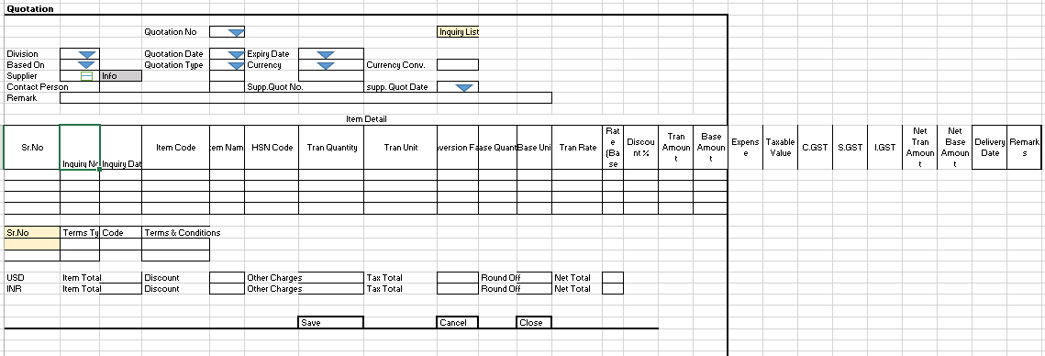

Screen notes / layout description:
Describe each visible area: panels, tabs, special controls, conditionally visible sections.
► Header panel — Quotation No. (auto),Quotation Date (Date), Division (Dropdown), Quotation Type (cascades from Division), Expiry Date (date), Department, Based On (dropdown – with single choice “Inquiry based”), Remark.
► Item Grid tab — EntryGrid with columns RB_PurQtnDet metadata (dynamic). Buttons: Add New | Select Item.
► Terms tab — static read-only table (Sr.No, Terms Type, Code, Terms & Conditions).

3. Header Fields
One row per field shown in the Header Panel. Control types: Textbox | Date | Dropdown | Textarea | Checkbox.

Field Label | Field ID (ColName) | Control Type | Required | Is ReadOnly | Is Lock  On Edit | Source SP / Cascade Note
Quotation No | Quotation No | Textbox | No | Yes | Yes | Auto-generated on save
Quotation Date | Quotation Date | Date | Yes | No | Yes | Default: today's date
Division | DivisionID | Dropdown | Yes | No | Yes | Fn_tbl_FetchUserWsDivision
Quotation Type | ConfigID | Dropdown | Yes | No | Yes | fn_tbl_ddl_Pur_Configuration — cascades from DivisionID  Pass “PQ” in @PrmFormTag parameter
Expiry Date | ExpiryDate | Date | No | No | No | —
Supplier | SupplierID | Dropdown | Yes | No | Yes | Fn_tbl_FetchCustomerSupplierTranWs4Web
Currency | CurrencyID | Textarea | Yes | Yes | Yes
Currency Conv | CurrencyRate | TextArea | Yes | No | Yes
Based On | BasedOn | Dropdown | Yes |  |  | Hardcoded: “Inquiry Based”
Remark | Remarks | Textarea | No |  |  | —
Contact Person | Remarks | Textarea | No | No | No
Supp.Quot No | Supplier Quot No | TextArea | No | No | No
Supp.Quot Date | Supplier Quot Date | Date | No | No | No
(add here) | (add here) | (add here) | (add here) |  |  | (add here)
(add here) | (add here) | (add here) | (add here) |  |  | (add here)

Cascade resets:
► When DivisionID changes → clear ConfigID (Inquiry Type) ,SupplierID(Supplier),Grid Data(RB_PurQtnDet) Refresh and reload its options.

4. Grid / Entry Columns
List every column in the Item Grid (EntryGrid). Source = "API (RB detail metadata)" or "Hardcoded" if static.

Column Label | Key (ColName) | Control Type | Editable | Source
Sr. No. | SrNo | Number | No | API — RB_PurQtnDet metadata
Item Code | ItemCode | Textbox | Yes | API — RB_PurQtnDet metadata
Item Name | ItemName | Textbox | No | API — RB_PurQtnDet metadata
Quantity | Qty | Number | Yes | API — RB_PurQtnDet metadata
Unit | Unit | Dropdown | No | API — RB_PurQtnDet metadata
Rate | Rate | Number | Yes | API — RB_PurQtnDet metadata
Amount | Amount | Number | No | API — auto-calculated: Qty × Rate
Remarks | Remarks | Textarea | Yes | API — RB_PurQtnDet metadata
(add here) | (add here) | (add here) | (add here) | (add here)
(add here) | (add here) | (add here) | (add here) | (add here)

Additional grids / tabs:
► Suppliers tab — hardcoded columns: Sr.No, Supplier Name, Address, City, Mobile No.
► Terms tab — static display table: Sr.No, Terms Type, Code, Terms & Conditions.

5. API Reference
List every stored procedure / function called. ObjType 2 = Function, 1 = Procedure. Source: backend DBA.

SP / Function Name | ObjType | Purpose | Key Parameters | Returns
Fn_Fetch_RBDetailByRBCode | 2 | Fetch RB column metadata (header + detail) | prmRBCode | Table[0]: RBID + column definitions
fn_tbl_ddl_Pur_Configuration | 2 | Inquiry Type dropdown options | prmDivisionID, prmYearID, prmLoginID | Table: value/label pairs
Fn_tbl_FetchUserWsDivision | 2 | Division dropdown options | prmYearID, prmLoginID | Table: division list
Fn_Tbl_FetchInquiryItemDetail4Web | 2 | Item picker — Direct mode (BasedOnID=0) | prmDivisionID, prmYearID, prmTranDate, prmConfigID, prmFrmOption=0 | Table: item rows
Fn_Tbl_FetchInquiryItemDetail4Web | 2 | Item picker — Inquiry wise mode (BasedOnID=2) | same SP, prmFrmOption=2, uses RB_PurQtnSelInqItem | Table: Inquiry item rows
(add here) | (add here) | (add here) | (add here) | (add here)
(add here) | (add here) | (add here) | (add here) | (add here)

Save endpoint (REST POST):
Endpoint path: /API/PurQtnSave/ Post_RB_PurQtnMst_Save
Payload keys: prmStrMstJSON | prmStrDetJSON

6. Business Rules
Every rule the developer must implement. Add or remove lines for your module.
1. Division cascade — When DivisionID changes, clear Inquiry Type (ConfigID) and reload its options via fn_tbl_ddl_Pur_Configuration.
2. Item picker mode -BasedOnID = 2 (Inquiry wise) loads with RB_PurQtnSelInqItem.
4. Three-phase metadata load — Phase 1 (mount): header RB + divisions in parallel. Phase 2: detail RB. Phase 3 (lazy, on first Add New / Select Item): grid columns.
6. Temp row IDs — New rows get negative temp IDs (nextTempId--) to avoid collisions with real DB IDs on save.
7. isNewRoute detection — /purchase-Quotation/new → IDNumber = 0 in save payload. /purchase- Quotation /:id → IDNumber = numeric id.
8. Edit mode gate — All inputs disabled until user clicks the ActionBar Add/Edit button. Prevents accidental edits on load.

9. (add here)

7. Constants (constants.js)
All values for the constants.js file. RB codes and SP names come from the backend DBA. Mark CONFIRM = Yes if value is uncertain.

Constant Name | Value | CONFIRM? | Notes
RB_MASTER | RB_PurQtnMst | No | Master board code — header column metadata
RB_DETAIL | RB_PurQtnDet | No | Detail board code — grid column metadata
FORM_TAG | RB_PurQtnMst | No | Short module tag used in save payload
TRAN_BOOK | PURQTN | No | Transaction book name for item picker SP
CONFIG_YEAR_ID | 2 | CONFIRM | Year ID passed to configuration SPs
DIVISION_YEAR_ID | 2 | CONFIRM | Year ID passed to division fetch SP
SUPPLIER_PARTY_TYPE | S | No | Party type filter for supplier picker
LIST_OBJ_TYPE | 2 | No | OBJ_TYPE.FUNCTION — for listing SP call
SP_Quotation_LIST | Fn_tbl_Pur_QtnMst_List | CONFIRM | SP to load listing page data
LIST_DIVISION_ID | 15 | CONFIRM | Default division ID for listing data fetch
SAVE_ENDPOINT | /API/PurQtnSave/ Post_RB_PurQtnMst_Save | No | REST gateway save path
STORAGE_HEADER_META | piHeaderMeta | No | localStorage key for cached header RB metadata

— END OF TEMPLATE —

