HORIZON ENTERPRISE IMS
Module Requirements Template
Module: [Maintenance]
Submitted by: [Richa]
Date: [20-Aug-2026]

COLOUR GUIDE
GREEN — Example value from Purchase Inquiry — replace for your module | BLUE — Empty slot — add your own rows here | AMBER — Instruction — read once, ignore after

HOW TO USE THIS TEMPLATE
1. Save a copy — rename to MRD_[ModuleName].docx before editing.
2. Replace every green value with your module's equivalent (SP names, RB codes, field names, routes, etc.).
3. Add your own rows in the blue slots at the bottom of each table.
4. In Section 2, delete the placeholder box and paste your design screenshot (Insert → Pictures).
5. Send completed document to the development team BEFORE coding starts.
6. Dev team signs off by stamping "Dev Confirmed" on each section.

1. Module Overview
Replace every green value below with your module's equivalent.
Module Name: Maintenance
Module Code: “PMI”
Purpose: To manage internal maintenance contract for assets item detail.
Primary Users: Procurement / Account Team
Listing Route: /Assets- PREVENTIVE MAINTENANCE INTERNAL
New Form Route: / Assets - PREVENTIVE MAINTENANCE INTERNAL /new
Edit Route: / Assets - PREVENTIVE MAINTENANCE INTERNAL /:id
Nav Menu Label: PREVENTIVE MAINTENANCE INTERNAL

2. Screen Design
Delete the placeholder box below and paste your design screenshot (Insert → Pictures). Add a second image for the listing view if applicable.

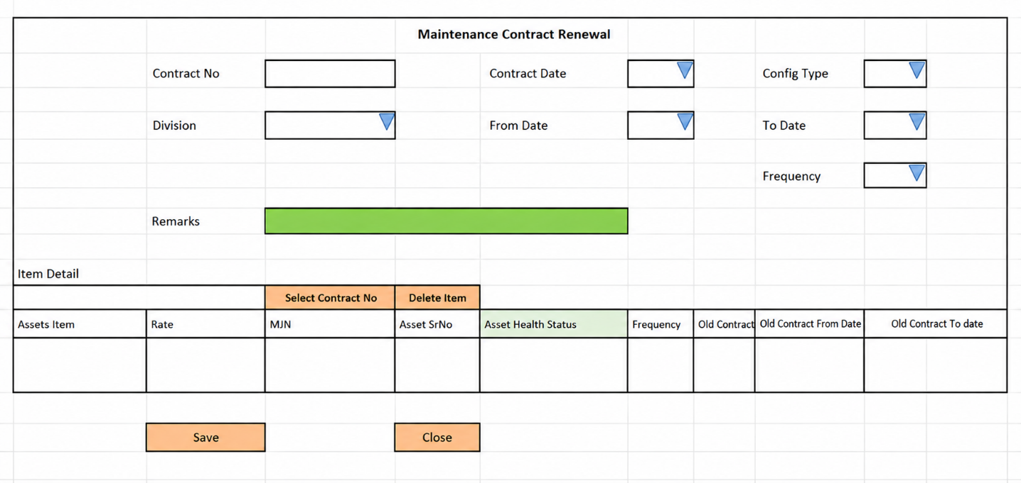

Notes :
Change caption “Maintenance Contract Renewal” to “Preventive Maintenance Internal”

Screen notes / layout description:
Describe each visible area: panels, tabs, special controls, conditionally visible sections.
► Header panel — contractno(auto), contractdate(Date), divisionid
(Dropdown), configtypeid(cascades from to Division - Dropdown), contractfromdate
(Date), contracttodate(DATE) ,frequencyid (Dropdown), remarks(TextArea)
With RB Name – (rb_mntpmimst)

► Item Grid— EntryGrid (Contract Item Detail) with columns rb_mntpmidet metadata (dynamic). Buttons: Add New | Select Item.

3. Header Fields
One row per field shown in the Header Panel. Control types: Textbox | Date | Dropdown | Textarea | Checkbox.

FieldID(colname) | Field Label | Control Type | Required | Is ReadOnly | Is Lock  On Edit | Source SP / Cascade Note
contractno | Contract No | TextAera | No | Yes | Yes | Auto-generated on save
contractdate | Contract Date | Date | Yes | No | Yes | Default: today's date
divisionid | Division | Dropdown | Yes | No | Yes | fn_tbl_fetchuserwsdivision(@prmuserid , @prmcompanyid , @prmyearid)
configtypeid | Config Type | Dropdown | Yes | No | Yes | fn_tbl_ddl_maintenanceconfiguration(  @prmcompanyid numeric(18,0),  @prmdivisionid numeric(18,0),  @prmyearid numeric(18,0),  @prmuserid numeric(18,0),  @prmformtag varchar(10)= " MNTCLT",  @prmreftype varchar(5)=“PMI”,  @prmref_mstid as numeric(18,0),  @prmref_detid as numeric(18,0)  )
contractfromdate | Contract From Date | Date | Yes | No | Yes
contracttodate | Contract To Date | Date | yes | No | Yes
frequencyid | Frequency | Dropdown | Yes | No | Yes | vw_gen_frequencytype – objtype = 3
remarks | Remarks | TextArea | No | No | No

Cascade resets:
► When divisionid changes → clear Grid Data(rb_mntpmidet) Refresh and reload its options.

Validations for masters:

4. Grid / Entry Columns
List every column in the Item Grid (EntryGrid). Source = "API (RB detail metadata)" or "Hardcoded" if static.

Column Label | Key (ColName) | Control Type | Editable | Source
Sr. No. | SrNo | Number | No | API — rb_mntpmidet metadata
Item Code | ItemCode | Textbox | Yes | API — rb_mntpmidet metadata
Item Name | ItemName | Textbox | No | API — rb_mntpmidet metadata
Quantity | Qty | Number | Yes | API — rb_mntpmidet metadata
Unit | Unit | Dropdown | No | API — rb_mntpmidet metadata
Rate | Rate | Number | Yes | API — rb_mntpmidet metadata
Amount | Amount | Number | No | API — auto-calculated: Qty × Rate
Remarks | Remarks | Textarea | Yes | API —rb_mntpmidet metadata
(add here) | (add here) | (add here) | (add here) | (add here)
(add here) | (add here) | (add here) | (add here) | (add here)

5. API Reference
List every stored procedure / function called. ObjType 2 = Function, 1 = Procedure. Source: backend DBA.

SP / Function Name | ObjType | Purpose | Key Parameters | Returns
Fn_Fetch_RBDetailByRBCode | 2 | Fetch RB column metadata (header + detail) | prmRBCode | Table[0]: RBID + column definitions
Fn_tbl_FetchUserWsDivision | 2 | Division dropdown options | prmYearID, prmLoginID | Table: division list
fn_tbl_rb_mntpmiselonly | 2 | Item Selection — | (  @prmdivisonid int,  @prmcompanyid int,  @prmloginid int,  @prmyearid int  ) | Table: item rows
(add here) | (add here) | (add here) | (add here) | (add here)
(add here) | (add here) | (add here) | (add here) | (add here)

Save endpoint (REST POST):
Endpoint path/API/ MntPMIMst / Post_RB_MntPMIMst_Save
Payload keys: prmStrMstJSON | prmStrContractItemDetail

5.1 RB Structure Detail

SP / Function Name | RB Name | Purpose
Master Data RB | rb_mntpmimst | Load Master Controls in form
Item Detail | rb_mntpmidet | Load Item grid in form
Assets Item Selection (Popup) | rb_mntpmiselonly | To load Assets Item selection popup RB data for Tab1
RB Save API | / API/ MntPMIMst / Post_RB_MntPMIMst_Save
List side Data fill | fn_tbl_rb_mntpmimst_list | [fn_tbl_rb_mntpmimst_list]  (  @prmcompanyid int,  @prmdivisionid int,  @prmyearid int,  @prmfromdate date,  @prmtodate date,  @prmloginid int  )
Assets Item Detail (Popup) | fn_tbl_rb_mntpmiselonly | fn_tbl_rb_mntpmiselonly (  @prmdivisonid int,  @prmcompanyid int,  @prmloginid int,  @prmyearid int  )
Edit Mode - Master | fn_tbl_rb_mntpmimst | fill data on edit in master controls
Edit mode – Item Detail | fn_tbl_rb_mntpmidet | fill data on edit in Item Grid

6. Business Rules
Every rule the developer must implement. Add or remove lines for your module.

1. (add here)

7. Constants (constants.js)
All values for the constants.js file. RB codes and SP names come from the backend DBA. Mark CONFIRM = Yes if value is uncertain.

Constant Name | Value | CONFIRM? | Notes
RB_MASTER | rb_mntpmimst | No | Master board code — header column metadata
RB_DETAIL | rb_mntpmidet | No | Detail board code — grid column metadata
FORM_TAG | rb_mntpmimst | No | Short module tag used in save payload
TRAN_BOOK | MCI | No | Transaction book name for item picker SP
CONFIG_YEAR_ID | 2 | CONFIRM | Year ID passed to configuration SPs
DIVISION_YEAR_ID | 2 | CONFIRM | Year ID passed to division fetch SP
SUPPLIER_PARTY_TYPE | S | No | Party type filter for supplier picker
LIST_OBJ_TYPE | 2 | No | OBJ_TYPE.FUNCTION — for listing SP call
SP_ LIST | fn_tbl_rb_mntpmimst_list | CONFIRM | Function to load listing page data
LIST_DIVISION_ID | 15 | CONFIRM | Default division ID for listing data fetch
SAVE_ENDPOINT | / API/ MntPMIMst / Post_RB_MntPMIMst_Save | No | REST gateway save path
STORAGE_HEADER_META | piHeaderMeta | No | localStorage key for cached header RB metadata

— END OF TEMPLATE —

