# Operation / maintenance data collection screen

|  |  |
| --- | --- |
| Number | Description |
| 1 | Corner tab.  Name of tab item is manufacture’s name. It is displayed with below format:  + Line 1: 6 characters  + Line 2: 6 characters  Or:  + Only a line: 6 characters |
| 2 | [Collect] button.  Collect and export to CSV file with formatted name:  + Operation data: "○○○○ _KADOXX.csv"  + Maintenance data: "○○○○ _MAINTEXX.csv"  (XX = corner number)  (○○○○ = ticket gate installation corner name) |
| 3 | Select all corner (maybe all tab) |
| 4 | Un-select all corner (maybe all tab) |
| 5 | Select all corner (for displaying corner only) |
| 6 | Un-select all corner (for displaying corner only) |
|  |  |

Figure ‑: Unit state

|  |  |
| --- | --- |
| 1 | Un-selected |
| 2 | Selected |
| 3 | Collected |
| 4 | Un-Collected (abnormal) |

## Collect data function

## Export to USB function

Figure ‑: outputted CSV file

# Kanshiban Deadline screen

|  |  |
| --- | --- |
| 1 | -When the button is pressed, deadline data collection from the ticket gate connected to the specified corner is started. (See ①) |
| 2 | ・ When you press the button, the deadline collected for the specified corner  Data output for higher-level transmission of data is started.  ・ The initial state cannot be pressed.  After the collection process is completed (regardless of normal end / abnormal end), it can be pressed. |
| 3. Deadline data offline output button | -When the button is pressed, the offline output processing of the upper transmission data of the specified corner is started. (See ③)  - Output file name:  Example: SIME ○○○○ △△△△ YYYYMMDDhhmmss.CSV  ・ ○○○○ = Station name with integrated monitoring board (maximum 4 full-width characters)  ・ △△△△ ＝ Output target corner name (maximum 12 full-width characters)  ・ YYYYMMDDhhmmss is the year, month, day, hour, minute, second (half-width) at the time of output.  -After the offline output is completed normally, the high-level transmission data clear confirmation pop-up screen is displayed.  If the upper transmission data of the specified corner exists, it can be pressed, and if it does not exist, it cannot be pressed.  (Data for higher transmission by pressing the integrated monitoring board deadline processing start button  When the output of is completed, this button can be pressed. ) |
| 4. Deadline data offline reoutput button | - When the button is pressed, the re-output processing of the latest offline output deadline data is started.  + The output file name is the same as the latest deadline data offline output.  + The output format is the same as the deadline data offline output.  - It cannot be pressed if the offline output data of the specified corner did not exist |

|  |  |
| --- | --- |
| Before collection | Gray |
| Collection completed normally | Green |
| Abnormal end of collection process | Red |
| Uninstalled | Not display |

Output format

## Collect data

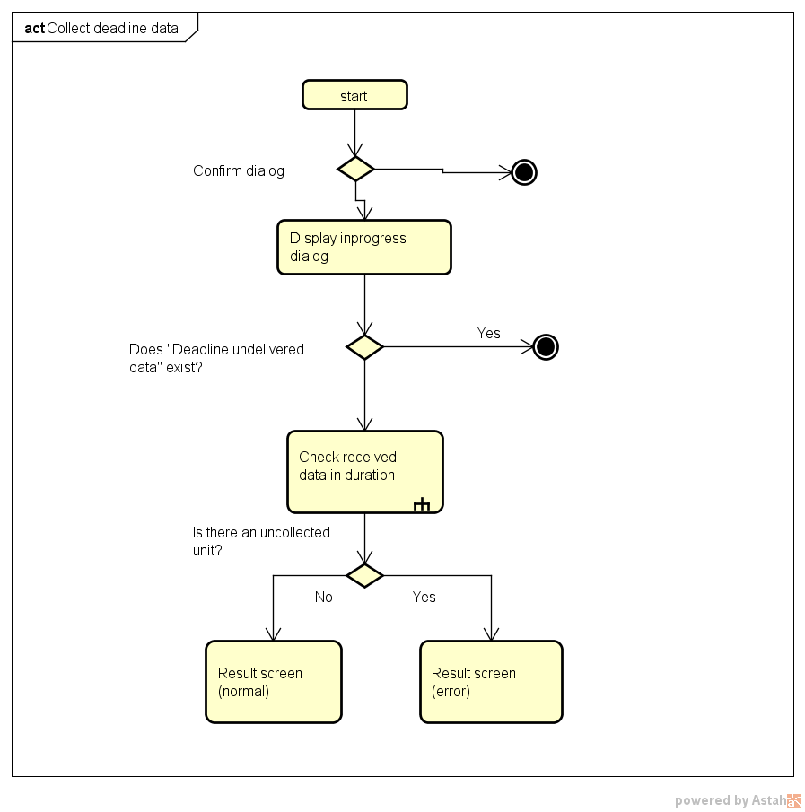

## Kanshiban deadline processing

## Offline output data

## Offline Re-output data

Same as offline output data but there is not “clear data” function.

# IC maintenance

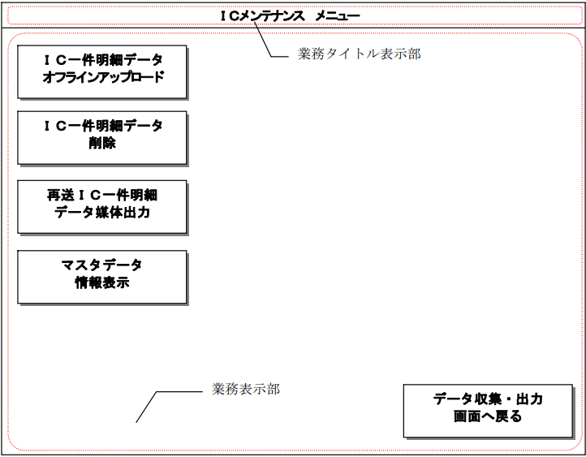

|  |  |
| --- | --- |
| ＩＣ一件明細データオフラインアップロード | IC single detail data offline upload |
| ＩＣ一件明細データ削除 | Delete IC single item detail data |
| 再送ＩＣ一件明細データ媒体出力 | Retransmission IC single item detail data medium output |
| マスタデータ情報表示 | Master data information display |

## IC single detail data offline upload screen

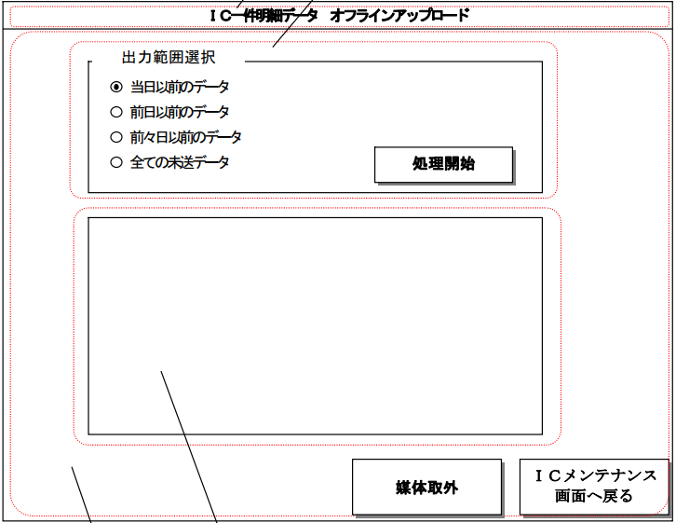

|  |  |
| --- | --- |
| 当日以前のデータ | Data before the day |
| 前日以前のデータ | Data before the previous day |
| 前々日以前のデータ | Data before the day before |
| 全ての未送データ | All undelivered data |

|  |  |
| --- | --- |
| [処理開始] | When the "Start processing" button is pressed:  + All button inside screen are locked  + The communication with the ID server is disconnected. |

Note: error and confirm dialog is designed inside pdf document.

## Delete IC single item detail data

Same as update IC data

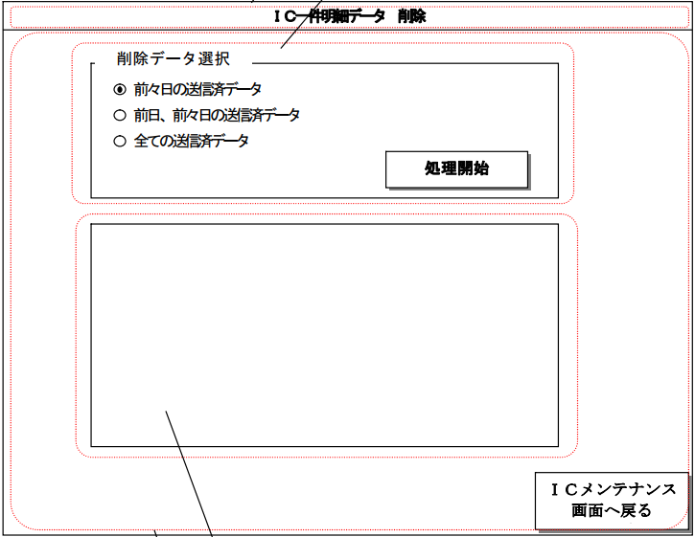

## Retransmit IC one case detail data output screen

|  |  |
| --- | --- |
| Unit item | - There are 16 units per corner  - Arranged according to the installation status of ICM at each corner.  - Name: 4x2 or 4x1  - Can toggle press.  - There are 6 display status. It is updated real time according to collection process.  - After corner is selected, display status is changed to default |
| [Execute output] button | - Must select units before click to [Execute output] button |

## Master data information display screen

* There is a combobox with below options:
  + "Information data for a certain period"
  + "Normal negative data"
  + "Emergency negative data"
  + "Credit negative data"
  + "Negative inquiry server private key"
  + 「一定期間情報データ」 (default)
  + 「通常ネガデータ」
  + 「緊急ネガデータ」
  + 「クレジットネガデータ」
  + 「ネガ照会サーバ秘密鍵」

Figure ‑: IC Master data

Figure ‑: Negative data

Figure ‑: Negative inquiry server private key

- The displayed contents are updated by pressing the "Update display" button.

- The [表示更新] button can not be press in “ネガ照会サーバ秘密鍵” option

- User can delete data by using [データ削除]

- User can input data in “ネガ照会サーバ秘密鍵” option only. Click to [データ入力] button then choose folder.

- [上位受信日時」、「一定期間」are displayed blank when below exception case occur:

+ When information is not retained for a certain period.

+ When an internal processing error occurs.