Simulation and optimization: demo notes

**Optimization**

Demo: grades.xlsx

1. To find what grade we need to get an A, we first need to calculate a plug for the final grade. We can do this by taking the SUMPRODUCT() of the current grades and weights.

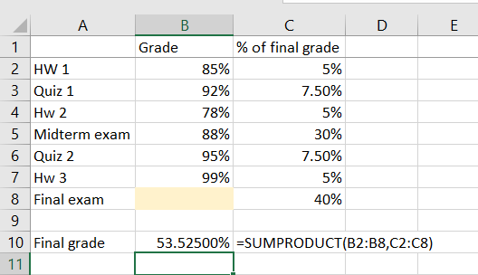

1. You can now start to experiment on your own with that grade will result in an A by trial and error. But why not just have Excel do this for you?

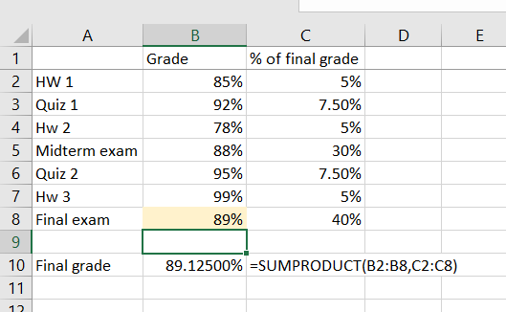

1. Select **Data > What-If Analysis > Goal Seek.** 
   1. We want to set our *final grade* (B10) to 90% by changing our *final exam grade* (B8).

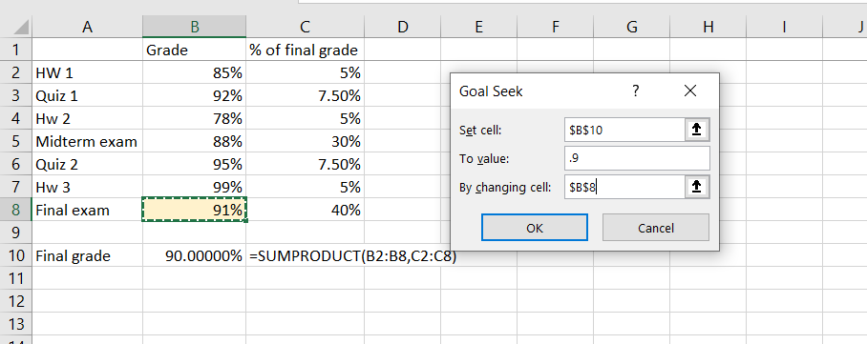

* 1. It turns out that we need a ~91% on the final exam to get a 90% for the course.

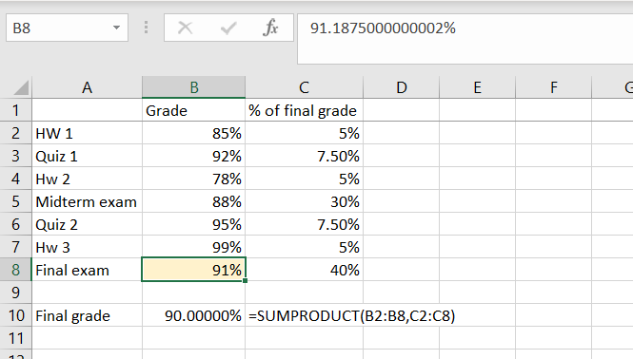

Demo: sales-price.xlsx

1. Notice that Goal Seek tells you to sell a fraction of a doo-hickey. That won’t work! Goal Seek has some limitations, so let’s get into using Solver.

Demo: product-mix.xlsx

1. In this example, we use cotton and acrylic to make two different types of products. Each takes a different blend of each product, and we only have so much cotton and acrylic. How do we optimize the units produced for each to maximize our revenue potential?

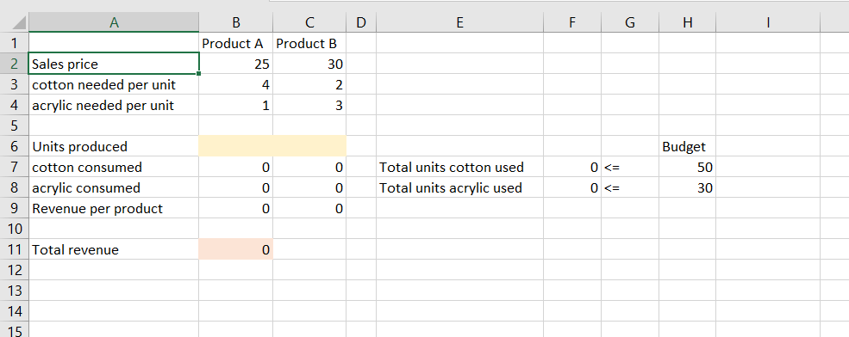

1. We will use **Solver** for this, so make sure you have it turned on! See the deck for instructions.
2. A “Solver parameters” pop-up box will appear. We need to set the parameters of this model:

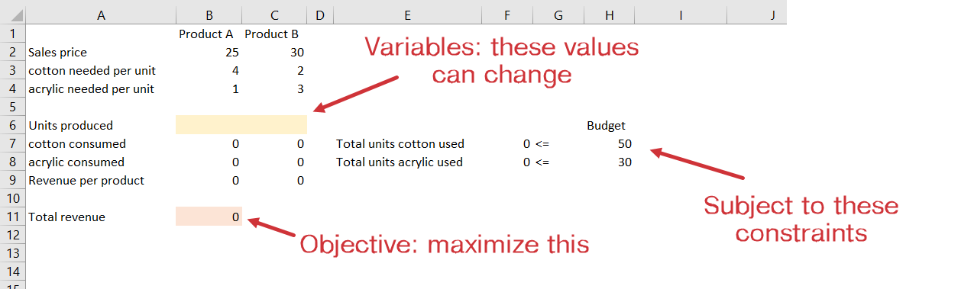

* 1. First we are asked to set our *objective,* which is again to maximize revenue. Set this objective to B11.
  2. Next we are asked to set the *variable cells.* These are the cells that can *change*, which are the units produced of Products A and B.
  3. Finally we are asked to set the constraints. This will be to make sure that the units of cotton and acrylic used do not exceed our budgets. Leave the rest as-is.

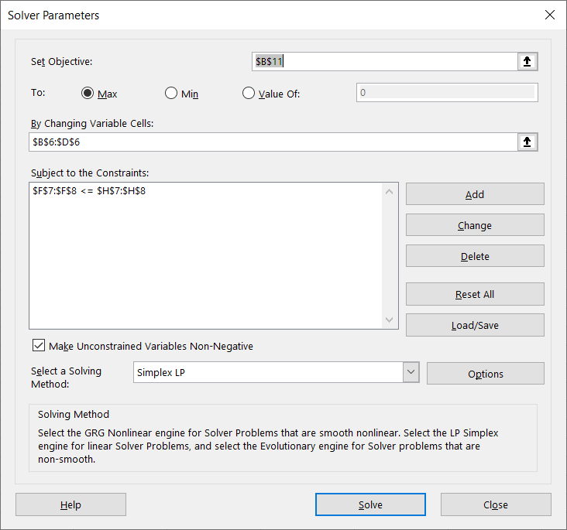

1. Solver converges to a result and it is populated to our worksheet. We use as much supply as available to maximize revenue.

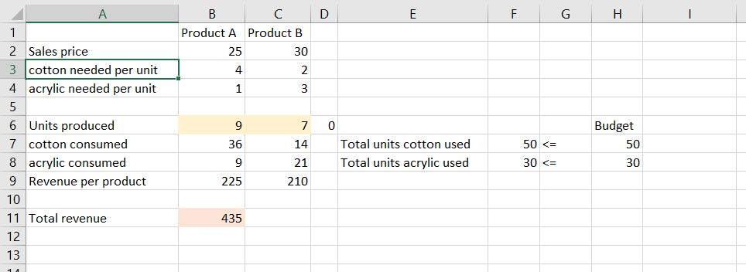

Drill: unit-production.xlsx

1. In this case, Solver may suggest you produce fractions of a unit. You can constrain variable to integers by setting the integer constraint.

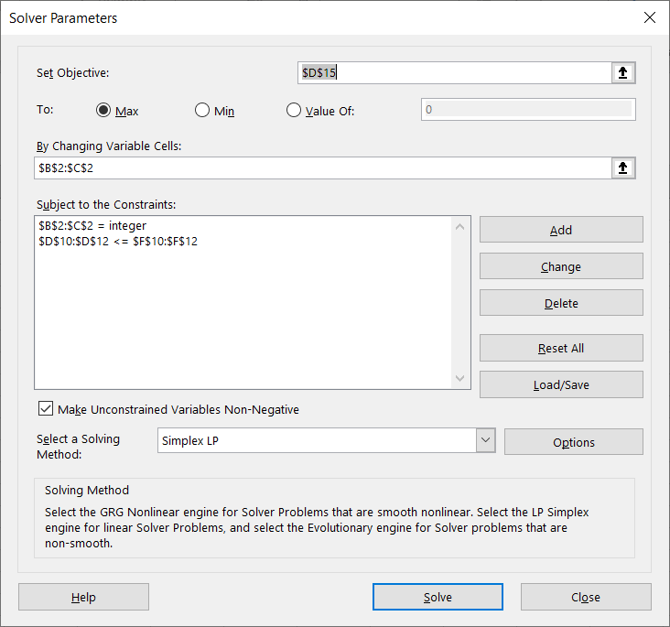

Demo: solver-regression.xlsx

Linear regression utilizes optimization to find the best-fit line to pass through the scatterplot. Let’s fit our own regression line using Solver.

1. Remember that our basic regression is Y = a + b*x. We will want to find the optimal intercept and slope of the line to predict each datapoint.

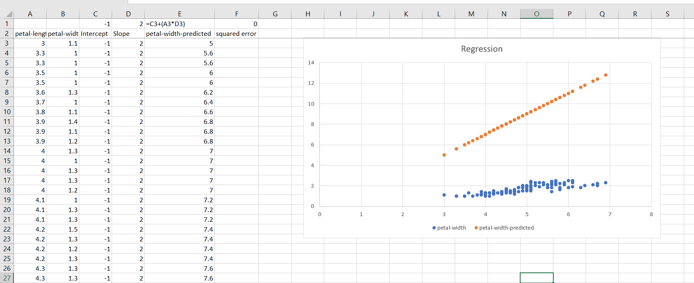

1. But how do we now it’s optimized? Linear regression aims to minimize the *sum of squared errors*. We will take the difference between the actual and forecasted value and square it, then sum all these results.

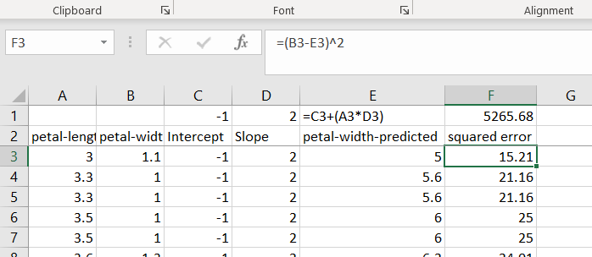

1. Now that we know our objective and variable cells, we can set up a Solver optimization to find the best values for the slope and intercept.

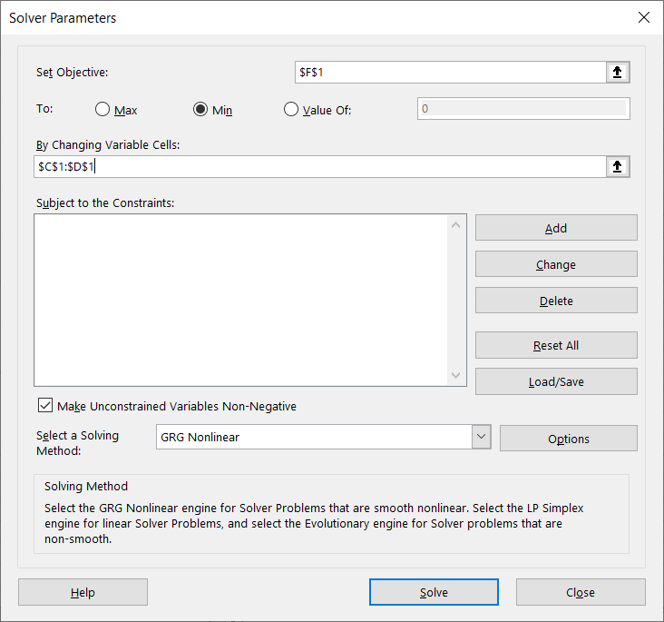

1. Solver has converged to a solution with an intercept of 0 and slope of .35. The fitted line is on our chart.
   1. Your results would be slightly different using the ToolPak or other regression methods. Solver has found a *sub-optimal solution ­*– a non-trivial problem in optimization methods!

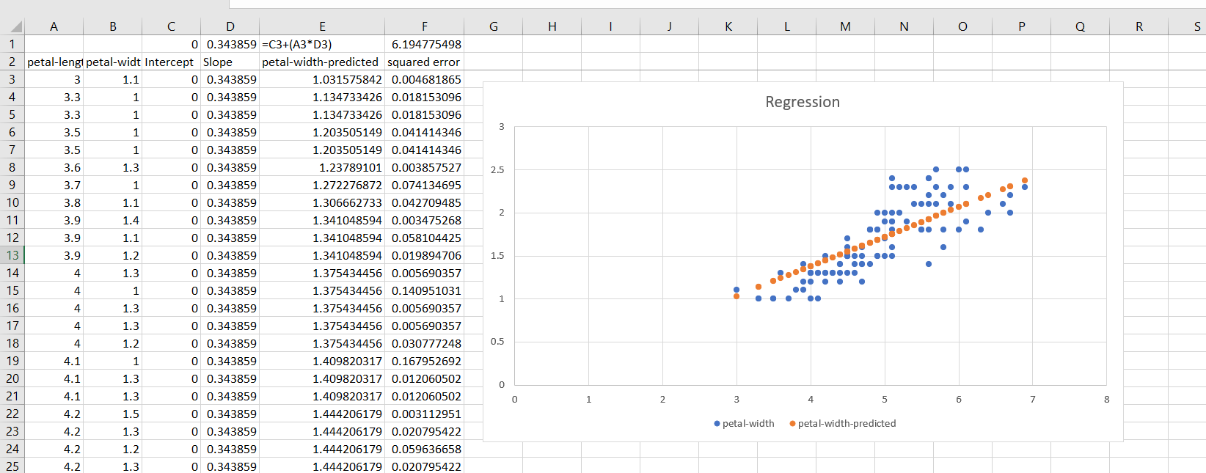

**Simulation**

Demo: widget-sales.xlsx

1. First, we want to simulate how many widgets get sold on Day 1, Day 2, etc. We can use NORM.INV() plus RAND() to find the value at a random part of the distribution curve generated. This will effectively pick a part of our bell curve at random and state what value is found there.
   1. Of course, we can’t sell fractions of a widget so this needs to be rounded.

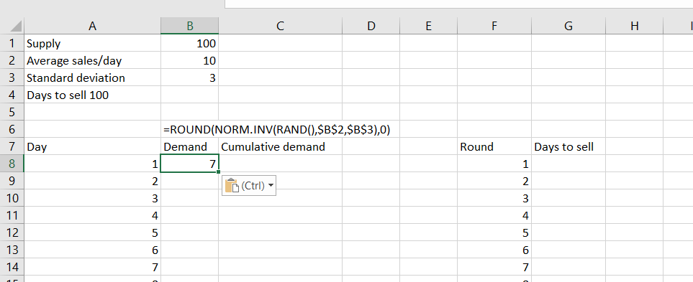

1. We can now find the running total of widgets sold by mixing our references for the SUM() function.

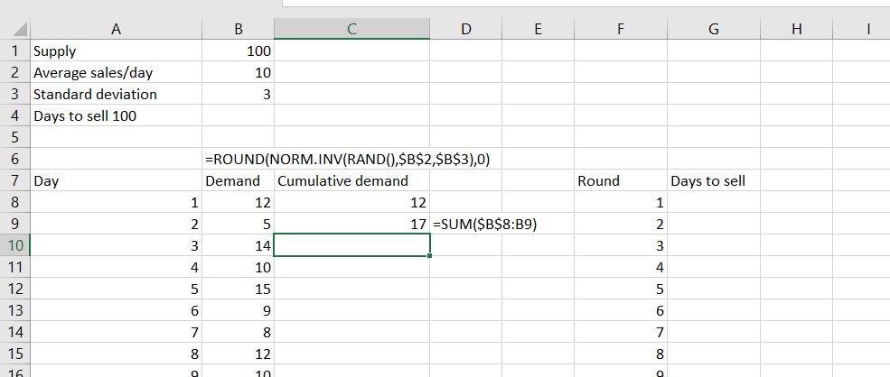

1. Now I want to find on what day we got to 100 widgets. I will use the XMATCH() function for this. This is a new Office 365 function. The way that our values are sorted, it’s easier to use XMATCH() than MATCH().

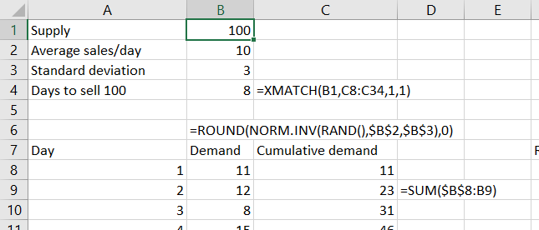

1. We’ve conducted this simulation once and saw it takes 8 days to sell 100 widgets. But what about doing this many, many times? We can use Data Tables to make this easier.
   1. Plug the result of B4 into G8.

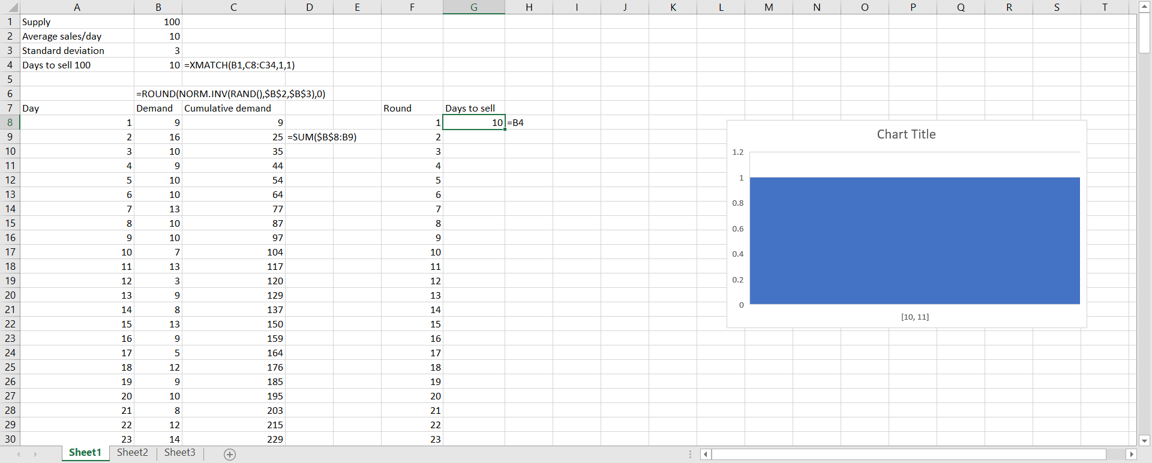

* 1. We now want to fill in the rest of this simulation table and can “trick” Data Tables into doing it for us. With the range F8:G307 highlighted, head to Data > What-If Analysis > Data Table.
  2. **This part is quite confusing!** 
     1. You will leave the Row input cell *blank.*
     2. You will set the Column input cell to a *random blank cell.* This will trick Excel into populating the table with the results of G8.

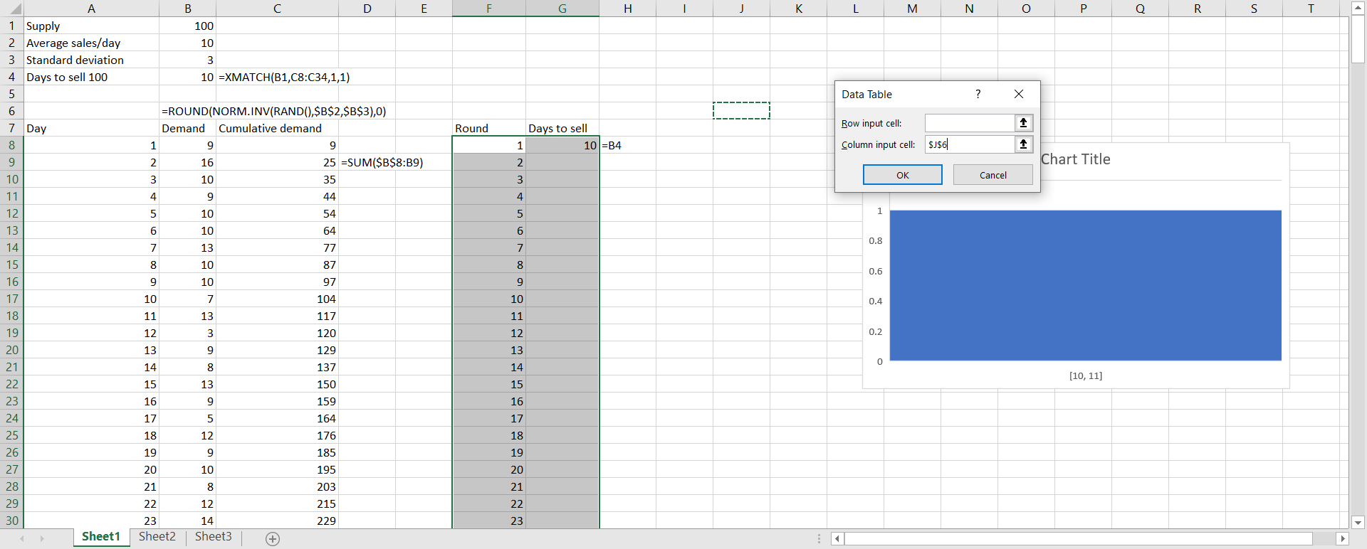

* 1. Our results of 300 simulations is completed. Now you can get a more balanced understanding of how many days it will take to sell 100 widgets.

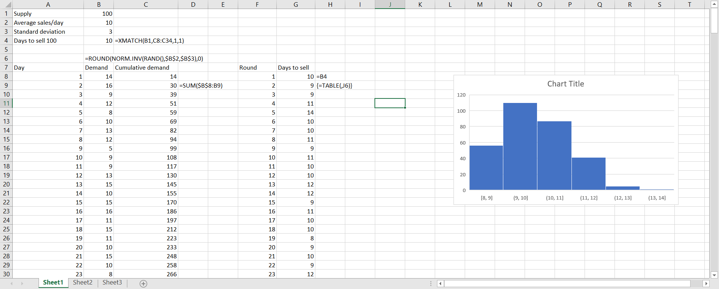

Drill: monte-carlo.xlsx

1. This file is so-called because these are called *Monte Carlo simulations.* 
   1. Again, make sure to leave the *column input cell blank* in the data table. That and getting the NORM.INV() functions down make this one take practice!