Forecasting and time series: demo notes

Demo: sp500.xlsx

1. We would like to forecast daily returns of the S&P 500. We will use three methods:
   1. Column C is a naive forecast. We will just use the value of the previous period to forecast the next period.
   2. Column D is a rolling average. We will do a rolling average of the last 4 days. For the first three days of the forecast, we don’t have that full history so we will just use the first 1, 2 and 3 days. Our chart and data now looks like this.

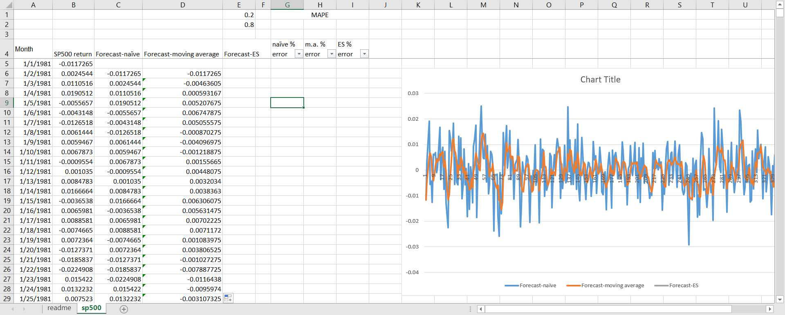

* 1. For the last one, exponential smoothing, we will use the ToolPak. Go to **Data > Data Analysis > Exponential Smoothing.** 
     1. Your input range is the actual S&P data in column B.
     2. We will start with a damping factor of .2.
     3. Our output range will be the blank column E. Do *not* include the label row.

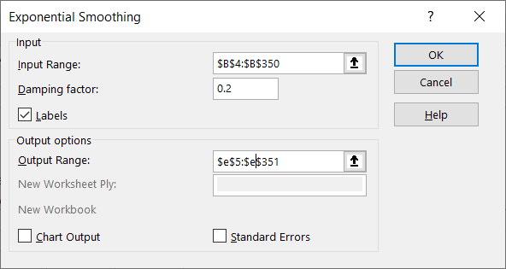

* 1. You will now see the resulting formulas used for exponential smoothing. Our damping factor is hard-coded into the formula.

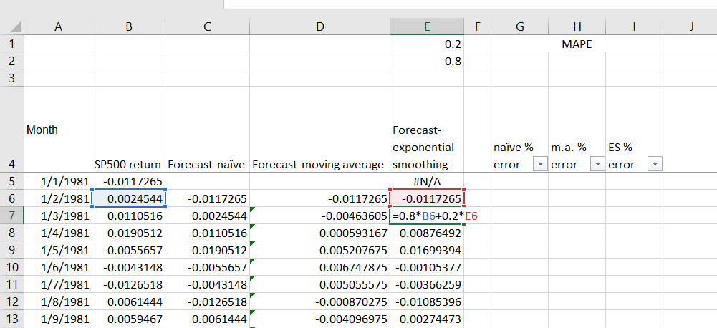

* 1. Let’s make this more dynamic by substituting our .2 and .8 with cell references. That way we can change the damping factor and see what happens to our curve.

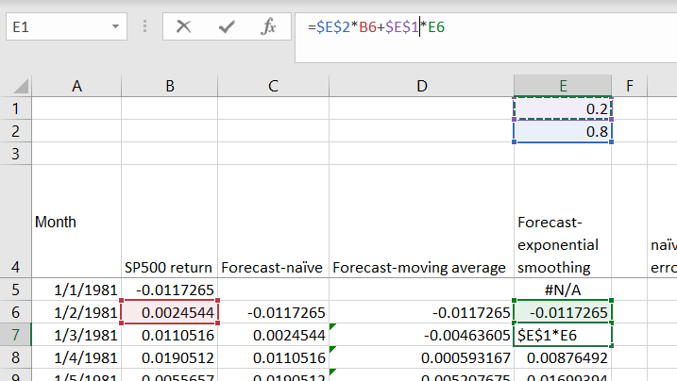

* 1. To make it easier to see the exponential smoothing forecast, you can right-click on the chart, click Select Data, and un-check the other forecasts from showing up on the chart.

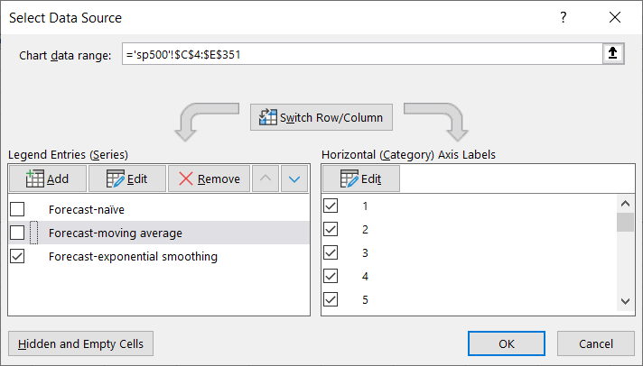

* 1. You will see that the more of a damping factor that is included, the more jagged the forecast is. We are weighting the current datapoint more highly.

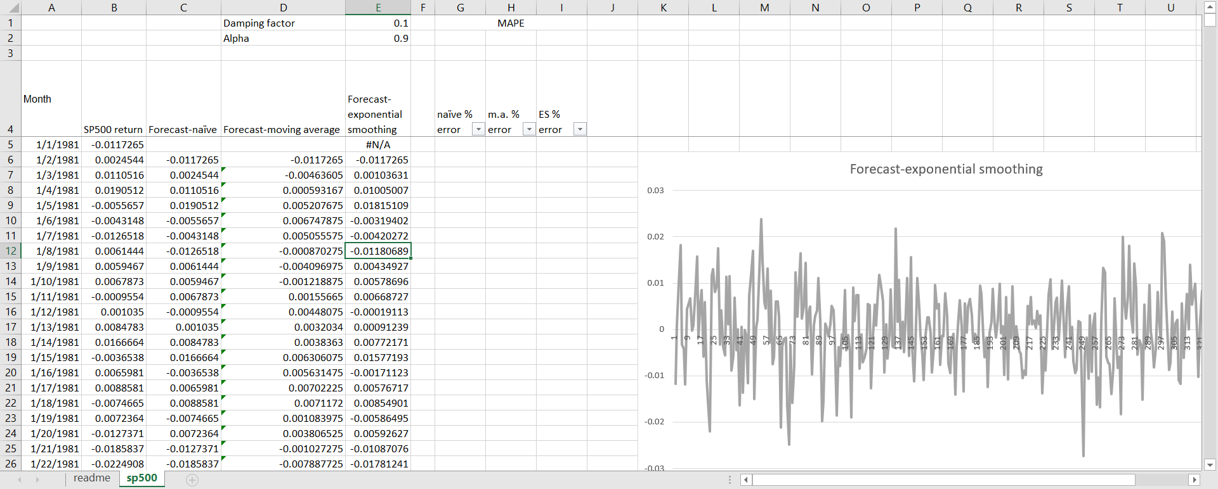

1. Now let’s evaluate the accuracy of our forecasts using the mean absolute percentage error, MAPE. I have the formulas for MAPE at the bottom of the columns, so paste them, fill them down the rows and then take the average for each one. Your model should look something like this. I have turned the other forecasts back on in the chart below.

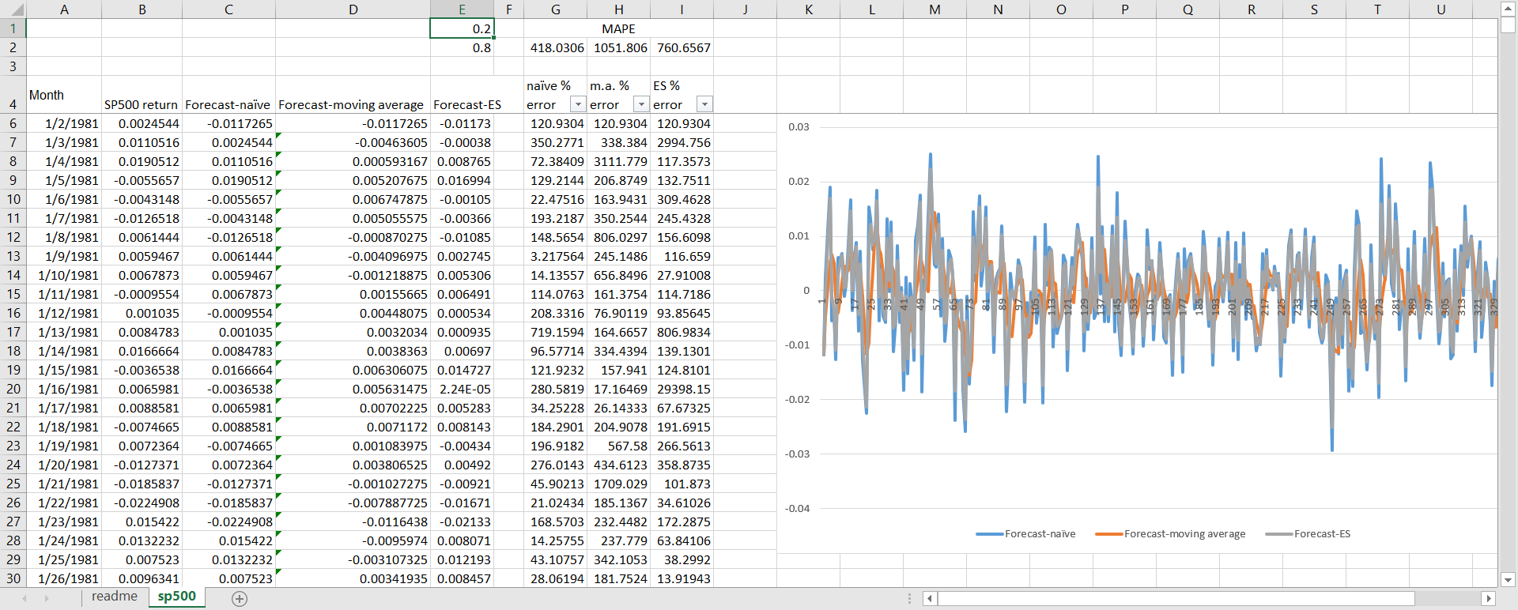

1. It looks like currently the forecast with the lowest MAPE is the naive forecast. But can we do better with the smoothing forecast by re-adjusting our damping factor to minimize MAPE? This sounds like a job for Solver:

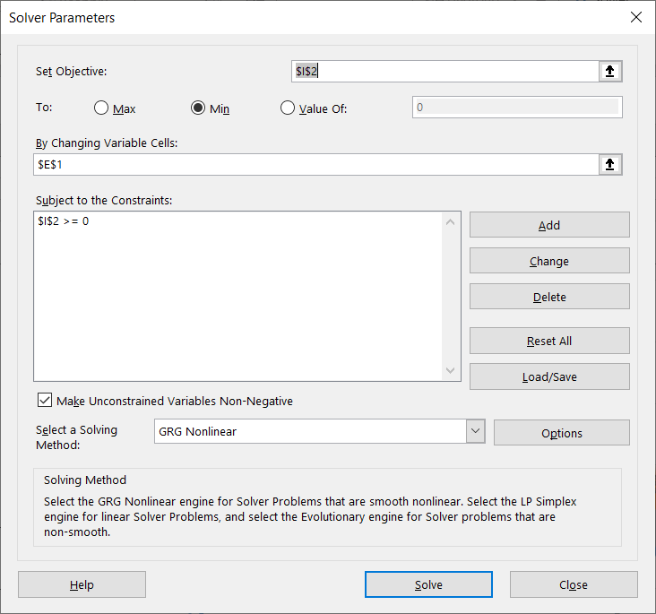

1. Turns out that we can do better with exponential smoothing by optimizing the damping factor.
   1. There is a *lot* more you could do to build up on this forecast. This is a good foundation, though.

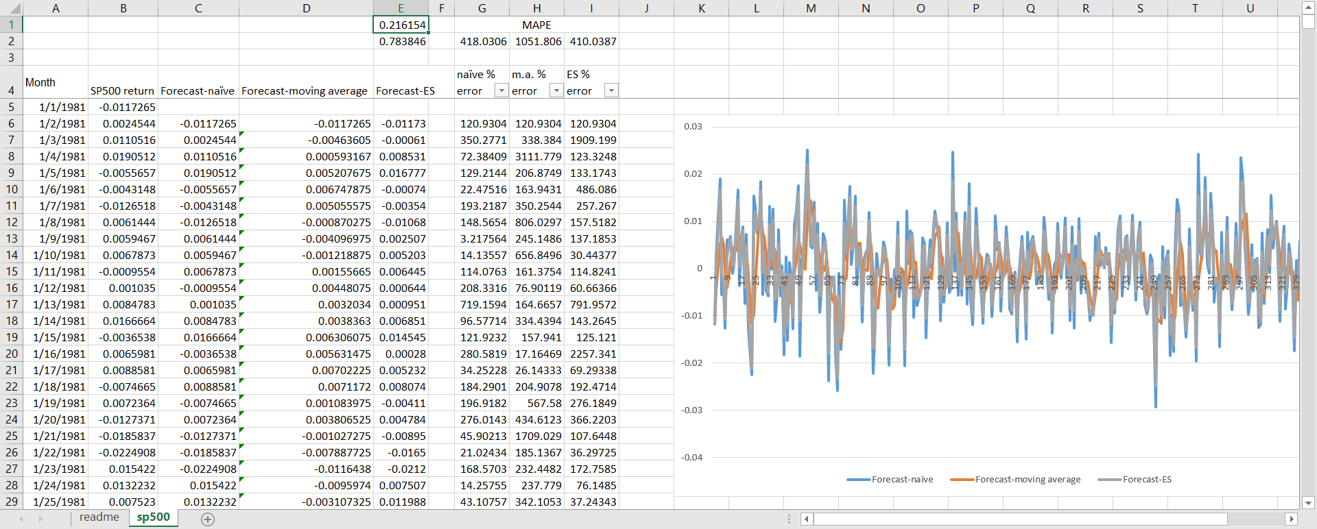

Drill: female-births.xlsx

Turns out in this case, a very high damping factor works best. This makes the forecast line look nearly smooth. We do get a better forecast accuracy than the other methods this way.

