**T-TESTS FOR BUSINESS IMPACT – DEMO NOTES**

1. Create a new worksheet, including the PivotTables with the records of the two categories you want to compare.

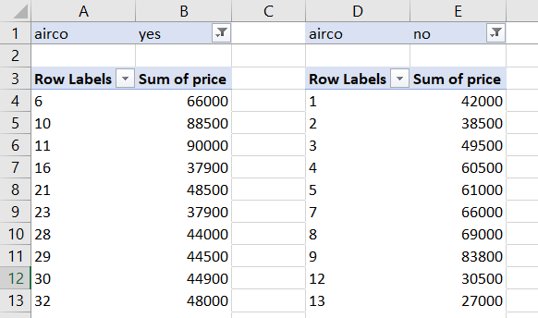

1. On the ribbon, go to Data -> Data Analysis -> t-Test: Two-Sample Assuming Unequal Variances

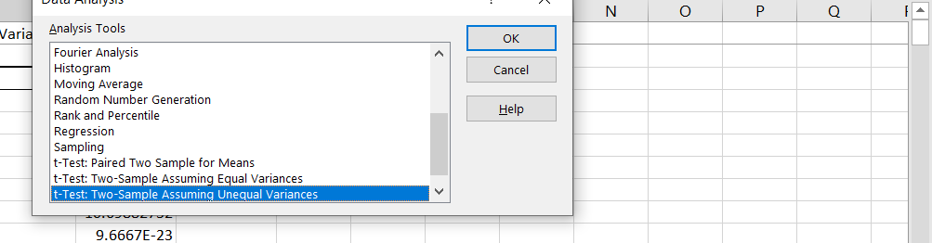

1. Select your variable ranges, and set the output range to somewhere on the same worksheet.

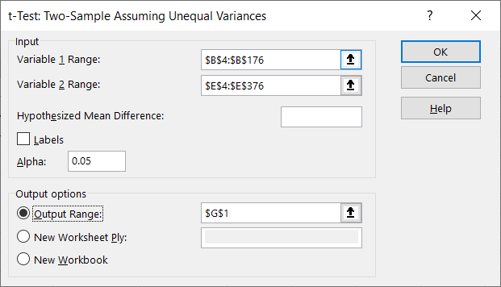

1. This gives you the p-value. Return to slides for explanation of confidence interval.
2. To calculate the confidence interval, follow with the formulas used below.

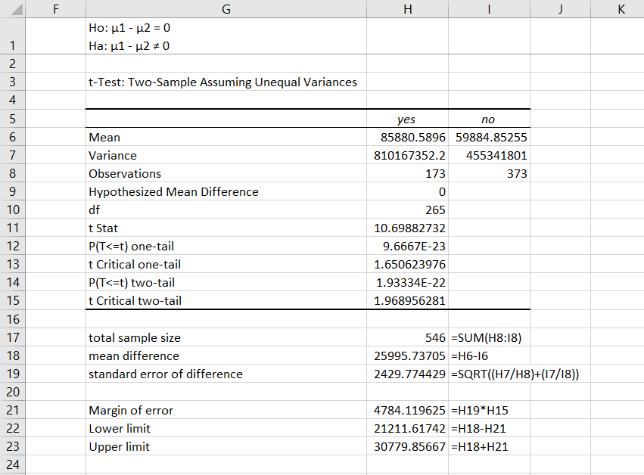

Return to slides for explanation of visualizing t-test results

1. To visualize t-test results, first set up the below formulas.

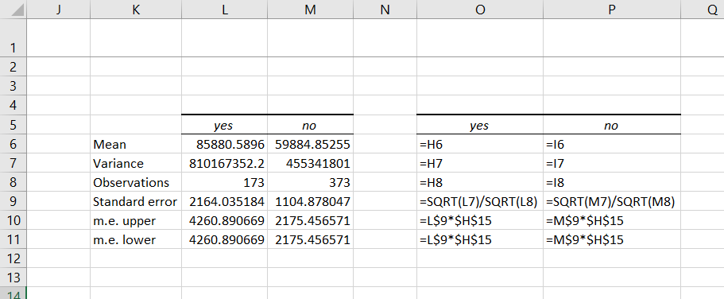

1. Create a bar chart based on the means of each category

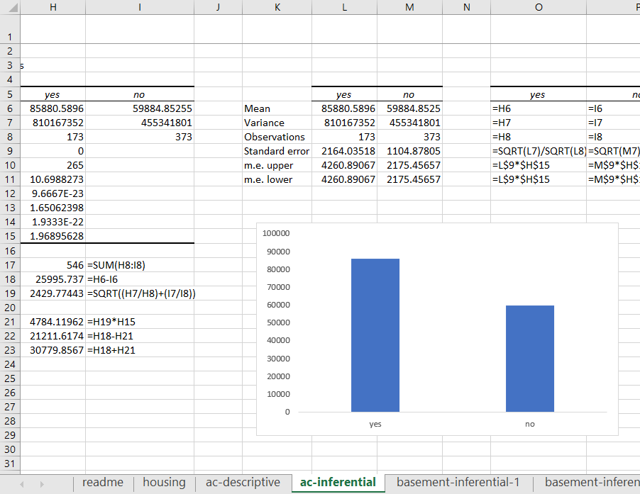

1. Click on the plus-sign next to the bar chart and select Error Bars, hit the right arrow next to it and select More Options.
2. Go to Custom and the bottom and set the error bars to be the margin of error values.
3. The bar chart now has error bars representing the 95% confidence interval for each sample. If the bars intersect between the two charts, there is no significant difference in means.

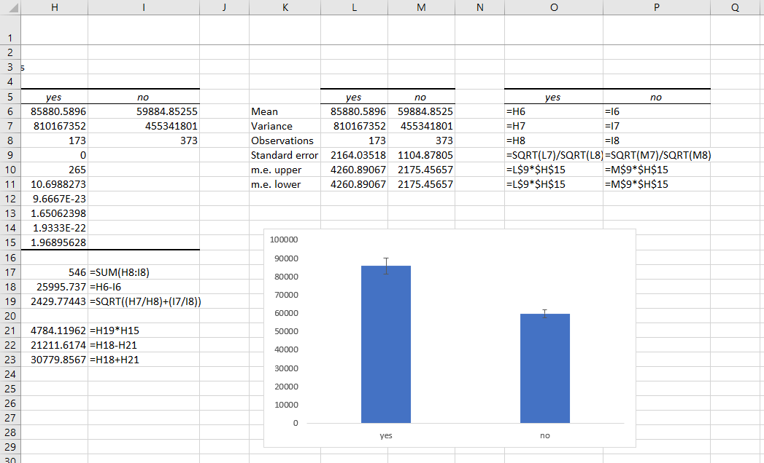

1. Adjust the y axis depending on the circumstances, with the knowledge that it is the best practice to start a y axis at zero.

**Demo: margin-of-error.xlsx**

|  |  |  |
| --- | --- | --- |
| **Column position** | **Column label** | **Formula** |
| C | Sample mean | =AVERAGE($B$3:INDEX($B$3:$B$548,$A4)) |
| D | Variance | =VAR.S($B$3:INDEX($B$3:$B$548,$A4)) |
| E | Standard Error | =SQRT(D4)/SQRT(A4) |
| F | Critical value | =VLOOKUP($A4,'critical-value'!$A$1:$B$34,2) |
| G | Margin of error | =E4*F4 |
| H | Margin of error as % of mean | =G4/C4 |

Plot column H as a line chart.