DIABETES PREDICTION SYSTEM

# Project Submission Part -5

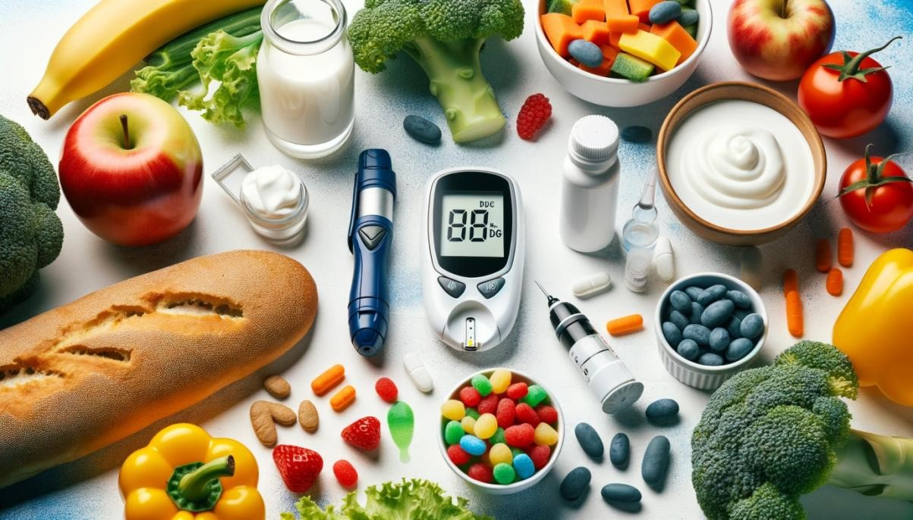

**Introduction :**

* Diabetes is a chronic metabolic disorder characterized by high levels of blood sugar, leading to various health complications if not managed effectively. Early diagnosis and timely intervention are crucial in mitigating the risks associated with diabetes. The primary goal of this documentation is to address the problem of diabetes prediction using machine learning techniques. We aim to develop predictive models that can analyze a set of patient attributes and accurately classify individuals into diabetic and non-diabetic groups.
* Machine learning and data analytics techniques have shown promise in predicting the risk of diabetes in individuals. By analyzing relevant medical and lifestyle data, it is possible to develop predictive models that can identify individuals at high risk of developing diabetes. These models can provide valuable insights to healthcare professionals and individuals, enabling them to take proactive steps in preventing or managing the disease.
* The importance of predicting diabetes cannot be overstated. Diabetes is a global health concern affecting millions of people, and its prevalence continues to rise. It leads to severe health complications, including heart disease, kidney failure, and vision impairment. By developing accurate diabetes prediction models

**Content for project :**

In this project we will document our project and make it well prepare for the submission

In documentation we will clearly outline the problem statement and describe the dataset used.

Begin by clearly defining the problem you are addressing in your project. Explain the context, the business or research problem, and why it is important to solve. For example, "Our project aims with AI Based Diabetes System."



**Data Source :**



A good data source of diabetes prediction using machine learning should be Accurate , Complete ,

Covering the physical details , Accessible

Data Source Link :

[https://www.kaggle.com/datasets/mathchi/diabetes-dataset](https://www.kaggle.com/datasets/mathchi/diabetes-data-set)

|  |  |  |  |  |  |  |  |  |  |  |
| --- | --- | --- | --- | --- | --- | --- | --- | --- | --- | --- |
|  | Preg nanc ies | Gluc ose | BloodPr essure | SkinThi ckness | Ins  ulin | BMI | DiabetesPed igreeFunctio n | Age | Ou tco  me | Pregn ancies |
| 0 | 6 | 148 | 72 | 35 | 0 | 33.6 | 0.627 | 50 | 1 | 6 |
| 1 | 1 | 85 | 66 | 29 | 0 | 26.6 | 0.351 | 31 | 0 | 1 |
| 2 | 8 | 183 | 64 | 0 | 0 | 23.3 | 0.672 | 32 | 1 | 8 |
| 3 | 1 | 89 | 66 | 23 | 94 | 28.1 | 0.167 | 21 | 0 | 1 |
| 4 | 0 | 137 | 40 | 35 | 168 | 43.1 | 2.288 | 33 | 1 | 0 |
| 5 | 5 | 116 | 74 | 0 | 0 | 25.6 | 0.201 | 30 | 0 | 5 |
| 6 | 3 | 78 | 50 | 32 | 88 | 31 | 0.248 | 26 | 1 | 3 |
| 7 | 10 | 115 | 0 | 0 | 0 | 35.3 | 0.134 | 29 | 0 | 10 |
| 8 | 2 | 197 | 70 | 45 | 543 | 30.5 | 0.158 | 53 | 1 | 2 |
| 9 | 8 | 125 | 96 | 0 | 0 | 0 | 0.232 | 54 | 1 | 8 |
| 10 | 4 | 110 | 92 | 0 | 0 | 37.6 | 0.191 | 30 | 0 | 4 |
| 11 | 10 | 168 | 74 | 0 | 0 | 38 | 0.537 | 34 | 1 | 10 |
| 12 | 10 | 139 | 80 | 0 | 0 | 27.1 | 1.441 | 57 | 0 | 10 |
| 13 | 1 | 189 | 60 | 23 | 846 | 30.1 | 0.398 | 59 | 1 | 1 |
| 14 | 5 | 166 | 72 | 19 | 175 | 25.8 | 0.587 | 51 | 1 | 5 |
| 15 | 7 | 100 | 0 | 0 | 0 | 30 | 0.484 | 32 | 1 | 7 |
| 16 | 0 | 118 | 84 | 47 | 230 | 45.8 | 0.551 | 31 | 1 | 0 |
| 17 | 7 | 107 | 74 | 0 | 0 | 29.6 | 0.254 | 31 | 1 | 7 |
| 18 | 1 | 103 | 30 | 38 | 83 | 43.3 | 0.183 | 33 | 0 | 1 |
| 19 | 1 | 115 | 70 | 30 | 96 | 34.6 | 0.529 | 32 | 1 | 1 |
| 20 | 3 | 126 | 88 | 41 | 235 | 39.3 | 0.704 | 27 | 0 | 3 |
| 21 | 8 | 99 | 84 | 0 | 0 | 35.4 | 0.388 | 50 | 0 | 8 |
| 22 | 7 | 196 | 90 | 0 | 0 | 39.8 | 0.451 | 41 | 1 | 7 |
| 23 | 9 | 119 | 80 | 35 | 0 | 29 | 0.263 | 29 | 1 | 9 |
| 24 | 11 | 143 | 94 | 33 | 146 | 36.6 | 0.254 | 51 | 1 | 11 |
| 25 | 10 | 125 | 70 | 26 | 115 | 31.1 | 0.205 | 41 | 1 | 10 |
| 26 | 7 | 147 | 76 | 0 | 0 | 39.4 | 0.257 | 43 | 1 | 7 |
| 27 | 1 | 97 | 66 | 15 | 140 | 23.2 | 0.487 | 22 | 0 | 1 |
| 28 | 13 | 145 | 82 | 19 | 110 | 22.2 | 0.245 | 57 | 0 | 13 |

 **Data Collection and Preprocessing :**

* + Describe the data sources and types used for this project (e.g., medical records, surveys, publicly available datasets).
  + Explain the data collection process, including ethical considerations.
  + Detail the steps taken to clean and prepare the data for analysis.
  + Address missing data, outliers, and any data transformation techniques used.

 **Exploratory Data Analysis :**

* + Present summary statistics and visualizations to better understand the dataset.
  + Identify potential correlations and patterns related to diabetes.

 **Feature Engineering :**

* + Present summary statistics and visualizations to better understand the dataset.
  + Identify potential correlations and patterns related to diabetes.

 **Advanced Regression Technique :**

**Ridge Regression:**

* + Ridge regression adds a regularization term to the linear regression equation, which helps prevent overfitting by penalizing large coefficient values.

➢ **Lasso Regression:**

▪ Lasso regression is similar to ridge regression but uses L1 regularization. It not only prevents overfitting but also performs feature selection by driving some coefficients to exactly zero.

* + - **Elastic Net Regression:** 
      * Elastic Net combines L1 (Lasso) and L2 (Ridge) regularization techniques, striking a balance between feature selection and coefficient shrinkage.
    - **Polynomial Regression:** 
      * Polynomial regression allows for modeling non-linear relationships between predictors and the target variable.
    - **Support Vector Regression (SVR):** 
      * SVR is a regression technique based on support vector machines (SVMs).
    - **Random Forest Regression:**
    - Random Forest is an ensemble learning method that combines multiple decision trees to make predictions.

 **Model Selection**

* + - Describe the machine learning models considered for diabetes prediction.
    - Explain the criteria for selecting the final model(s).

 **Model Development**

* + - Detail the process of training and fine-tuning the selected model(s).
    - Discuss hyperparameter tuning and crossvalidation techniques.

 **Model Evaluation**

* + - Present the metrics used to evaluate the model's performance (e.g., accuracy, precision, recall, F1-score, ROC-AUC).
    - Provide the results of model evaluation on the test dataset.

**Program :**

**Diabetes Prediction:**

|  |
| --- |
| importnumpyasnp import pandas aspd importseabornassns importmatplotlib.pyplotasplt importplotly.expressaspx  # open Data set    df=pd.read_csv('/kaggle/input/diabetes-data-set/diabe tes.csv')    **Data Visualization :**  ln[08] |

f, ax = plt.subplots(1, 2, figsize=(10, 5)) df['Outcome'].value_counts().plot.pie(explode=[0, 0.1], autopct='%1.1f%%', ax=ax[0], shadow=True) ax[0].set_title('Outcome') ax[0].set_ylabel(' ')

sns.countplot(x='Outcome', data=df, ax=ax[1]) # Use

'x' instead of 'Outcome' ax[1].set_title('Outcome')

N, P = df['Outcome'].value_counts() print('Negative (0):', N) print('Positive (1):', P) plt.grid() plt.show()

Negative (0): 500

Positive (1): 268

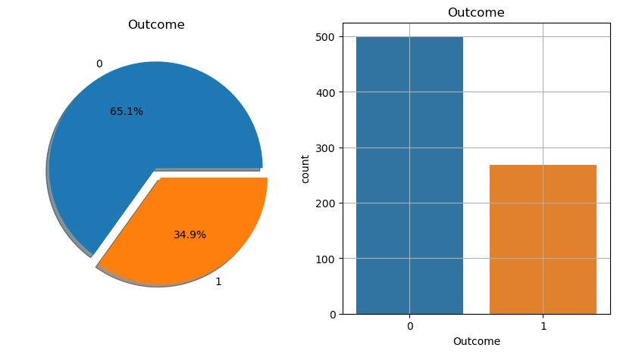

Histograms :

ln[ 21]: df.hist(bins=10, figsize=(10, 10)) plt.show()

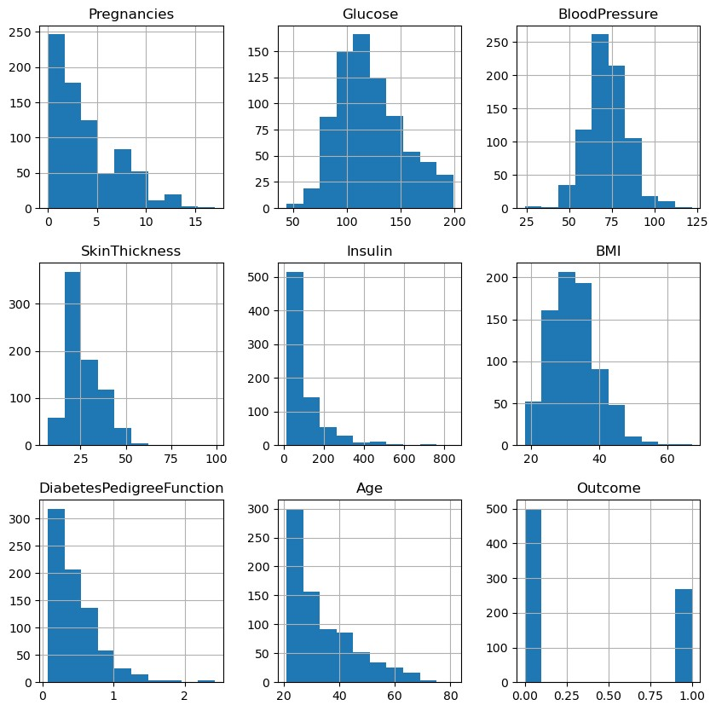

Linear Regression : from sklearn.linear_model import LogisticRegression lr = LogisticRegression(solver='liblinear', multi_class='ovr') lr.fit(X_train, y_train)

out[]

Decision Tree :

**from sklearn.tree import DecisionTreeClassifier dt=DecisionTreeClassifier() dt.fit(X_train, y_train)**

**out[]**

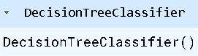

Making Prediction :

#logistic regression

X_test.shape

Out[] (154, 8) ln[] lr_pred=lr.predict(X_test) lr_pred.shape out[]

(154,)

#Decision Tree

dt_pred=dt.predict(X_test) dt_pred.shape out[]

(154,)

Model Evaluation : from sklearn.metrics import accuracy_score print("Train Accuracy of Logistic Regression: ", lr.score(X_train, y_train)*100) print("Accuracy (Test) Score of Logistic Regression:

", lr.score(X_test, y_test)*100) print("Accuracy Score of Logistic Regression: ", accuracy_score(y_test, lr_pred)*100)

out[]

Train Accuracy of Logistic Regression:

77.36156351791531

Accuracy (Test) Score of Logistic Regression:

77.27272727272727

Accuracy Score of Logistic Regression:

77.27272727272727

#for decision tree

print("Train Accuracy of Decesion Tree: ", dt.score(X_train, y_train)*100) print("Accuracy (Test) Score of Decesion Tree: ", dt.score(X_test, y_test)*100) print("Accuracy Score of Decesion Tree: ", accuracy_score(y_test, dt_pred)*100)

out[]

Train Accuracy of Decesion Tree: 100.0

Accuracy (Test) Score of Decesion Tree:

80.51948051948052

Accuracy Score of Decesion Tree: 80.51948051948052

ROC Curve & ROC AUC :

# Area under Curve: auc= roc_auc_score(y_test, lr_pred) print("ROC AUC SCORE of logistic Regression is ", auc) out[]

ROC AUC SCORE of logistic Regression is

0.7327726532826913 ln[] from sklearn.metrics import roc_curve, auc import matplotlib.pyplot as plt fpr, tpr, thresholds = roc_curve(y_test, lr_pred) plt.plot(fpr, tpr, color='orange', label="ROC") plt.plot([0, 1], [0, 1], color='darkblue', linestyle='--', label='ROC curve (area = %0.2f)' % auc(fpr, tpr)) plt.xlabel("False Positive Rate") plt.ylabel("True Positive Rate") plt.title("Receiver Operating Characteristics (ROC)

Curve of Logistic Regression") plt.legend() plt.grid() plt.show()

out[]

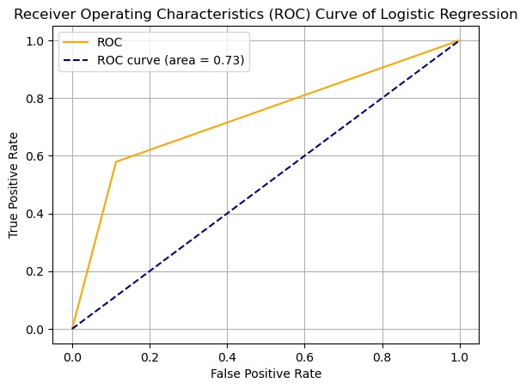

**Conclusion :**

In this documentation, we have explored the process of diabetes prediction using machine learning, from data collection and preprocessing to model selection and deployment. The development of predictive models for diabetes has significant implications for healthcare, and our work here serves as a valuable guide for those seeking to make a positive impact in this domain.

We've learned that accurate diabetes prediction is not only feasible but also crucial for several reasons. Early intervention, optimized healthcare resource allocation, and personalized preventive care are just a few of the benefits that come with successfully predicting diabetes. By leveraging data and machine learning, we can empower healthcare professionals and individuals to take proactive steps in managing this chronic condition.