PATENT FIGURES
Adaptive Patient Monitoring and Context-Aware Clinical Alert Management System Using Wearable Bands

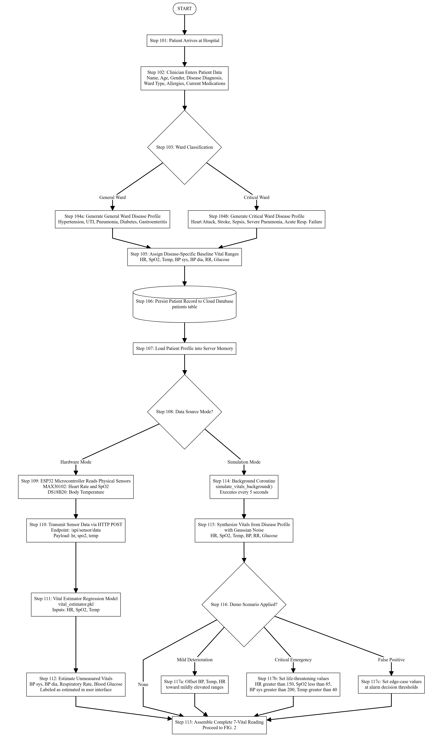
FIG. 1
Flowchart illustrating patient admission and multimode physiological data acquisition.

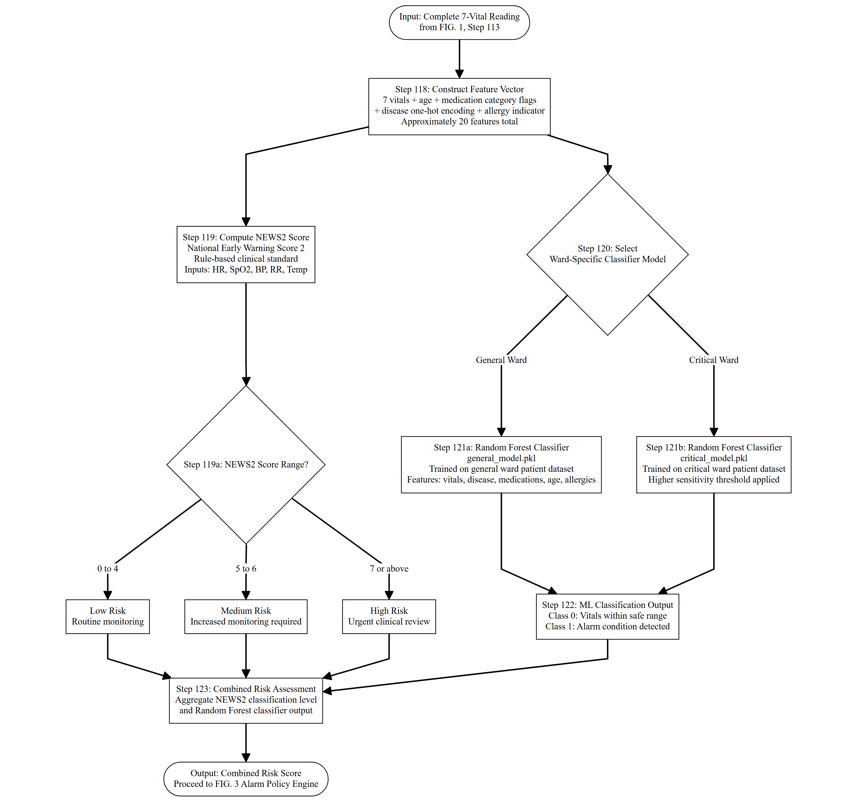
FIG. 2
Flowchart illustrating feature engineering, NEWS2 scoring, and ward-specific machine-learning prediction.

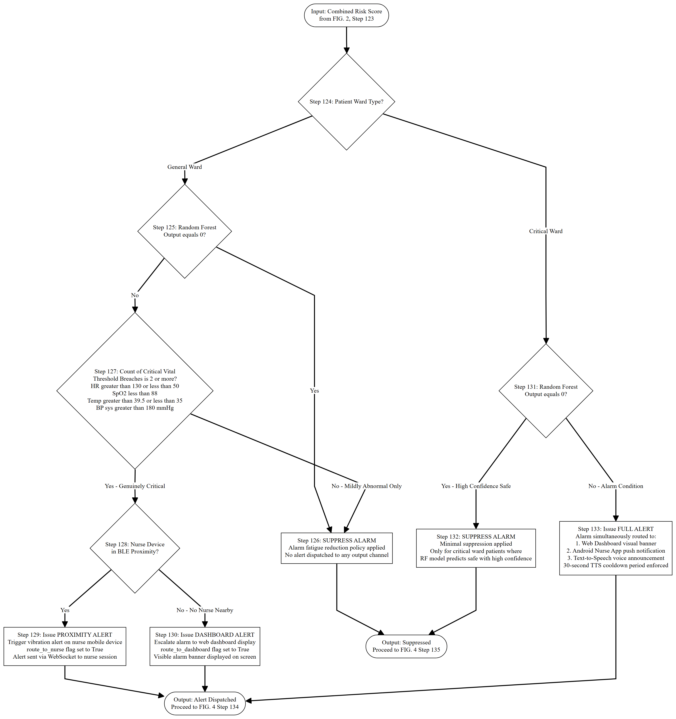
FIG. 3
Flowchart illustrating context-aware alarm policy evaluation and alert routing logic.

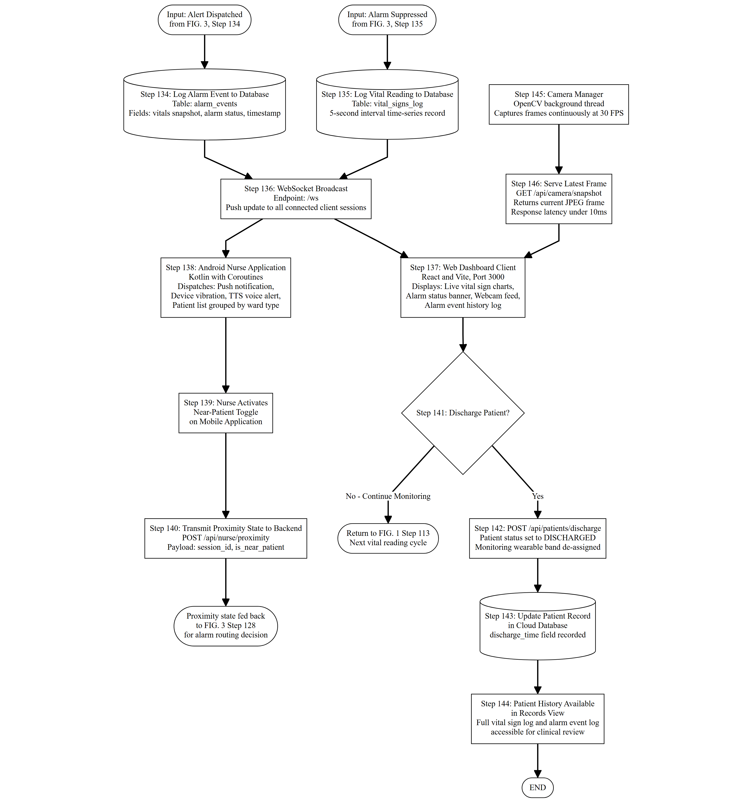
FIG. 4
Flowchart illustrating event logging, client broadcast, nurse feedback loop, and discharge processing.

FIG. 5
Prototype implementation of wearable-band hardware integrated with the clinical monitoring platform.
[Insert prototype image here]

