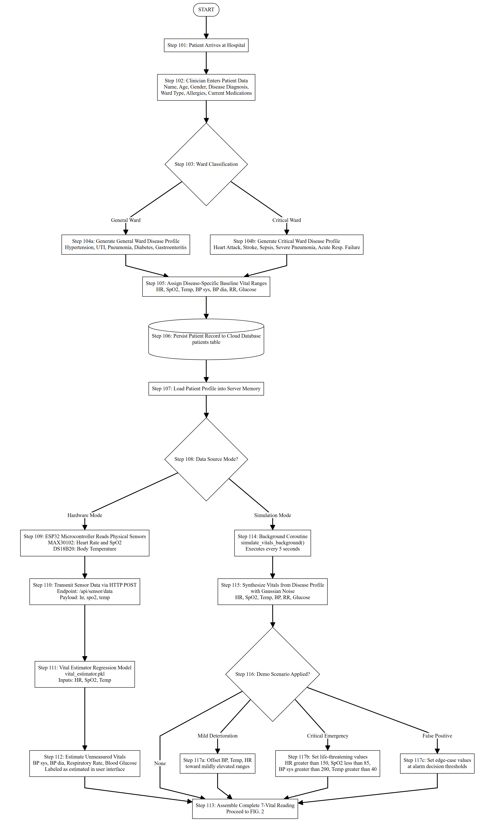
FIG. 1
Flowchart illustrating patient admission and multimode physiological data acquisition.

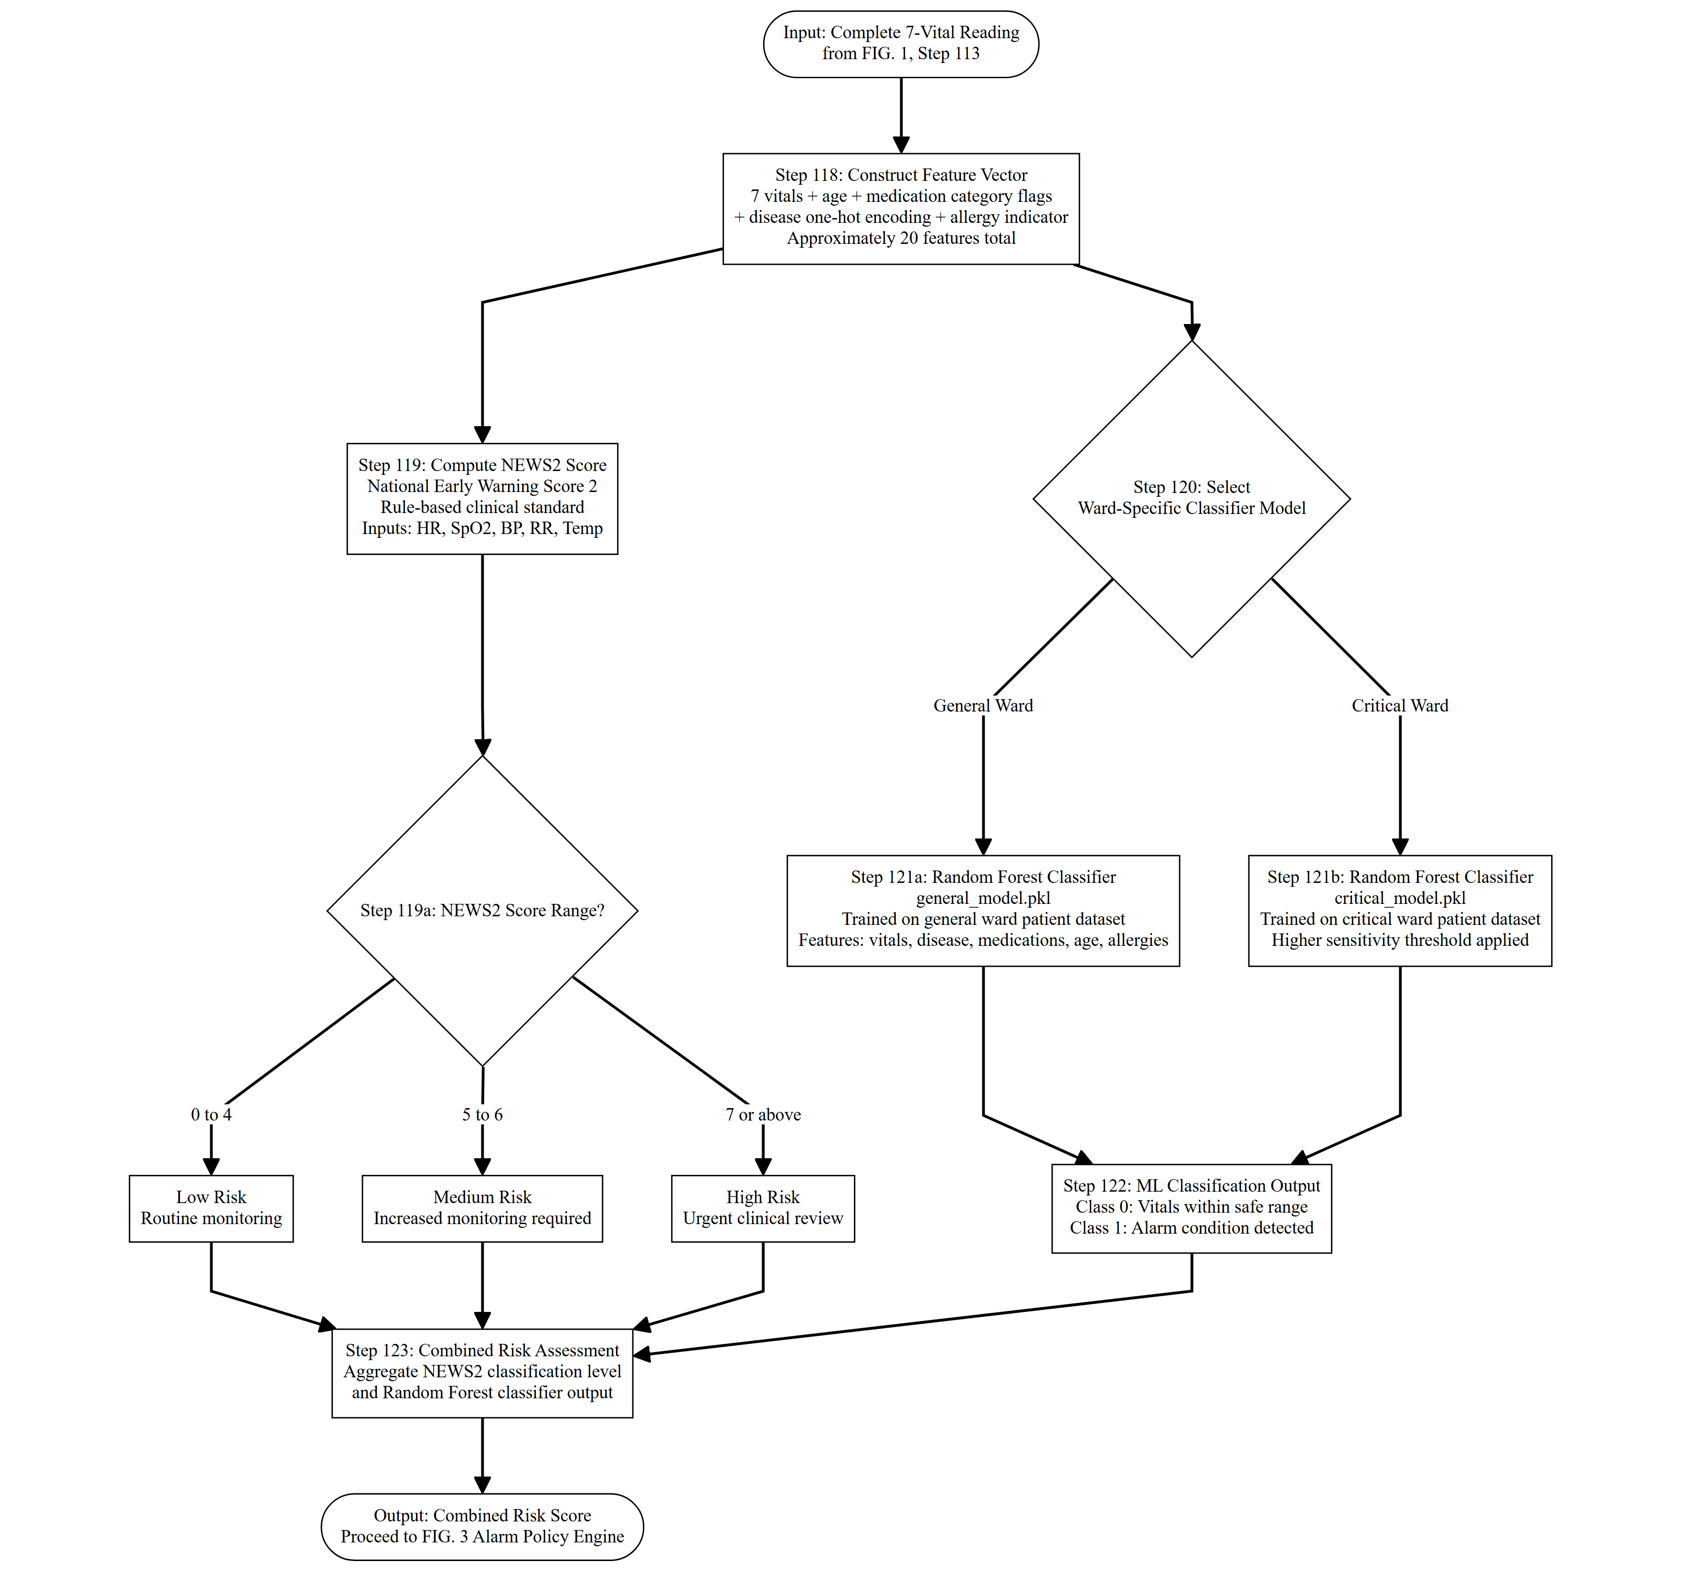
FIG. 2
Flowchart illustrating feature engineering, NEWS2 scoring, and ward-specific machine-learning prediction.

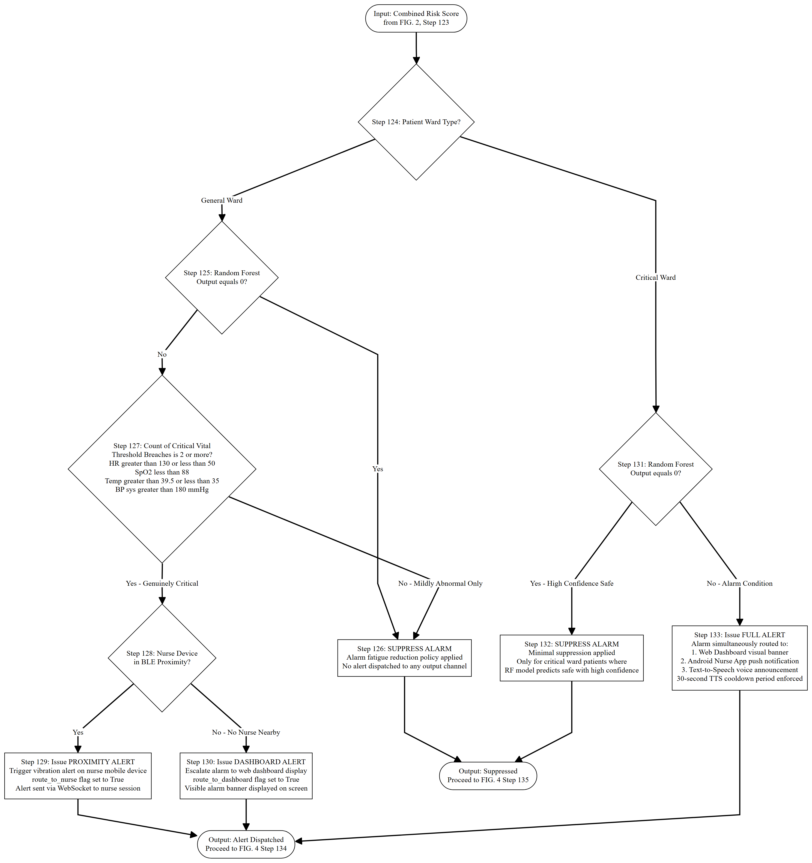
FIG. 3
Flowchart illustrating context-aware alarm policy evaluation and clinical alert routing logic.

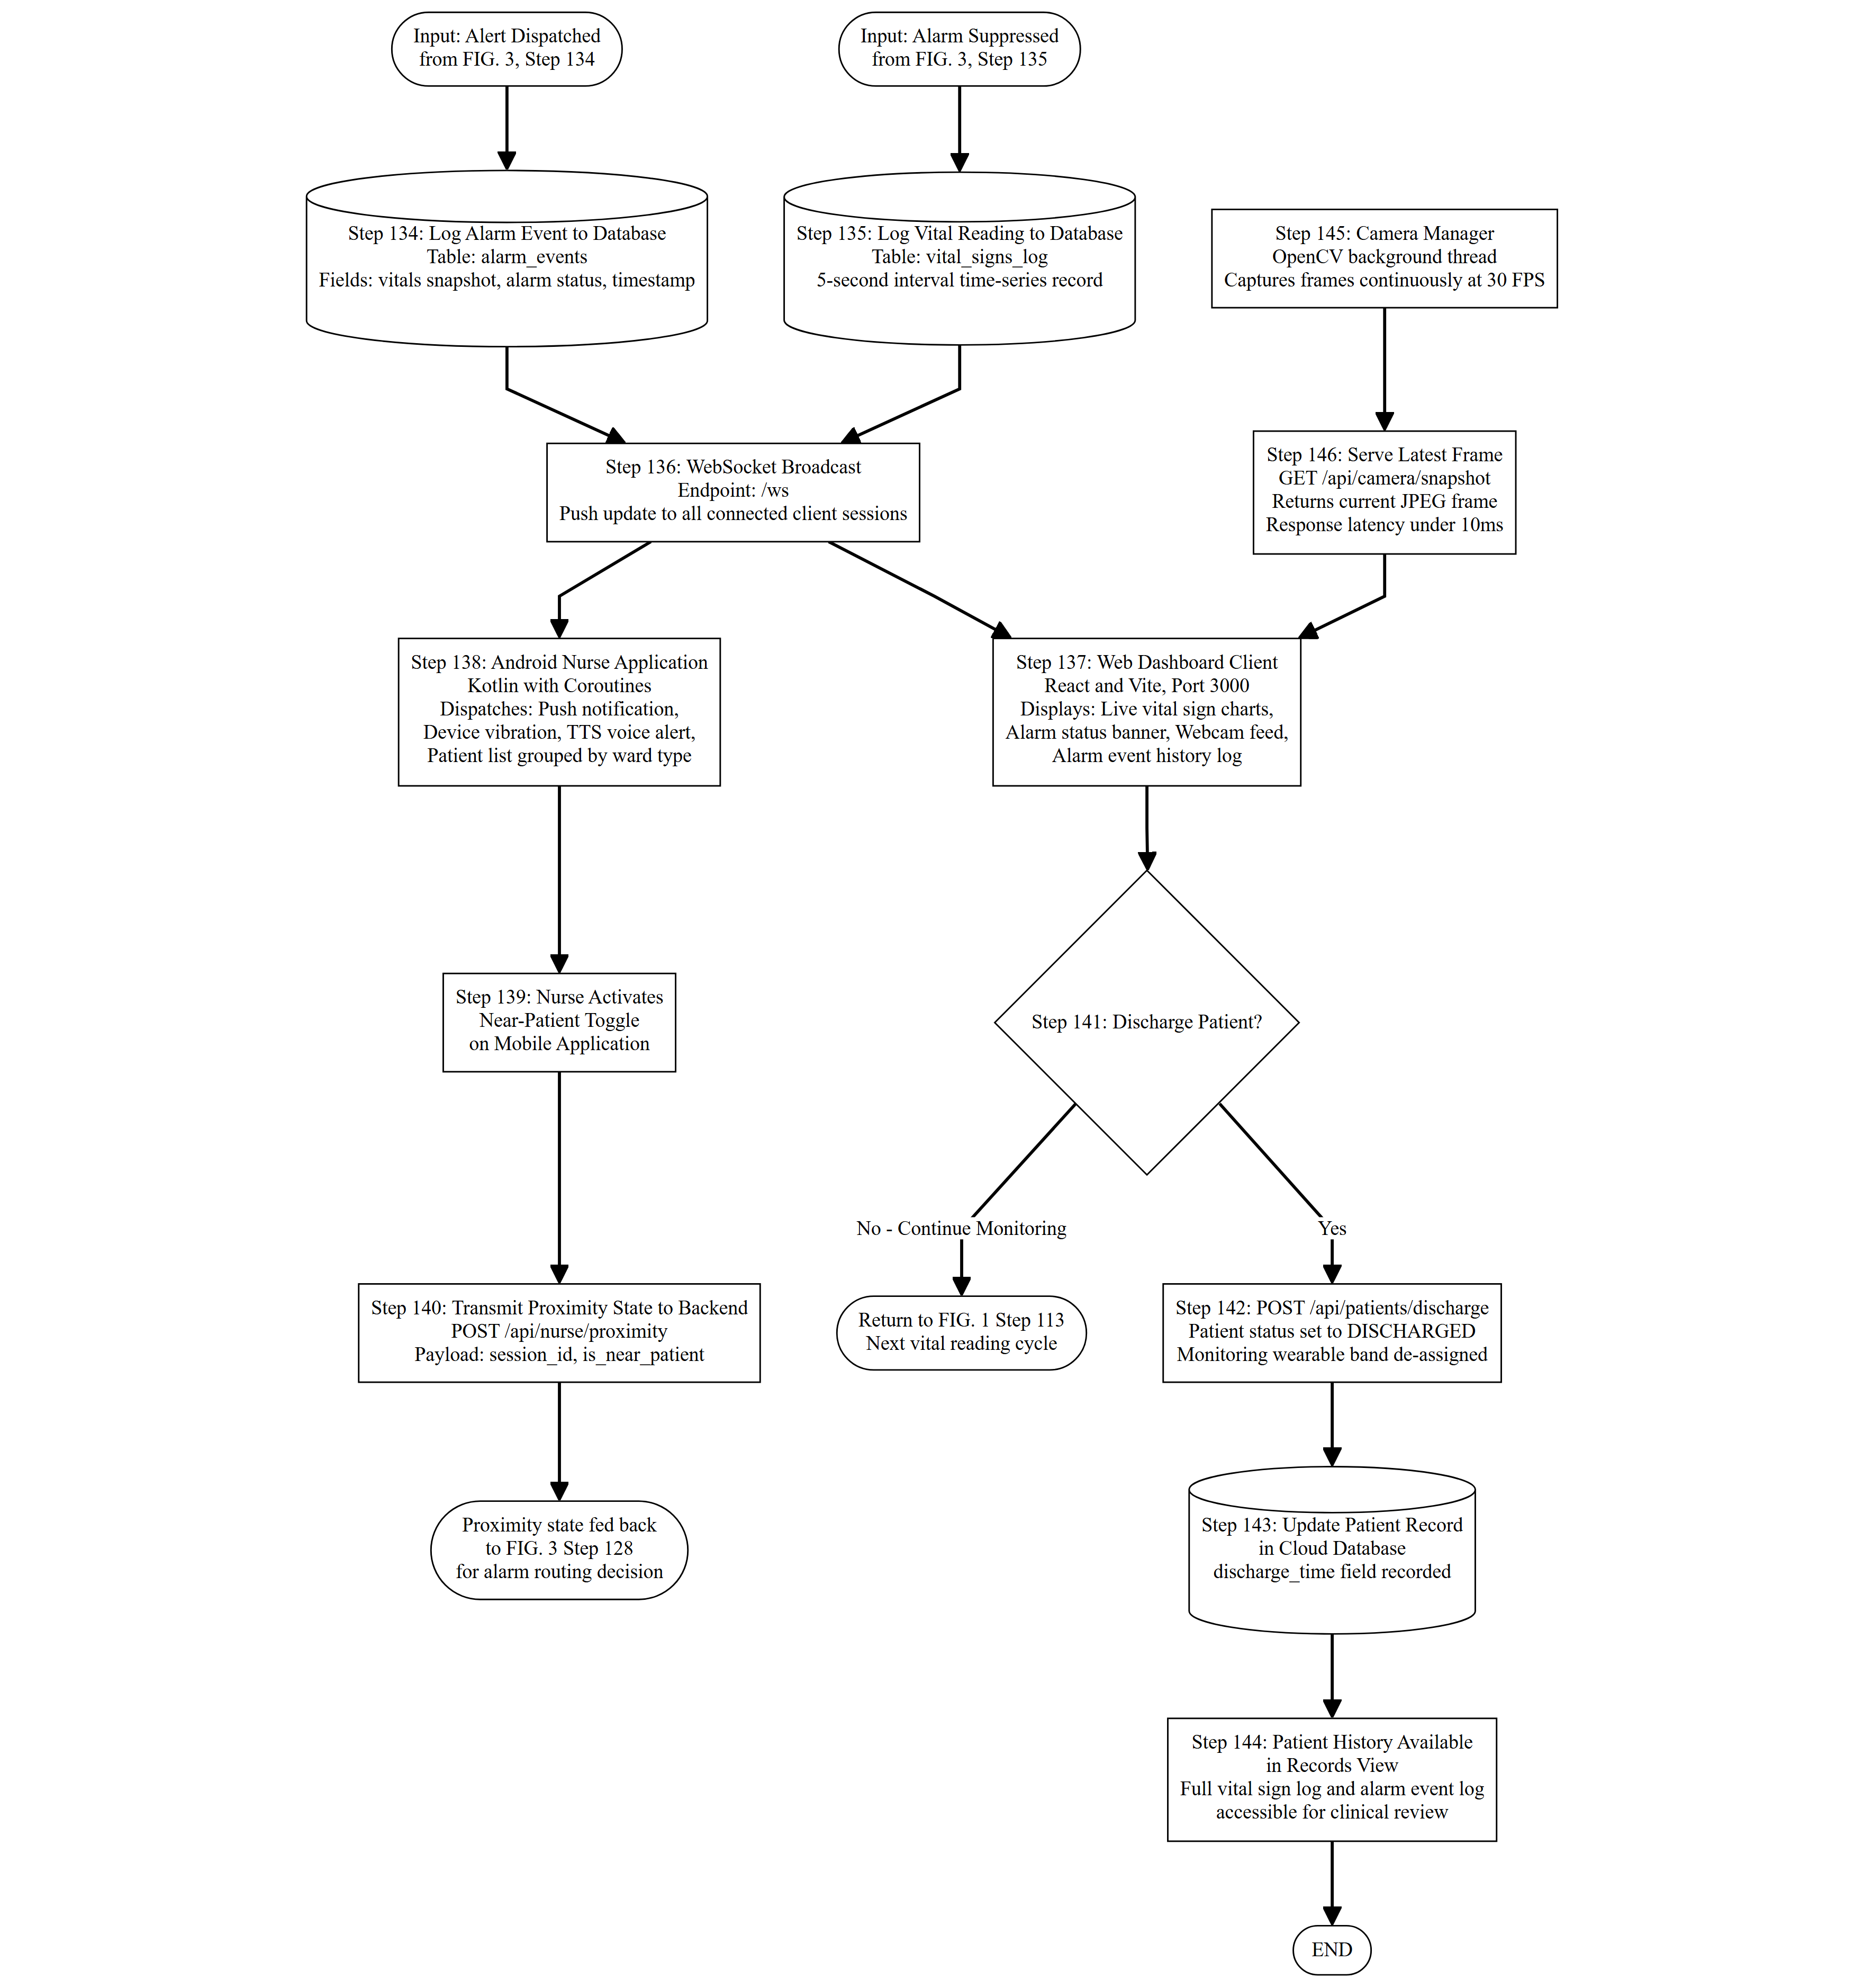
FIG. 4
Flowchart illustrating event logging, real-time broadcast, nurse feedback loop, and discharge processing.

