ROUGH DRAFT - UTILITY PATENT SPECIFICATION

Title of the Invention
Smart Adaptive Patient Monitoring System Using Wearable Bands and Machine-Learning-Based Alerting

Inventors
V. Chandrasekhar Bhargava; L. Susanta; J. Krishna Kantha; K. V. Sowmyaa; V. Teju; L. Naga Srinivasu

1. Field of the Invention
The present invention relates to healthcare monitoring systems, wearable Internet-of-Things devices, intelligent alarm management, and machine-learning-assisted clinical decision support. More particularly, the invention relates to a patient monitoring system that combines wearable band based vital collection, patient-specific metadata, ward-aware prioritization, and context-aware alert routing for improving response efficiency and reducing alarm fatigue in hospital environments.

2. Background of the Invention
Conventional patient monitoring systems used in hospital wards and critical care environments commonly rely on fixed threshold alarms. In such systems, an alarm may be triggered whenever a physiological parameter crosses a preset boundary, without sufficient consideration of patient-specific context. This often produces excessive false or non-actionable alarms, which in turn contributes to alarm fatigue among nurses and other healthcare staff.
Existing wearable and IoT-based health monitoring systems are capable of measuring and transmitting vital signs, but many of them remain limited to threshold-based monitoring or generic anomaly detection. They frequently fail to incorporate disease-specific context, medication status, age-related risk amplification, ward-specific prioritization, and context-aware caregiver notification. As a result, existing systems may generate unnecessary alerts, fail to prioritize the right patient at the right time, and inadequately support real clinical workflow.
There is therefore a need for an integrated monitoring and alert management system that not only acquires physiological data from a wearable device and software platform, but also adaptively determines alert priority using patient metadata, ward category, and caregiver context in order to improve patient safety and healthcare staff response efficiency.

3. Problem Statement
Hospital staff, particularly nurses in general and critical wards, are often required to supervise multiple patients simultaneously. Fixed-threshold monitoring systems generate frequent alarms, many of which are false, low-priority, or insufficiently personalized. Such systems do not adequately distinguish between patients in general wards and those in critical wards, nor do they route alerts based on caregiver proximity or patient-specific metadata such as medication status, age, allergies, and disease condition. This creates a need for a smart adaptive monitoring system capable of improving alarm relevance, reducing alarm fatigue, and supporting faster and more appropriate response.

4. Objectives of the Invention
The objectives of the invention include: (i) providing a wearable-band-based patient monitoring workflow; (ii) collecting physiological parameters in real time in hardware mode and software-generated monitoring mode; (iii) integrating patient metadata including disease, medication, allergy, age, body condition, and genetic predisposition into alarm decision support; (iv) differentiating monitoring and escalation logic for general wards and critical wards; (v) adaptively prioritizing alerts using a machine-learning-assisted decision pipeline; (vi) routing alerts to caregiver devices based on context including caregiver proximity; (vii) providing remote monitoring through a web dashboard and mobile nurse application; and (viii) maintaining patient records, attendance history, alarm history, and band release workflow.

5. Summary of the Invention
The invention provides a smart adaptive patient monitoring system comprising a wearable monitoring band, a backend processing server, a web-based hospital dashboard, and a mobile nurse application. In one mode, physiological readings including heart rate, oxygen saturation, and temperature are acquired from real sensors connected to a wearable IoT device. In another mode, patient monitoring is simulated for testing, training, or demonstration. The backend receives vital data, derives or estimates additional monitoring values where required, computes a clinical early warning score, and applies a patient-specific machine-learning-assisted alerting process that considers disease context, medications, allergies, age, and ward type.
The system classifies patients into general ward and critical ward monitoring flows. In the general ward flow, alerts may be routed based on nurse proximity so that vibration-only warnings are used when the nurse is near the patient and stronger notifications are issued when the nurse is farther away. In the critical ward flow, monitoring remains continuously active with more sensitive escalation behavior. The system further supports patient admission, wearable-band assignment, occupancy control, alert history, caregiver attendance logging, discharge handling, and patient-linked camera observation through the nurse application.

6. Brief Description of the Drawings
Figure 1 illustrates an overall system architecture flowchart showing the hardware layer, backend layer, and client layers for web and mobile interaction.
Figure 2 may illustrate the hardware arrangement including the wearable band, sensors, microcontroller, and communication module.
Figure 3 may illustrate the software architecture including admission workflow, patient profile generation, machine-learning-assisted alarm processing, and alert dissemination.
Figure 4 may illustrate the general ward alert routing workflow including proximity-aware nurse notification.
Figure 5 may illustrate the critical ward monitoring workflow including continuous camera-assisted observation and stricter escalation conditions.
Figure 6 may illustrate the patient attendance, alert acknowledgement, discharge, and wearable-band release process.

7. Detailed Description of the Invention
7.1 Overall Architecture
Figure 1 below shows the applicable system architecture flowchart for the disclosed invention.
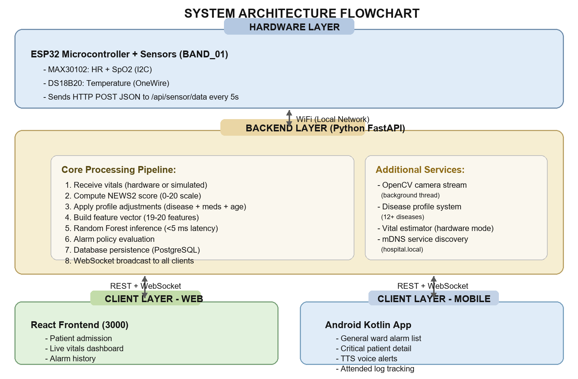
Figure 1. System architecture flowchart of the disclosed smart adaptive patient monitoring system.

In one embodiment, the invention includes three layers: a hardware layer, a backend intelligence layer, and a client interaction layer. The hardware layer includes a wearable patient band associated with a patient identity and configured to support physiological data acquisition. The backend intelligence layer includes a server configured to receive, process, store, classify, and broadcast patient data. The client interaction layer includes a web dashboard for ward staff and a mobile application for nursing staff.
7.2 Hardware Layer
In one embodiment, the wearable band is associated with an ESP32-based or functionally equivalent wireless controller. The band may be connected to a MAX30102 sensor for heart rate and oxygen saturation acquisition and a DS18B20 sensor for body temperature acquisition. The wearable unit transmits physiological measurements to the backend over a wireless network using structured data messages. In certain embodiments, additional physiological values such as blood pressure, respiratory rate, glucose, or derived risk indicators may be estimated, simulated, or generated through backend processing when direct sensing is not available.
7.3 Patient Admission and Metadata Layer
A patient is admitted through an operator interface and associated with a monitoring band. During admission, patient metadata may be recorded including age, disease type, medication list, allergies, body condition, genetic predisposition, and ward type. The ward type may include a general ward category or a critical ward category. The metadata is stored in a backend database and used in subsequent monitoring and alert prioritization.
7.4 Dual Operating Modes
The system supports at least two operating modes. In a hardware mode, the backend receives live readings originating from physical sensors. In a simulation mode, the backend produces or manages synthetic or controlled vital values for demonstration, validation, or testing. This dual-mode capability allows the system to be used in prototype, educational, research, training, and deployment environments.
7.5 Machine-Learning-Assisted Alarm Logic
In one embodiment, the backend computes an early warning score based on patient vital signs, such as a National Early Warning Score framework or functionally comparable scoring method. The system then processes a patient-specific feature set including one or more of disease condition, medications, allergies, age, and ward category. The backend uses a machine-learning classifier, such as a Random Forest classifier or equivalent predictive model, to determine alarm priority or deterioration likelihood.
In a preferred embodiment, the alerting process does not rely solely on static threshold crossing. Instead, it incorporates patient metadata so that similar raw vital readings may produce different escalation outcomes depending on whether the patient is already on corresponding treatment, belongs to a higher-risk age group, presents a particular disease profile, or is admitted in a critical versus general ward. This provides adaptive alerting and improved prioritization relative to conventional threshold-only monitoring.
7.6 Ward-Specific Monitoring Logic
In the general ward flow, multiple patients may be monitored concurrently. Alerts may be escalated to a mobile nurse device with differentiated vibration and notification behavior depending on contextual state. In the critical ward flow, the system applies stricter monitoring logic and maintains continuous observation for a smaller set of high-risk patients. Separate machine-learning models, risk criteria, or escalation parameters may be used for different ward categories.
7.7 Proximity-Aware Alert Routing
In one embodiment, the mobile nurse application maintains a nurse-session state and proximity state relative to the monitored patient or band identifier. When the system determines that the caregiver is near the monitored patient, the alert can be delivered in a reduced-disruption form such as local vibration. When the caregiver is not near the patient, the alert can be delivered through stronger notification mechanisms. This context-aware routing reduces unnecessary disruption while preserving timely escalation.
7.8 Remote Observation and Camera Monitoring
The invention may include a patient-linked remote observation function. A camera associated with the patient location or bed area may be accessed through the nurse application so that clinical staff can remotely inspect the patient after or during an alert event. In certain embodiments, the camera stream is represented by repeatedly refreshed image frames or other network-delivered visual monitoring content.
7.9 Attendance Logging and Discharge Workflow
The mobile application allows nursing staff to mark a patient as attended after responding to an alert. The system stores attendance timestamps and counts, thereby generating a response history. Upon discharge through the dashboard, the patient record is updated, alert history and timestamps are preserved, and the monitoring band is released for reassignment to another patient. The occupancy state of the band prevents conflicting reuse while an existing patient remains active.
7.10 Data Storage and Interfaces
The backend may use a relational database for storing admitted patient records, metadata, current monitoring state, alarm history, and discharge records. The dashboard and mobile application communicate with the backend through one or more of REST interfaces, WebSocket messaging, polling, and event-triggered notifications.

8. Advantages of the Invention
The invention provides several advantages over conventional hospital monitoring systems. These include reduced false or non-actionable alerts; adaptive prioritization rather than purely fixed-threshold alarming; support for different ward types; patient-specific risk reasoning using metadata; proximity-aware nurse notification; integrated attendance logging; remote camera-assisted observation; reusable wearable-band assignment with occupancy control; and support for both live hardware and simulated testing environments.

9. Applications of the Invention
The invention may be used in hospitals, step-down wards, critical care settings, general wards, training laboratories, prototype healthcare systems, remote observation environments, rural healthcare settings, and educational medical IoT research systems.

10. Novelty / Inventive Features
The presently disclosed system is distinguished by the combination of: (i) wearable-band-linked patient assignment and occupancy control; (ii) ward-aware dual monitoring logic for general and critical patients; (iii) machine-learning-assisted alert prioritization using patient metadata instead of only raw threshold crossing; (iv) proximity-aware nurse alert routing; (v) integrated nurse attendance logging with patient history; and (vi) patient-linked remote observation support as part of the monitoring workflow. The novelty lies not in a single isolated sensor or software module, but in the integrated adaptive alert-management architecture and workflow.

11. Claims
Claim 1. A patient monitoring system comprising: a wearable monitoring band associated with a patient; a backend server configured to receive physiological data from the wearable monitoring band or from a simulation source; a patient-profile database storing patient-specific metadata; an alert evaluation engine configured to determine an alarm priority using the physiological data together with the patient-specific metadata; and at least one caregiver interface configured to present an alert based on the determined alarm priority.
Claim 2. The system of claim 1, wherein the patient-specific metadata comprises one or more of age, disease condition, medication list, allergies, body condition, genetic predisposition, and ward type.
Claim 3. The system of claim 1, wherein the alert evaluation engine uses an early warning score together with a machine-learning classifier to determine the alarm priority.
Claim 4. The system of claim 1, wherein the system operates in a hardware mode using sensor-derived physiological data and in a simulation mode using generated or controlled physiological data.
Claim 5. The system of claim 1, wherein the caregiver interface includes a general ward flow and a critical ward flow having different alerting or monitoring behavior.
Claim 6. The system of claim 1, wherein a nurse mobile application determines whether a caregiver is near the monitored patient and changes alert delivery behavior according to the determined proximity state.
Claim 7. The system of claim 1, wherein the system provides a patient-linked remote observation interface that enables a caregiver to view camera content associated with a monitored patient location.
Claim 8. The system of claim 1, further comprising an attendance logging mechanism configured to store one or more timestamps representing caregiver response to an alert event.
Claim 9. The system of claim 1, wherein the wearable monitoring band is subject to an occupancy control mechanism that prevents reassignment of the wearable monitoring band while an existing patient session remains active.
Claim 10. A method for adaptive patient monitoring comprising: associating a patient with a wearable monitoring band; receiving physiological data and patient-specific metadata; computing an alert decision using an early warning score and machine-learning-assisted context evaluation; routing an alert according to ward-specific and caregiver-context conditions; recording caregiver attendance; and releasing the wearable monitoring band when the patient session is discharged.

12. Abstract
A smart adaptive patient monitoring system using wearable bands and machine-learning-based alerting is disclosed. The system associates a patient with a wearable monitoring band and stores patient-specific metadata including age, disease condition, medications, allergies, body condition, genetic predisposition, and ward type. Physiological data are obtained from physical sensors in a hardware mode or from generated monitoring inputs in a simulation mode. A backend server receives the data, computes an early warning score, and applies a machine-learning-assisted alert evaluation process to determine alarm priority. The system supports separate monitoring workflows for general wards and critical wards, thereby enabling differentiated escalation behavior. In general ward operation, alert routing may further depend on caregiver proximity so that notification intensity is adapted according to whether a nurse is near the patient. The system also supports remote caregiver interfaces including a dashboard and a nurse mobile application, patient-linked camera observation, attendance logging, alert history retention, discharge handling, and wearable-band occupancy control. By combining wearable sensing, patient metadata, ward-aware logic, and context-aware caregiver notification, the invention reduces unnecessary alarms and improves clinical response efficiency.

Note: This document is a rough draft prepared for concept framing and should be reviewed by a patent professional before filing.

