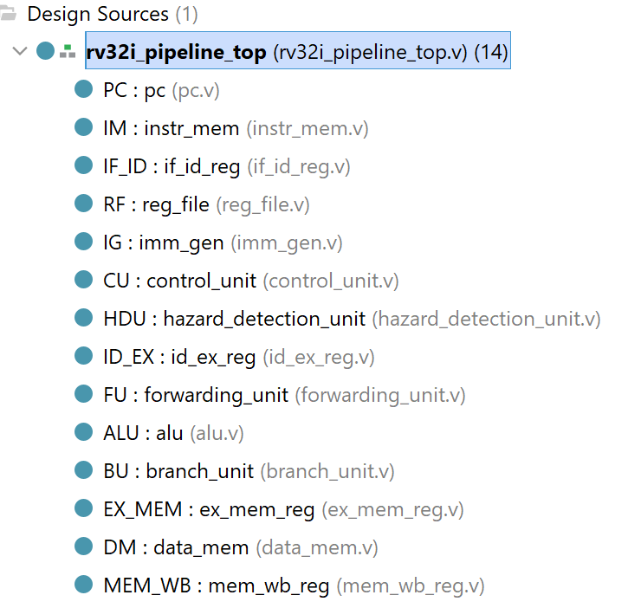
- pc.v
`timescale 1ns/1ps

module pc(
input clk,
input reset,
input enable,
input [31:0] pc_next,
output reg [31:0] pc
);

always @(posedge clk or posedge reset) begin
if (reset)
pc <= 0;
else if (enable)
pc <= pc_next;
end
endmodule

- instr_mem.v
`timescale 1ns/1ps

module instr_mem (
input [31:0] addr,
output [31:0] instr
);
reg [31:0] memory [0:1023];

initial begin
$readmemh("C:/Kittu/M.Tech_NITR_EIE/RISC_V/Codes_new_store/test.hex", memory);
end
assign instr = memory[addr[11:2]]; // word aligned
endmodule
- if_id_reg.v
`timescale 1ns/1ps

module if_id_reg (
input clk,
input reset,
input stall,
input flush,

input [31:0] pc_in,
input [31:0] instr_in,

output reg [31:0] pc_out,
output reg [31:0] instr_out
);

always @(posedge clk or posedge reset) begin
if (reset) begin
pc_out <= 32'b0;
instr_out <= 32'b0;
end
else if (flush) begin
pc_out <= 32'b0;
instr_out <= 32'b0; // Insert bubble
end
else if (!stall) begin
pc_out <= pc_in;
instr_out <= instr_in;
end
end

endmodule
- reg_file
`timescale 1ns/1ps

module reg_file (
input clk,
input we,
input [4:0] rs1,
input [4:0] rs2,
input [4:0] rd,
input [31:0] wd,
output [31:0] rd1,
output [31:0] rd2
);

reg [31:0] regs [0:31];

integer i;

initial begin
for(i = 0; i < 32; i = i + 1)
regs[i] = 32'b0;
end

assign rd1 = (rs1 == 0) ? 32'b0 : ((we && (rd == rs1)) ? wd : regs[rs1]);
assign rd2 = (rs2 == 0) ? 32'b0 : ((we && (rd == rs2)) ? wd : regs[rs2]);

always @(posedge clk) begin
if (we && rd != 0)
regs[rd] <= wd;
end

endmodule
- imm_gen.v
`timescale 1ns/1ps

module imm_gen (
input [31:0] instr,
output reg [31:0] imm
);
wire [6:0] opcode = instr[6:0];

always @(*) begin
case (opcode)

// I-type
7'b0010011,
7'b0000011,
7'b1100111:
imm = {{20{instr[31]}}, instr[31:20]};

// S-type
7'b0100011:
imm = {{20{instr[31]}}, instr[31:25], instr[11:7]};

// B-type
7'b1100011:
imm = {{19{instr[31]}}, instr[31], instr[7],
instr[30:25], instr[11:8], 1'b0};

// U-type
7'b0110111,
7'b0010111:
imm = {instr[31:12], 12'b0};

// J-type
7'b1101111:
imm = {{11{instr[31]}}, instr[31],
instr[19:12], instr[20],
instr[30:21], 1'b0};

default:
imm = 32'b0;
endcase
end
endmodule
- control_unit.v
`timescale 1ns/1ps

module control_unit (

input [6:0] opcode,
input [2:0] funct3,
input [6:0] funct7,

output reg reg_write,
output reg mem_read,
output reg mem_write,
output reg branch,
output reg jump,
output reg alu_src,
output reg mem_to_reg,
output reg [3:0] alu_ctrl
);

always @(*) begin

// defaults
reg_write = 0;
mem_read = 0;
mem_write = 0;
branch = 0;
jump = 0;
alu_src = 0;
mem_to_reg = 0;
alu_ctrl = 4'b0000;

case (opcode)

// ---------------- R TYPE ----------------
7'b0110011: begin
reg_write = 1;

case ({funct7,funct3})

10'b0000000000: alu_ctrl = 4'b0000; // ADD
10'b0100000000: alu_ctrl = 4'b0001; // SUB
10'b0000000111: alu_ctrl = 4'b0010; // AND
10'b0000000110: alu_ctrl = 4'b0011; // OR
10'b0000000100: alu_ctrl = 4'b0100; // XOR
10'b0000000001: alu_ctrl = 4'b0101; // SLL
10'b0000000101: alu_ctrl = 4'b0110; // SRL
10'b0100000101: alu_ctrl = 4'b0111; // SRA
10'b0000000010: alu_ctrl = 4'b1000; // SLT
10'b0000000011: alu_ctrl = 4'b1001; // SLTU

endcase
end

// ---------------- I TYPE ----------------
7'b0010011: begin

reg_write = 1;
alu_src = 1;

case (funct3)

3'b000: alu_ctrl = 4'b0000; // ADDI
3'b010: alu_ctrl = 4'b1000; // SLTI
3'b011: alu_ctrl = 4'b1001; // SLTIU
3'b100: alu_ctrl = 4'b0100; // XORI
3'b110: alu_ctrl = 4'b0011; // ORI
3'b111: alu_ctrl = 4'b0010; // ANDI
3'b001: alu_ctrl = 4'b0101; // SLLI
3'b101: alu_ctrl = funct7[5] ? 4'b0111 : 4'b0110; // SRAI/SRLI

endcase
end

// ---------------- LOAD ----------------
7'b0000011: begin
reg_write = 1;
mem_read = 1;
alu_src = 1;
mem_to_reg = 1;
alu_ctrl = 4'b0000;
end

// ---------------- STORE ----------------
7'b0100011: begin
mem_write = 1;
alu_src = 1;
alu_ctrl = 4'b0000;
end

// ---------------- BRANCH ----------------
7'b1100011: begin
branch = 1;
alu_ctrl = 4'b0001;
end

// ---------------- JAL ----------------
7'b1101111: begin
reg_write = 1;
jump = 1;
end

// ---------------- JALR ----------------
7'b1100111: begin
reg_write = 1;
jump = 1;
alu_src = 1;
end

// ---------------- LUI ----------------
7'b0110111: begin
reg_write = 1;
end

// ---------------- AUIPC ----------------
7'b0010111: begin
reg_write = 1;
end

endcase

end

endmodule
- hazard_detection_unit.v

module hazard_detection_unit(

input id_ex_mem_read,
input [4:0] id_ex_rd,

input [4:0] if_id_rs1,
input [4:0] if_id_rs2,

output reg pc_stall,
output reg if_id_stall,
output reg id_ex_flush
);

always @(*) begin

pc_stall = 0;
if_id_stall = 0;
id_ex_flush = 0;

if (id_ex_mem_read &&
(id_ex_rd != 0) &&
((id_ex_rd == if_id_rs1) ||
(id_ex_rd == if_id_rs2))) begin

pc_stall = 1;
if_id_stall = 1;
id_ex_flush = 1;

end
end

endmodule

- id_ex_reg.v
`timescale 1ns/1ps

module id_ex_reg (
input clk,
input reset,
input flush,

// DATA
input [31:0] pc_in,
input [31:0] rd1_in,
input [31:0] rd2_in,
input [31:0] imm_in,
input [4:0] rs1_in,
input [4:0] rs2_in,
input [4:0] rd_in,
input [2:0] funct3_in,

// CONTROL
input reg_write_in,
input mem_read_in,
input mem_write_in,
input mem_to_reg_in,
input alu_src_in,
input branch_in,
input jump_in,
input [3:0] alu_ctrl_in,

// OUTPUTS
output reg [31:0] pc_out,
output reg [31:0] rd1_out,
output reg [31:0] rd2_out,
output reg [31:0] imm_out,
output reg [4:0] rs1_out,
output reg [4:0] rs2_out,
output reg [4:0] rd_out,
output reg [2:0] funct3_out,

output reg reg_write_out,
output reg mem_read_out,
output reg mem_write_out,
output reg mem_to_reg_out,
output reg alu_src_out,
output reg branch_out,
output reg jump_out,
output reg [3:0] alu_ctrl_out
);

always @(posedge clk or posedge reset) begin
if (reset || flush) begin
pc_out <= 0;
rd1_out <= 0;
rd2_out <= 0;
imm_out <= 0;
rs1_out <= 0;
rs2_out <= 0;
rd_out <= 0;
funct3_out <= 0;

reg_write_out <= 0;
mem_read_out <= 0;
mem_write_out <= 0;
mem_to_reg_out <= 0;
alu_src_out <= 0;
branch_out <= 0;
jump_out <= 0;
alu_ctrl_out <= 0;
end
else begin
pc_out <= pc_in;
rd1_out <= rd1_in;
rd2_out <= rd2_in;
imm_out <= imm_in;
rs1_out <= rs1_in;
rs2_out <= rs2_in;
rd_out <= rd_in;
funct3_out <= funct3_in;

reg_write_out <= reg_write_in;
mem_read_out <= mem_read_in;
mem_write_out <= mem_write_in;
mem_to_reg_out <= mem_to_reg_in;
alu_src_out <= alu_src_in;
branch_out <= branch_in;
jump_out <= jump_in;
alu_ctrl_out <= alu_ctrl_in;
end
end

endmodule
- forwarding_unit.v
`timescale 1ns/1ps

module forwarding_unit(

input [4:0] id_ex_rs1,
input [4:0] id_ex_rs2,

input [4:0] ex_mem_rd,
input ex_mem_reg_write,

input [4:0] mem_wb_rd,
input mem_wb_reg_write,

output reg [1:0] forwardA,
output reg [1:0] forwardB
);

always @(*) begin

forwardA = 2'b00;
forwardB = 2'b00;

//////////////////////////
// EX hazard (priority)
//////////////////////////

if (ex_mem_reg_write &&
(ex_mem_rd != 0) &&
(ex_mem_rd == id_ex_rs1))
forwardA = 2'b10;

if (ex_mem_reg_write &&
(ex_mem_rd != 0) &&
(ex_mem_rd == id_ex_rs2))
forwardB = 2'b10;

//////////////////////////
// MEM hazard
//////////////////////////

if (mem_wb_reg_write &&
(mem_wb_rd != 0) &&
!(ex_mem_reg_write &&
(ex_mem_rd != 0) &&
(ex_mem_rd == id_ex_rs1)) &&
(mem_wb_rd == id_ex_rs1))
forwardA = 2'b01;

if (mem_wb_reg_write &&
(mem_wb_rd != 0) &&
!(ex_mem_reg_write &&
(ex_mem_rd != 0) &&
(ex_mem_rd == id_ex_rs2)) &&
(mem_wb_rd == id_ex_rs2))
forwardB = 2'b01;

end

endmodule
- alu.v
`timescale 1ns/1ps

module alu (
input [31:0] a,
input [31:0] b,
input [3:0] alu_ctrl,
output reg [31:0] result
);

always @(*) begin
case (alu_ctrl)
4'b0000: result = a + b; // ADD
4'b0001: result = a - b; // SUB
4'b0010: result = a & b; // AND
4'b0011: result = a | b; // OR
4'b0100: result = a ^ b; // XOR
4'b0101: result = a << b[4:0]; // SLL
4'b0110: result = a >> b[4:0]; // SRL
4'b0111: result = $signed(a) >>> b[4:0]; // SRA
4'b1000: result = ($signed(a) < $signed(b)); // SLT
4'b1001: result = (a < b); // SLTU
default: result = 32'b0;
endcase
end
endmodule
- branch_unit.v
`timescale 1ns/1ps

module branch_unit (

input [31:0] a,
input [31:0] b,
input [2:0] funct3,
output reg take_branch

);

always @(*) begin

take_branch = 1'b0;

case (funct3)

3'b000: take_branch = (a == b); // BEQ
3'b001: take_branch = (a != b); // BNE
3'b100: take_branch = ($signed(a) < $signed(b)); // BLT
3'b101: take_branch = ($signed(a) >= $signed(b)); // BGE
3'b110: take_branch = (a < b); // BLTU
3'b111: take_branch = (a >= b); // BGEU

default: take_branch = 1'b0;

endcase

end

endmodule
- ex_mem_reg.v
`timescale 1ns/1ps

module ex_mem_reg (
input clk,
input reset,
input flush,

input [31:0] alu_result_in,
input [31:0] write_data_in,
input [31:0] branch_target_in,
input zero_in,
input [4:0] rd_in,
input [2:0] funct3_in,

input reg_write_in,
input mem_read_in,
input mem_write_in,
input mem_to_reg_in,
input branch_in,
input jump_in,

output reg [31:0] alu_result_out,
output reg [31:0] write_data_out,
output reg [31:0] branch_target_out,
output reg zero_out,
output reg [4:0] rd_out,
output reg [2:0] funct3_out,

output reg reg_write_out,
output reg mem_read_out,
output reg mem_write_out,
output reg mem_to_reg_out,
output reg branch_out,
output reg jump_out
);

always @(posedge clk or posedge reset) begin
if (reset || flush) begin
alu_result_out <= 0;
write_data_out <= 0;
branch_target_out <= 0;
zero_out <= 0;
rd_out <= 0;
funct3_out <= 0;

reg_write_out <= 0;
mem_read_out <= 0;
mem_write_out <= 0;
mem_to_reg_out <= 0;
branch_out <= 0;
jump_out <= 0;
end
else begin
alu_result_out <= alu_result_in;
write_data_out <= write_data_in;
branch_target_out <= branch_target_in;
zero_out <= zero_in;
rd_out <= rd_in;
funct3_out <= funct3_in;

reg_write_out <= reg_write_in;
mem_read_out <= mem_read_in;
mem_write_out <= mem_write_in;
mem_to_reg_out <= mem_to_reg_in;
branch_out <= branch_in;
jump_out <= jump_in;
end
end
endmodule

- data_mem.v
`timescale 1ns/1ps

module data_mem (
input clk,
input mem_read,
input mem_write,
input [2:0] funct3,
input [31:0] addr,
input [31:0] write_data,
output reg [31:0] read_data
);

reg [7:0] memory [0:4095];

always @(posedge clk) begin
if (mem_write) begin
case (funct3)
3'b000: memory[addr] <= write_data[7:0]; // SB
3'b001: begin // SH
memory[addr] <= write_data[7:0];
memory[addr+1] <= write_data[15:8];
end
3'b010: begin // SW
memory[addr] <= write_data[7:0];
memory[addr+1] <= write_data[15:8];
memory[addr+2] <= write_data[23:16];
memory[addr+3] <= write_data[31:24];
end
endcase
end
end

always @(*) begin
if (mem_read) begin
case (funct3)
3'b000: read_data = {{24{memory[addr][7]}}, memory[addr]}; // LB
3'b001: read_data = {{16{memory[addr+1][7]}},
memory[addr+1], memory[addr]}; // LH
3'b010: read_data = {memory[addr+3], memory[addr+2],
memory[addr+1], memory[addr]}; // LW
3'b100: read_data = {24'b0, memory[addr]}; // LBU
3'b101: read_data = {16'b0, memory[addr+1], memory[addr]}; // LHU
default: read_data = 32'b0;
endcase
end
else read_data = 32'b0;
end
endmodule

- mem_wb_reg.v
`timescale 1ns/1ps

module mem_wb_reg (
input clk,
input reset,

input [31:0] mem_data_in,
input [31:0] alu_result_in,
input [4:0] rd_in,

input reg_write_in,
input mem_to_reg_in,

output reg [31:0] mem_data_out,
output reg [31:0] alu_result_out,
output reg [4:0] rd_out,

output reg reg_write_out,
output reg mem_to_reg_out
);

always @(posedge clk or posedge reset) begin
if (reset) begin
mem_data_out <= 0;
alu_result_out <= 0;
rd_out <= 0;
reg_write_out <= 0;
mem_to_reg_out <= 0;
end
else begin
mem_data_out <= mem_data_in;
alu_result_out <= alu_result_in;
rd_out <= rd_in;
reg_write_out <= reg_write_in;
mem_to_reg_out <= mem_to_reg_in;
end
end

endmodule

- rv32i_pipeline_top.v
`timescale 1ns/1ps

module rv32i_pipeline_top(
input clk,
input reset
);

//////////////////// GLOBAL CONTROL ////////////////////

wire pc_stall;
wire if_id_stall;
wire id_ex_flush;
wire if_flush;

//////////////////// IF STAGE ////////////////////

wire [31:0] pc;
wire [31:0] pc_next;
wire [31:0] instr;

//////////////////// IF/ID ////////////////////

wire [31:0] if_id_pc;
wire [31:0] if_id_instr;

//////////////////// ID STAGE ////////////////////

wire [4:0] rs1;
wire [4:0] rs2;
wire [4:0] rd;

wire [31:0] rd1;
wire [31:0] rd2;
wire [31:0] imm;

wire reg_write;
wire mem_read;
wire mem_write;
wire mem_to_reg;
wire alu_src;
wire branch;
wire jump;

wire [3:0] alu_ctrl;

//////////////////// ID/EX ////////////////////

wire [31:0] id_ex_pc;
wire [31:0] id_ex_rd1;
wire [31:0] id_ex_rd2;
wire [31:0] id_ex_imm;

wire [4:0] id_ex_rs1;
wire [4:0] id_ex_rs2;
wire [4:0] id_ex_rd;

wire [2:0] id_ex_funct3;

wire id_ex_reg_write;
wire id_ex_mem_read;
wire id_ex_mem_write;
wire id_ex_mem_to_reg;
wire id_ex_alu_src;
wire id_ex_branch;
wire id_ex_jump;

wire [3:0] id_ex_alu_ctrl;

//////////////////// EX ////////////////////

wire [1:0] forwardA;
wire [1:0] forwardB;

wire [31:0] alu_in1;
wire [31:0] alu_in2_raw;
wire [31:0] alu_in2;

wire [31:0] alu_result;

wire branch_taken;
wire [31:0] branch_target;

//////////////////// EX/MEM ////////////////////

wire branch_taken_final;

wire [31:0] ex_mem_alu_result;
wire [31:0] ex_mem_write_data;
wire [31:0] ex_mem_branch_target;

wire ex_mem_branch_taken;

wire [4:0] ex_mem_rd;
wire [2:0] ex_mem_funct3;

wire ex_mem_reg_write;
wire ex_mem_mem_read;
wire ex_mem_mem_write;
wire ex_mem_mem_to_reg;
wire ex_mem_branch;
wire ex_mem_jump;

//////////////////// MEM ////////////////////

wire [31:0] mem_data;

//////////////////// MEM/WB ////////////////////

wire [31:0] mem_wb_mem_data;
wire [31:0] mem_wb_alu_result;

wire [4:0] mem_wb_rd;

wire mem_wb_reg_write;
wire mem_wb_mem_to_reg;

//////////////////// WB ////////////////////

wire [31:0] wb_data;

////////////////////////////////////////////////////////////
//////////////////////// IF STAGE //////////////////////////
////////////////////////////////////////////////////////////

pc PC(
.clk(clk),
.reset(reset),
.enable(~pc_stall),
.pc_next(pc_next),
.pc(pc)
);

instr_mem IM(
.addr(pc),
.instr(instr)
);

////////////////////////////////////////////////////////////
/////////////////////// IF/ID REG //////////////////////////
////////////////////////////////////////////////////////////

if_id_reg IF_ID(
.clk(clk),
.reset(reset),
.stall(if_id_stall),
.flush(if_flush),
.pc_in(pc),
.instr_in(instr),
.pc_out(if_id_pc),
.instr_out(if_id_instr)
);

////////////////////////////////////////////////////////////
//////////////////////// ID STAGE //////////////////////////
////////////////////////////////////////////////////////////

assign rs1 = if_id_instr[19:15];
assign rs2 = if_id_instr[24:20];
assign rd = if_id_instr[11:7];

reg_file RF(
.clk(clk),
.we(mem_wb_reg_write),
.rs1(rs1),
.rs2(rs2),
.rd(mem_wb_rd),
.wd(wb_data),
.rd1(rd1),
.rd2(rd2)
);

imm_gen IG(
.instr(if_id_instr),
.imm(imm)
);

control_unit CU(
.opcode(if_id_instr[6:0]),
.funct3(if_id_instr[14:12]),
.funct7(if_id_instr[31:25]),
.reg_write(reg_write),
.mem_read(mem_read),
.mem_write(mem_write),
.branch(branch),
.jump(jump),
.alu_src(alu_src),
.mem_to_reg(mem_to_reg),
.alu_ctrl(alu_ctrl)
);

////////////////////////////////////////////////////////////
//////////////////// HAZARD DETECTION //////////////////////
////////////////////////////////////////////////////////////

hazard_detection_unit HDU(
.id_ex_mem_read(id_ex_mem_read),
.id_ex_rd(id_ex_rd),
.if_id_rs1(rs1),
.if_id_rs2(rs2),
.pc_stall(pc_stall),
.if_id_stall(if_id_stall),
.id_ex_flush(id_ex_flush)
);

////////////////////////////////////////////////////////////
//////////////////////// ID/EX REG /////////////////////////
////////////////////////////////////////////////////////////

id_ex_reg ID_EX(
.clk(clk),
.reset(reset),
.flush(id_ex_flush| if_flush),

.pc_in(if_id_pc),
.rd1_in(rd1),
.rd2_in(rd2),
.imm_in(imm),

.rs1_in(rs1),
.rs2_in(rs2),
.rd_in(rd),

.funct3_in(if_id_instr[14:12]),

.reg_write_in(reg_write),
.mem_read_in(mem_read),
.mem_write_in(mem_write),
.mem_to_reg_in(mem_to_reg),
.alu_src_in(alu_src),
.branch_in(branch),
.jump_in(jump),
.alu_ctrl_in(alu_ctrl),

.pc_out(id_ex_pc),
.rd1_out(id_ex_rd1),
.rd2_out(id_ex_rd2),
.imm_out(id_ex_imm),

.rs1_out(id_ex_rs1),
.rs2_out(id_ex_rs2),
.rd_out(id_ex_rd),

.funct3_out(id_ex_funct3),

.reg_write_out(id_ex_reg_write),
.mem_read_out(id_ex_mem_read),
.mem_write_out(id_ex_mem_write),
.mem_to_reg_out(id_ex_mem_to_reg),
.alu_src_out(id_ex_alu_src),
.branch_out(id_ex_branch),
.jump_out(id_ex_jump),
.alu_ctrl_out(id_ex_alu_ctrl)
);

////////////////////////////////////////////////////////////
//////////////////// FORWARDING UNIT ///////////////////////
////////////////////////////////////////////////////////////

forwarding_unit FU(
.id_ex_rs1(id_ex_rs1),
.id_ex_rs2(id_ex_rs2),
.ex_mem_rd(ex_mem_rd),
.ex_mem_reg_write(ex_mem_reg_write),
.mem_wb_rd(mem_wb_rd),
.mem_wb_reg_write(mem_wb_reg_write),
.forwardA(forwardA),
.forwardB(forwardB)
);

////////////////////////////////////////////////////////////
//////////////////////// EX STAGE //////////////////////////
////////////////////////////////////////////////////////////

assign alu_in1 =
(forwardA==2'b10) ? ex_mem_alu_result :
(forwardA==2'b01) ? wb_data :
id_ex_rd1;

assign alu_in2_raw =
(forwardB==2'b10) ? ex_mem_alu_result :
(forwardB==2'b01) ? wb_data :
id_ex_rd2;

assign alu_in2 = id_ex_alu_src ? id_ex_imm : alu_in2_raw;

alu ALU(
.a(alu_in1),
.b(alu_in2),
.alu_ctrl(id_ex_alu_ctrl),
.result(alu_result)
);

branch_unit BU(
.a(alu_in1),
.b(alu_in2_raw),
.funct3(id_ex_funct3),
.take_branch(branch_taken)
);

// Determine if we are doing a JALR (alu_src=1) or JAL (alu_src=0)
// JALR uses the ALU result (rs1 + imm), but forces the LSB to 0.
assign branch_target = (id_ex_jump && id_ex_alu_src) ? {alu_result[31:1], 1'b0} : (id_ex_pc + id_ex_imm);

// Calculate the return address (PC + 4) to save in 'rd'
wire [31:0] return_addr = id_ex_pc + 4;

// If it's a jump, send the return address down the pipeline instead of the math result
wire [31:0] final_ex_val = id_ex_jump ? return_addr : alu_result;

////////////////////////////////////////////////////////////
//////////////////////// EX/MEM REG ////////////////////////
////////////////////////////////////////////////////////////

ex_mem_reg EX_MEM(
.clk(clk),
.reset(reset),
.flush(1'b0),

.alu_result_in(final_ex_val),
.write_data_in(alu_in2_raw),

.branch_target_in(branch_target),
.zero_in(branch_taken),

.rd_in(id_ex_rd),
.funct3_in(id_ex_funct3),

.reg_write_in(id_ex_reg_write),
.mem_read_in(id_ex_mem_read),
.mem_write_in(id_ex_mem_write),
.mem_to_reg_in(id_ex_mem_to_reg),
.branch_in(id_ex_branch),
.jump_in(id_ex_jump),

.alu_result_out(ex_mem_alu_result),
.write_data_out(ex_mem_write_data),

.branch_target_out(ex_mem_branch_target),
.zero_out(ex_mem_branch_taken),

.rd_out(ex_mem_rd),
.funct3_out(ex_mem_funct3),

.reg_write_out(ex_mem_reg_write),
.mem_read_out(ex_mem_mem_read),
.mem_write_out(ex_mem_mem_write),
.mem_to_reg_out(ex_mem_mem_to_reg),
.branch_out(ex_mem_branch),
.jump_out(ex_mem_jump)
);

////////////////////////////////////////////////////////////
//////////////////////// MEM ///////////////////////////////
////////////////////////////////////////////////////////////

data_mem DM(
.clk(clk),
.mem_read(ex_mem_mem_read),
.mem_write(ex_mem_mem_write),
.funct3(ex_mem_funct3),
.addr(ex_mem_alu_result),
.write_data(ex_mem_write_data),
.read_data(mem_data)
);

////////////////////////////////////////////////////////////
//////////////////////// MEM/WB ////////////////////////////
////////////////////////////////////////////////////////////

mem_wb_reg MEM_WB(
.clk(clk),
.reset(reset),

.mem_data_in(mem_data),
.alu_result_in(ex_mem_alu_result),

.rd_in(ex_mem_rd),

.reg_write_in(ex_mem_reg_write),
.mem_to_reg_in(ex_mem_mem_to_reg),

.mem_data_out(mem_wb_mem_data),
.alu_result_out(mem_wb_alu_result),

.rd_out(mem_wb_rd),

.reg_write_out(mem_wb_reg_write),
.mem_to_reg_out(mem_wb_mem_to_reg)
);

////////////////////////////////////////////////////////////
//////////////////////// WRITEBACK /////////////////////////
////////////////////////////////////////////////////////////

assign wb_data =
mem_wb_mem_to_reg ?
mem_wb_mem_data :
mem_wb_alu_result;

////////////////////////////////////////////////////////////
//////////////////////// PC UPDATE /////////////////////////
////////////////////////////////////////////////////////////

// PC UPDATE LOGIC
// Trigger a branch if a conditional branch is taken, OR if it's an unconditional jump
assign branch_taken_final = (id_ex_branch && branch_taken) || id_ex_jump;

assign pc_next = branch_taken_final ? branch_target : pc + 4;
assign if_flush = branch_taken_final;

endmodule
test.hex
00A00093 addi x1, x0, 10
01400113 addi x2, x0, 20
002081B3 add x3, x1, x2
00118233 add x4, x3, x1
00202023 sw x2, 0(x0)
00002283 lw x5, 0(x0)
00528333 add x6, x5, x5
00700393 addi x7, x0, 7
00108663 beq x1, x1, 12
06400413 addi x8, x0, 100
0C800493 addi x9, x0, 200
04D00513 addi x10, x0, 77
001505B3 add x11, x10, x1
40258633 sub x12, x11, x2
001666B3 add x13, x12, x1
Waveforms:

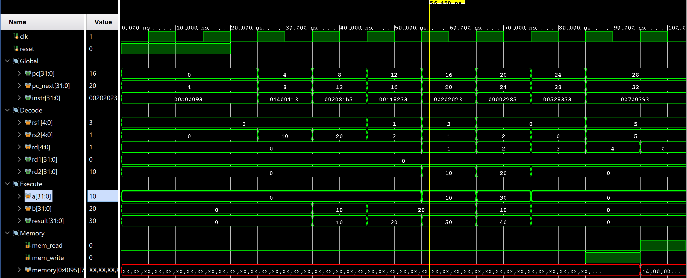
- RAW Hazard

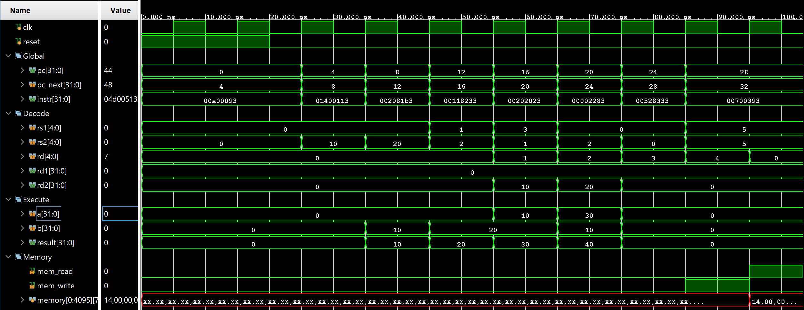

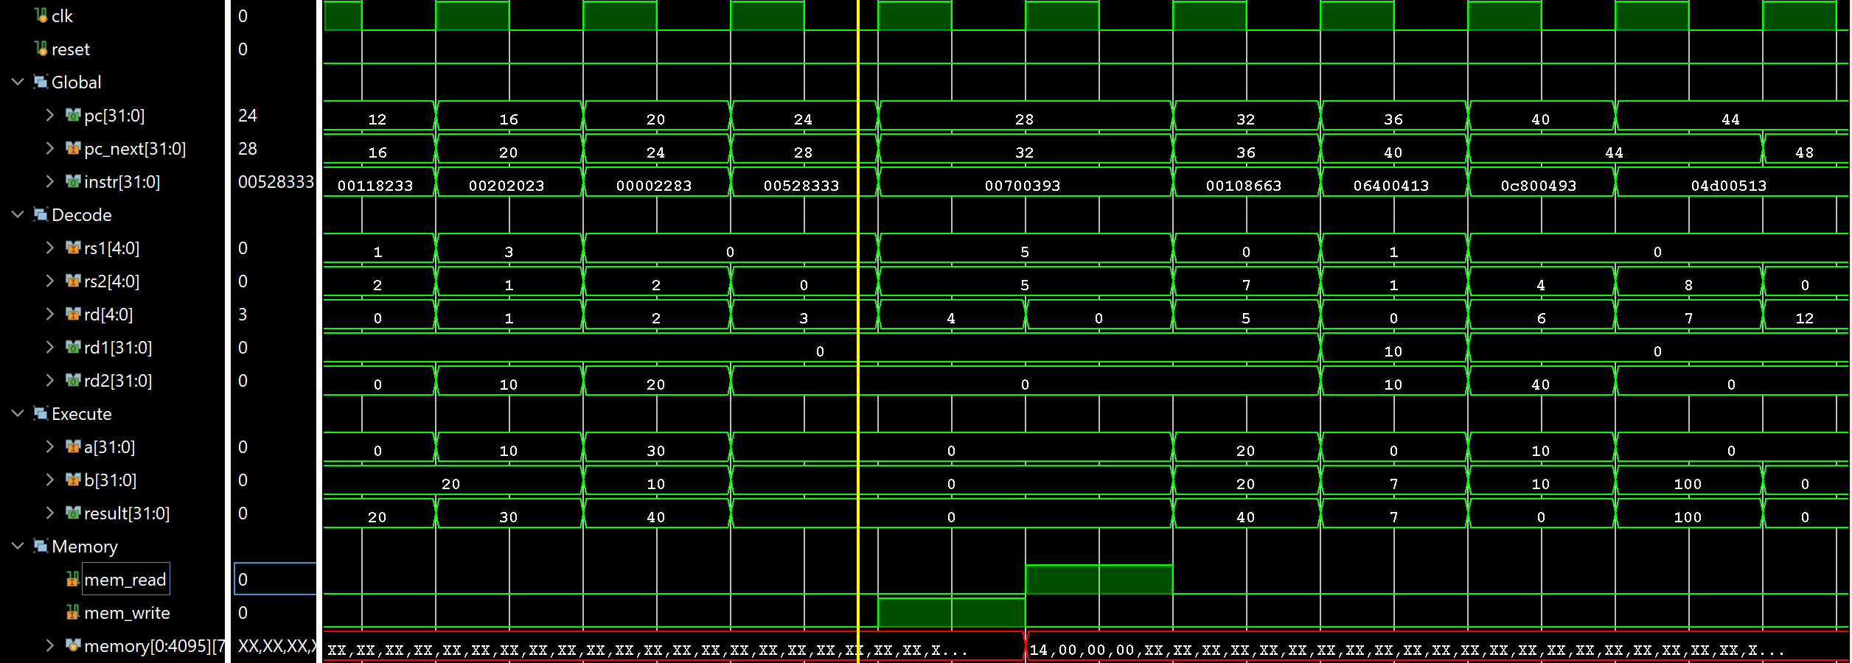
- Load use hazard

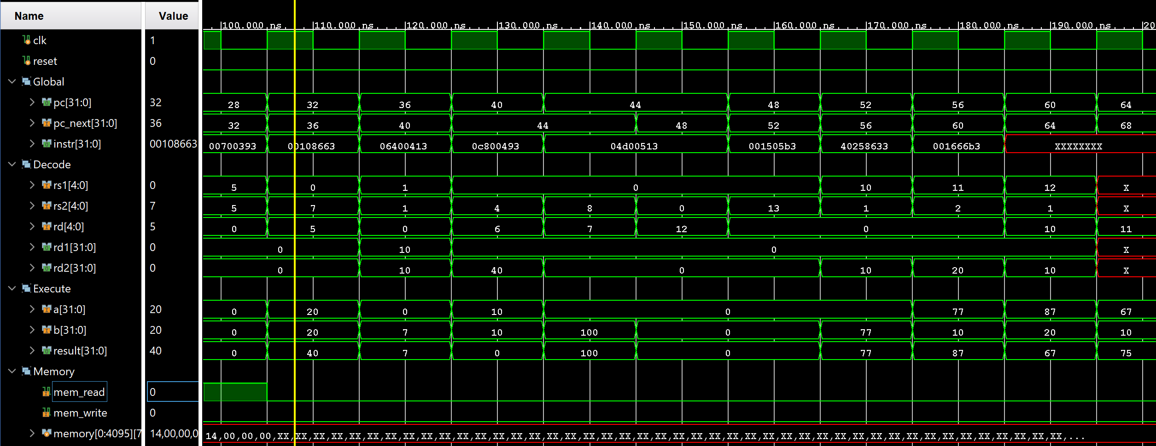
- Control Hazard

