# A Project Report on

**E-LEARNING PLATFORM**

***Submitted in the Partial Fulfilment of the Requirements of the Award of the Degree***

**BACHELOR OF TECHNOLOGY**

**IN**

**COMPUTER SCIENCE AND ENGINEERING**

**Submitted by**

Y. Kavya (21W61A0592)

V. Bhavani Shankar (21W61A0590)

K. Prem Sagar (21W61A0528)

P. Sai Kiran (21W61A0566)

**Under the Esteemed Guidance of**

Ms.P. Harika

Assistant Professor



**Department of Computer Science & Engineering**

**Sri Sivani College of Engineering**

(Approved by AICTE, New Delhi, Affiliated to JNTU-GV, Vizianagaram

CC: W6,‘A’Grade by AP Knowledge Mission, ISO 9001:2015 Certified campus) Chilakapalem Jn,. Etcherla (M) Srikakulam (Dist), A.P, India.

**2021-2025**

**SRI SIVANI COLLEGE OF ENGINEERING**

(Approved by AICTE, New Delhi, Permanently Affiliated to JNTU-GV,

‘A’ Grade by AP Knowledge Mission, ISO 9001:2015 Certified campus)

**DEPARTMENT OF COMPUTER SCIENCE &**

**ENGINEERING**



# Certificate

This is to certify that this project work entitled "**E-LEARNING PLATFORM**" is the bonafide work carried out by **Y. Kavya (21W61A0592), V. Bhavani Shankar (21W61A0590), K. Prem Sagar (21W61A0528), P. Sai Kiran (21W61A0566).** submitted in partial fulfilment of the requirements for the Award of degree of Bachelor of Technology in Computer Science and Engineering, during the year 2021-2025.

**Signature of the guide Head of the Department**

**(Ms. P. Harika) (Mr. Y. Jagadeesh Kumar)**

**Assistant Professor Assistant professor**

## External Examiner

|  |
| --- |
|  |

**Institute Vision**

To be an institute of eminence, to produce highly Skilled, globally competent technocrats.

**Institute Mission**

* Providing high quality, real world, industry relevant, career oriented Professional education to rural students towards their excellence and growth.
* Serving as a center of technical excellence, creating globally competent, human resources with ethical and moral values.

|  |
| --- |
|  |

**DEPARTMENT OF CSE**

**VISION.**

Strive to be a center of eminence for developing holistic computer science professionals.

**MISSION**

M1: To contribute to the advancement of knowledge, in both fundamental and applied Areas of computer Science Engineering.

M2: To promote a sense of excitement among the students in research, design, Development and entrepreneurship.

M3: To nurture communication skills, leadership, ethics and entrepreneurship among Students for their sustained growth.

M4: To forge mutually beneficial relationships with industries and governmental entities to Develop sustainable computing solutions for the benefits of society.

## ACKNOWLEDGEMENT

It is indeed with a great sense of pleasure and immense sense of gratitude that we acknowledge the help of these individuals. We feel elated in manifesting our sense of gratitude to our guide **P. Harika**, Assistant Professor in the Department of Computer Science and Engineering for his valuable guidance. He has been a constant source of inspiration for us and we are very deeply thankful to him for his support and invaluable advice. We would like to thank our Head of the Department **Y. Jagadeesh Kumar**, for his constructive criticism throughout our project. We are highly indebted to Principal **Dr. Y Srinivasa Rao**, for the facilities provided to accomplish this project. We are extremely grateful to our Departmental staff members, lab technicians and non-teaching staff members for their extreme help throughout our project. Finally we express our heartfelt thanks to all of our friends who helped us in successful completion of this project.

### Project Members

Y. Kavya (21W61A0592)

V. Bhavani Shankar(21W61A0590)

K. Prem Sagar (21W61A0528)

P. Sai Kiran (21W61A0566)

## DECLARATION

I do hereby declare that the work embodied in this project report entitled "**E-LEARNING PLATFORM**" is the outcome of genuine research work carried out by me under the direct supervision of **Y. Jagadeesh Kumar** Asst prof, Department of Computer Science Engineering and is submitted by me to Sri Sivani College of Engineering. The work is original and has not been submitted elsewhere for the award of any other degree or diploma.

### Project Members

Y. Kavya (21W61A0592)

V. Bhavani Shankar (21W61A0590)

K. Prem Sagar (21W61A0528)

P. Sai Kiran (21W61A0566)

## ABSTRACT

E-Learning platforms have transformed education to provide a digital environment for education, offering learners flexible and accessible ways to acquire knowledge. These platforms integrate multimedia content, interactive assessments to improve learning outcomes. They support various educational needs, from academic courses to corporate training and skill development. This platform is designed to support students, educators, and professionals. This project helps for B-Tech students using an E-Learning platform, with a particular focus on changes across academic years. This platform contains all the information about the B-Tech student’s education with their respective streams and syllabus. This is the best platform for the students to prepare for the exams. This provides video references for every topic. So, this platform covers their entire classes for their examinations with videos and books references.

**Keywords:** Activity analysis, classification techniques, smartphone data, E-learning platform, learning management system, evaluation approach of the LMSs

|  |  |  |
| --- | --- | --- |
| **FIG NO.** | **FIG NAME** | **PAGE NO.** |
| Fig 4.3 | Agile Model Diagram | 40 |
| Fig 4.4 | E-R Diagram | 41 |
| Fig 5.3 | Use Case Diagram | 49 |
| Fig 5.4 | Class Diagram | 50 |
| Fig 5.5 | Sequence Diagram | 51 |
| Fig 5.6 | Component Diagram | 52 |
| Fig 5.7 | Activity Diagram | 53 |
| Fig 5.8 | State Diagram | 54 |
| Fig 6.1 | Home Landing Page | 65 |
| Fig 6.2 | Authentication Page | 65 |
| Fig 6.3 | Add materials/videos in Admin Panel | 66 |
| Fig 6.4 | Manage Students in Admin Panel | 66 |
| Fig 6.5 | Bookmarks in Student Panel | 67 |

## TABLE OF CONTENT

|  |  |  |
| --- | --- | --- |
| **S.NO** | **CONTENT** | **PAGE NO** |
|  | Certificate | i |
|  | Acknowledgement | iv |
|  | Declaration | v |
|  | Abstract | vi |
|  | **Chapter - 1** |  |
| **1.** | Introduction | 1-7 |
|  | **Chapter - 2** |  |
| **2.** | Literature Survey | 8-13 |
| 2.1 | Introduction | 8 |
| 2.2 | Description | 8-12 |
| 1. | Impact of E-Learning on student performance |  |
| 2. | Approaches in E-Learning |  |
| 3. | E-Learning in organizational settings |  |
| 4. | E-Learning challenges in developing countries |  |
| 5. | Comparative analysis of E-Learning platforms |  |
| 6. | Social implications of E-Learning |  |
| 7. | Case studies and practical implementations |  |
| 2.3 | Strategic importance of E-Learning | 12-13 |
| 2.4 | Conclusion | 13 |
|  | **Chapter-3** |  |
| **3.** | Feasibility study | 14-31 |
|  | **Chapter-4** |  |
| **S.NO** | **CONTENT** | **PAGE NO** |
| **4.** | System analysis | 32-44 |
| 4.1 | Introduction | 32-37 |
| 4.2 | Objectives of input and output design | 37-38 |
| 4.3 | Software development model | 38-40 |
| 4.4 | E-R Diagram | 41 |
| 4.5 | Database design | 42-44 |
|  | **Chapter-5** |  |
| **5** | System design | 45-54 |
| 5.1 | System architecture | 45 |
| 5.2 | UML Diagrams | 46-47 |
| 5.3 | Use-case diagram | 48-49 |
| 5.4 | Class diagram | 49-50 |
| 5.5 | Sequence diagram | 50-51 |
| 5.6 | Component diagram | 52 |
| 5.7 | Activity diagram | 53 |
| 5.8 | State diagram | 54 |
|  | **Chapter-6** |  |
| **6.** | Development & Implementation | 55-67 |
|  | Data set Description | 55 |
|  | Sample code &Interfaces | 56-67 |
|  | **Chapter-7** |  |
| **7.** | Conclusion & References | 68-70 |
|  | POs and PSOs | 71-72 |

**CHAPTER-1**

### INTRODUCTION

E-learning is a fast and efficient way of providing and sharing knowledge with learners in different parts of the world. According to [5, 6], it is defined as the following: “E-learning uses the Internet or other digital content for learning and education activities, that takes full advantage of modern educational technology to provide a new mechanism for communication and a learning environment rich in resources to achieve a new way of learning.”

In the 20th century, there was an international movement in Favor of e-learning integration in higher education. This movement has been operationalized due to the variety of the educational offer by universities, which most have opted to diversify knowledge dissemination means (sounds, images, animations, etc.) to meet the needs of their target public. If access to knowledge was previously conditioned by the physical presence in the classroom, technology enables its learners to exceed this condition of presence and be opened towards other learning modalities today. We can say that e-learning brings solutions within the distance learning framework without pretending to represent the panacea for all pedagogical dysfunctions. Among these solutions, distance learning seems to be the challenge ahead to face the new training requirements in the digital era.

In the case of our study, the e-learning solutions that interest us are free e-learning platforms, because their costs, their states of development, their directions, and used technologies rendered them very close to the axis of this research.

If e-learning has many advantages in training, it cannot be said that its use sometimes poses certain problems.

Among these problems, we can point out the reluctance of teachers towards this new approach to academic and professional training. The change in habits indeed requires time to settle in. Bringing people to adapt to the journeys of change requires taking up this problem of integrating e-learning into training by university teachers.

Furthermore, an Indonesian study aimed to explore the effectiveness of e-learning usage in the classroom teaching process to promote students’ critical thinking ability at the Institute IKIP Mataram. Another work is mainly based on the prototyping of disciplinary information space for a new LMS. This work is first to think about the conditions for creating a real smart LMS between learners and teachers.

Therefore, we conducted a further analytical study on free e-learning platforms. This is based on an approach to assess their quality.

**E-LEARNING**

For several years, information and communication technologies (ICT) have been not only a new tool, a new medium, but also a means of opening up resources from around the world. ICT can be considered the result of the convergence of three technologies: IT, telecommunications, and audiovisual, these three fields are associated with the connected computer. The Internet has made this convergence a reality today.

We are thus faced with a new mode of communication which, by the quantity of information which it makes available and the variety of its sources, poses problems with considerable educational stakes in parallel to the certain advantages which it provides at all levels.

We hear about distance learning, online training, e-learning, distance education. It's a whole multitude of terms with similar apparent meaning, but which refers to different aspects of new educational technology to the fashion, and that should be distinguished.

**DEFINITION**

The most possible and most current distance learning is currently based on the Internet. For this, the term E-learning is increasingly used to include any open and distance learning using information and communication technologies. We adopt this term as moreover in the rest of this book.

E-learning: This means "electronic education"; it is a discipline where teaching theory and computer network technologies are combined to allow learners to complete their courses via a computer network (Internet or Intranet).

Distance learning: A more general concept in the sense that the means used to communicate between learners and trainers are not specified. Traditional correspondence training, communication by telephone, fax, etc. can be part of distance learning. We will note the linguistic nuance between the terms "teaching" and "training", the first evokes a longer duration and the compulsory sanction by a diploma while the second can mean a simple improvement of knowledge as is the case for training staff of companies. We also speak of ODL1 for open and distance learning; the opening is made to a large audience. The most used opening tool today remains the Web.

Tele-education or tele-training: The use of telecommunication means it is more important in this case (telephone, fax, Internet)

E-learning platform: is software that supports the conduct of distance learning. This type of software brings together the tools necessary for the three main users - teacher, student, administrator - of a device, which aims at the remote consultation of educational contents, the individualization of learning, and tele-tutoring. These systems aim to put online comprehensive lessons where the student can prepare his contrives, his license, his baccalaureate via these platforms.

**TYPOLOGIES OF E-LEARNING**

Moving from the implementation of “face-to-face” training to the development of e-learning requires cultural, organizational, and educational changes. The relationships between trainees, content, and trainers are disrupted, making this development delicate.

In fact, according to the needs of each learning situation (target audience, type of training, area of training, etc.), we should end up with multiple systems articulating in varying proportions remote working time, time of self-study work, and face-to-face working times to adapt to the educational process and approach. Several categorizations have been proposed for e-learning systems ranging from the most global to the most detailed. The most general classification offers two categories:

Synchronous systems define a "virtual classroom" where communication between distance learning players is in real-time using sound, video, or chat

Asynchronous systems where the student is not necessarily online with the teacher, he can work in offline mode and communicate at scheduled times or on-demand. The necessary and most used mode of communication in this kind of system is electronic mail.

Training with tutored and synchronized self-learning: This type of training combines remote work at a given time and face-to-face work. The device combines self-learning at a distance (a tool and its concepts for example) with a common "reformulation" and an appropriation in the classroom. Self-learning is based on different activities based on documents of different natures (reading, guided handling, exercises) described in a standardized guide sheet for the whole training, all available for download from the training site. This self-learning takes place over a day identified in the timetable of the trainees containing compulsory contacts with the trainers by sending documents, replies to questionnaires or productions. Trainers and tutors, present remotely, can be reached during this period at any time by various means (telephone, messaging, etc.) to resolve any difficulties.

Training with tutored and desynchronized self-learning: In this type of training is found all the principles of the previous type. The difference lies in the desynchronization of the distance. In this case, the work to be done remotely takes place within a given period with a deadline. Contact with trainers and tutors still exists, but the answers to the questions are not immediate.

Self-training: This device is based on tools integrating the entire learning process, from initiation to assessment without resorting to face-to-face. It is necessarily desynchronized and the use of the tutor is limited since the tool should in principle guide the learner as well as possible.

Cooperative production: The distancing of trainees, if it individualizes their training, isolates them at the same time. However, group work remains a learning de vice, which must continue within the framework of these new methods. The setting up, for example, of cooperative productions by precise specifications, generates a dialogue and a confrontation between the different members of a group thus restoring the interactivity between them. The trainers follow the progress of the work by observing the development of production and reacting to it. All of the players are therefore involved in the work. This modality probably requires the greatest inventiveness on the part of the trainers.

Alternating training tutored the use of remote communication tools to help develop learning by action, at the place of action, and by the specificity of the work-study program. Organized around work to be carried out in establishments, based on theoretical contributions in face-to-face or online and the use of an electronic logbook. Each trainee has a referent trainer-tutor who follows the progress of the work through this logbook and the delivery of the requested productions. The tutor can be asked by the trainee any questions he has about his work.

• Autonomous work: The concept of autonomy naturally exists in the different types of situations listed above. However, it is possible to identify forms of work that do not require the presence of trainees at the training site. For example, the reading, document, and information gathering phases, clearly identified in the training devices and the schedule are not subject to face-to-face. They thus allow trainees to broaden their research possibilities by using personal, local, academic resources, whether documentary, material, or human.

**E-LEARNING PLATFORMS**

The development of an e-learning platform poses the constraints relating to the development of websites but also presents certain specificities coming from its use for learning. The main considerations are:

• **On the technical level**: They relate mainly to computer and communication hardware and software such as the hardware and operating system of platform users and at the server level, multimedia tools, Internet connection (type, speed, etc.), down load, and messaging tools.

**• On the pedagogical level**: They consist of taking into account the distance of the teacher and possibly the pedagogical place on the one hand and the individuality of the training on the other hand, and define the pedagogical contents and the standard courses so that the platform has interest and motivation. It is also within this framework that we define the modules, lessons, and envisaged courses.

**• On the administrative level**: They relate to the management of learners' schooling (registration, transcript of marks, etc.), the management of trainers (recruitment, remuneration, etc.), assignment of learners to groups, assignment of trainers to groups, etc.

• **Modelling Considerations**: This is the engineering of e-learning systems. At this level, models are chosen for the acquisition and representation of knowledge as well as the design of interfaces to facilitate interoperability with other systems related to the platform, the reusability of modules, adapting to changes in the plat form environment.

The structure of an e-learning platform essentially comprises three actors: the learner, the teacher, and the administrator of the platform. The role of a teacher can be subdivided into teacher-designer, teacher-trainer (or teacher-tutor), teacher-corrector, etc. We also find the administrator of educational materials and administrator of schooling as a subdivision for the role of administrator. Each role is assigned specific modules for its management. The main features of a platform are:

• Creation of courses, tests, and standard courses.

• Management of educational documents (indexing, classification, updates, etc.).

• Management of a cooperative workspace between learners and / or teachers.

• Monitoring of the learner's learning and evaluation.

• Management of the learner's education.

• Provision of work tools to the learner (specific editors, download tools, T.P simulation tools, etc.).

• Making available to the various actors of communications tools and the procedures for their management (forums, messaging, chat, videoconferencing, etc.).

There are a large number of distance learning platforms on the international market, around more than 600 including around forty under free licenses. Among the platforms under a free license (or GPL2 license), we can cite Claroline3, Ganesha4, and Moodle5, etc.

There are also proprietary licensed platforms such as E-deco 6, MyTeacher7, Blackboard8 (new name since 2006 of WEBCT, etc.

**ADVANTAGES OF E-LEARNING PLATFORM**

**Flexibility:** Learners can access courses anytime, anywhere, allowing them to learn at their own pace and convenience. This is particularly beneficial for people with busy schedules or those in different time zones.

**Cost-Effective**: E-learning often reduces costs related to travel, textbooks, and in-person classes. Many platforms also offer free or low-cost courses, making education more accessible.

**Wide Range of Courses**: E-learning platforms typically offer a broad variety of courses across different subjects, allowing learners to explore topics of interest that might not be available locally.

**Personalized Learning**: These platforms often use adaptive learning technology to tailor courses to the learner’s level and pace, ensuring they get the most out of the experience.

**Access to Expert Instructors**: Learners can access top-tier instructors and industry experts from around the world, which may not be possible through traditional education systems.

**Instant Feedback and Assessment**: Many platforms provide immediate feedback through quizzes and assignments, helping learners track their progress and understand areas for improvement.

**Interactivity**: Many e-learning platforms include multimedia (videos, quizzes, simulations) and collaborative features (discussion forums, peer interactions) that enhance engagement and learning retention.

**Self-Discipline Development**: E-learning encourages learners to take responsibility for their own learning, helping them develop self-discipline and time-management skills.

**Environmentally Friendly**: As courses are offered online, there's less need for physical materials like paper and textbooks, reducing the carbon footprint of education.

**Scalability**: E-learning platforms can reach a global audience, allowing education to scale across regions and demographics that may not have access to traditional educational institutions.

**OBJECTIVE**

The main objective behind this project is to provide a user-friendly environment to provide knowledge and give everyone a chance to learn, irrespective of where they are, provided they register themselves with the system.

The main features that the system provides can be made use of, once the registered people select their interested subject and take a starter test. This helps to establish an incremental learning process. After taking this, based on their level of competence, they can take available tutorials, take online tests and also discuss an issue/topic by posting messages in the discussion forum. Along with this they can also take real time simulations of the most widely known competitive exams.

Project on E-learning management system is to manage the details of assignment, student, TEACHER, QUIZ, QUESTION. It manages all the information about assignment, CLASS, QUESTION, assignment. The project is totally built at the administrative end and thus only the administrator is guaranteed access. The purpose of the project is to build an application program to reduce the manual work for managing the assignment, student, CLASS, TEACHER, it tracks all the details about the TEACHER, QUIZ, QUESTION.

**CHAPTER – 2**

**LITERATURE SURVEY**

#### 2.1 INTRODUCTION

E-learning platforms have transformed education by leveraging digital technologies to facilitate learning and teaching. This literature review examines various aspects of e-learning platforms, drawing insights from recent research papers and case studies.

**LITERATURE REVIEW ON E-LEARNING PLATFORMS**

E-learning platforms have gained widespread use in recent years, revolutionizing the way education is delivered. The transition to online learning was accelerated by the COVID-19 pandemic, which prompted educational institutions to adapt quickly. This review examines previous research studies and case studies on e-learning platforms, highlighting their impact on students, teachers, and educational outcomes.

**2.2 DESCRIPTION**

**1. E-LEARNING PLATFORM DESIGN AND USABILITY**

A central focus of several studies is the design and usability of e-learning platforms. According to Ally (2004), the design of an e-learning platform should cater to diverse learning styles and provide flexible, interactive, and engaging experiences for users. Usability is often a key determinant of how well an e-learning platform is received. Usability testing and interface design studies highlight the need for user-friendly navigation and integration of multimedia to enhance learning experiences (Nielsen & Tahir, 2012). A study by Sung, Yang, and Hwang (2015) found that platforms with intuitive interfaces led to improved user satisfaction and learning outcomes.

**2. IMPACT OF E-LEARNING ON STUDENT PERFORMANCE**

Several studies have explored the impact of e-learning on student academic performance. Means et al. (2013) conducted a meta-analysis on online learning and concluded that students in online courses performed better, on average, than those in traditional face-to-face courses. However, the effectiveness of e-learning often depends on the platform's structure, content quality, and student engagement. A case study by Bawa (2016) focused on retention rates in online learning environments, highlighting that students who were more engaged in discussions and interacted with instructors had higher success rates.

**3. PEDAGOGICAL APPROACHES IN E-LEARNING**

Research also highlights different pedagogical approaches used in e-learning platforms. Anderson (2008) proposed the Community of Inquiry (Coi) framework, which stresses the importance of social, cognitive, and teaching presence in an online learning environment. Similarly, Garrison et al. (2000) noted that a balanced approach between these three elements is crucial for effective e-learning experiences. Studies have shown that platforms offering collaborative learning tools, such as forums and group projects, promote deeper learning experiences (Garrison & Arbaugh, 2007).

**4. E-LEARNING IN ORGANIZATIONAL SETTINGS**

E-learning platforms are also pivotal in organizational learning. A systematic review by García-Penal and Conde (2021) explored how e-learning capabilities enhance organizational learning processes. The study identified that e-learning facilitates continuous learning, knowledge sharing, and adaptability within organizations. The integration of advanced technologies, such as learning analytics and personalized learning paths, can further augment these benefits.

**5. E-LEARNING CHALLENGES IN DEVELOPING COUNTRIES**

In developing countries, e-learning platforms face unique challenges. A study by Thakker, Parab, and Kaisar (2021) focused on the Indian context, revealing issues such as technical shortcomings, limited access to reliable internet, and a lack of digital literacy among students. The research emphasized the importance of addressing these challenges to improve the e-learning experience and suggested that tailored solutions considering local contexts are essential.

**6. COMPARATIVE ANALYSIS OF E-LEARNING PLATFORMS**

Adeniyi et al. (2024) conducted a comparative review of e-learning platforms in higher education between the USA and Africa. The study highlighted that while the USA has a well-established e-learning infrastructure, African countries face challenges such as accessibility, connectivity issues, and the digital divide. Despite these hurdles, innovative initiatives and partnerships are emerging in Africa to address these constraints, indicating a positive trend toward embracing digital education.

**7. SOCIAL IMPLICATIONS OF E-LEARNING**

The social implications of technology-enhanced education are profound, especially in developing countries. A review by Kadambari et al. (2024) examined how e-learning platforms improve educational access, foster inclusivity, and challenge traditional educational models. The study found that e-learning can democratize education by reaching underrepresented demographics and promoting gender inclusivity. However, challenges such as economic barriers, limited technological literacy, and language constraints persist.

**8.CASE STUDIES AND PRACTICAL IMPLEMENTATIONS**

Practical implementations of e-learning platforms provide valuable insights. For instance, the integration of chatbots in educational settings has shown promise. Harvard's CS50 course utilizes an AI-powered chatbot named CS50 Duck to assist students with coding assignments, enhancing learning efficiency.

| **Literature Reference** | **Focus Area** | **Key Findings from Study** | **Your Workflow Feature** | **Improvement Over Existing Systems** |
| --- | --- | --- | --- | --- |
| **Khaldiet al. (2023)** | Gamification in Higher Ed | Gamification (badges, leaderboards) improves engagement when integrated well | Bookmarking, video view tracking, usage-based analytics | Provides lightweight engagement tools without complexity; analytics for future gamified upgrades |
| **García-Peñalvo & Conde (2021)** | Organizational E-Learning | E-learning enhances continuous learning and adaptability | Regulation/Department-based material delivery; personalized content filters | Personalized academic content delivery system aligned with learner structure |
| **Thakker et al. (2021)** | Challenges in Developing Countries (India) | Infrastructure, internet reliability, and digital literacy limit effectiveness | Offline-possible resource links (YouTube), minimal UI via Bootstrap, admin-controlled access | Focuses on accessibility with minimal server load, supports low-infra hardware environments |
| **Adeniyi et al. (2024)** | USA vs Africa E-Learning | Developed countries have infrastructure; African e-learning faces accessibility issues | Modular, role-based system (Admin vs Student), local XAMPP deployment | Localized deployment; easily scalable for regions with infrastructure limitations |
| **Kadibagil et al. (2024)** | Social Implications of E-Learning | Platforms improve inclusivity, but barriers like tech literacy and language exist | Admin-student control ensures verified access; student-specific material access | Better control on student registration; content relevancy filtered to user's context |
| **Harvard CS50 Chatbot (2024)** | Chatbot in Learning Support | AI chatbot enhances student learning experience | (Planned scope) Modular backend can integrate chatbot in future | Provides clear structure for AI integration later—e.g., assistant for content search |
| **TALIA (Virtual Field Tools)** | Immersive Learning Tools | Tools allow deeper virtual interaction | YouTube video embedding simulates external resource use | Basic immersive element (videos), supports future expansion to interactive tools |

**2.3 STRATEGIC IMPORTANCE OF E-LEARNING**

The concept of the learning organization (Marwick & Watkins, 1993) has grown exponentially with the technological era. McRea, Gay & Bacon (2000) related that today, corporate learning and the corporate learning organization have ascended to a position of strategic prominence in the context of managing and growing the enterprise. Urdang & Wagen (2000) identified the knowledge-based economy, the paradigm shifts in the way education is viewed and delivered, and huge knowledge gaps as significant trends that have given rise to e-learning. In addition, they mention that the second largest sector of the U.S economy is the $772 billion education industry. The increase in complexity and velocity of the work environment brought about by technological changes are also major issues that have fuelled the demand for e-learning. McRea, Gay & Bacon (2000) presented the shift from the industrial to the knowledge era, rapid technological change, the ever-shortening product developmental cycles, lack of skilled personnel, enterprise resource planning, and migration towards a value chain integration and the extended enterprise as being prominent contributors to the e-learning value chain. McRea, Gay and Bacon (2000) also recognized the robust economy and the increasingly competitive global business environment as central to the e-learning movement. Nicoll, Lowy & Kalakoda (1998) related that the competitive environment requires companies to work together to create online networks of customers, suppliers, and value-added processes – that is, an e business community (EBC).

Digital knowledge reduces the time and financial costs of information and coordination. Nicoll, Lowy & Kolkata (1998) added that it is now economically feasible for large and diverse sets of people to have the information they need to make safe decisions in near real time. Thus, companies can increase wealth by adding knowledge value to a product through innovation, enhancement, cost reduction, or customization at each step in its life cycle.

With the strategic importance of e-learning being unsurpassed by the old corporate learning paradigm, the projected benefits are highly attractive. Hall and Karon (2000) capitalized on the accessibility of courses via intranets and internet, training can be self-paced, availability of training at any time and place, training being less expensive, and reduced or eliminated travel time. Urdang & Wagen (2000) added that a higher retention of content through personalized learning is possible because technology-based solutions allow more room for individual differences in learning styles. Furthermore, they highlighted improved collaboration and productivity among students as the online environment offers case studies, story-telling, demonstrations, role-playing, and simulations among other tools. Along this line, Urdang and Wagen also commented that online training is less intimidating than instructor-led courses. Online learning, they say, is risk free environment that supports trying out new things and making mistakes.

**2.4 CONCLUSION**

E-learning platforms have significantly impacted education by offering flexible, accessible, and personalized learning experiences. While benefits are evident, challenges such as technological limitations, digital literacy, and infrastructural constraints need to be addressed. Continued research and tailored solutions are essential to fully harness the potential of e-learning platforms across diverse educational contexts.

**CHAPTER-3**

### FEASIBILITY STUDY

**INTRODUCTION**

A feasibility study for an e-learning platform evaluates the practicality and potential success of developing and launching the platform. The study is critical in identifying challenges and determining whether the project is worth pursuing.

A feasibility study assesses the practicality of launching an e-learning platform by evaluating its technical, financial, market, and operational viability. Below is a structured feasibility study:

**OBJECTIVES**

* To evaluate the feasibility of launching an e-learning platform.
* To assess the technical, economic, and operational viability.
* To identify potential risks and mitigation strategies.

Two types of feasibility are:

* operational feasibility
* technical feasibility
* legal and regulatory feasibility
* timeline feasibility
* economic feasibility

**1.OPERATIONAL FEASIBILITY:**

operational feasibility assesses whether an e-learning platform can be successfully developed, managed, and maintained with available resources, including human, technical, and legal aspects.

**Content Creation**: Determine how educational content will be created, managed, and updated. This could involve partnerships with content creators, educational institutions, or in-house teams.

**Content Delivery**: Plan the method of delivering content (e.g., video lectures, quizzes, discussion forums, etc.) and the associated technologies (e.g., streaming, cloud storage).

**Maintenance and Support**: Consider the ongoing maintenance required to keep the platform running smoothly, including technical support, user feedback handling, updates, and content management.

**Staffing Requirements**: Identify the resources required to operate the platform, such as educators, technical support staff, developers, or content curators.

**2.TECHNICAL FEASIBILITY:**

Technical feasibility assesses whether the required technology, infrastructure, and development resources are available to successfully implement the e-learning platform. This section outlines the platform requirements, technology stack, development challenges, and security considerations.

**Platform Development**: Analyse the technical requirements needed to build the platform. This includes choosing the right programming languages, frameworks, and tools (e.g., LMS (Learning Management System) software, database systems, content delivery technologies, etc.).

**Scalability**: Evaluate whether the platform can handle growth in users, content, and features. Scalability is crucial to accommodate future expansion without compromising performance.

**Integration with Third-Party Services**: Check the possibility of integrating tools such as payment gateways, video conferencing software, or content libraries.

**Mobile and Web Accessibility**: Ensure the platform is responsive and works across various devices (smartphones, tablets, desktops) and operating systems.

**Security**: Assess the security features of the platform, including data protection, secure payments, and user privacy.

### 3.LEGAL AND REGULATORY FEASIBILITY:

* **Licensing and Compliance**: Identify any legal requirements related to online education (e.g., copyright, intellectual property, and data protection laws like GDPR or COPPA).
* **Privacy and Security Regulations**: Ensure the platform complies with all data privacy regulations to protect users' personal information.

**4.TIMELINE FEASIBILITY:**

Timeline Feasibility for an e-learning platform refers to assessing whether the development and launch of the platform can be completed within a reasonable and practical time frame. It involves evaluating the various stages of the project and determining if they can be accomplished on time, given available resources and potential challenges.

**1.PROJECT PHASES & DURATION**:

* **Planning & Research**: Includes market research, gathering user feedback, defining objectives, and developing a project roadmap.
* **Design**: Designing the user interface (UI) and user experience (UX), ensuring accessibility, and creating wireframes and mock-ups.
* **Platform Development**: Developing the platform’s functionality (e.g., course management, content delivery, assessments) and backend (e.g., databases, server integration).
* **Content Creation**: Developing or sourcing educational content, such as videos, quizzes, and interactive materials.
* **Testing & QA**: Ensuring the platform works seamlessly across devices and browsers, checking for bugs, and making necessary improvements.
* **Launch & Marketing**: Preparing for the platform's public release, finalizing marketing strategies, and conducting a soft launch for feedback.

**2.RESOURCE ALLOCATION**:

Estimating how many team members (developers, designers, content creators, testers) are needed at each phase and ensuring their availability.

**3.DEPENDENCIES**:

Recognizing which tasks must be completed before others (e.g., platform design must be finalized before development starts)

**5.ECONOMIC FEASIBILITY:**

An economic feasibility study for a web-based e-learning platform evaluates whether the idea is financially viable and sustainable. It assesses costs, potential revenue, and economic risks to determine if the project is worth pursuing. Below, I’ll break it down and highlight key issues specific to an e-learning platform.

1. **Costs:** Initial investment, ongoing expenses, and resource requirements.

2. **Revenue Potential:** Income streams and market demand.

3. **Return on Investment (ROI):** Whether the platform can generate profit or meet financial goals over time.

4. **Risks:** Economic challenges or uncertainties that could impact success.

**KEY COMPONENTS OF THE STUDY FOR AN E-LEARNING PLATFORM**

**1. DEVELOPMENT COSTS:**

**Website Development:** Hiring developers, designers, and UX experts to build a user-friendly platform.

**Technology Stack:** Servers, cloud hosting (e.g., AWS, Google Cloud), domain registration, and content management systems.

**Content Creation:** Producing or licensing courses (videos, quizzes, interactive tools), which may involve educators, videographers, or subject matter experts.

**2. OPERATIONAL COSTS:**

**Maintenance:** Regular updates, bug fixes, and server upkeep.

**Marketing:** Advertising (e.g., Google Ads, social media campaigns) to attract users.

**Staffing:** Customer support, IT team, and instructors or moderators.

**Bandwidth:** High data usage for video streaming or large user bases.

**3. REVENUE STREAMS:**

**Subscription Model:** Monthly or annual fees for access (e.g., Coursera, Udemy).

**Pay-Per-Course:** One-time purchases for specific courses.

**Freemium Model:** Free basic access with premium upgrades.

**Corporate Partnerships:** Licensing content to businesses for employee training.

**4. MARKET ANALYSIS:**

**Target Audience:** Students, professionals, hobbyists, or specific industries (e.g., tech, healthcare).

**Competition:** Platforms like Khan Academy, LinkedIn Learning, or Skill share—how will you differentiate?

**Demand:** Is there a growing need for online education in your niche (e.g., coding, language learning)?

**5. BREAK-EVEN ANALYSIS:**

Calculate how long it will take to recover costs based on projected user growth and pricing.

**CONCLUSION:**

An e-learning platform is economically feasible if you can:

Keep development and content costs manageable.

Identify a clear, underserved niche with demand.

Build a scalable revenue model that balances affordability and profitability

**SOFTWARE ENVIRONMENT**

Python is a high-level general purpose open-source programming language. It is both object oriented and procedural. Python is an extremely powerful language. This language is very easy to learn and is a good choice for most professional programmers. Python was invented by Guido Van Rossum at CWI in the Netherlands in 1989. It is a binding of C, C++, Java. It also provides a library for GUI.

**1. HUMAN RESOURCE REQUIREMENTS**

A skilled team is essential to develop and operate the e-learning platform.

**1.1 KEY PERSONAL & ROLES**

|  |  |
| --- | --- |
| Role | Responsibilities |
| Software Developers | Develop web and mobile applications |
| UI/UX Designers | Design user-friendly interfaces |
| Content Developers | Create educational materials, videos |
| Customer Support | Handle queries, technical issues, and complaints |
| IT Support & Security | Maintain platform security and troubleshoot issues |

**2. PLATFORM INFRASTRUCTURE & TECHNOLOGY REQUIREMENTS**

To ensure smooth operations, the platform requires reliable technical infrastructure.

**2.1 TECHNICAL SETUP**

|  |  |
| --- | --- |
| Component | Technology Used |
| Frontend Development | Html,Css,Javascript |
| Backend Development | php |
| Database | My Sql |
| Video Hosting ,materials | YouTube integration, google reference |

**2.2 SECURITY & DATA PRIVACY**

* **User Authentication**: Two-factor authentication (2FA) and encrypted passwords.
* **Data Protection**: Compliance with *GDPR* and *CCPA* regulations.
* **Secure Transactions**: SSL encryption for safe payments.

**2.3 SCALABILITY**

* The platform should handle **increasing users** without performance issues.
* Cloud-based architecture ensures **flexibility and growth**.
* AI-driven recommendations for **personalized learning experiences**.

**3. LEGAL & COMPLIANCE REQUIREMENTS**

To operate legally, the platform must comply with various regulations.

**3.1 LICENSING & COPYRIGHT**

* Ensure **original course content** or proper licensing agreements with instructors.
* Protect intellectual property through **trademarking and copyright registration**.

**3.2 DATA PRIVACY LAWS**

* **General Data Protection Regulation (GDPR)**: * Applies to European users.
* **California Consumer Privacy Act (CCPA):** * Protects user data in the U.S.
* **Children’s Online Privacy Protection Act (COPPA):** * Required for platforms targeting students under 13.

**3.3 PAYMENT & TAX REGULATIONS**

* Must comply with **international e-commerce laws** for online transactions.
* Tax considerations for different countries (e.g., VAT, GST).

**4. CONTENT MANAGEMENT & COURSE DELIVERY**

A well-structured content strategy ensures effective learning experiences.

**4.1 COURSE CREATION PROCESS**

* Identify trending and in-demand topics.
* Collaborate with **subject matter experts** to develop high-quality courses.
* Use **multimedia elements** (videos, quizzes, assignments) for engagement.

**4.2 LEARNING MANAGEMENT SYSTEM (LMS) FEATURES**

**video lectures:** deliver video contents

**4.3 INSTRUCTOR & STUDENT MANAGEMENT**

* Provide **training for instructors** on course creation tools.
* Offer **technical support** to students for seamless learning.

**5. CONCLUSION & RECOMMENDATIONS**

* The e-learning platform is operationally feasible with proper infrastructure and management.
* A skilled team, strong security, and legal compliance are critical for smooth operation.
* Scalability and continuous content updates will ensure long-term success.

**PLATFORM REQUIREMENTS**

An e-learning platform requires a robust and scalable architecture to support various functionalities. The key requirements include:

**1.1 USER FEATURES**

* **Student Dashboard:** Course progress tracking, assignments, quizzes.
* **Instructor Dashboard:** Course creation, student analytics, certification issuance.
* **Admin Panel:** User management, course approvals, analytics.
* **Interactive Learning Tools:** Video lectures, live classes, discussion forums.

**1.2 SYSTEM FEATURES**

* **Content Management System (CMS):** Upload, organize, and deliver courses.
* **Learning Management System (LMS):** Course scheduling, grading, and feedback system.
* **Payment Gateway Integration:** PayPal, Stripe, or local payment options.
* **AI-Powered Recommendations:** Personalized learning based on user behaviour.

**2. TECHNOLOGY STACK**

A modern technology stack ensures performance, scalability, and security.

**2.1 FRONTEND DEVELOPMENT (USER INTERFACE)**

**Technologies:**

Html, CSS, JavaScript

**Purpose:**

Provides a responsive and interactive UI for students and instructors.

**2.2 BACKEND DEVELOPMENT (SERVER & LOGIC)**

**Technologies:**

Laravel (PHP)

**Purpose:**

Handles user authentication, database operations, and API communication.

**2.3 DATABASE MANAGEMENT**

**Technologies:**

MySQL

**Purpose:**

Stores user data, course content, progress tracking.

**2.4 CLOUD STORAGE & HOSTING**

**Cloud Providers:**

AWS, Google Cloud, Microsoft Azure

**Purpose:**

Scalable storage for course materials (videos, PDFs, assessments).

**2.5 SECURITY MEASURES**

**Encryption:**

SSL/TLS for secure data transfer

**User Authentication:**

OAuth, JWT for secure logins

**Data Backup:**

Cloud-based automated backup solutions

**6. CONCLUSION**

* The technical feasibility is strong with modern web and cloud technologies.
* Challenges like scalability, security, and performance must be addressed using best practices.
* Investing in AI, automation, and mobile compatibility will improve long-term success.

### SERVER-SIDE WEB DEVELOPMENT

Server-side web development includes the complex backend functions that websites perform to display information to the user. For example, websites must interact with databases, talk to other websites, and protect data when sending it over the network.

Python is useful for writing server-side code because it offers many libraries that consist of prewritten code for complex backend functions. Developers also use a wide range of Python frameworks that provide all the necessary tools to build web applications faster and more easily. For example, developers can create the skeleton web application in seconds because they don’t need to write it from scratch. They can then test it using the framework’s testing tools, without depending on external testing tools

**PHP FEATURES AND CHARACTERISTICS:**

PHP (Hypertext Preprocessor) is a widely-used open-source server-side scripting language primarily designed for web development. It is often used to create dynamic websites and web applications. Here are some of its key features and characteristics:

### 1. SERVER-SIDE SCRIPTING

### PHP is primarily used as a server-side scripting language. It processes code on the server and sends the output (usually HTML) to the client's web browser.

### 2. OPEN SOURCE

### PHP is open-source software, meaning it is free to use, and the source code is available for modification. This encourages a large community of developers to contribute to its improvement.

### 3. CROSS-PLATFORM

### PHP is platform-independent. It runs on various operating systems like Windows, Linux, macOS, etc. It also works with various web servers such as Apache, Nginx, and IIS.

### 4. EMBEDDED INTO HTML

### PHP code can be embedded directly into HTML code, making it easy to use in web pages. This allows developers to create dynamic web pages with embedded PHP code within the HTML structure

### .5. DATABASE SUPPORT

### PHP is well-known for its database connectivity, especially with MySQL, but it also supports many other databases, including PostgreSQL, SQLite, Oracle, and others. This makes PHP a great choice for database-driven websites.

### 6. SUPPORT FOR OBJECT-ORIENTED PROGRAMMING (OOP)

### PHP supports object-oriented programming principles, allowing developers to create classes, objects, inheritance, encapsulation, and polymorphism. This makes PHP more flexible and maintainable for large projects.

### 7. RICH SET OF BUILT-IN FUNCTIONS

### PHP offers a vast number of built-in functions that simplify tasks like string manipulation, date/time handling, file operations, form handling, and more.

### 8. SIMPLE AND EASY TO LEARN

### PHP has a relatively easy learning curve compared to other programming languages. Its syntax is similar to other C-based languages like C, C++, and Java, making it easier for developers familiar with these languages.

### 9. SECURITY FEATURES

### PHP offers various security features like data sanitization, password hashing functions, and various tools for working with SSL and encryption to help developers build secure applications.

### 10. EXTENSIVE DOCUMENTATION

### PHP has excellent documentation available online, which makes it easier for developers to find answers and troubleshoot issues. The PHP manual is comprehensive and contains examples and use cases.

### 11. FRAMEWORKS AND CMS INTEGRATION

### There are many frameworks available for PHP, such as Laravel, Symfony, and CodeIgniter, that make web development faster and more efficient.

### PHP is also commonly used in many popular Content Management Systems (CMS) like WordPress, Joomla, and Drupal.

### 12. ERROR REPORTING

### PHP provides detailed error messages that help developers identify problems quickly, making it easier to debug and fix issues in the code.

### 13. SUPPORTS SESSIONS AND COOKIES

### PHP has built-in support for handling sessions and cookies, which allows developers to maintain user state across multiple pages or visits.

### 14. SPEED AND PERFORMANCE

### PHP has a fast execution time, especially with the advent of newer versions like PHP 7.x and 8.x. The language has been optimized for better performance, particularly in terms of memory usage and speed.

### 15. INTEGRATION WITH HTML, CSS, AND JAVASCRIPT

### PHP works well with other web technologies such as HTML, CSS, and JavaScript. It can output HTML dynamically and interact with JavaScript in web applications.

### 16. ERROR HANDLING AND LOGGING

### PHP provides mechanisms for catching and handling errors, which allows for more robust applications. Developers can log errors or display them based on the environment (development vs. production).

### 17. COMMUNITY SUPPORT

### Since PHP is one of the most widely used programming languages, it enjoys strong community support, with many tutorials, forums, and resources available online.

### 18. COMPATIBILITY WITH CONTENT MANAGEMENT SYSTEMS (CMS)

### PHP is the backbone of many popular content management systems (CMS) like WordPress, Joomla, and Drupal. These CMS platforms make building and managing websites easier without needing much coding knowledge.

### 19. ASYNCHRONOUS PROGRAMMING (IN RECENT VERSIONS)

### With improvements in PHP 7.x and 8.x, the language has started to support asynchronous programming, making it more capable of handling I/O operations efficiently, which is important for real-time applications.

### 20. REGULAR EXPRESSIONS SUPPORT

### PHP has built-in support for regular expressions, which are useful for string matching and manipulation tasks. 21. PHP CLI (COMMAND LINE INTERFACE)

* PHP can be used from the command line for executing scripts, running cron jobs, and managing background tasks.

**WHY CHOOSE PHP**

Choosing PHP for web development comes with several advantages that make it a popular

choice for both beginners and experienced developers. Here’s a concise breakdown of why

you might choose PHP:

**THE PHP STANDARD LIBRARY**

PHP's **Standard Library (SPL)** is a set of built-in functions and classes that cover various common tasks and functionalities in web development, which eliminates the need for third-party libraries. It’s built into PHP, so developers don't need to install anything externally, and can directly access its functionalities right after setting up a PHP environment. These libraries are designed to make tasks more efficient, consistent, and secure.

### ADVANTAGES OF PHP STANDARD LIBRARIES (SPL)

1. **Consistency**: SPL functions and classes offer a consistent approach to common tasks, reducing the need to develop custom solutions or rely on third-party packages.
2. **Performance**: Many SPL classes and functions are optimized for performance, ensuring that operations on data structures, strings, arrays, and files are efficient.
3. **Security**: Built-in functions like password_hash() and filter_var() provide important security measures out of the box, reducing the chances of common vulnerabilities.
4. **Portability**: SPL is supported across multiple platforms and environments, ensuring that PHP code remains portable and can run on various servers without requiring additional setup.
5. **Ease of Use**: The inclusion of simple, intuitive functions helps developers solve problems without having to write complex code, speeding up the development process.

**THE PHP ISSUE TRACKER**

The **PHP Issue Tracker** (also known as **PHP Bug Tracker**) is an essential tool for developers who want to report bugs, request new features, or submit issues related to the PHP language. It is also used for tracking documentation issues, patching PHP itself, and other related concerns. If you encounter bugs, whether related to PHP’s core functionality or documentation, the issue tracker is the platform to report these problems.

### 1. ACCESSING THE PHP ISSUE TRACKER

The PHP Bug Tracker is hosted at<https://bugs.php.net>. It serves as the central repository for bug reports, documentation issues, and other requests related to the PHP language.

* **PHP Issue Tracker**:<https://bugs.php.net>

**2. TYPES OF ISSUES IN THE PHP BUG TRACKER**

The PHP Issue Tracker is divided into categories, allowing you to file reports for different types of issues. The primary categories include:

* **Bug Reports**: For reporting errors or unexpected behaviours in PHP’s core code or extensions.
* **Documentation Problems**: For issues with the official PHP documentation (missing information, inaccuracies, etc.).
* **Feature Requests**: For suggesting new features or changes to PHP's functionality.
* **Security Issues**: For reporting security vulnerabilities in PHP.
* **Performance Issues**: For bugs related to performance degradation in specific versions or scenarios.

For **documentation bugs**, select the "Documentation problem" category when submitting your report.

### 3. CREATING AN ACCOUNT

To use the PHP Issue Tracker, you must create an account:

* **Go to the PHP Issue Tracker’s Registration Page**: [Create an Account](https://bugs.php.net/user-create-page.php)
* **Fill out the registration form**: Provide a username, email address, and other details.
* **Confirm your email**: After registration, you will receive a confirmation email to activate your account.  
  **Login**: Once activated, you can log in to the tracker and start reporting issues.

### 4. REPORTING AN ISSUE

Here’s how to report a bug or issue in the PHP Issue Tracker:

#### STEP 1: SEARCH FOR EXISTING REPORTS

Before submitting a new bug report, search the PHP Issue Tracker to check if the issue has already been reported. This helps avoid duplicate submissions.

* **Go to the Search Page**: [Search for Bugs](https://bugs.php.net/search.php)
* **Use Keywords**: Enter keywords related to the issue you encountered (e.g., function name, error message, or PHP version).
* **Review Existing Results**: Check if your issue is already listed. If you find an identical report, you can add additional comments or details to that existing issue instead of creating a new one.

#### STEP 2: SUBMIT A NEW BUG REPORT

If your issue is unique, follow these steps to submit a new report:

* **Log in**: Make sure you’re logged into your account on the PHP Issue Tracker.
* **Go to the "Report a Bug" Page**:
  + You can find the link to "Report a Bug" at the top of the issue tracker homepage.
* **Choose the Bug Category**:
  + Select the **Category** of the bug from the dropdown menu. For documentation-related bugs, choose **Documentation problem**.
  + Other categories include "Feature request", "Security", "Performance issue", etc.
* **Fill in the Bug Report Form**:
  + **Summary**: Provide a concise title for the issue (e.g., "Incorrect return type for str_replace() function in PHP documentation").
  + **Description**: Describe the issue in detail. Include the following:
    - The exact PHP version you are using.
    - The page or function in the documentation where you found the issue.
    - A clear explanation of the problem, such as missing or inaccurate details, wrong examples, or outdated information.
    - Expected behaviour or how the documentation should be improved or corrected.
    - Any relevant code or observations (if applicable).
  + **PHP Version**: Select the PHP version where the issue occurs (e.g., PHP 7.4, PHP 8.0).
  + **Operating System**: Optionally, specify the operating system you’re using (e.g., Windows, macOS, Linux).
* **Submit the Report**: After filling out the report, click **"Submit Bug"** to submit your issue.

### 5. AFTER REPORTING THE ISSUE

Once you submit a bug report, it will be reviewed by the PHP development team or community members. Here’s what you can expect:

#### A. CONFIRMATION AND UPDATES

* After submission, you will receive an email confirmation acknowledging that your bug has been reported.
* The issue will be assigned to a developer or documentation team member who will investigate and resolve the bug.
* You may receive follow-up emails if the team needs further clarification or more information about the issue.

#### B. BUG RESOLUTION

* If the issue is confirmed and fixed, the PHP team will:
  + - Update the official documentation to reflect the correct information.
    - Update the PHP source code if the bug is code-related.
* The status of the issue will be updated to **"Resolved"**, and the issue will be marked as **closed**.
* If additional information or clarification is needed, you will be asked to provide further details.

**C. TRACKING PROGRESS**

You can track the progress of your issue by logging into the PHP Issue Tracker and checking the status of your reported issue. You will be able to see whether the issue is still open or has been resolved.

**6. CONTRIBUTING TO DOCUMENTATION FIXES (OPTIONAL)**

If you notice an issue with PHP documentation and would like to fix it yourself, you can contribute directly to the PHP documentation repository.

#### STEPS TO CONTRIBUTE TO PHP DOCUMENTATION:

* **Fork the Repository**: PHP’s documentation is open-source and hosted on GitHub. You can fork the official [PHP documentation repository](https://github.com/php/doc-en).
* **Make Changes**: Once you’ve forked the repository, make changes to the documentation file. Documentation files are usually written in **restructured Text (rest)** format.
* **Submit a Pull Request**: After making your changes, submit a pull request (PR) to the official repository. Your changes will be reviewed by the PHP documentation team.
* **Wait for Review and Merge**: Once the PR is approved, your changes will be merged, and the documentation will be updated.

**7. OTHER FEATURES OF THE PHP BUG TRACKER**

* **Status and Severity**: Each issue has a status that indicates its current state (e.g., Open, Resolved, Closed). Issues are also marked with severity levels such as **minor**, **major**, or **critical**.
* **Tags**: Issues can be tagged to help categorize or filter specific topics. Tags help identify specific types of bugs or documentation errors.
* **Votes**: If other users experience the same issue, they can add their vote to the bug, helping prioritize issues that affect many developers.
* **Comments**: You can leave comments on a bug to offer more details, report additional bugs, or offer solutions to the problem.

### 8. BEST PRACTICES FOR REPORTING BUGS

When reporting an issue, follow these best practices to ensure your bug report is clear and helpful:

* **Be Specific**: Provide detailed information about the issue, including PHP version, operating system, and steps to reproduce the issue.
* **Use Clear Language**: Write in clear, concise language so that anyone reviewing your bug report can easily understand the problem.
* **Include Reproducible Code**: If applicable, provide a small code snippet that demonstrates the problem.
* **Provide Expected vs. Actual Behaviour**: Explain what you expected to happen and what actually happened.

**CHAPTER-4**

**SYSTEM ANALYSIS**

### 4.1 INTRODUCTION

### 

System analysis is the process of studying the current system (or proposing a new system) in order to identify its components, functions, and how it works. For an e-learning platform, the goal of system analysis is to understand how the platform should operate, what features it needs, and how users will interact with it. Below is a general system analysis for an e-learning platform.

**1. OBJECTIVES OF THE E-LEARNING PLATFORM**

The main goal of an e-learning platform is to provide an accessible, efficient, and interactive learning environment that supports educational content delivery, student interaction, assessment, and progress tracking.

**KEY OBJECTIVES INCLUDE:**

Providing online courses and content (videos, text.).

Enabling student-teacher interaction (forums, live classes, messaging).

Tracking student progress (reviews, completion rates).

Supporting diverse learning styles (multimedia content, discussion forums).

Supporting scalability (ability to handle a growing number of users and content).

**2. SYSTEM REQUIREMENTS**

**FUNCTIONAL REQUIREMENTS:**

These are the core features that the platform needs to provide:

**USER MANAGEMENT:**

Admin Panel: For managing users (students, instructors, and administrators).

Student Registration/Enrolment: Allow students to sign up and enrol in courses.

Instructor Dashboard: Instructors can create, manage, and track courses.

Profile Management: Users can manage personal details, passwords, and preferences.

**COURSE MANAGEMENT:**

Course Creation: Instructors should be able to create courses with videos, documents.

Course CatLog: A searchable cataLog for students to browse available courses.

Course Progression: Tracking the progression of students through the course.

Content Delivery: Multimedia Content: Support for video lectures, audio files, slideshows, and PDFs.

**NON-FUNCTIONAL REQUIREMENTS:**

These are quality attributes that ensure the platform works efficiently and meets user expectations:

**Scalability**: The platform must be able to handle increasing numbers of users and content.

**Performance**: Fast loading times and smooth user experience

**Security**: Data protection, especially regarding user information, grades, and payment details.

**Usability**: The platform must be easy to use, especially for non-technical users.

**Accessibility**: The system should be accessible to users with disabilities, with support for screen readers, etc.

**3. USER STORIES**

**STUDENT USER STORIES:**

As a student, I want to sign up for the platform so I can access courses.

As a student, I want to browse available courses and enrol in one.

As a student, I want to watch course videos and download supporting materials.

As a student, I want to track my progress in the course.

**ADMIN USER STORIES:**

As an admin, I want to manage user accounts, including students and instructors.

As an admin, I want to create reports about course engagement and student progress.

**4. SYSTEM ARCHITECTURE**

The architecture of the e-learning platform typically follows a client-server model. Here's a breakdown of the components:

**Frontend:** The user interface of the platform that interacts with students, instructors, and admins.

**Web Interface**: HTML, CSS, JavaScript (React, Angular, etc.).

Mobile Interface: Native mobile apps (Android/iOS) for learning on the go.

**Backend**: The server-side that processes requests, stores data, and serves dynamic content.

**Web Server**: A web server (e.g., Apache, Nginx) that handles incoming HTTP requests.

**Database**: A database (e.g., MySQL, PostgreSQL) to store user data, course data, progress, etc.

**Application Server**: The application logic (e.g., PHP, Node.js, Ruby on Rails) that processes business rules and interacts with the database.

**APIs**: RESTful APIs can be used for external integrations (payment gateways, third-party content, etc.).

**Cloud Hosting**: The platform can be hosted on a cloud infrastructure (e.g., AWS, Google Cloud, Microsoft Azure) for scalability and availability.

**Security**: The system must use encryption (SSL/TLS), secure login (OAuth, Two-factor authentication), and data backup mechanisms to ensure privacy and integrity.

**5. DATA FLOW DIAGRAM (DFD)**

A **Data Flow Diagram (DFD)** is a graphical representation used to visualize the flow of data within a system. It helps to show how data moves between processes, data stores, and external entities. A DFD is primarily used to describe the flow of data in an information system and is helpful for understanding system functionality at various levels of abstraction.

Level 0: High-level overview showing user inputs and the system output.

### LEVEL 0 DFD (CONTEXT DIAGRAM)

At **Level 0**, the DFD represents the entire system as a single process, showing how it interacts with external entities. This level provides a high-level overview of the system.

**Level 1: In** **Level 1** we break down the main process (e.g., the **Order Processing System**) into sub-processes, showing a more detailed view of how data flows within the system.

**6. USE CASES**

**STUDENT USE CASE:**

Sign up and log in to the system.

Browse available courses.

Enrol in a course.

Watch videos and participate in discussions.

Track course progress.

**INSTRUCTOR USE CASE:**

Log in to the system.

Create a new course.

Add multimedia content.

**ADMIN USE CASE**:

Monitor user activity.

Manage user accounts.

Generate reports on platform usage and performance.

Maintain course content.

**7. TECHNOLOGY STACK**

Frontend: HTML, CSS, JavaScript

Backend: PHP for server-side logic.

Database: MySQL for data storage.

Communication: WebSocket’s or Firebase for real-time chat/live classes.

| **Category** | **Technology** | **Purpose** |
| --- | --- | --- |
| **Frontend** | HTML5, CSS3 | Structure & Styling |
|  | JavaScript | Dynamic content handling |
|  | Bootstrap | Responsive UI Components |
| **Backend** | PHP | Server-side scripting, authentication, business logic |
| **Database** | MySQL (via XAMPP) | Data storage (Students, Materials, Videos, Analytics, etc.) |
| **Server** | Apache HTTP Server | Web server via XAMPP |
| **Platform** | XAMPP | Local server environment (Apache, MySQL, PHP) |
| **Protocol** | HTTP | Client-server communication |

**8. CHALLENGES AND CONSIDERATIONS**

**Scalability**: The platform needs to efficiently handle a growing number of users, courses, and content.

**Security**: Protecting personal data, grades, and payment details is crucial.

**User Experience**: The platform should be easy to navigate, even for non-technical users.

**Mobile Accessibility**: As many users access platforms from mobile devices, ensure responsive design and mobile apps.

**Content Management**: Organizing and delivering content efficiently while ensuring the system can handle multimedia content.

### 4.2 OBJECTIVES OF INPUT AND OUTPUT DESIGN:

#### 1. INPUT DESIGN OBJECTIVES:

Input design focuses on ensuring that data entry is accurate, efficient, and user-friendly. The key objectives include:

* **User-Friendly Interface**: Designing intuitive and accessible input forms for students, instructors, and administrators.
* **Data Validation and Accuracy**: Implementing validation techniques (e.g., required fields, format checks) to minimize errors in user inputs.
* **Efficiency and Automation**: Reducing manual input through features like dropdowns, auto-fill, and integration with external databases.
* **Security and Authentication**: Ensuring secure login and data submission using authentication measures (e.g., username-password, OTP verification).
* **Device Compatibility**: Supporting multiple devices (desktops, tablets, mobile) for seamless data entry.
* **Accessibility Compliance**: Adhering to accessibility guidelines to accommodate users with disabilities.

#### 2. OUTPUT DESIGN OBJECTIVES:

Output design ensures that information is presented effectively, clearly, and meaningfully. The key objectives include:

* **Readable and Well-Formatted Data**: Presenting information (e.g., grades, course materials, reports) in a structured and visually appealing way.
* **Real-Time Feedback and Notifications**: Providing instant feedback on quizzes, assignments, and system alerts.
* **Customizable Reports**: Allowing users to generate personalized reports based on their requirements (e.g., student progress reports, course analytics).
* **Multiple Output Formats**: Supporting outputs in different formats such as PDFs, Excel files, or interactive dashboards.  
  ss
* **Cross-Platform Compatibility**: Ensuring output can be accessed on various devices and platforms.
* **Secure Information Delivery**: Protecting sensitive information through encryption and role-based access.

These objectives help improve the usability, efficiency, and security of the e-learning platform, ensuring a seamless experience for all users.

**4.3 SOFTWARE DEVELOPMENT MODEL**

**AGILE MODEL**

The Agile Model is chosen for this project due to its iterative, collaborative, and flexible nature, which aligns well with the modular structure and evolving requirements (e.g., animations, analytics). Here’s how Agile works for this workflow:

**WHY AGILE?**

* Iterative Development: The system’s modules (admin: 6, student: 4) can be developed in short sprints, delivering functional increments (e.g., login system, material management) quickly.
* Flexibility: Agile accommodates changes, such as adding animations or refining UI, based on feedback after each sprint.
* Collaboration: Frequent reviews ensure alignment with requirements (e.g., admin’s ability to manage students, student’s restricted material access).
* User-Centric: Agile prioritizes delivering value to users (admins and students) by focusing on usable features early.

**AGILE WORKFLOW FOR THIS PROJECT:**

Agile organizes development into sprints with planning, development, testing, and review phases. Here’s how the workflow maps to Agile:

* + **PRODUCT BACKLOG:**
* Features: Admin login, material/video management, student management, analytics, password reset, student registration/login, material access, bookmarks, logout.
  + - * + Enhancements: Animations, transitions, search functionality.
        + Prioritized based on importance (e.g., authentication first, analytics later).

1. **SPRINT PLANNING:** 
   * + Sprint 1: Admin/student login, session management, basic UI.
     + Sprint 2: Admin Module 1 (view materials/videos), Module 2 (add materials/videos).
     + Sprint 3: Admin Module 3 (add/search/remove students), basic student registration.
     + Sprint 4: Student Module 1 (view materials with search), Module 2 (viewed courses).
     + Sprint 5: Admin Module 4 (analytics), Student Module 3 (bookmarks).
     + Sprint 6: Admin Module 5 (reset requests), Student reset password, Module 4 (logout).
     + Sprint 7: UI enhancements (animations, transitions), testing, and deployment.
2. **SPRINT EXECUTION:** 
   * + Each sprint delivers a working increment (e.g., admin can log in and add materials by Sprint 2).
     + Daily stand-ups (if team-based) track progress, address blockers (e.g., database issues).
     + Developers use HTML/CSS/JS for frontend, PHP/MySQL for backend.
3. **TESTING:** 
   * + Each sprint includes unit testing (e.g., login validation), integration testing (e.g., material upload to database), and user acceptance testing (e.g., admin removes student).
     + Bugs (e.g., broken YouTube embeds) are logged for the next sprint.
4. **REVIEW AND FEEDBACK:**

* End-of-sprint demos show features (e.g., student dashboard with search).
* Feedback (e.g., “add more animations”) is added to the backlog for future sprints.

1. **RETROSPECTIVE:**

* Reflect on what went well (e.g., quick login implementation) and improve (e.g., better error handling).
* Adjust processes for the next sprint.

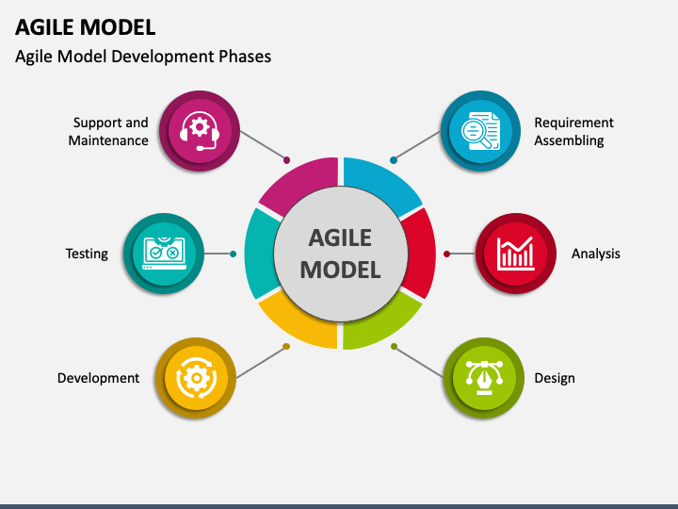

fig 4.3 Agile model diagram

**4.4 E-R (ENTITY RELATIONSHIP) DIAGRAM**

An Entity-Relationship (ER) Diagram is a visual representation of the data structure of a system, showing how entities (tables) relate to each other in a database. It is widely used in database design to plan the structure before implementation. An Entity-Relationship (ER) Diagram in DBMS visually represents the logical structure of a database by showing entities, their attributes, and the relationships between them. It's a graphical tool used for database design, helping to visualize and understand the data relationships in a system.

To describe the E-R diagram for the learning platform in terms of a UML model, we need to translate the Entity-Relationship (E-R) concepts into UML class diagram notation. In UML, entities become classes, attributes are class attributes, and relationships are represented as associations with appropriate multiplicities. Below, I’ll provide a detailed description of the E-R diagram from your learning platform requirements as a UML class diagram, ensuring it captures all entities, attributes, and relationships described previously. This will align with the admin and student functionalities (admin modules 1–6, student modules 1–4, and reset password workflow).

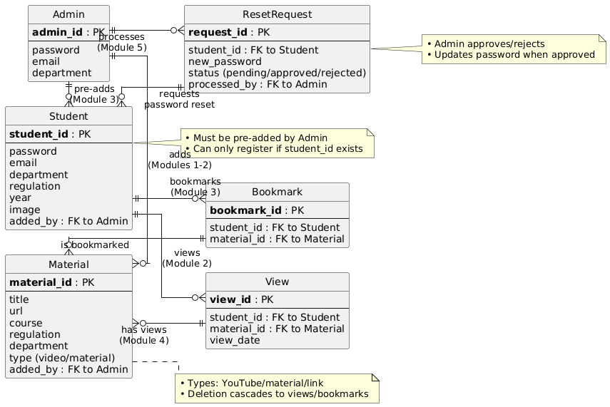

Fig 4.4 E-R Diagram

**4.5 DATABASE DESIGN**

**NORMALIZATION**

Normalization is a database design process that organizes tables to:

* Eliminate redundancy: Avoid storing the same data multiple times.
* Ensure data integrity: Prevent inconsistencies during insertions, updates, or deletions.
* Optimize efficiency: Simplify queries and maintenance.

Normalization is achieved by adhering to a series of normal forms, each with specific rules that build upon the previous form. The primary forms are 1NF, 2NF, 3NF, and BCNF, with higher forms like 4NF and 5NF for specialized cases.

**NORMALIZATION RULES**

1. **FIRST NORMAL FORM (1NF):**

**RULES:**

* All attributes must be **atomic** (indivisible, no multi-valued or composite values).
* No **repeating groups** or arrays in a single column.
* Each table must have a **primary key** to uniquely identify records.

**PURPOSE:** Ensures data is structured for relational operations, eliminating ambiguity.

**HOW IT WORKS AND SATISFIES WORKFLOW:**

**1NF (ATOMIC VALUES, UNIQUE RECORDS):**

**Works:** All tables (admins, students, materials, etc.) use atomic attributes and primary keys (admin id, student id, id). No repeating groups.

**Satisfies:** Ensures unique admins, students, and materials for login, registration, and content management (Admin Modules 1-6, Student Modules 1-4).

1. **SECOND NORMAL FORM (2NF):**

**RULES:**

* Must satisfy 1NF.
* All non-key attributes must be fully functionally dependent on the entire primary key (no partial dependency).
* Applies only to tables with composite primary keys (multiple columns in the key).

**PURPOSE:** Removes partial dependencies to prevent update anomalies in tables with composite keys.

**2NF (NO PARTIAL DEPENDENCIES):**

**Works**: Single-column primary keys (admin id, student id, id) in all tables prevent partial dependencies.

**Satisfies**: Attributes like department, regulation depend fully on primary keys, supporting consistent data for material filtering (Student Module 1) and student management (Admin Module).

1. **THIRD NORMAL FORM (3NF)**:

**RULES**:

* + Must satisfy 2NF.
  + No **transitive dependencies**: Non-key attributes must depend directly on the primary key, not on other non-key attributes.

**PURPOSE**: Eliminates redundancy caused by dependencies between non-key attributes.

**3NF**:

* **Rules Satisfied**: No transitive dependencies (e.g., department does not depend on email). All attributes depend directly on admin id.
* **Workflow Support**: Prevents anomalies when updating admin details, ensuring data integrity for managing materials (Module 1, 2) and students (Module 3).

1. **BOYCE-CODD NORMAL FORM (BCNF)**:

**RULES**:

* + Must satisfy 3NF.
  + For every functional dependency X→Y X \right arrow Y X→Y, X X X must be a **super key** (a key that uniquely identifies a record).

**PURPOSE**: Addresses cases where 3NF allows anomalies due to overlapping candidate keys.

**BCNF**:

* **Rules Satisfied**: id → all attributes, and id is a super key.
* **Workflow Support**: Reliable bookmark management
* **Connection**: Indexes optimize queries, supporting fast searches (Admin Module 3:
* search student) and analytics (Module 4), without affecting normalization.

### CHAPTER-5

### SYSTEM DESIGN

#### 5.1 SYSTEM ARCHITECTURE

**ARCHITECTURE FLOW**

Below architecture diagram represents mainly flow of request from the users to database through servers. In this scenario the overall system is designed in three tiers separately using three layers called presentation layer, business layer, data link layer. This project was developed using 3-tier architecture.

**3-TIER ARCHITECTURE**

The three-tier software architecture (three-layer architecture) emerged in the 1990s to overcome the limitations of the two-tier architecture. The third tier (middle tier server) is between the user interface (client) and the data management (server) components.

This middle tier provides process management where business logic and rules are executed and can accommodate hundreds of users (as compared to only 100 users with the two-tier architecture) by providing functions such as queuing, application execution, and database staging.

The three-tier architecture is used when an effective distributed client/server design is needed that provides (when compared to the two tier) increased performance, flexibility, maintainability, reusability, and scalability, while hiding the complexity of distributed processing from the user. These characteristics have made three-layer architectures a popular choice for Internet applications and net-centric information systems.

**ADVANTAGES OF THREE-TIER:**

* Separates functionality from presentation.
* Clear separation – better

understanding.

* Changes limited to well define components.

### 5.2 UML DIAGRAMS

UML (Unified Modelling Language) is a standard language for specifying, visualizing, constructing, and documenting the artifacts of software systems. UML was created by the Object Management Group (OMG) and UML 1.0 specification draft was proposed to the OMG in January 1997. It was initially started to capture the behaviour of complex software and non-software systems and now it has become an OMG standard. This tutorial gives a complete understanding of UML.

UML is a standard language for specifying, visualizing, constructing, and documenting the artifacts of software systems.

UML was created by the Object Management Group (OMG) and UML 1.0 specification draft was proposed to the OMG in January 1997.

UML (Unified Modelling Language) diagrams are visual representations used in software engineering to design, analyse, and document systems. They help in understanding system components, interactions, and workflows. UML diagrams are categorized into two main types:

### STRUCTURAL & BEHAVIOURAL DIAGRAMS ( ASPECTS )

* **Class Diagram** – Shows system classes, attributes, methods, and relationships.
* **Object Diagram** – Represents instances of classes at a specific moment.
* **Component Diagram** – Illustrates system components and their dependencies.
* **Deployment Diagram** – Shows the physical deployment of software on hardware.
* **Use Case Diagram** – Describes system interactions from a user’s perspective.
* **Sequence Diagram** – Represents the sequence of interactions between objects.
* **Activity Diagram** – Models workflows and business processes.
* **State Diagram** – Depicts an object's states and transitions.

UML diagrams are essential for software development, helping teams communicate ideas, plan architectures, and improve system design.

### COMPONENTS OF THE UML

UML diagrams are the ultimate output of the entire discussion. All the elements, relationships are used to make a complete UML diagram and the diagram represents a system. The visual effect of the UML diagram is the most important part of the entire process. All the other elements are used to make it complete.

UML includes the following nine diagrams, the details of which are described in the subsequent chapters.

Class diagram

Object diagram

Use case diagram

Sequence diagram

Collaboration diagram

Activity diagram

State chart diagram

Deployment diagram

Component diagram

The following are the main components of UML: -

Use-case Diagram

Class Diagram

Sequence Diagram

Component Diagram

Activity Diagram

State Diagram

#### 5.3 USE-CASE DIAGRAM

A use case diagram in the Unified Modelling Language (UML) is a type of behavioural diagram defined by and created from a Use-case analysis. Its purpose is to present a graphical overview of the functionality provided by a system in terms of actors, their goals (represented as use cases), and any dependencies between those use cases. The main purpose of a use case diagram is to show what system functions are performed for which actor. Roles of the actors in the system can be depicted.

The important role of the use Case diagram in the unified modelling language is to gather system requirements and actors. The staff and the students are the two actors in this application and the use case diagram shown explains the different types of roles and how they interact with the system.

**PURPOSE**

* To visualize the system’s functionality from the end-user’s perspective.
* To identify the external and internal actors that interact with the system.
* To outline what the system should do, without detailing how it does it.

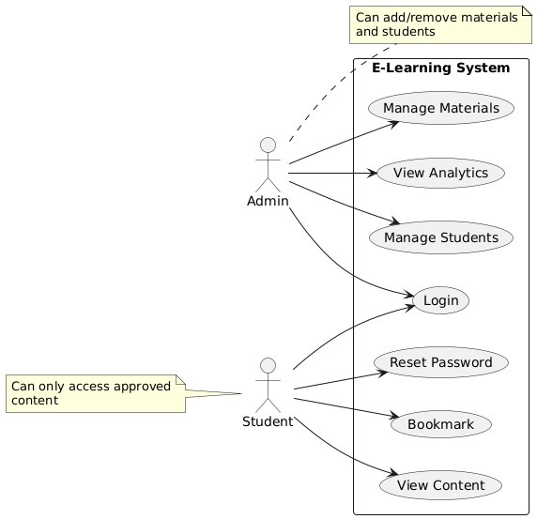

Fig 5.3 Use case diagram for our system

**5.4 CLASS DIAGRAM**

In software engineering, a class diagram in the Unified Modelling Language (UML) is a type of static structure diagram that describes the structure of a system by showing the system's classes, their attributes, operations (or methods), and the relationships among the classes. It explains which class contains information.

Class diagram in the unified modelling language describes the relationship among the objects. In this application there are two main modules that are student module and staff module. The class diagram shown in the figure 3.5 explains the role of staff and the user in this application

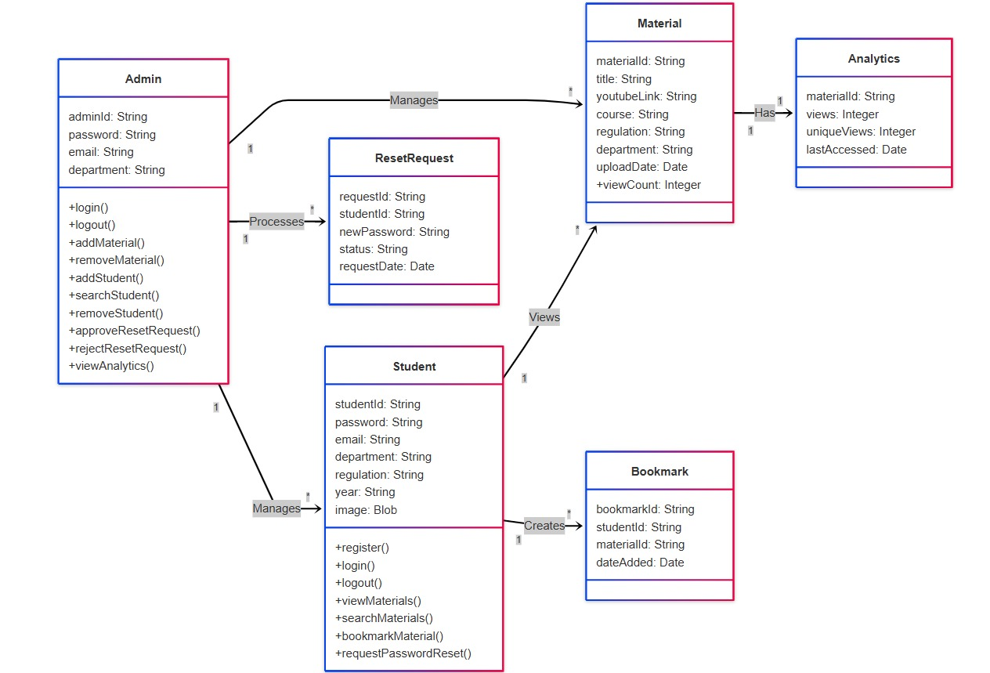

Fig 5.4 Class Diagram for Our System

**5.5 SEQUENCE DIAGRAM**

Sequence diagrams are a popular dynamic modelling solution in UML because they specifically focus on lifelines, or the processes and objects that live simultaneously, and the messages exchanged between them to perform a function before the lifeline ends. Along with

our UML diagramming tool, use this guide to learn everything there is to know about sequence diagrams in UML. A sequence diagram, a type of interaction diagram in the Unified Modeling Language (UML), illustrates the sequence of messages exchanged between objects within a system over time. It's essentially a visual representation of how different objects collaborate to achieve a specific task or use case.

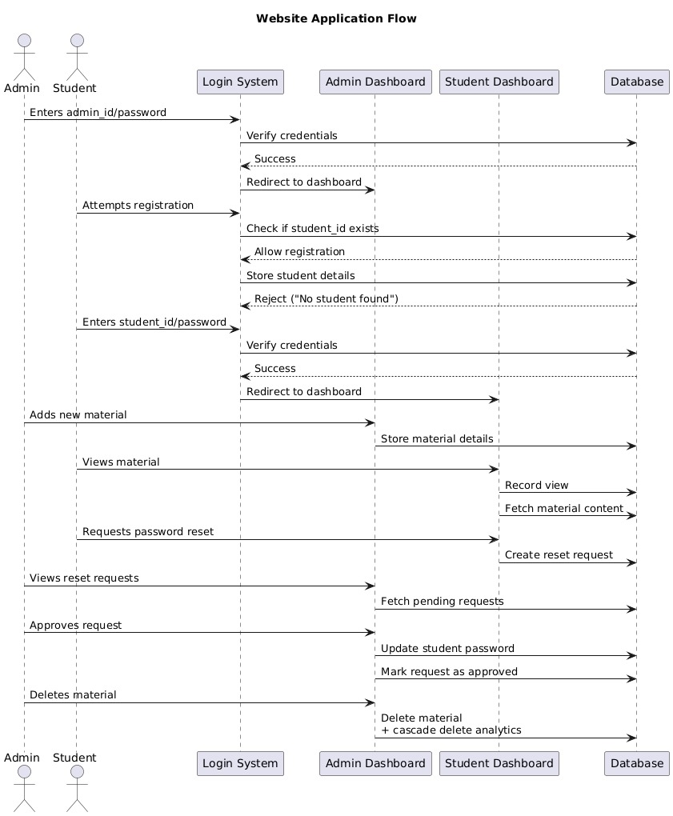. Fig 5.5 Sequence Diagram for Our System

**5.6 COMPONENT DIAGRAM**

A Component Diagram in UML (Unified Modelling Language) is used to represent the high-level structure of a software system. It shows how the system is divided into components and how they are connected to form a working system.

**PURPOSE**

* To model the physical and logical components of a system.
* To show the dependencies and interfaces between components.
* To provide a blueprint for system implementation and deployment.

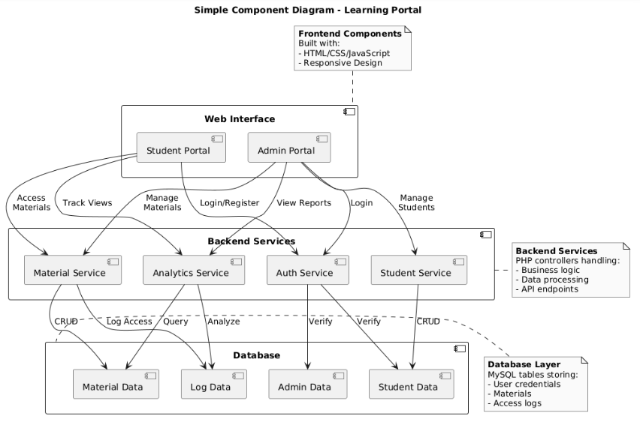

Fig 5.6 Component diagram for our system

**5.7 ACTIVITY DIAGRAM**

Activity diagrams show the workflow from a start point to the finish point detailing the many decision paths that exist in the progression of events contained in the activity.

The activity diagram is a type of flow chart to describe the flow from one activity to another activity. Action, decision node, control flows, start node and end node are the basic components of the activity diagram. Activity diagram describes the steps performed in the unified modelling language use case diagram. The activity diagram shown in the figure 3.8 clarifies complicated use case diagram. The activity diagram is one of the important diagram in the unified modelling language. The workflow between user and the system are illustrated in this activity diagram.

An activity diagram is a type of Unified Modeling Language (UML) diagram that visually represents the flow of activities within a system or process. It depicts the sequence of actions, decisions, and parallel activities involved in achieving a specific goal.

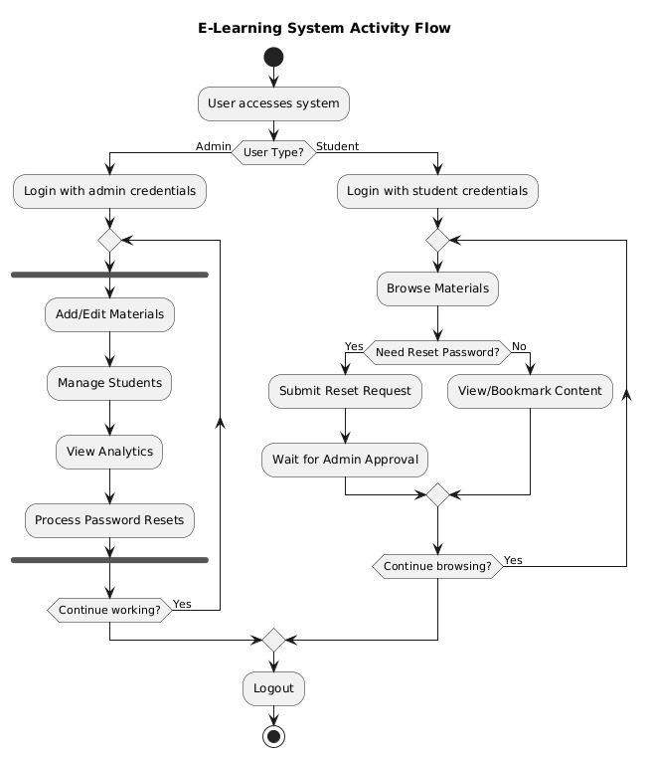.

Fig 5.7 Activity diagram for our system

**5.8 STATE DIAGRAM**

A State Diagram (also known as a State Machine Diagram) in UML (Unified Modelling Language) is used to describe the behaviour of a system or an object in response to external events. It shows how an object transitions from one state to another based on events or conditions.

**PURPOSE**

* To model the dynamic behaviour of an object.
* To show the lifecycle of a class or object, especially when its behaviour depends on its state.
* Commonly used in systems where object states change over time, such as embedded systems, user interfaces, and workflow-based systems.

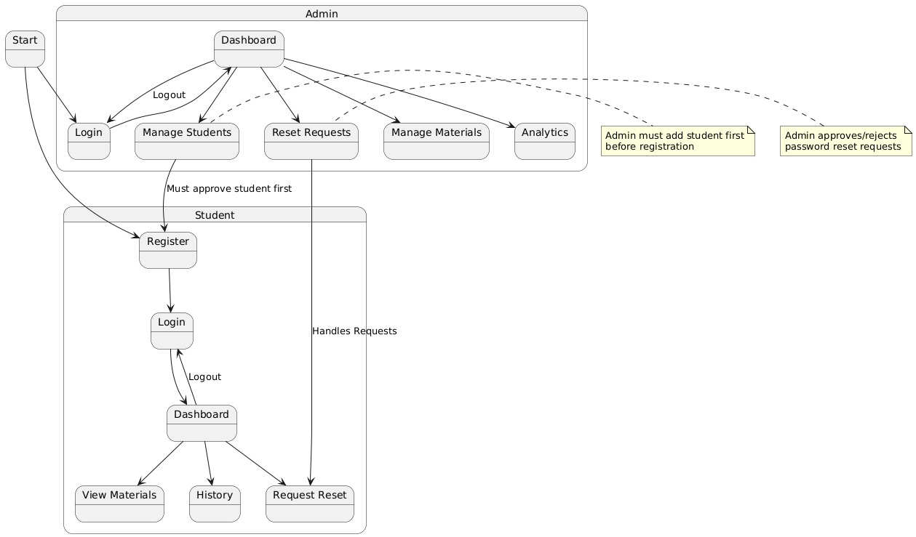

Fig 5.8 State diagram for our system

**CHAPTER-6**

### DEVELOPMENT & IMPLEMENTATION

Development process and documentation are one of the activities in the software development life cycle. Development process includes requirement analysis, design, testing and implementation.

## REQUIREMENT ANALYSIS

The requirement analysis includes input requirements, output requirements and resource requirements that are given as follows

### INPUT REQUIREMENTS

The user needs to register with user id, password, but needed details regulation and department. After registration the user can login with registered username and password.

**OUTPUT REQUIREMENTS**

The output requirements of this project is assignment details, user details manage, after user report a complaint, the admin respond to it and give a solution.

**RESOURCE REQUIREMENTS**

The hardware and software requirements for this system were analysed and the required configuration is as given below. The following are the software requirements for the project.

### ARCHITECTURAL DESIGN

The architectural design explains overall concept of the entire project. The structure of the developed system, the different modules and their externally visible properties and the relationship among them are defined in this.

The architectural design of an e-learning system defines its structure, components, and interactions. A well-designed e-learning system ensures scalability, security, and a seamless user experience. Below is a common **multi-tier architecture** for an e-learning platform.

**IMPLEMENTATION**

**1.SAMPLE CODE**

. <?php

session_start();

if ($_SERVER id'];

    $password = $_POST['password'];

    $role = $_POST['role'];

    $conn = new mysqli("localhost", "root", "", "elearn_db");

    if ($conn->connect_error) die("Connection failed");

    if ($role == "admin") {

        $stmt = $conn->prepare("SELECT * FROM admins WHERE adminid = ? AND password = ?");

        $stmt->bind_param("ss", $id, $password);

        $stmt->execute();

        if ($stmt->get_result()->num_rows > 0) {

            $_SESSION['adminid'] = $id;

            header("Location: admin/dashboard.php");

        } else {

            echo '<div class="alert alert-danger mt-3 mx-4">Invalid admin credentials</div>';

        }

    } else {

        $stmt = $conn->prepare("SELECT * FROM students WHERE studentid = ? AND password = ? AND added_by_admin = TRUE");

        $stmt->bind_param("ss", $id, $password);

        $stmt->execute();

        if ($stmt->get_result()->num_rows > 0) {

            $_SESSION['studentid'] = $id;

            header("Location: student/dashboard.php");

        } else {

            echo '<div class="alert alert-danger mt-3 mx-4">Invalid student credentials or not approved</div>';

        }

    }

    $stmt->close();

    $conn->close();

}

?>

1. **Add material.php**

<?php

session_start();

if (!isset($_SESSION['adminid'])) header("Location: ../index.php");

$conn = new mysqli("localhost", "root", "", "elearn_db");

// Search functionality

$searchTerm = isset($_GET['search']) ? $conn->real_escape_string($_GET['search']) : '';

// Filter by content type if selected

$contentType = isset($_GET['content_type']) ? $_GET['content_type'] : 'all';

$query = "SELECT * FROM materials";

// Add search condition if search term is provided

$searchCondition = "";

if (!empty($searchTerm)) {

    $searchCondition = " WHERE (course LIKE '%$searchTerm%' OR regulation LIKE '%$searchTerm%' OR department LIKE '%$searchTerm%')";

}

if ($contentType == 'videos') {

    $query = "SELECT * FROM materials WHERE type = 'youtube'";

    if (!empty($searchTerm)) {

        $query .= " AND (course LIKE '%$searchTerm%' OR regulation LIKE '%$searchTerm%' OR department LIKE '%$searchTerm%')";

    }

} elseif ($contentType == 'documents') {

    $query = "SELECT * FROM materials WHERE type = 'material'";

    if (!empty($searchTerm)) {

        $query .= " AND (course LIKE '%$searchTerm%' OR regulation LIKE '%$searchTerm%' OR department LIKE '%$searchTerm%')";

    }

} else if (!empty($searchTerm)) {

    $query .= $searchCondition;

}

$result = $conn->query($query);

// Count queries for stats - adjust to respect search terms if present

$videoCountQuery = "SELECT COUNT(*) as count FROM materials WHERE type = 'youtube'";

$documentCountQuery = "SELECT COUNT(*) as count FROM materials WHERE type = 'material'";

if (!empty($searchTerm)) {

    $videoCountQuery .= " AND (course LIKE '%$searchTerm%' OR regulation LIKE '%$searchTerm%' OR department LIKE '%$searchTerm%')";

    $documentCountQuery .= " AND (course LIKE '%$searchTerm%' OR regulation LIKE '%$searchTerm%' OR department LIKE '%$searchTerm%')";

}

$videoCount = $conn->query($videoCountQuery)->fetch_assoc()['count'];

$documentCount = $conn->query($documentCountQuery)->fetch_assoc()['count'];

$totalCount = $videoCount + $documentCount;

?>

1. **Student view Dashboard of materials and videos**

<?php

session_start();

if (!isset($_SESSION['studentid'])) header("Location: ../index.php");

$conn = new mysqli("localhost", "root", "", "elearn_db");

$studentid = $_SESSION['studentid'];

$student = $conn->query("SELECT department, regulation FROM students WHERE studentid = '$studentid'")->fetch_assoc();

// Handle view tracking

if (isset($_GET['view'])) {

$material_id = $_GET['view'];

$conn->query("INSERT INTO views (material_id, studentid) VALUES ($material_id, '$studentid')");

}

// Handle file download

if (isset($_GET['download'])) {

$material_id = (int)$_GET['download'];

$file_query = $conn->query("SELECT file_path FROM materials WHERE id = $material_id");

if ($file_query->num_rows > 0) {

$file = $file_query->fetch_assoc();

$file_path = $file['file_path'];

// Track the view

$conn->query("INSERT INTO views (material_id, studentid) VALUES ($material_id, '$studentid')");

// Process the download

if (file_exists($file_path)) {

// Get file info

$file_name = basename($file_path);

$file_size = filesize($file_path);

$file_type = mime_content_type($file_path);

// Set headers for download

header("Content-Type: $file_type");

header("Content-Disposition: attachment; filename=\"$file_name\"");

header("Content-Length: $file_size");

header("Cache-Control: no-cache, must-revalidate");

header("Pragma: no-cache");

header("Expires: 0");

// Output file content

readfile($file_path);

exit;

}

}

}

// Handle bookmarking

if (isset($_GET['bookmark'])) {

$material_id = $_GET['bookmark'];

$conn->query("INSERT INTO bookmarks (studentid, material_id) VALUES ('$studentid', $material_id)");

}

// Build the base query

$baseQuery = "SELECT * FROM materials WHERE department = '{$student['department']}' AND regulation = '{$student['regulation']}'";

// Add search condition if provided

$searchCondition = "";

if (isset($_GET['search']) && !empty($_GET['search'])) {

$search = $conn->real_escape_string($_GET['search']);

$searchCondition = " AND course LIKE '%$search%'";

}

// Filter by content type if selected

$contentType = isset($_GET['content_type']) ? $_GET['content_type'] : 'all';

$typeCondition = "";

if ($contentType == 'videos') {

$typeCondition = " AND type = 'youtube'";

} elseif ($contentType == 'documents') {

$typeCondition = " AND type = 'material'";

}

// Complete query

$query = $baseQuery . $searchCondition . $typeCondition;

$result = $conn->query($query);

// Separate queries for stats

$videoCount = $conn->query($baseQuery . " AND type = 'youtube'" . $searchCondition)->num_rows;

$documentCount = $conn->query($baseQuery . " AND type = 'material'" . $searchCondition)->num_rows;

$totalCount = $videoCount + $documentCount;

?>

1. **Logout.php for both admin and student**

<?php

session_start();

session_destroy();

header("Location: ../index.php");

exit();

?

**BACKEND CODE:**

CREATE TABLE admins (

adminid varchar(50) NOT NULL PRIMARY KEY,

password varchar(255) NOT NULL,

department varchar(100) DEFAULT NULL,

email varchar(100) DEFAULT NULL UNIQUE

);

CREATE TABLE students (

studentid varchar(50) NOT NULL PRIMARY KEY,

email varchar(100) DEFAULT NULL UNIQUE,

password varchar(255) DEFAULT NULL,

department varchar(100) DEFAULT NULL,

regulation varchar(50) DEFAULT NULL,

year int(11) DEFAULT NULL,

image varchar(255) DEFAULT NULL,

added_by_admin tinyint(1) DEFAULT 0

);

CREATE TABLE materials (

id int(11) NOT NULL AUTO_INCREMENT PRIMARY KEY,

course varchar(100) NOT NULL,

regulation varchar(50) NOT NULL,

department varchar(100) NOT NULL,

type enum('material','youtube','link') NOT NULL,

link varchar(255) DEFAULT NULL,

file_path varchar(255) DEFAULT NULL,

created_at timestamp NOT NULL DEFAULT current_timestamp()

);

CREATE TABLE reset_requests (

requestid int(11) NOT NULL AUTO_INCREMENT PRIMARY KEY,

studentid varchar(50) DEFAULT NULL,

new_password varchar(255) DEFAULT NULL,

status enum('pending','approved','rejected') DEFAULT 'pending',

FOREIGN KEY (studentid) REFERENCES students (studentid)

);

CREATE TABLE views (

id int(11) NOT NULL AUTO_INCREMENT PRIMARY KEY,

material_id int(11) DEFAULT NULL,

studentid varchar(50) DEFAULT NULL,

view_date timestamp NOT NULL DEFAULT current_timestamp(),

FOREIGN KEY (material_id) REFERENCES materials (id) ON DELETE CASCADE,

FOREIGN KEY (studentid) REFERENCES students (studentid)

);

CREATE TABLE bookmarks (

id int(11) NOT NULL AUTO_INCREMENT PRIMARY KEY,

studentid varchar(50) DEFAULT NULL,

material_id int(11) DEFAULT NULL,

FOREIGN KEY (studentid) REFERENCES students (studentid),

FOREIGN KEY (material_id) REFERENCES materials (id) ON DELETE CASCADE

);

**INTRFEACE:**



Fig 6.1Home landing page

From above fig 6.1 Home landing page interface diagram of our project. This landing page will open starting page of our website. This page mainly contain login and register blocks. And then student and admin can login and register their accounts using these landing page.

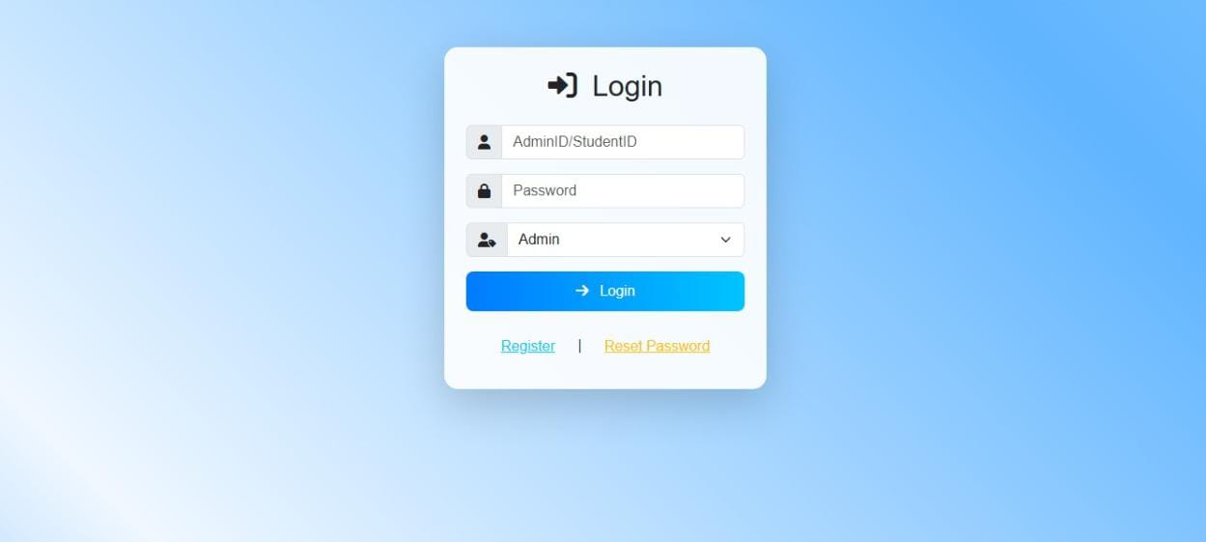

Fig 6.2 Authentication page

From above fig 6.2 is either student or admin login and registration page interface. This page will open from home landing page. using this page, student can register their accounts then if admin will approve student registration. And then student gets login in our website.

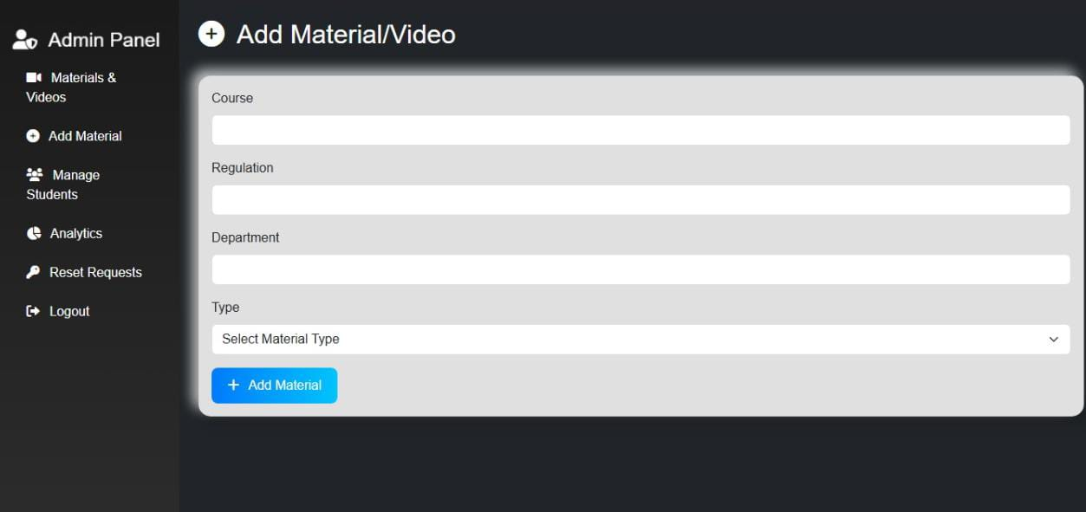

Fig 6.3 Add materials in admin panel

From above fig 6.3 is the add material /video interface page in admin panel. In this interface will open once admin can login of our website and goes to add material block interface, then it will open this interface. In this interface, admin can add a material / video from browsers.

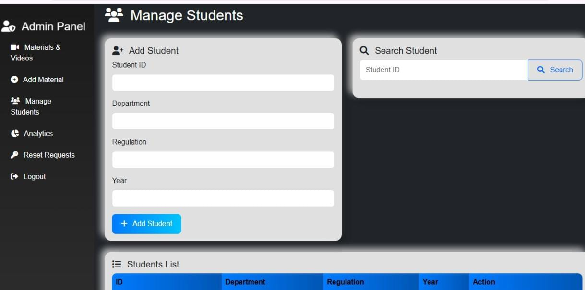

Fig 6.4 Manage students in admin panel

From above fig 6.4 is to manage students in admin panel. In this interface of admin panel, admin can manage student in our website. Admin can add any student using their Id’s and if admin can check the student using id, then it will display all the information about that student.

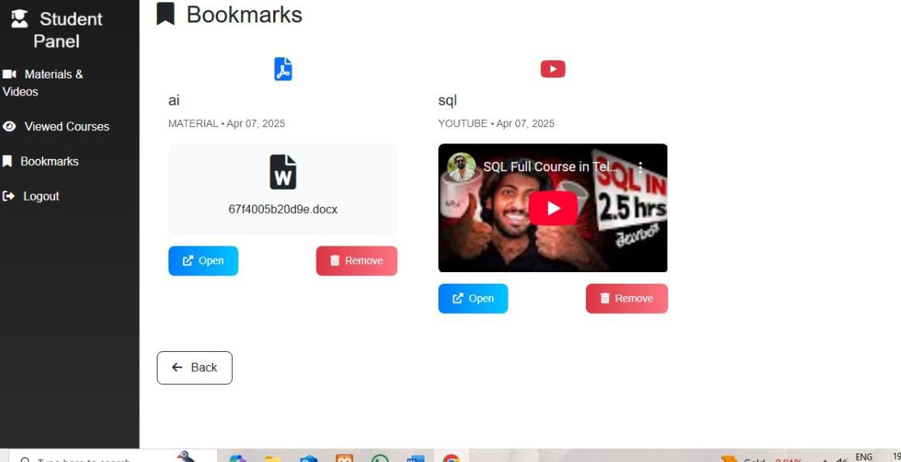

Fig 6.5 Bookmarks in student panel

From above fig 6.7 is displays bookmarks in student panel. In this interface, if any student can bookmark of any video or any material, then it saved to in their student accounts bookmarks block. then student can view these bookmarked videos or materials in anytime.

**CHAPTER -7**

**CONCLUSION & REFERENCES**

**CONCLUSION**

The E-Learning platform provides a secure and organized environment for managing and delivering educational content. It ensures that only authorized students can access learning materials based on their department and regulation, while giving the admin full control over content, student access, and analytics. With features like material management, student registration, password reset approval, view tracking, and bookmarks, the system supports efficient learning and administration. This platform enhances learning accessibility, ensures accountability, and simplifies content management for educational institutions.

* This application is designed to provide a structured and secure educational content platform, where:
* The admin has complete control over content, student management, and system operations including password resets and analytics.
* The student can access relevant materials/videos tailored to their department and regulation and interact with them via views and bookmarks.
* Security is ensured by the admin-controlled registration, where only pre-approved students can register.
* The analytics system ensures admins can track content usage.
* The reset request approval flow ensures password updates are verified, preventing unauthorized changes.
* This approach ensures content integrity, user access control, and easy scalability for educational institutions looking to manage learning resources efficiently.

This workflow creates a comprehensive learning management system with robust administrative controls and student-focused features. The system ensures:

* Controlled Access: Students can only register after admin approval, maintaining system integrity
* Content Organization: Materials are properly categorized by course, department, and regulation
* Usage Tracking: Detailed analytics help understand content engagement
* Security: Proper password reset protocols and session management
* Personalization: Students see only relevant content and can bookmark favourites

The separation of admin and student modules with appropriate permissions creates a secure, efficient platform for educational content delivery and management. The analytics component provides valuable insights for content optimization, while the approval-based registration and password reset systems maintain security standards.

**REFERENCES**

[1] Alhazzani, N. (2022). The Impact of Gamification on Student Engagement and Academic Performance in E-Learning Environments: Evidence from Saudi Higher Education. Education and Information Technologies, 27(4), 5123–5144. <https://doi.org/10.1007/s10639-021-108457>

[2] Wang, Y., & Tahir, R. (2020). E-Learning as a Strategic Tool for Organizational Training and Development: A Case Study Approach. Journal of Workplace Learning, 32(6), 429–445. <https://doi.org/10.1108/JWL-02-2020-0023>

[3] Bhaumik, R., & Priya, S. (2022). Bridging the Digital Divide: E-Learning Challenges and Opportunities in Rural India. International Journal of Educational Development, 89, 102543. <https://doi.org/10.1016/j.ijedudev.2021.102543>

[4] Osei, H. V., Kwateng, K. O., & Boateng, R. (2023). Digital Transformation in African Higher Education: A Comparative Study of E-Learning Adoption. Computers & Education, 194, 104701. <https://doi.org/10.1016/j.compedu.2022.104701>

[5] Rahman, M. M., & Pandita, D. (2023). E-Learning and Social Equity: Exploring Access and Inclusion in South Asian Education Systems. Asian Journal of Distance Education, 18(1), 45–62. <https://doi.org/10.5281/zenodo.7854321>

[6] Mayer, R. E., & Fiorella, L. (2021). Enhancing E-Learning with Interactive Multimedia: A Case Study of Online Course Design. Journal of Educational Psychology, 113(7), 1354–1368. <https://doi.org/10.1037/edu0000662>

[7] Siemens, G., & Baker, R. S. (2022). Learning Analytics in E-Learning Platforms: Opportunities and Challenges for Personalized Education. British Journal of Educational Technology, 53(5), 1089–1106. <https://doi.org/10.1111/bjet.13245>

[8] Dicheva, D., & Dichev, C. (2023). Gamifying Online Education: A Longitudinal Study on Engagement and Retention in STEM Courses. Journal of Computer Assisted Learning, 39(2), 456–472. <https://doi.org/10.1111/jcal.12789>

[9] Jayalath, J., & Esichaikul, V. (2022). E-Learning for Organizational Resilience: A Multi-Country Study on Corporate Training Platforms. Corporate Governance and Organizational Behavior Review, 6(4), 112–125. <https://doi.org/10.22495/cgobr_v6_i4_p10>

[10] Zhang, L., & Yu, S. (2023). E-Learning Ecosystems in Higher Education: A Comparative Study of China and Southeast Asia. Asia Pacific Education Review, 24(3), 389–404. <https://doi.org/10.1007/s12564-022-09812-5>

[11] Fatima, N., & Ahmad, M. (2023). E-Learning for Inclusive Education: Addressing Gender and Socioeconomic Barriers in Pakistan. International Journal of Inclusive Education, 27(6), 712–729. <https://doi.org/10.1080/13603116.2021.1985432>

[12] Hodges, C. B., & Kirschner, P. A. (2024). Adaptive E-Learning Systems: Leveraging AI for Personalized Learning Experiences. Educational Technology Research and Development, 72(1), 245–263. <https://doi.org/10.1007/s11423-023-10312-8>

[13] Mwale, C., & Dlamini, N. (2023). Mobile Learning in Southern Africa: Opportunities and Constraints for E-Learning Scalability. Journal of Open, Flexible and Distance Learning, 27(2), 34–50. https://doi.org/10.61468/jofdl.v27i2.534

**SRI SIVANI COLLEGE OF ENGINEERING**

**(affiliated to JNTU-GURAJADA VIZIANAGARAM)**

**DEPARTMENT OF COMPUTER SCIENCE AND ENGINEERING**

|  |
| --- |
|  |

Program outcomes attained after completion of the project work with attainment levels

|  |  |  |  |
| --- | --- | --- | --- |
| **Program Outcomes(POs) and Program Specific Outcomes(PSOs)** | Attainment level | | |
| 1 | 2 | 3 |
| **PO 1.Engineering knowledge**: Apply the knowledge of mathematics, science, engineering fundamentals, and an engineering specialization to the solution of complex engineering problems. |  |  |  |
| **PO 2. Problem analysis**: Identify, formulate, research literature, and analyze complex engineering problems reaching substantiated conclusions using first principles of mathematics, natural sciences, and engineering sciences. |  |  |  |
| **PO 3.Design/development of solutions**:Design solutions for complex engineering problems and design system components or processes that meet the specified needs with appropriate consideration for the public health and safety, and the cultural, societal, and environmental considerations. |  |  |  |
| **PO 4.Conduct investigations of complex problems**: Use research-based knowledge and research methods including design of experiments, analysis and interpretation of data, and synthesis of the information to provide valid. conclusions. |  |  |  |
| **PO 5. Modern tool usage**: Create, select, and apply appropriate techniques, resources, and modern engineering and IT tools including prediction and modeling to complex engineering activities with an understanding of the limitations. |  |  |  |
| **PO 6. The engineer and society**: Apply reasoning informed by the contextual knowledge to assess societal, health, safety, legal and cultural issues and the consequent responsibilities relevant to the professional engineering practice |  |  |  |
| **PO 7. Environment and sustainability**: Understand the impact of the professional engineering solutions in societal and environmental contexts, and demonstrate the knowledge of, and need for sustainable development |  |  |  |
| **PO 8. Ethics**: Apply ethical principles and commit to professional ethics andresponsibilities and norms of the engineering practice |  |  |  |
| **PO 9. Individual and team work**: Function effectively as an individual, and as amember or leader in diverse teams, and in multidisciplinary settings |  |  |  |
| **PO10.Communication**: Communicate effectively on complex engineering activities with the engineering community and with society at large, such as, being able to comprehend and write effective reports and design documentation, make effective presentations, and give and receive clear instructions. |  |  |  |
| **PO11.Project management and finance**: Demonstrate knowledge and understanding of the engineering and management principles and apply these to one's own work, as a member and leader in a team, to manageprojects and in multidisciplinary environments. |  |  |  |
| **PO12.Life - long learning**: Recognize the need for, and have the preparation and ability to engage in independent and life-long learning in the broadest context of technologicalchange |  |  |  |

73