REPORT – INTEGRATION OF DJANGO WITH

AN API AND DATABASE

Setting up development environment

* Installing all the python dependencies.
* If you're using Windows, you can easily install Linux as your secondary OS [VirtualBox](https://www.virtualbox.org/wiki/Downloads).
* Creating environment for project.
* Create Django project.
* Install necessary dependencies for running the project.

TDD (Test Driven Development)

TDD is an approach that focuses on writing tests before you start implementing the business logic of your application. Writing tests first requires you to really consider what do you want from the code. Its merits are:

* Solid code
* Maintainable and extensive code.
* Shorter development time to market

Integrating Django to create API

1. Before writing tests for the API, we need to know how the HTTP interacts with the Django REST framework.
2. HTTP defines methods like GET, POST, PUT, DELETE, OPTIONS, and HEAD to indicate the desired action that should be performed on the resource you identify. So, the REST APIs depend/rely on these methods.
3. With unittests framework, it becomes easier to write our tests. To test your APIs, you can use the following command: python manage.py test (or with docker : docker-compose run app sh -c “python manage.py test”).
4. To begin our API development process we must first create some serializers to handle our data interchange (Django REST framework uses JSON by default) and then write some basic viewsets.
5. Finally, it requires some routing and connecting of viewsets.

Integrating Django with a database

* We need to tell Django what our database connection parameters are. We can do that in the setttings.py in DATABASES and assigning values to the default connection: NAME, ENGINE, HOST, USER, PASSWORD, PORT.
* Create a Django application within your project by running python manage.py startapp <yourappname>
* Once you got the databases pointed to postgres, you can build the default schema and then create a superuser as: python manage.py createsuperuser.
* Now you will be able to open the browser to the corresponding port displayed and login successfully as shown.

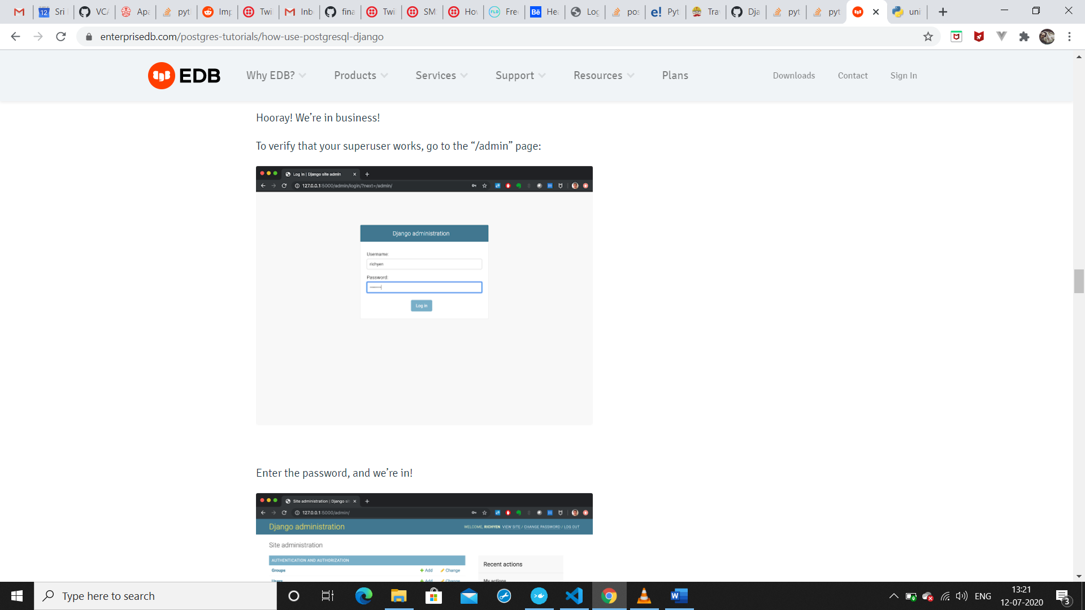

* Enter the created id password and log in to verify the superuser in the admin/ page.