REPORT -1

HTTP BASICS-STUDY

Aparna Shankar | 10.07.2020

# HTTP

* HTTP is a protocol which allows the fetching of resources, such as HTML documents.
* A complete document is reconstructed from the different sub-documents fetched, for instance text, layout description, images, videos, scripts etc.
* An HTTP client sends a request message to an HTTP server.  The server, in turn, returns a response message, ie- it pulls information from the server.

## Basic architecture

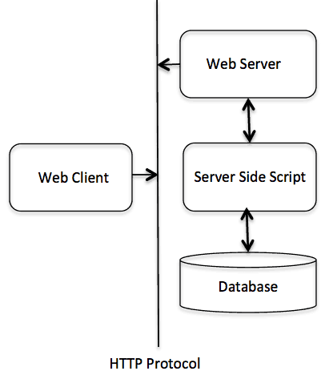

Responses consist of the following elements:

* The version of the HTTP protocol they follow.
* A [status code](https://developer.mozilla.org/en-US/docs/Web/HTTP/Status), indicating if the request was successful, or not, and why.
* A status message, a non-authoritative short description of the status code.
* HTTP [headers](https://developer.mozilla.org/en-US/docs/Web/HTTP/Headers), like those for requests.
* Optionally, a body containing the fetched resource.

HTTP REQUEST METHODS

* A set of request methods can be used to send a request message to an HTTP server: GET, POST, PATCH, DELETE, HEAD, PUT, TRACE, OPTIONS, CONNECT.
* The first line of the response message (i.e., the status line) contains the response status code, which is generated by the server to indicate the outcome of the request. These are categorized as:

Informational responses

Successful responses

Redirect

Client errors

Server errors.