KIC_DAT Version 0.5: new features/fixes/updates

1. In a source csv file the headers for cells can now have any format, like abc123, cell_1123, abc_123_cell etc. Only NUMBERS will be used as Cell_ID by the software.
2. Introduced parameter SignalType: Volatge or Calcium;
3. Implemented detection of Rise_10_90 and Fall 90_10 for Parameters.PulseAnalysis.SignalType == SignalType.Calcium;
4. Rise_10_90_ms and Fall 90_10_ms added to the xls QC report;
5. Implemented visualization of the Rise_10_90 and Fall 90_10: purple dashed/solid line with arrows up (rise) and down (fall);
6. Legend for figures improved;
7. QC: implemented parameter to validate: HasPulsesDetected, i.e. cells for which no pulses detected to be marked as non-passes QC;
8. Pulse detection algorithm improved: the pulse start and end shift to left and right from the point of intersection with the threshold line until the next local minima, so detection of APD90 and Rise_10 and Fall_10 is improved;
9. For APDs, Rise and Fall implemented flags IsStartPointApproximated, IsEndPointApproximated, which are set to True if Start/End points of these intervals are beyond the pulse frame;
10. QC report xls file: if an APD or Rise_10_90 had IsStartPointApproximated, the ‘*’ symbol is added at the left side of the StartTime; if an APD or Fall_90_10 had IsEndPointApproximated = True, the ‘*’ symbol is added at the right side of the EndTime;
11. Pulse Upstroke detection improved;
12. Pulse now has property Upstroke, which is the front of the pulse (see Fig. 1 and Fig. 2);
13. Pulse now has property UpstrokePeakPoint, which is the highest point in the UpstrokeEnsemble – combination of rises/falls at the beginning of the pulse (see Fig. 1 and Fig. 2);
14. Pulse.StartPointType property is introduced: it is used to specify which point to be treated as pulse’s start point to detect if the pulse’s start is within given tolerance time to the stimulus. Possible values: UpstrokeStart, UpstrokeEnd, ActivationPoint (i.e. time at 50% of upstroke).
15. Pulse.PulseOnStimulusNumber introduced to detect number of stimulus if Pulse Start is within Parameters.PulseAnalysis.PulSeStartOnStimulusDetectionDelta_ms tolerance interval; if Pulse.PulseOnStimulusNumber = -1 means no stimulus corresponding to the pulse start;
16. Pulse.IsPulseStartOnStimulus introduced to detect if Pulse Start is within Parameters.PulseAnalysis.PulSeStartOnStimulusDetectionDelta_ms tolerance interval;
17. QC report xls file: if Pulse.IsPulseStartOnStimulus = True, the StartTime_ms field includes ‘^’ symbol;
18. QC report xls file: column PulseOnStimulusNumber shows number of stimulus corresponding to the pulse’s start; -1 if no stimuli detected;
19. Pulse.APD_50_90_Ratio property added;
20. QC report xls file: column APD_50_90_Ratio added;

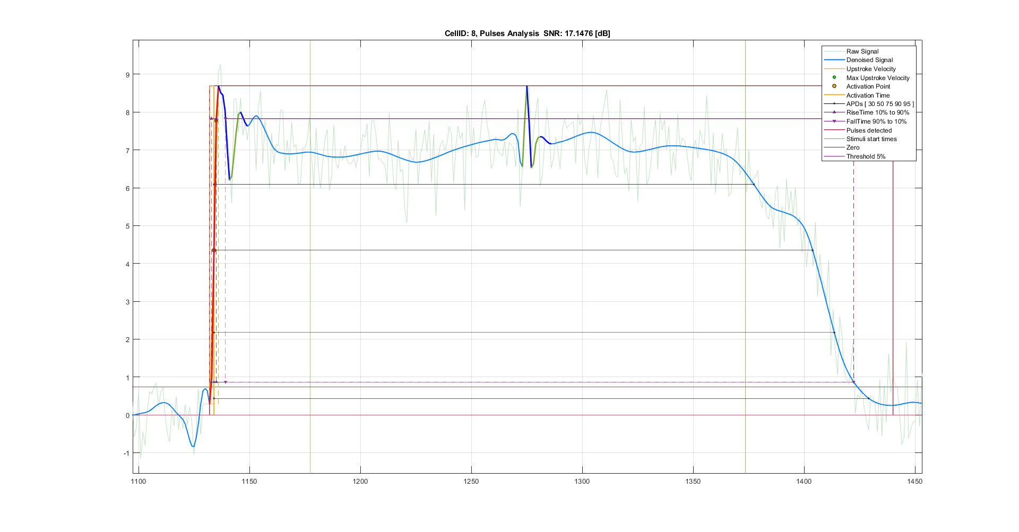

Figure 1: Pulse Analysis: a) Red line – Upstroke; b) Ensemble of Red (up)+Blue (down) + Green(up) + Blue (down) is the pulse’s UpstrokeEnsemble, which includes Upstroke (rise) and Peak (the highest point); c) Ensemble of Green (up) + Blue (down) + Green (Up) + Blue (down) – possible EAD;

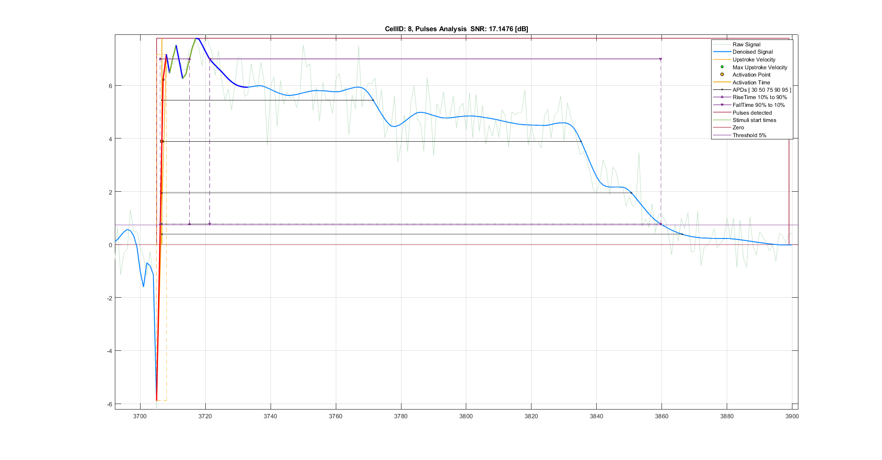

Figure 2: Pulse Analysis: a) Red line – Upstroke; b) Ensemble of Red (up)+Blue (down) + Green(up) + Blue (down) + Green(up) + Blue (down) is the pulse’s UpstrokeEnsemble, which includes Upstroke (rise) and Peak (the highest point);