**Question 1:**

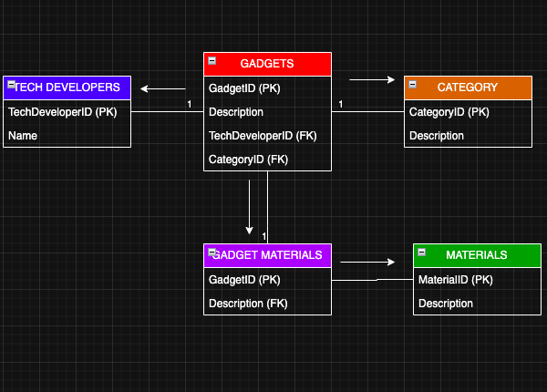

**Question 2:**

Q2.1) not enough time

**Question 3:**

