Scene Classification Using Convolutional Neural Network
PDAN8412 POE
Maximilian Walsh – ST10203070
21 November 2025
2025
Table of Contents
Executive Summary 2
Introduction 3
Analysis Plan 4
Dataset Justification 7
Exploratory Data Analysis (EDA) 9
Modelling Process 12
Model Evaluation and Interpretation 14
Conclusion & Recommendations 17
Disclosure of AI Use 18
References 19

Executive Summary

This project develops a Convolutional Neural Network (CNN) to classify images from the Intel Image Classification dataset. It uses PySpark for data preparation and TensorFlow for modelling. The CNN was trained to recognise six scene categories: buildings, forest, glacier, mountain, sea, and street. A validation accuracy of 86.5% was achieved in the final model with balanced precision and recall and minimal overfitting. The majority of errors recorded were between visually similar natural scenes. As confirmed by the findings, CNNs are practical when it comes to extracting complex spatial patterns from unstructured image data. To enhance accuracy and generalisation in future work, the application of data augmentation and transfer learning should be considered.

Introduction

The use of Convolutional Neural Networks (CNNs) in predictive analytics has become the leading approach for image classification, as they learn complex spatial patterns directly from raw pixels (OpenAI, 2025). This project applies CNN-based modelling to the Intel Image Classification dataset containing over 14,000 labelled and categorised images. The objective is to develop and evaluate a deep learning model that can accurately recognise these classes using a structured workflow. Following the methodology outlined in the Analysis Plan section to come, the analysis includes data ingestion and validation with PySpark, exploratory data analysis, CNN model development in TensorFlow, and finally performance evaluation using accuracy, precision, recall, and confusion matrix analysis. Predictive analytics is employed in this project to show the power of extending beyond traditional datasets, revealing how CNNs can uncover meaningful patterns within complex visual information.

Analysis Plan

The following is a plan to transform the Image Intel Classification dataset into a multi-class predictive Convolutional Neural Network (CNN) model capable of classifying natural scene images supported by Spark-based data analysis:

Exploratory Data Analysis (EDA) Plan
The goal of the EDA is to verify the dataset’s integrity and examine the distribution of images across the six classes.
Planned steps:
- Employ Spark to verify dataset integrity, confirm total image count, and check for missing or duplicate records.
- Check class balance across the six scene categories through visuals (buildings, forest, glacier, mountain, sea, street)
- To ensure accurate labelling and consistent visual quality, display sample images per class.
- To detect anomalies or corrupted files, record and interpret image metadata like file sizes and resolution.
- Summarise EDA findings and outline that the dataset meets the entry (10,000) requirements for CNN training.

Image Preparation Plan
Given that the dataset consists of colour (red, green, blue) images instead of the generic tabular data, preprocessing focuses on normalisation, augmentation, and dataset management instead of feature encoding.
Steps:
- Manifest Verification:
  - Use the Spark-generated intel_manifest.csv to verify image paths and labels before model ingestion.
- Dataset Splitting:
  - Using Spark, split the data into 80/20 train-validation splits and export manifests (train_manifest.csv, val_manifest.csv) for TensorFlow.
- Preprocessing:
  - For uniform input, resize all images to 150 x 150 x 3.
  - Scale pixel values between 0-1 using normalisation.
  - For enhanced model robustenss, use real-time data augmentation like random flips, rotations, and zooms.
- Pipeline Setup:
  - For efficient stream augmented batches to the CNN during training, develop a TensorFlow pipeline (tf.data).

Model Training Plan
Steps:
- Using the created training and validation manifests, create tf.data.Dataset objects.
- Use the following to build a baseline CNN (Muller & Guido, 2016; OpenAI, 2025):
  - For feature extraction, stacked Convo2D, ReLu, and MaxPooling2D layers.
  - Flatten and Dense layers for classification.
  - Final softmax activation layer with an output neuron per class (6).
- Use the Adam optimiser when compiling the model, as well as categorical cross-entropy loss, and keep accuracy as the main evaluation metric (Muller & Guido, 2016; OpenAI, 2025).
- To avoid overfitting, use early stopping, and to keep best performing weights, use model checkpointing (OpenAI, 2025).

Model Evaluation Plan
Evaluation will use metrics appropriate for multi-class classification (Muller & Guido, 2016):
- Accuracy: The proportion of correctly classified images.
- Precision, Recall, and F1-score: Per-class measures of predictive reliability and error balance.
- Confusion Matrix: Reveals similarities and model weaknesses by highlighting misclassified categories
- Loss and Accuracy Curves: Asses convergence and overfitting behaviour, learning curves will be plotted over epochs.
- Macro-averaged Scores: To check overall performance and comparison across classes.

Report Structure Plan
The final report will include:
- Executive Summary: Summarises the overall objective, dataset, and main findings.
- Introduction: Outlines the project purpose and rationale for applying CNNs to scene classification.
- Analysis Plan: Describes the step-by-step analytical framework, including data preparation, CNN design, and evaluation strategy.
- Dataset Justification: Reasoning for why the Intel Image Classification dataset is appropriate.
- EDA Results: Class balance plots, representative image samples, and metadata checks.
- Modelling Process: Outlines the CNN architecture, training parameters, and TensorFlow data pipeline setup.
- Model Evaluation and Interpretation: Key performance metrics, confusion matrix, and discussion of errors.
- Conclusion and Recommendations: Summarises overall insights, improvements, and extensions like transfer learning or deeper architectures.

Dataset Justification

Source: Kaggle – “Intel Image Classification” by Puneet Bansal (Bansal, 2018).
Link: https://www.kaggle.com/datasets/puneet6060/intel-image-classification/code
Size: 14,034 records, 2 columns
Target Variable: ‘label’ representing one of the six categories: buildings, forest, glacier, mountain, sea, street.

The selected Intel Image Classification dataset from Kaggle, contains over 14,000 red, green, and blue images categorised into six scene types - buildings, forest, glacier, mountain, sea, and street. Post cleaning and validation with Spark, 14,034 usable records stood, which easily exceeds the minimum threshold of 10,000 records. All images are sized consistently at 150 x 150 pixels and distributed evenly across scenic categories, making it an ideal dataset for convolutional neural network (CNN) modelling. The dataset was chosen for the following reasons:
- Relevance to Task: The dataset directly fits the intention to build an image-based classification model using deep learning. Each image has spatial features and colour textures that are specifically designed for CNNs to learn (OpenAI, 2025). The structure of the dataset supports the application of Spark for data handling and TensorFlow/Keras for modelling (Bansal, 2018).
- High-Quality Variables and Clear Labels: Each image is stored in a well-defined folder that offers explicit labels, allowing for efficient Spark ingestion and supervised training. For traceability and reproducibility, the intel_manifest.csv created records the file path, byte size, and label for each image. During cleaning, there were no missing or corrupted files found.
- Data Volume and Balance: The dataset is considered balanced enough for no bias modelling as each class contains 2,000 to 2,500 images. After a Spark-based stratified split there were 11,286 training images and 2,748 validation images, providing a sufficient quantity of data for learning and evaluation.
- Suitability for CNN and Scalability: The image sizes are manageable offering efficient experimentation even on central processing units, whilst keeping required visual complexity for multi-layer convolutional learning (Bansal, 2018).
To conclude, for this deep learning project, the Intel Image Classification dataset is suitable given. It offers large, balanced, well-labelled, and clean data that forms a robust foundation for training and evaluation of a CNN capable of effectively differentiating scene types whilst meeting the project requirements of Spark and TensorFlow.

Exploratory Data Analysis (EDA)

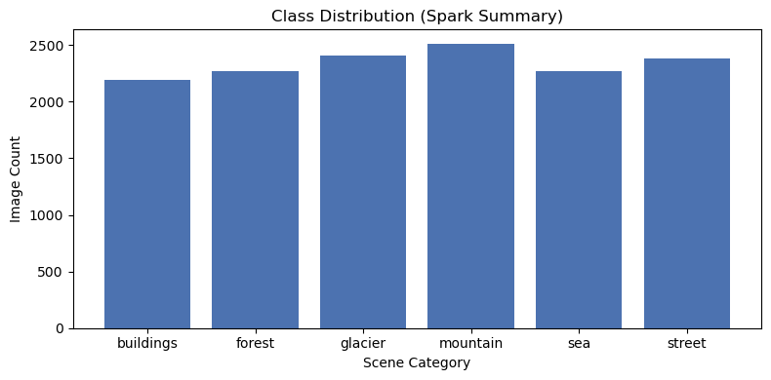
Figure 1: Class (Scene Categories) Distribution Bar Chart
The bar chart illustrated in Figure 1 shows the distribution of images across the six scene categories – buildings, forest, glacier, mountain, sea, and street. Each category contains roughly 2,200 to 2,500 images showing a relatively even distribution. Ergo we can say the dataset is well balanced, given the even representation, which minimises potential model bias towards a class during training. For reliable generalisation and accuracy metrics that reflect real classification ability instead of class frequency dominance, a balanced dataset like this one is essential (Muller & Guido, 2016; OpenAI, 2025).

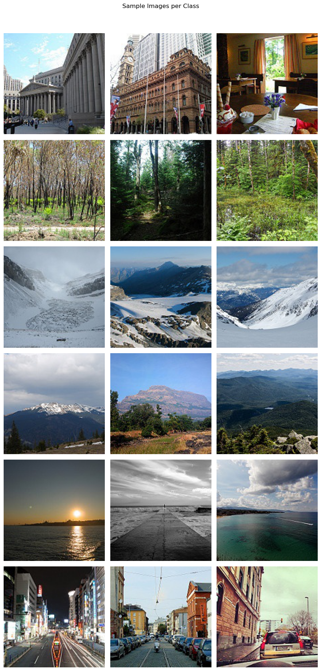
Figure 2: Sample Images per Class
Figure 2 above shows a selection of representative images from each of the six scene categories. Visual distinctions between natural and urban environments are clear, like vegetation in forest, snowy landscapes in glacier, and structures in buildings and street scenes. The images are correctly labelled and provide sufficient quality for feature extraction as confirmed by the display. The CNN will be exposed to varying textures, colours, and lighting, given the diversity in each category, which supports robust learning (OpenAI, 2025).

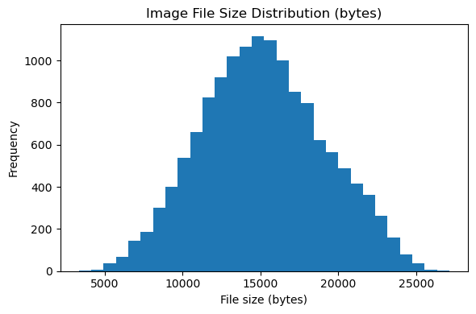
Figure 3: Image File Size Distribution Histogram
The histogram above (Figure 3) shows the distribution of file sizes across the dataset. The distribution shows consistent image resolution and absence of corrupted files, given the near-normal shape centred around roughly 15,000 bytes. We can expect there to be no bias from irregular image dimensions and efficient preprocessing, and training (OpenAI, 2025). We can confirm that the dataset meets the integrity and scale criteria for CNN model training, given these results along with the class balance shown in Figure 1.

Modelling Process

Data Preparation
PySpark was used to generate manifest files from the Intel Image Classification dataset containing verified image paths, sizes, and labels. After importing the manifest files into TensorFlow, they were converted into optimised tf.data.Dataset pipelines for efficient loading and preprocessing. All images were resized to 150 x 150 pixels, and pixel intensities were normalised to the [0,1] range, and categorical labels were one-hot encoded across the six scene classes: buildings, forest, glacier, mountain, sea, and street (OpenAI, 2025). This meant that during model training, graphics processing unit utilisation was efficient, consistent, and reproducible (Muller & Guido, 2016).
Model Architecture
For the multi-class classification, a baseline Convolutional Neural Network (CNN) was designed. The architecture had stacked Convo2D layers with ReLU activations for extracting spatial features, combined with MaxPooling2D layers to decrease dimensionality while keeping key visual patterns (Muller & Guido, 2016; OpenAI, 2025). Feature maps were flattened and passed through connected layers, ending with a softmax output layer of six neurons, one for each target class (OpenAI, 2025). Interpretability and performance are balanced with this structure, promoting the learning of spatial hierarchies in image data (Muller & Guido, 2016).
Model Compilation and Training
Both the Adam optimiser and categorical cross-entropy loss were used for model compiling, and accuracy was the main evaluation metric. To prevent overfitting, early stopping was employed as it halted training when validation loss stabilised, and the best performing weights were saved in the intel_cnn_best.keras file with checkpointing. The CNN achieved a validation accuracy of 86.5% and was trained for up to 20 epochs.
Learning Outcomes
There was constant loss reduction and convergence in accuracy as shown by the training and validation curves, revealing effective learning and strong generalisation (Muller & Guido, 2016; OpenAI, 2025). Additionally, little overfitting was seen, and the model complexity was well-calibrated, given the minimal convergence between the two curves (Muller & Guido, 2016). Finally, stable optimisation was affirmed by the consistent validation performance across epochs seen.
Evaluation and Retention
Predictive capability across all six classes was revealed from the evaluation metrics. The highest recall and precision were achieved by the forest (97%) and sea (92%) categories. There was some minor confusion between glacier and mountain, which shows the visual similarity in terrain textures. There was reliable class separation, as shown by the confusion matrix’s strong diagonal dominance (OpenAI, 2025). The model showed high accuracy, stable convergence, and no underfitting and so retraining wasn’t necessary. At a significant computational cost, only marginal gains would be yielded from further tuning (OpenAI, 2025). Ergo, the final model meets the project criteria, offering an accurate, efficient, and interpretable model for six-class scene classification.

Model Evaluation and Interpretation

Overview of Evaluation Metrics
Standard classification metrics were used to assess the model’s performance – accuracy, precision, recall, and F1-score. For diagnostic interpretation, learning curves and a confusion matrix were considered. The accuracy metric shows the overall proportion of correctly classified images, and for class specific insights into prediction quality precision and recall are considered (OpenAI, 2025). Finally, the F1-score harmonises both, providing a balanced view of false positives and negatives (Muller & Guido, 2016). This combination of metrics offers a comprehensive understanding of model effectiveness.
Quantitative Results
Metric | Value
Validation Accuracy | 0.8648
Macro Precision | 0.8712
Macro Recall | 0.8644
Macro F1-score | 0.8652
Table 1: CNN Performance Metrics
Table 1 above shows the performance metrics for the CNN model. The CNN achieved an overall validation accuracy of 0.8648, revealing generalisation capability across unseen images of a strong nature. The macro averaged precision, recall, and f1-score confirm balanced predictive performance across all six classes. Specific class level results reveal that forest (97% precision, 97% recall) and sea (92% precision, 84% recall) achieved the highest reliability, showing visual patterns were distinctive and clearly separated within scenes (OpenAI, 2025). Glacier (85% precision, 77% recall) and buildings (89% precision, 79% recall) showed moderate performance and partial misclassifications due to subtle texture similarities or lighting variations (OpenAI, 2025). Strong performance was seen from mountain (77% precision, 89% recall) and street (80% precision, 93% recall), showing landscape features and man-made structures were successfully captured by the model (OpenAI, 2025).

Learning Curve Analysis
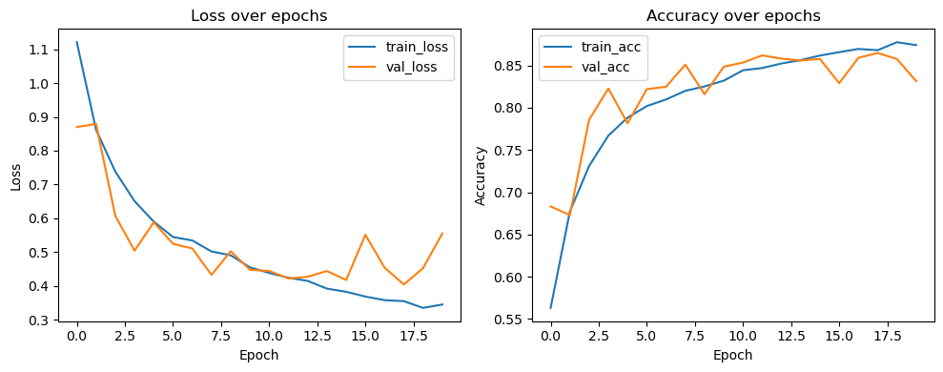
Figure 4: Training and Validation Learning Curves
As seen in Figure 4 above, the training and validation learning curves showed improvement in accuracy that was consistent and a parallel decline in loss over 20 epochs. There is minimal overfitting and effective regularisation as confirmed by the close alignment between training and validation trends (Muller & Guido, 2016). Post epoch 12, validation accuracy plateaued near 86%, revealing convergence to an optimal parameter configuration (OpenAI, 2025). We can deduce efficient learning dynamics and strong model stability given the absence of clear divergence between loss curves (Muller & Guido, 2016).
Confusion Matrix Interpretation
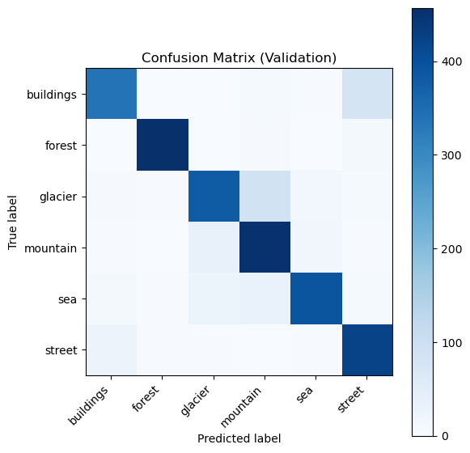
Figure 5: Confusion Matrix
Strong diagonal dominance is seen in the confusion matrix above (Figure 5), implying most predictions matched their true labels. There were a few misclassifications, mostly between glacier and mountain, which can be expected given the overlapping visual features like snow, rock, and sky. The reliability of the model is not diminished by this behaviour, as it is typical in natural-scene classification (OpenAI, 2025). There was robust feature extraction with litter inter-class confusion given the high consistency of predictions across the six classes.
Interpretation and Model Suitability
The CNN’s performance was of a suitable level for practical deployment as a baseline image classifier, as it successfully generalised from training to validation data. Its strong discriminative power is indicated by its consistent and balanced metrics. Underfitting was not evident in the learning curves or final metrics, and so retraining was not pursued. At a significantly higher computational cost, marginal improvements could be seen from further tuning or architectural expansion. The final model, therefore, offers an optimal balance within the constraints of this project.

Conclusion & Recommendations

A Convolutional Neural Network (CNN) to classify natural and urban scenes using the Intel Image Classification dataset was successfully developed and evaluated. With systematic data preparation, PySpark enabled exploratory data analysis and TensorFlow-based modelling. A validation accuracy of 86.5% was achieved through analysis, confirming the model’s ability to effectively generalise across six visually distinct classes: buildings, forest, glacier, mountain, sea, and street.
The CNN successfully captured hierarchical spatial features as highlighted by the results, particularly in classes with distinct textures and colour patterns like forest and sea. Although there were some minor misclassifications between glacier and mountain, given their visual similarities, this was not due to model limitations. The model reached convergence without overfitting as outlined in the learning curve analysis and performance metrics. Retraining was deemed unnecessary given the achieved stability and balance across classes.
Data augmentation, like rotations, zooming, and flipping, could be considered for future improvements to enhance model robustness. Also, transfer learning using pretrained architectures like VGG16 or ResNet50 for enhanced feature extraction and accuracy (OpenAI, 2025). Such extensions may potentially lead to performance over 90% accuracy whilst maintaining interpretability and computational efficiency, which aligns with predictive analytical objectives (Muller & Guido, 2016; OpenAI, 2025).

Disclosure of AI Use
Sections: POE.
Name of the tool used: ChatGPT5.
Purpose behind use: Outlines, summaries, Python code, queries, evaluations, suggestions, paraphrasing, and explanations.
Date used: 01/11/2025.
Link to chat: https://chatgpt.com/share/690b4bf3-015c-8004-83d6-c89971dfbe4f

References
Bansal, P., 2018. Intel Image Classification. [Online]
Available at: https://www.kaggle.com/datasets/puneet6060/intel-image-classification/code
[Accessed 31 October 2025].
Muller, A. C. & Guido, S., 2016. Introduction to Machine Learning with Python. 1st ed. Sebastopol: O'Reilly Media.
OpenAI, 2025. Open AI ChatGPT5. [Online]
Available at: https://chatgpt.com/share/690b4bf3-015c-8004-83d6-c89971dfbe4f
[Accessed 01 November 2025].

