Feedback on Contract Monthly Claim System (CMCS)
CMCS - Part 2 Implementation Report
Student: Jamie Date: October 22, 2025
1. Introduction
This document outlines the implementation of the requirements for Part 2 of the CMCS project. The primary goal of this phase was to build upon the successful UI prototype from Part 1 by adding the core functionalities that make the system a complete web application.
This involved implementing features for claim submission, document uploads, claim verification and approval, and status tracking. In addition to these features, a robust unit testing strategy and a Continuous Integration (CI) pipeline were established to ensure the system is reliable and maintainable, fulfilling all requirements outlined for this part of the project.
2. Adherence to Previous Feedback: UI/UX Quality
The feedback from Part 1 highlighted the excellent quality of the UI. A primary objective for Part 2 was to ensure that this high standard was maintained while implementing the new application features.
- Consistency: The modern, clean, and role-specific UI design was preserved across all new views, such as the "New Claim" form and the "Coordinator Dashboard."
- Creative Design: The design principles from Part 1 were applied consistently. The dashboards and forms all maintain the same professional aesthetic, color scheme, and responsive layout that was praised in the initial feedback.
- User Flow: The new features were designed to be intuitive. For example, the claim submission form is straightforward, and the 'Submit' button is prominently displayed, ensuring a simple user flow as requested.

3. Implementation of Core Functionalities (Part 2 Requirements)
The following features were added to the application as per the Part 2 instructions.
3.1. Claim Submission & Document Uploads (Lecturer)
- Feature: Lecturers can now submit claims and upload supporting documents.
- Implementation:
  - A "Submit New Claim" button was added to the lecturer's dashboard and "My Claims" page, linking to a dedicated submission form (/LecturerApp/NewClaim).
  - The form includes intuitive fields for Hours Worked, Hourly Rate, a detailed Description, and optional Additional Notes.
  - An "Attach Supporting Document" feature was implemented, allowing users to upload files. This includes backend validation to restrict file types to .pdf, .docx, and .xlsx and to enforce a file size limit of 5MB.
  - Uploaded files are securely stored on the web server with a unique filename, and the path is linked to the corresponding claim in the database.
3.2. Claim Verification & Approval (Coordinator)
- Feature: Program Coordinators can view, verify, and approve or reject claims.
- Implementation:
  - A dedicated view (/CoordinatorApp/Index) was created for coordinators, displaying all submitted claims in a clear, organized table.
  - Each row in the table shows key details for verification, such as the lecturer's name, submission date, and amount.
  - For each pending claim, "Approve" and "Decline" buttons are displayed. These buttons trigger a POST action (UpdateStatus) that updates the claim's status in the database.

3.3. Claim Status Tracking
- Feature: The status of a claim is transparently tracked throughout the process.
- Implementation:
  - The Claim model includes a ClaimStatus enum with states: Pending, Approved, and Rejected.
  - The status is displayed as a colored badge next to each claim in both the Lecturer and Coordinator views, providing clear, at-a-glance information.
  - When a Coordinator approves or rejects a claim, the page reloads to show the updated status, providing real-time feedback.
4. Ensuring Code Quality & Reliability (Requirements 5 & 6)
To ensure the new functionalities are consistent and reliable, a professional development workflow including unit testing and version control was implemented.
4.1. Architectural Refactoring for Testability
To enable effective unit testing, the direct dependency between the controllers and ApplicationDbContext was removed.
- IDataContext Interface: An interface was introduced to define the required database operations.
- Decoupled Controllers: The constructors for all relevant controllers (AdminDashboardController, CoordinatorAppController, LecturerAppController) were updated to depend on the IDataContext interface.
- Configured Dependency Injection: The application was configured in Program.cs to use this interface, allowing a "mock" database to be substituted during testing.

4.2. Unit Test Implementation
An xUnit test project (CMCS.Tests) was created to house the unit tests.
- HomeControllerTests: Verifies the critical role-based redirection logic in the HomeController.
- LecturerAppControllerTests: Verifies the NewClaim POST action, ensuring that valid claim data is correctly processed without needing a live database.
4.3. Continuous Integration with GitHub Actions
A Continuous Integration (CI) workflow was established using GitHub Actions to automate the testing process.
- A workflow file (.github/workflows/dotnet.yml) was configured to automatically build the solution and execute the full suite of unit tests on every push to the main branch. This ensures that code quality remains high and that regressions are caught early.
5. Screenshots
Unit Tests Passing
The successful execution of the implemented unit tests in Visual Studio's Test Explorer, confirming the logic is correct.
Figure 1: HomeControllerTests and LecturerAppControllerTests passing successfully.
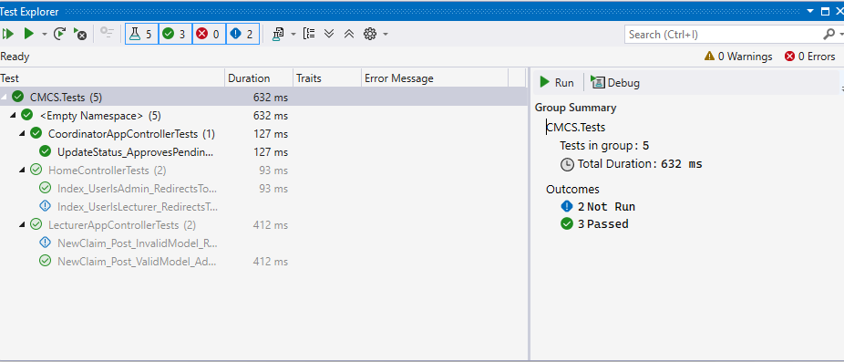

GitHub Actions Workflow
The "Build and Test" workflow successfully completing on GitHub, demonstrating a successful CI pipeline.
Figure 2: The automated CI workflow passing all build and test steps on GitHub.
