PROG6212

**POE PART 1**

**ST10440112**

**September 2025**

Table of Contents

Introduction 3

GitHub Link: 3

Purpose 3

Key Users 3

Design Choices 4

Structure 4

Overall Layout 4

Overall Structure: 5

Colour Scheme 6

Assumptions and Constraints 6

UML 6

Project Plan 6

UML Class Diagram 7

Project Plan 8

GUI 9

Lecturer UI Pages 9

Admin UI Pages 12

References 15

# Introduction

## GitHub Link:

<https://github.com/VCCT-PROG6212-2025-G3/ST10440112-PROG6212-CCMS>

## Purpose

The Contract Monthly Claim System (CMCS) is an administrative tool or system that helps to significantly cut time spent on the administrative task of writing, submitting, reviewing and approving claims by Independent Contract Lecturers and School admins. Using .NET to digitise the process the system eliminates the mundane and repetitive tasks, reduces errors and guarantee’s transparency.

## Key Users

* **Lecturers:** They submit claims with supporting documents.
* **Programme Coordinator:** Reviews the claims and verify its accuracy and legitimacy.
* **Academic Managers:** Finalises the approval process based institutional policies.

**Scope**

The scope of this part is very defined and rigid. It’s solely for the planning and design of the Contract Monthly Claim System (CMCS). The deliverables are:

* UML class diagram
* A project plan
* GUI Frames or Prototypes

There will be no actual functionality programmed, the prototype will serve purely as a **visual representation** of the intended system for later development.

# Design Choices

## Structure

There are two primary user roles, lecturer and administrator. The lecturer submits claims, adds documents and tracks the status of claims. The administrator role has two types, the Programme Coordinators and academic managers, they review & validate submitted claims, write comments/notes and approve or reject claims.

This role-based access control structure keeps each user’s interface simple, easy-to-use and task focused.

## Overall Layout

* **Navbar (Constant/Static):** This is positioned on top of the page and is present on all pages for easy navigation. It enables quick access to key pages (Dashboard, File New Claim, Track Claims for lecturers; Dashboard, Review & Approve, Track Claims for admins).
* **Page Content (Dynamic):**
  + Dashboard (All users): Uses summary cards to for quick statistics, and a searchable table of claims.
  + File Claims (Lecturers): An interactive form for Lecturers to input data and upload documents
  + Review and Approve (Admins): Details of a claim, a text area to add comments and action buttons to approve, extend, or deny claims.
  + Track Claims (All Users): A timeline-style tracker that shows claim progress through the approval chain.

The design follows **admin dashboard best practices**, ensuring familiarity, minimal training needs, and a professional look.

## Overall Structure:

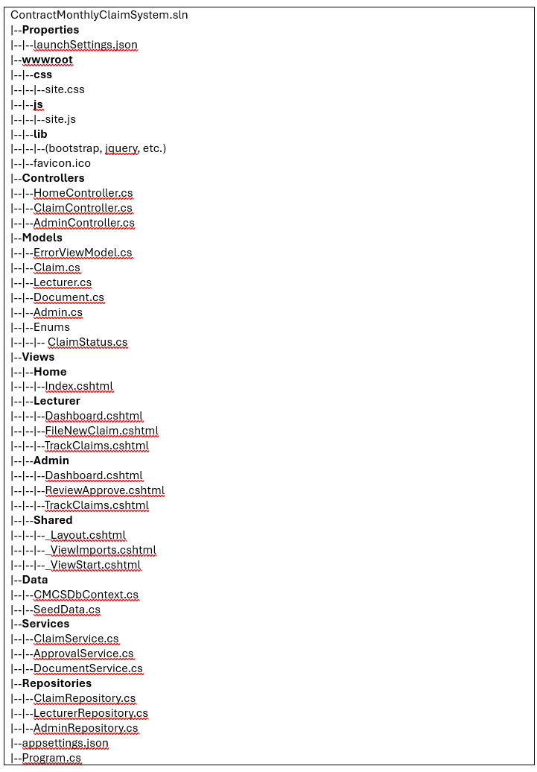

## Colour Scheme

The primary colour is #13325B (Deep Navy Blue). It portrays the academic environment, conveys trust and authority. It is used in headers, navigation and key components. (Figma, 2025)

The secondary colour is a #9F7944 (Gold/Brass). Its used as contrast and highlight colour and is a symbol of prestige, value and achievement. (Figma, 2025)

There are traditional status indicators: green (approved/positive), yellow (pending/neutral) and red (deny/requires attention)

This colour system makes statuses instantly recognisable while maintaining a consistent professional theme.

## Assumptions and Constraints

**Assumptions**

* All data added is truthful and valid, the system assumes truthfulness.
* Administrators review and approve claims before passing the claim.
* Users are intuitive enough to navigate the UI.

**Constraints**

* Only pdf, docx and xlsx files are allowed.
* Claims cannot be edited after first approval.
* Desktop is the primary usage not mobile.

## UML

* **Lecturer**: can submit many **Claims**.
* **Claim**: attributes: ClaimID, Hours, Amount, Date, Status. Linked to **Documents**.
* **Administrator**: reviews and updates claim statuses.
* **Document**: attributes: FileID, FileType, FilePath; associated with one Claim.

## Project Plan

**Part 1 – Project Planning & Prototype (Weeks 1–3)**

This is the phase where all the initial system is designed, requirements are gathered, documentation is created, and CI/CD is setup

**Part 2 – Implement Prototype Web Application (Weeks 4–6)**

The is the phase where actual coding is done, forms are made, data flow is built, uploads and downloads are coded error handling and unit tests are all completed.

**Part 3 – Automation & Presentation (Weeks 7–9)**

This is where the claim submission is automated for the lecturers, verification workflow is automated, and the app is presented

# UML Class Diagram

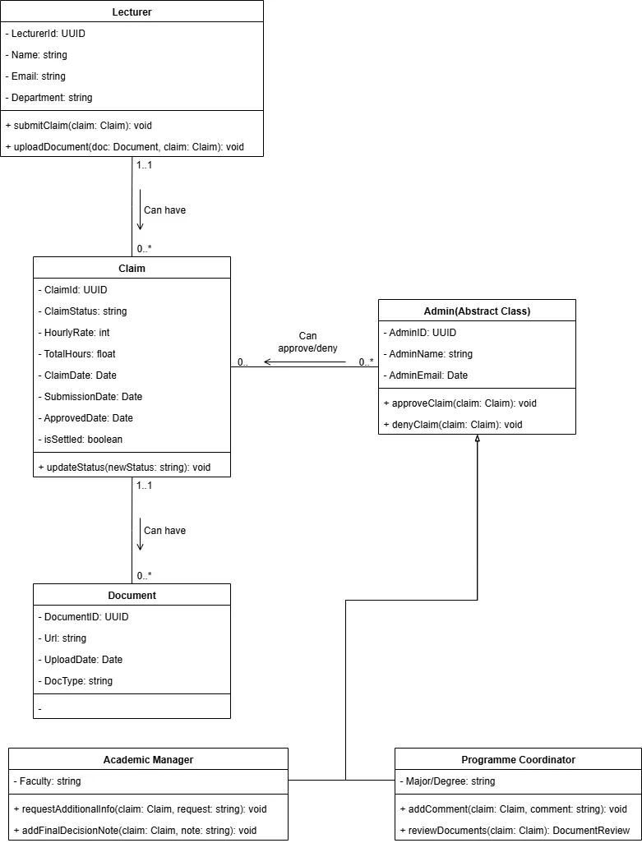

(Sanchhaya Education Private Limited, 2025)

# Project Plan

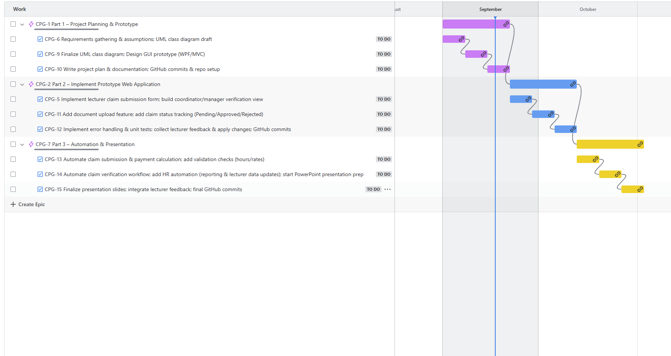

(ProjectManager.com, Inc, 2025)

# GUI

Inspired by: (Shukla, 2025)

## Lecturer UI Pages

**Home/Dashboard:** This is where they see an overview of their claims, it shows a list of all their claims, the status of their claims as well as important stats.

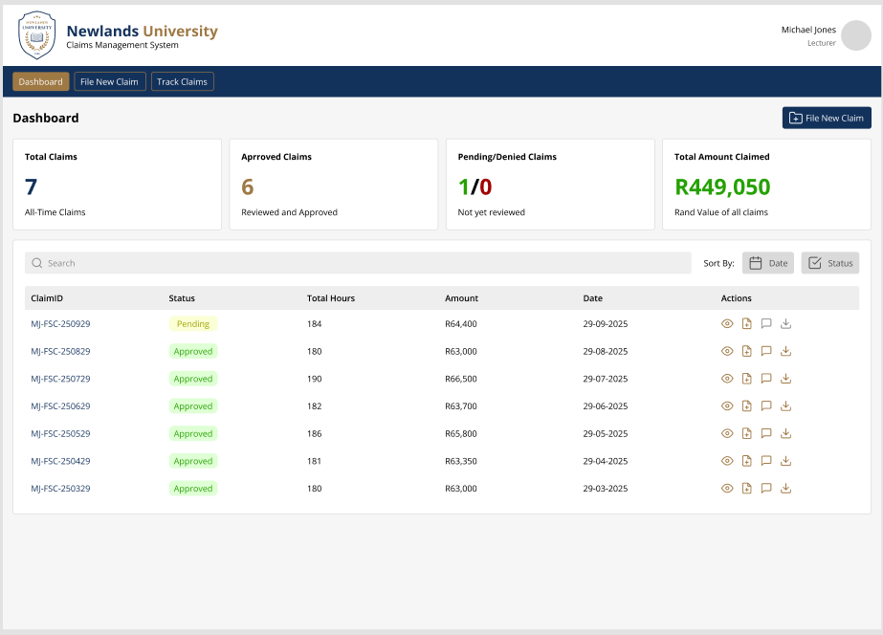

**File New Claim:** This is where the lecturer can fill in the required information and upload the required documents into a claim request.

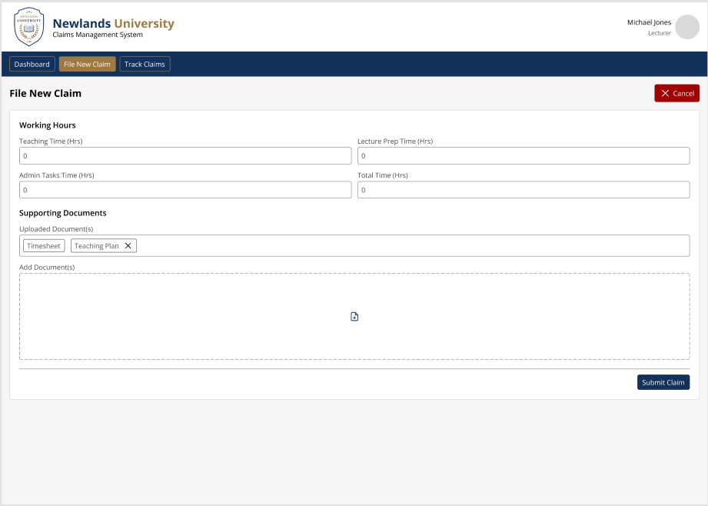

**Track Claims:** This is where the lecturer can see the status of their submitted claim(s). It displays where the claim is in the approval chain from submission to outcome.

## Admin UI Pages

**Home/Dashboard:** This is where the admin sees an overview of claims submitted by lecturers, it shows a list of all their claims, the status of their claims as well as important stats, it also gives them quick actions to approve or deny claims.

**Review and Approve:** On this page the admins get more detailed information of claims, they can write comments/notes, extend the review or deny a claim entirely.

**Track Claims:** This is where the admin can see the status of submitted claim(s) on the platform. It displays where the claim is in the approval chain from submission to outcome. They get more details than the lecturers

# References

Figma, 2025. *Brass.* [Online]   
Available at: https://www.figma.com/colors/brass/  
[Accessed 16 September 2025].

Figma, 2025. *Navy blue.* [Online]   
Available at: https://www.figma.com/colors/navy-blue/  
[Accessed 16 September 2025].

ProjectManager.com, Inc, 2025. *A Gantt Chart Guide with Definitions & Examples.* [Online]   
Available at: https://www.projectmanager.com/guides/gantt-chart  
[Accessed 16 September 2025].

Sanchhaya Education Private Limited, 2025. *UML Class Diagram.* [Online]   
Available at: https://www.geeksforgeeks.org/system-design/unified-modeling-language-uml-class-diagrams/  
[Accessed 15 September 2025].

Shukla, A., 2025. *Health Insurance Claims Management System.* [Online]   
Available at: https://www.figma.com/files/team/1130068648348070591/resources/community/file/1533807969486953650  
[Accessed 15 September 2025].