A mobile application for No Body Better, a fitness franchise offering customised fitness and dietary services. No Body Better aims to establish itself as South Africans’ preferred partner in their journey towards a healthier lifestyle. The application will feature up-to-date, medically sound information and advice about the benefits of a healthier lifestyle and the steps towards achieving one.

The application will also offer a platform for health and fitness experts to showcase their professional profiles and for clients to select and book personal, online consultations with their experts of choice and post or view reviews.

No Body Better want to increase their client base and build client loyalty by providing a digital subscription-based health and fitness service that provides clients with weekly customised eating and fitness plans based on their personal goals.

To promote their reputation as a supportive health and fitness partner, subscribers will be able to track, celebrate and share their achievements with friends. They will also be able to connect with peers on similar journeys for ongoing peer support and encouragement.

No Body Better’s product goal is to:

* Offer customised fitness and dietary services.
* Medically sound information and device about the benefits of a healthier lifestyle and the steps towards achieving one.
* The application will also offer a platform for health and fitness experts to showcase their professional profiles and for clients to select and book personal, online consultations with their experts of choice and post or view reviews.
* Their client base and build client loyalty by providing a digital subscription-based health and fitness services.
* Promote their reputation as a supportive health and fitness partner subscribers will be able to track, celebrate and share their achievements
* Connect with peers on similar journeys for ongoing peer support and encouragement.

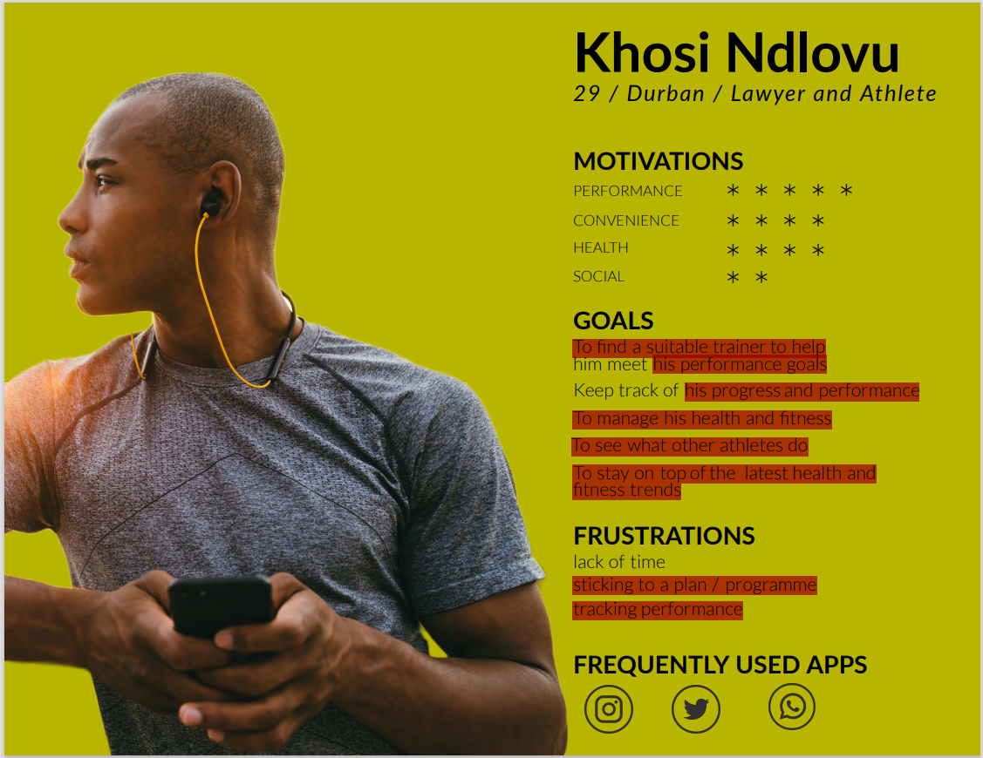

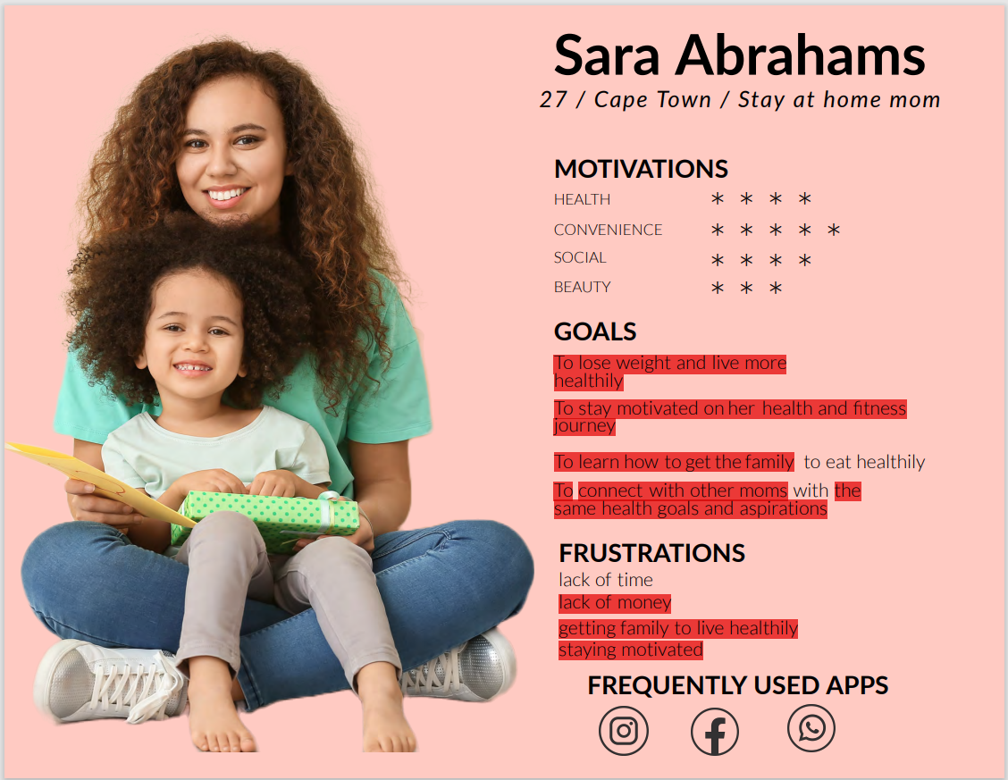

Khosi Ndlovu goals:

* To find a suitable trainer to help.
* To meet his performance goals.
* His progress and performance.
* To manage his health and fitness.
* To see what other athletes do.
* To stay on the top the latest health and fitness trends.
* Sticking to a plan / programme.
* Tracking performance.

Sara Abrahams goals:

* To lose weight and live more healthily.
* To stay motivated on her health and fitness journey.
* To learn how get the family.
* To connect with other moms.
* The same health goals and aspirations.
* Lack of money.
* Getting family to live healthily staying motivated.

|  |  |  |
| --- | --- | --- |
| **Goals (Product and User Goals)** | **Content Requirements** | **Context Rationale** |
| No Body Better can offer a fitness and lost their height to be health in our body (Product Goal). | Text – Titles: “When the training began.”  - The training is very important in our country  - The explanation of the fitness in the different cultures.  - Training can help people for their living.  - The evolution of fitness in different countries. | Many customers want to be strong and stay cool for that they need training their body and their personality to get respect of the friends and trainer. They have many training to be skinny and bodyguard. Fitness has evolution between the ancient Greeks and Egyptians in the history of the wholesome “Happy Days” era of the 1950s. |
| To get their progress and performance with the best trainer (User Goal). | Text – Titles: “Learn to be strong for a living”  - Developing a working relationship with your coach (Bold Athlete).  - When you do talk with your coach, speak with confidence. Ask them if there is anything you could have done differently (Long text in Bold Athlete).  - Spend the next days working your tail off (Short text in Bold Athlete). | Many young want to be strong for a living because they need to develop your self-confidence and do it your best. The appreciation will be gained for the significance of fitness as a sport. Developing your work and training every week to get your best result. |
| To promote as a fitness trainer in the planet fitness (Product Goal). | Title:  “Connect of the application to be subscribe and get their progress”.  - Every exercise comes with a tutorial on how perform it with good form and also tell the number of sets and repetitions to do it now (YouTube). | Customers can get their result when they do it the repetitions for the exercise for their progress. |
| Get more time for your training if you have a lot of work for a living (User Goal). | Title:  “For their training you need to listen the music for your motivations”.  - Get desire to be stronger in the world.  - Take the time to develop positive working relationships with your coaches. | Many people have a lot of motivations to be strong and they want to be respectful. They can think of your goal to be health and social. |
| Follow the steps to eat healthy in the book and get more experience (Product Goal). | - Consult the book for their training and after follow these steps.  - Follow the steps of the training before you start.  - Every day work very hard to stronger for your close. | The book of fitness can help you to develop your first experience when you read these steps after you start your training to follow these steps. Watch the video to see how can we have a motivation to work and play in your favourite sport. |
| Your best performance when you are done with your training and see your statistic (User Goal). | Title: “Key takeaways”.  - Progression plan was in place.  -Introducing weights gave our athletes the opportunity to get stronger and faster. | You can see your performance on the machine when you run, raise and push. After you can do your best all the time. |

|  |  |  |  |  |
| --- | --- | --- | --- | --- |
| **Goal (Product and User Goal)** | **Content Requirements** | **Content Rationale** | **Functional Specifications** | **Functional Spec Rationale** |
| No Body Better can offer a fitness and lost their height to be health in our body (Product Goal). | Text – Titles: “When the training began”.  - The training is very important in our country.  - The explanation of the fitness in the different cultures.  - Training can help people for their living. | Many customers want to be strong and stay cool for that they need training their body and their personality to get respect of the friends and trainer. They have many training to be skinny and bodyguard. Fitness has evolution between the ancient Greeks and Egyptians in the history of the wholesome “Happy Days” era of the 1950s. | For the user to go on the website to get more information for the training they can do it for their limit but for that they need motivation to do it. | User can get more information on the website for subscription on place for training and to be accept in sports hall. |
| To get their progress and performance with the best trainer (User Goal). | Text – Titles: “Learn to be strong for a living”.  - Developing a working relationship with your coach (Bold Athlete).  - When you do talk with your coach, speak with confidence. Ask them if there is anything you could have done differently (Long text in Bold Athlete).  - Spend the next days working your tail off (Short text in Bold Athlete). | Many young want to be strong for a living because they need to develop your self-confidence and do it your best. The appreciation will be gained for the significance of fitness as a sport. Developing your work and training every week to get your best result. | Certainly, user would like to preface this article. And read more information about younger. | In the website the user can connect on the link to follow these steps if they are younger for that they need to work anymore. |
| To promote as a fitness trainer in the planet fitness (Product Goal). | Title:  “Connect of the application to be subscribe and get their progress”.  - Every exercise comes with a tutorial on how perform it with good form and also tell the number of sets and repetitions to do it now (YouTube). | Customers can get their result when they do it the repetitions for the exercise for their progress. | User can be connected on the application to see which trainer they can take to get your best performance. | The user can engage with the application of fitness and selecting the day to start their training. |
| Get more time for your training if you have a lot of work for a living (User Goal). | Title:  “For their training you need to listen the music for your motivations”.  - Get desire to be stronger in the world.  - Take the time to develop positive working relationships with your coaches. | Many people have a lot of motivations to be strong and they want to be respectful. They can think of your goal to be health and social. | The training is very important and special so we can understand the method when users listen their favourite music such as rock, fight and adventure. | Take more information on the fitness for your training. User can understand the functionality of the training. |
| Follow the steps to eat healthy in the book and get more experience (Product Goal). | - Consult the book for their training and after follow these steps.  - Follow the steps of the training before you start.  - Every day work very hard to stronger for your close. | The book of fitness can help you to develop your first experience when you read these steps after you start your training to follow these steps. Watch the video to see how can we have a motivation to work and play in your favourite sport. | Follow the steps on the book to eat very well and work to be healthy. User needs money to start their training and sticking a plan for the programme. | In these elements in the media social many coaches can give you the secret to be strong and faster in the book. Get more determination for a living and your experience. |
| Your best performance when you are done with your training and see your statistic (User Goal). | Title: “Key takeaways”.  - Progression plan was in place.  -Introducing weights gave our athletes the opportunity to get stronger and faster. | You can see your performance on the machine when you run, raise and push. After you can do your best all the time. | The key of the result to get the result of your performance and stamina. The user can see their performance in the machine. | User can connect with peers on similar journey and get encouragement for their trainers. |