Student number: ST10033808

Name: Leighché Jaikarran

Module Code: CLDV6212

Module Name: Cloud Development B

**PART A**

|  |  |  |
| --- | --- | --- |
| **Component** | **Technology Choice** | **Hosting Model** |
| Azure SQL Database | Storage (Microsoft, 2023). | Platform as a Service (PAAS) (Microsoft, 2023). |
| Azure Function (Queue storage) | Storage (Microsoft, 2023). | Infrastructure as a Service (IAAS) (Microsoft, 2023). |
| Azure Function (Http Trigger) | Compute (Microsoft, 2023). | Function as a Service (FAAS) (Microsoft, 2023). |
| Azure Function (Queue trigger) | Compute (Microsoft, 2023). | Function as a Service (FAAS) (Microsoft, 2023). |
| Azure SQL Server | Storage (Microsoft, 2023). | Infrastructure as a Service (IAAS) (Microsoft, 2023). |
| Azure Function App | Compute (Microsoft, 2023). | Platform as a Service (PAAS) (Microsoft, 2023). |

**PART B**

Azure Table Storage is the best option for Aweh Productions' vaccination status check prototype due to its seamless alignment with the project's requirements. One of its advantages is its ability to retrieve data rapidly, which is crucial for efficient security checks at events. Compared to Blob Storage, which is designed for unstructured data, Azure Table Storage's key-based retrieval and tabular structure enable it to quickly retrieve information, ensuring swift access to vaccination details within seconds. This is vital for the smooth execution of security procedures at venues, improving overall operational efficiency. When compared to File Storage, which is intended for shared file access, Azure Table Storage's schema-less nature is a critical factor. File Storage's hierarchical structure is less adaptable to the flexible data format needs specified by Aweh Productions. In contrast, Azure Table Storage accommodates entities with varying properties without requiring frequent schema modifications. This flexibility ensures that the prototype can easily handle diverse data formats from different manufacturers, meeting a critical requirement for the vaccination status check process. In situations where rapid access to specific records is essential, such as Aweh Productions' security procedures, Azure Table Storage surpasses Queue Storage. Its key-based access and efficient indexing mechanisms contribute to superior capabilities for direct data storage and retrieval. The tabular structure of Azure Table Storage is essential for efficient query performance, ensuring that the process of retrieving vaccination information remains swift and responsive, thereby enhancing the solution's effectiveness in real-time security checks. Aside from it being better in terms of performance, Azure Table Storage is also a cost-effective option when compared to alternative storage options like Blobs, Files, and Queues, each of which is designed for specific use cases. Azure Table Storage's simplified structure and efficient indexing mechanisms contribute to reduced operational costs, which is particularly advantageous in scenarios involving frequent read and write abilities on smaller to medium-sized datasets. The pay-as-you-go pricing model ensures that Aweh Productions only incurs costs based on actual resource consumption, aligning perfectly with their emphasis on a cost-effective solution, also in the long run if they wish to expand their capbalitlies they can expand their solution cause of Azures scalabilities as you pay for what you use. In conclusion, Azure Table Storage not only meets Aweh Productions' specific requirements but also provides a comprehensive and economical solution, making it the optimal choice for their vaccination status check prototype (Microsoft, 2023).

**PART C :** QUEUE TRIGGER CODE

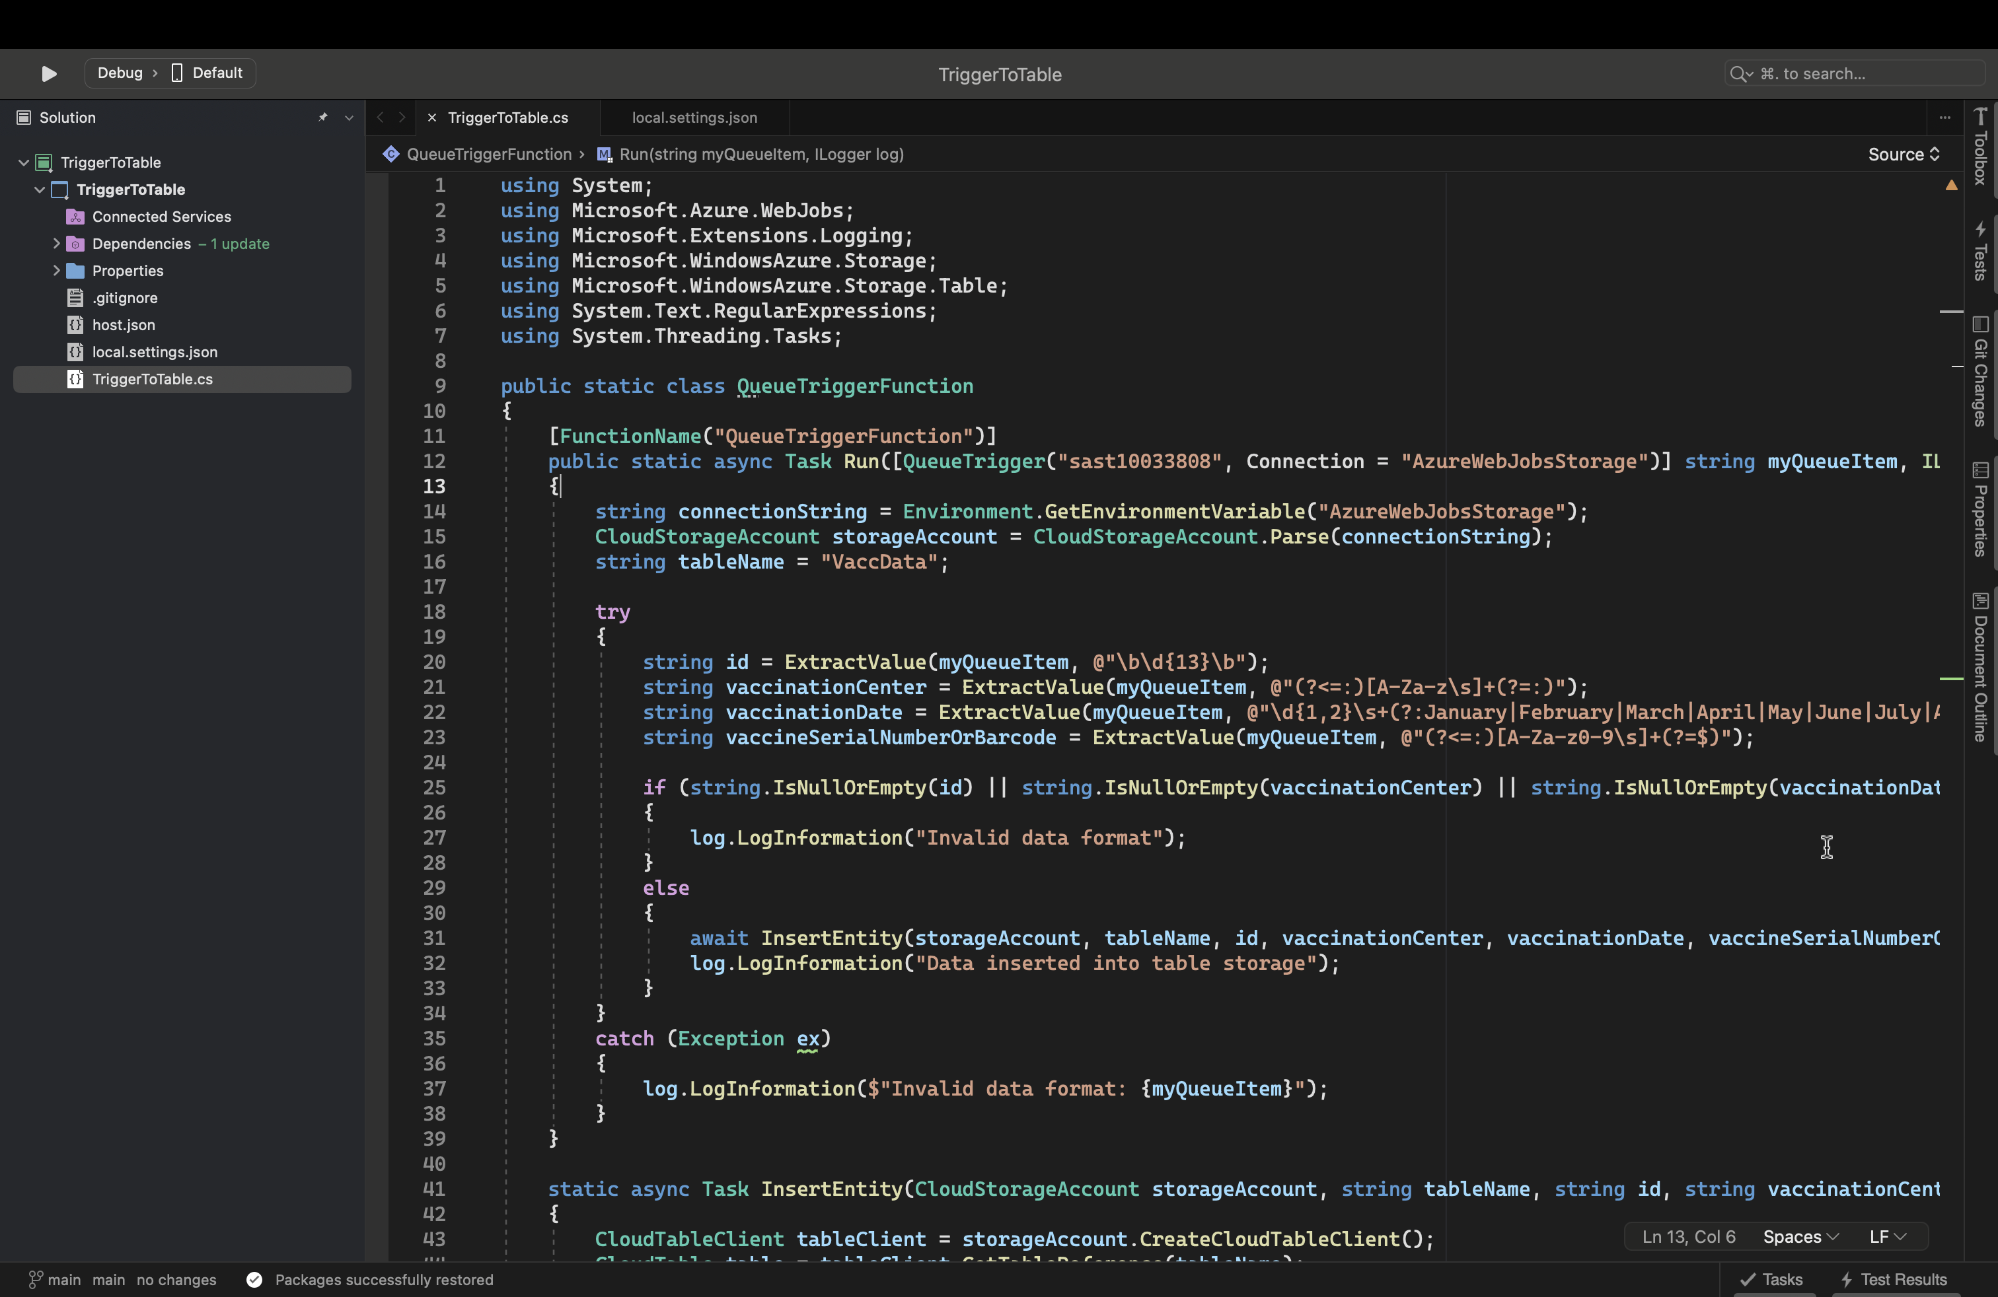

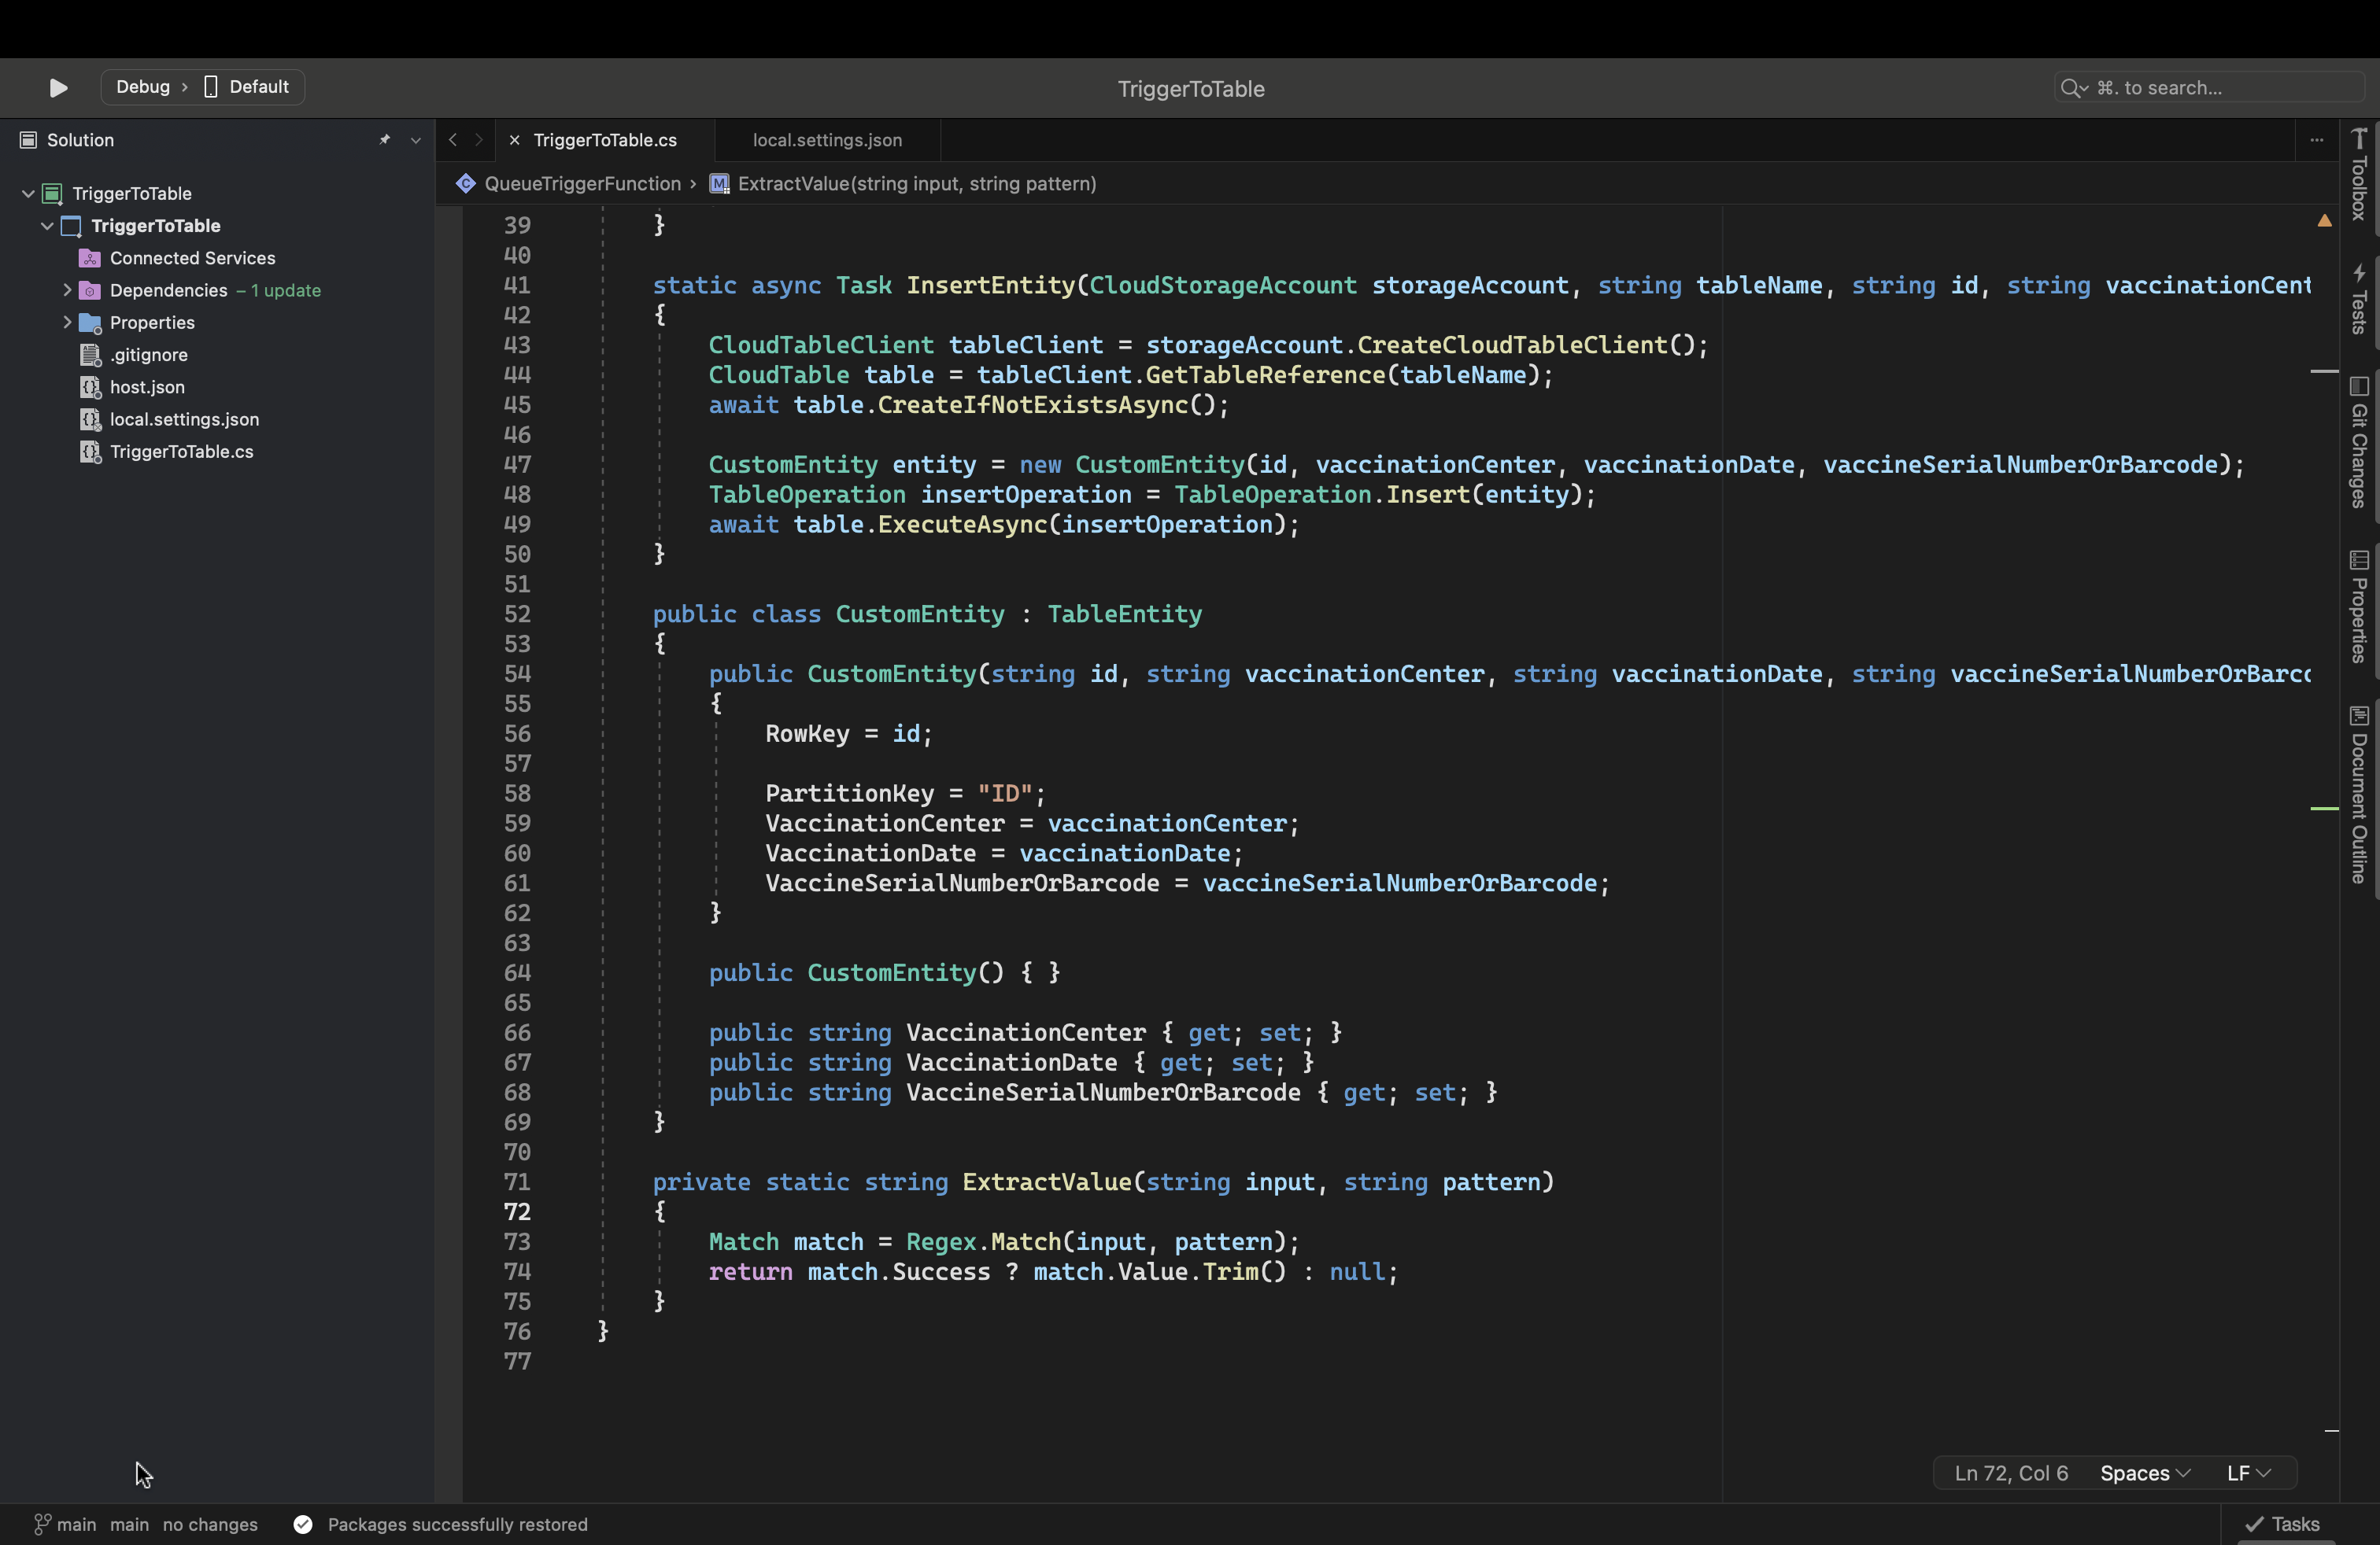

(Microsoft, 2023).

QUEUE STORAGE CONTENTS

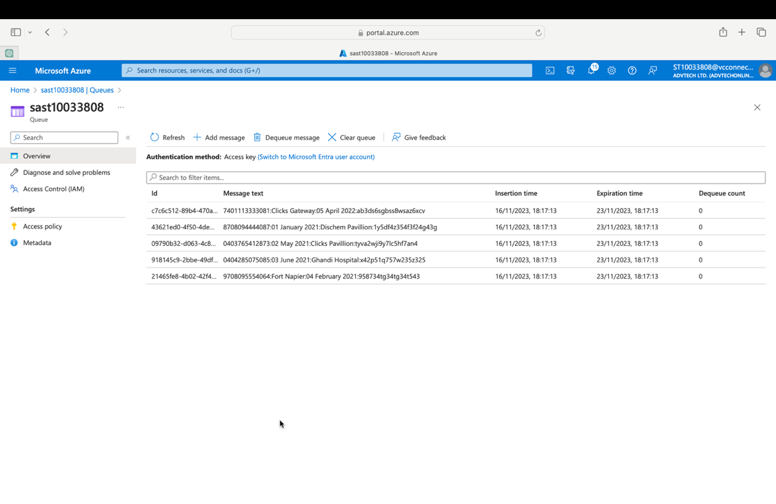

MESSAGE IN TABLE STORAGE

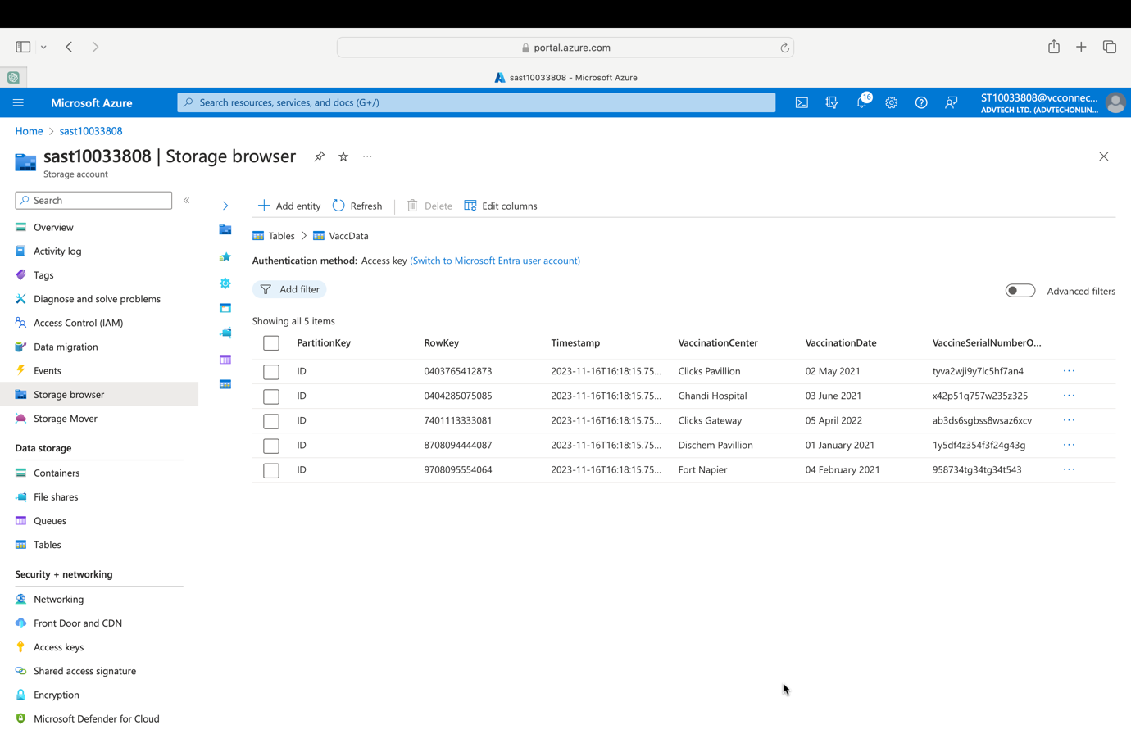

**PART D**

CONSOLE APP OUTPUT

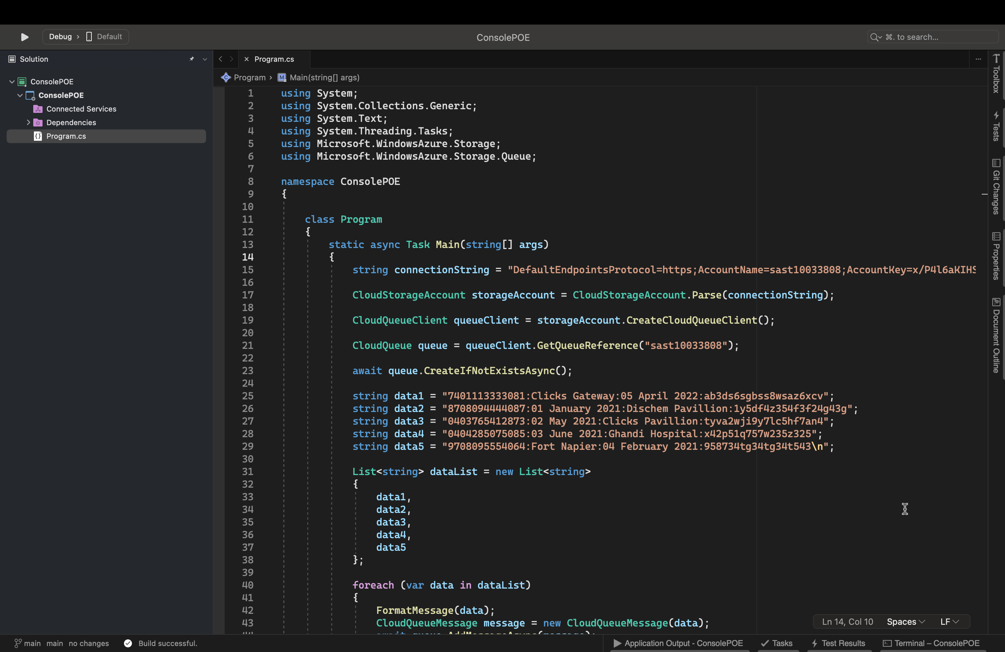



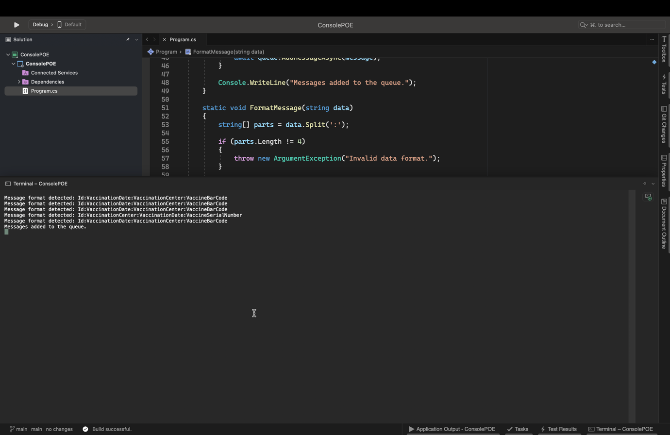

5 DIFFERENT FORMATS



Different format





Different format detected





Different format, formatted In the table storage



(Microsoft, 2023).

**REFERENCE LIST**

Microsoft. 2023. Introduction to Azure Storage, 12 October 2023.

[Online]. Available at:

<https://learn.microsoft.com/en-us/azure/storage/common/storage-introduction>

[Accessed 10 November 2023].

Microsoft. 2023. Azure Functions overview, 24 May 2023.

[Online]. Available at:

<https://learn.microsoft.com/en-us/azure/azure-functions/functions-overview?pivots=programming-language-csharp>

[Accessed 10 November 2023].

Microsoft. 2023. Azure Queue storage trigger for Azure Functions, 14 September 2023.

[Online]. Available at:

<https://learn.microsoft.com/en-us/azure/azure-functions/functions-bindings-storage-queue-trigger?tabs=python-v2%2Cisolated-process%2Cnodejs-v4%2Cextensionv5&pivots=programming-language-csharp>

[Accessed 10 November 2023].

Microsoft. 2023. Azure Tables client library for .NET - version 12.8.2, 14 September 2023.

[Online]. Available at:

<https://learn.microsoft.com/en-us/dotnet/api/overview/azure/data.tables-readme?view=azure-dotnet>

[Accessed 10 November 2023].