**DBAS6211**

**Assignment**

**ST10083156**

**Tewahido Tefera**

**Question 1**

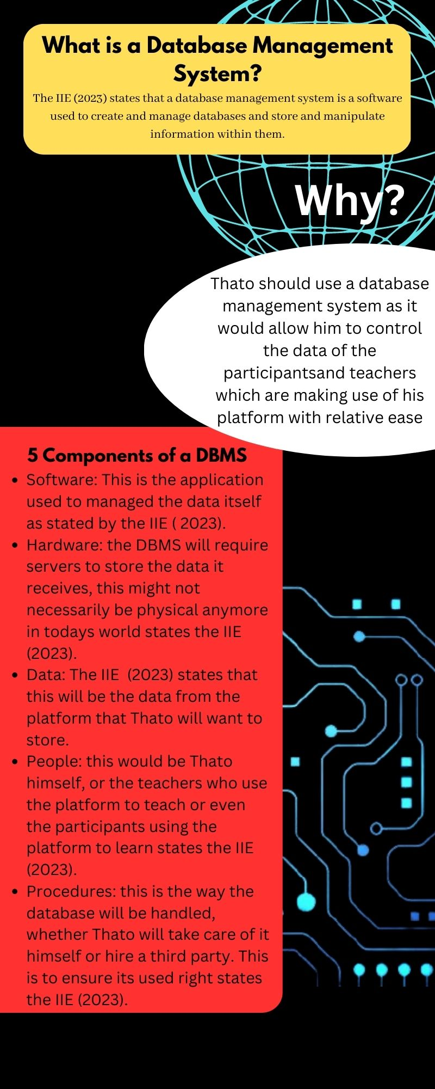

**Question 2**

2.1) The IIE (2023) states that relational databases are best used for structured data and the data Thato wishes to store is of that sort, so ordered data like this would require a relational database as the data being stored is structured and thus needs to be organised for it to be used well.

2.2)The IIE (2023) states that NoSQL databases store semi-structured or unstructured data. Pictures and videos will not be related to each other when being stored so this type of database would be more efficient as NoSQL databases excel in their ease-of-use as well as scalability as stated by the IIE (2023).

**Question 3**

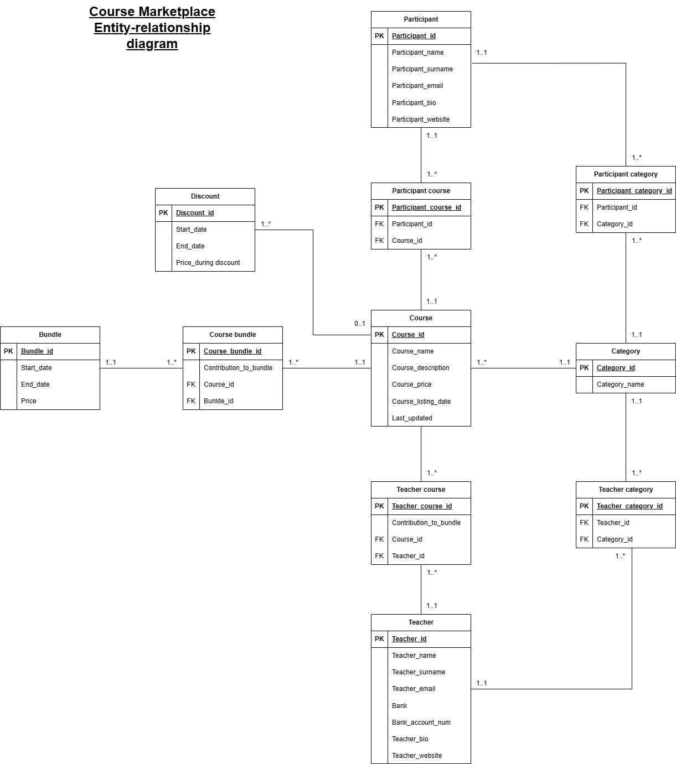

**Question 4**

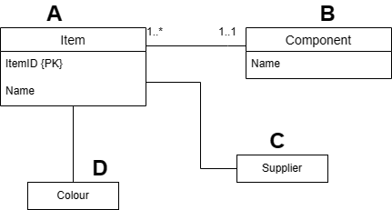

1. The relationship between entity A and entity B is reversed so it should be (1..*) on entity B and (1..1) on entity A
2. Entity B needs to have an attribute for quantity in it as the database needs to store the quantity of components used
3. Entity B does not have a primary key so a surrogate key needs to be given to it
4. Entity C has no attributes, it needs to be given a primary key
5. There should be no relationship between entities A and C
6. Entity C should have a relationship with entity B
7. The relationship between entity C and B would be one-to-many, one being on entity C’s side and many being entity B
8. The attributes name and address need to be added to entity C
9. Entity D should be named production line, as “colour” is an attribute of the entity
10. The relationship between entity A and entity D is a one-to-one so it should have (1..1) on both sides

**Bibliography**

* The IIE. 2023. DATABASES DBAS6211/d MODULE MANUAL, 1st ed. The IIE.