ADARSH RAMGOBIN

ST10316986

MAST5112-PART-1

Contents

HOME PAGE : page 2- page 3

HISTORY PAGE : page 4-page 5

GENRE PAGE : page 6-page7

REFERENCES : page 8

ST10316986_ADARSH-RAMGOBIN_MAST5112_PART-1

HOME PAGE

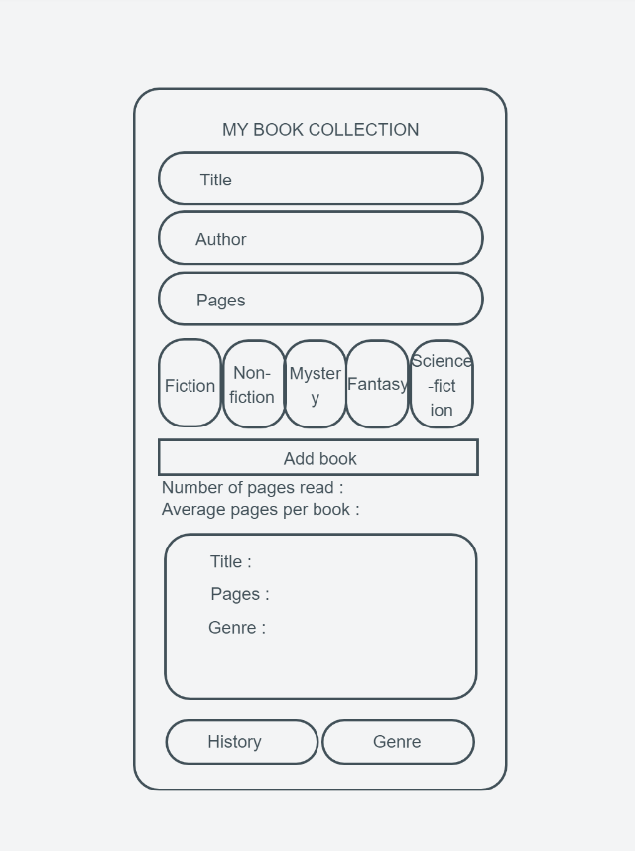

Details:

Home Screen: The initial screen, in this code, is the entry point of the app. Users interact with various elements on this screen to perform actions related to bookkeeping

Tab Navigation: Tab navigation is used to organize the app's sections. It's implemented as a set of buttons at the bottom of the screen, such as "History" and "Genre." Users can tap these tabs to switch between different sections or screens.

Navigation Actions: When a user taps a tab, navigation actions like navigate or push are typically used to transition to the corresponding screen. For example, when the "History" tab is tapped, it navigates to the screen displaying the transaction history and there is also a genre tab to navigate to

Screen Structure: Each section or screen (e.g., "History" or "Genre") is structured separately within the code. These screens are designed to display specific content and functionality related to their respective tabs.

HISTORY PAGE

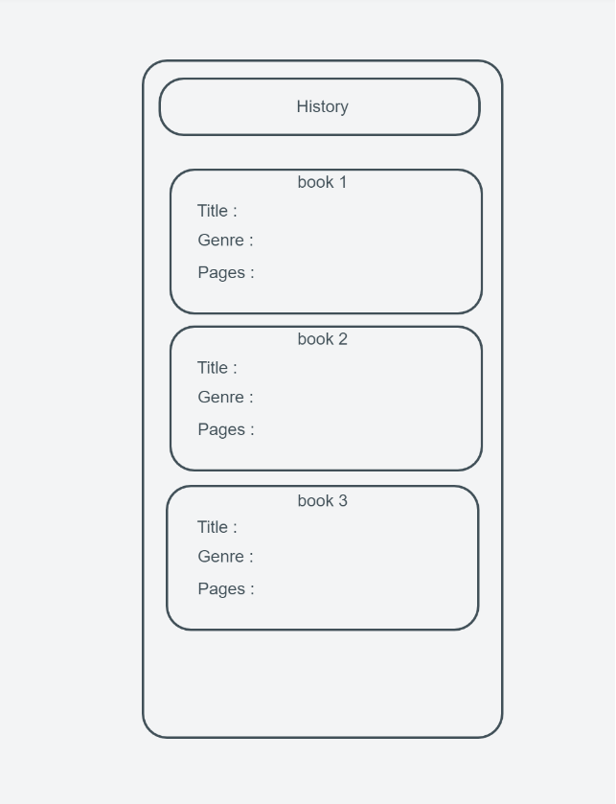

Details:

Screen Structure and navigation: The "History Page" is structured separately within the code. It's designed to display specific content: the titles of the last three books you've read, their genres, authors, and the number of pages you've read. Each book's information is like a neatly organized paragraph in this chapter of the app. This page dynamically shows your reading history based on the data you've entered. It's like having an automatically updating diary of your recent book adventures.

GENRE PAGE

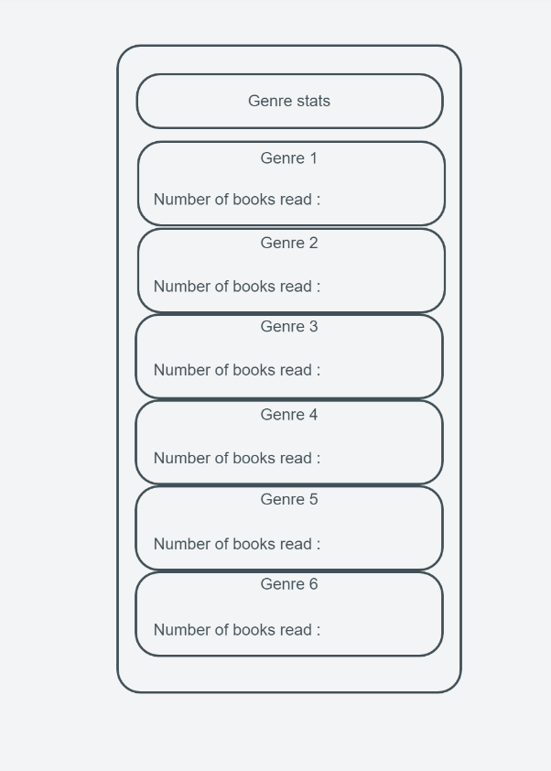

Details:

Page Purpose: The "Genre Page" is your go-to place for exploring the different book genres you've read and how many books belong to each genre. It's like a library catalog that organizes books by genre.

Screen Structure: Inside the code, the "Genre Page" is structured separately. It's designed to display a list of genres along with the number of books you've read in each genre. Each genre is like a category in your personal library, and the book counts are like the bookshelf labels. his page dynamically shows you how your reading interests are distributed across different genres based on the data you've entered

References

mockitt.wondershare.com. (n.d.). *Mockitt*. [online] Available at: https://mockitt.wondershare.com/flow/design/pblmj2vbkoj7nb52 [Accessed 14 Sep. 2023].

‌ W3Schools (2023). *W3Schools Online Web Tutorials*. [online] W3schools.com. Available at: <https://www.w3schools.com/>.

reactnative.dev. (n.d.). *Style · React Native*. [online] Available at: https://reactnative.dev/docs/style.

‌