ST10352114

Muhammed Safwaan Ally

MAST5112

https://www.loom.com/share/My-Troubles-with-BlueStacks-2eb9266bb3074be8853dac6dc7116b6f?sid=61966b92-08c1-4d38-8102-b375a0caac85

User Interface Design:

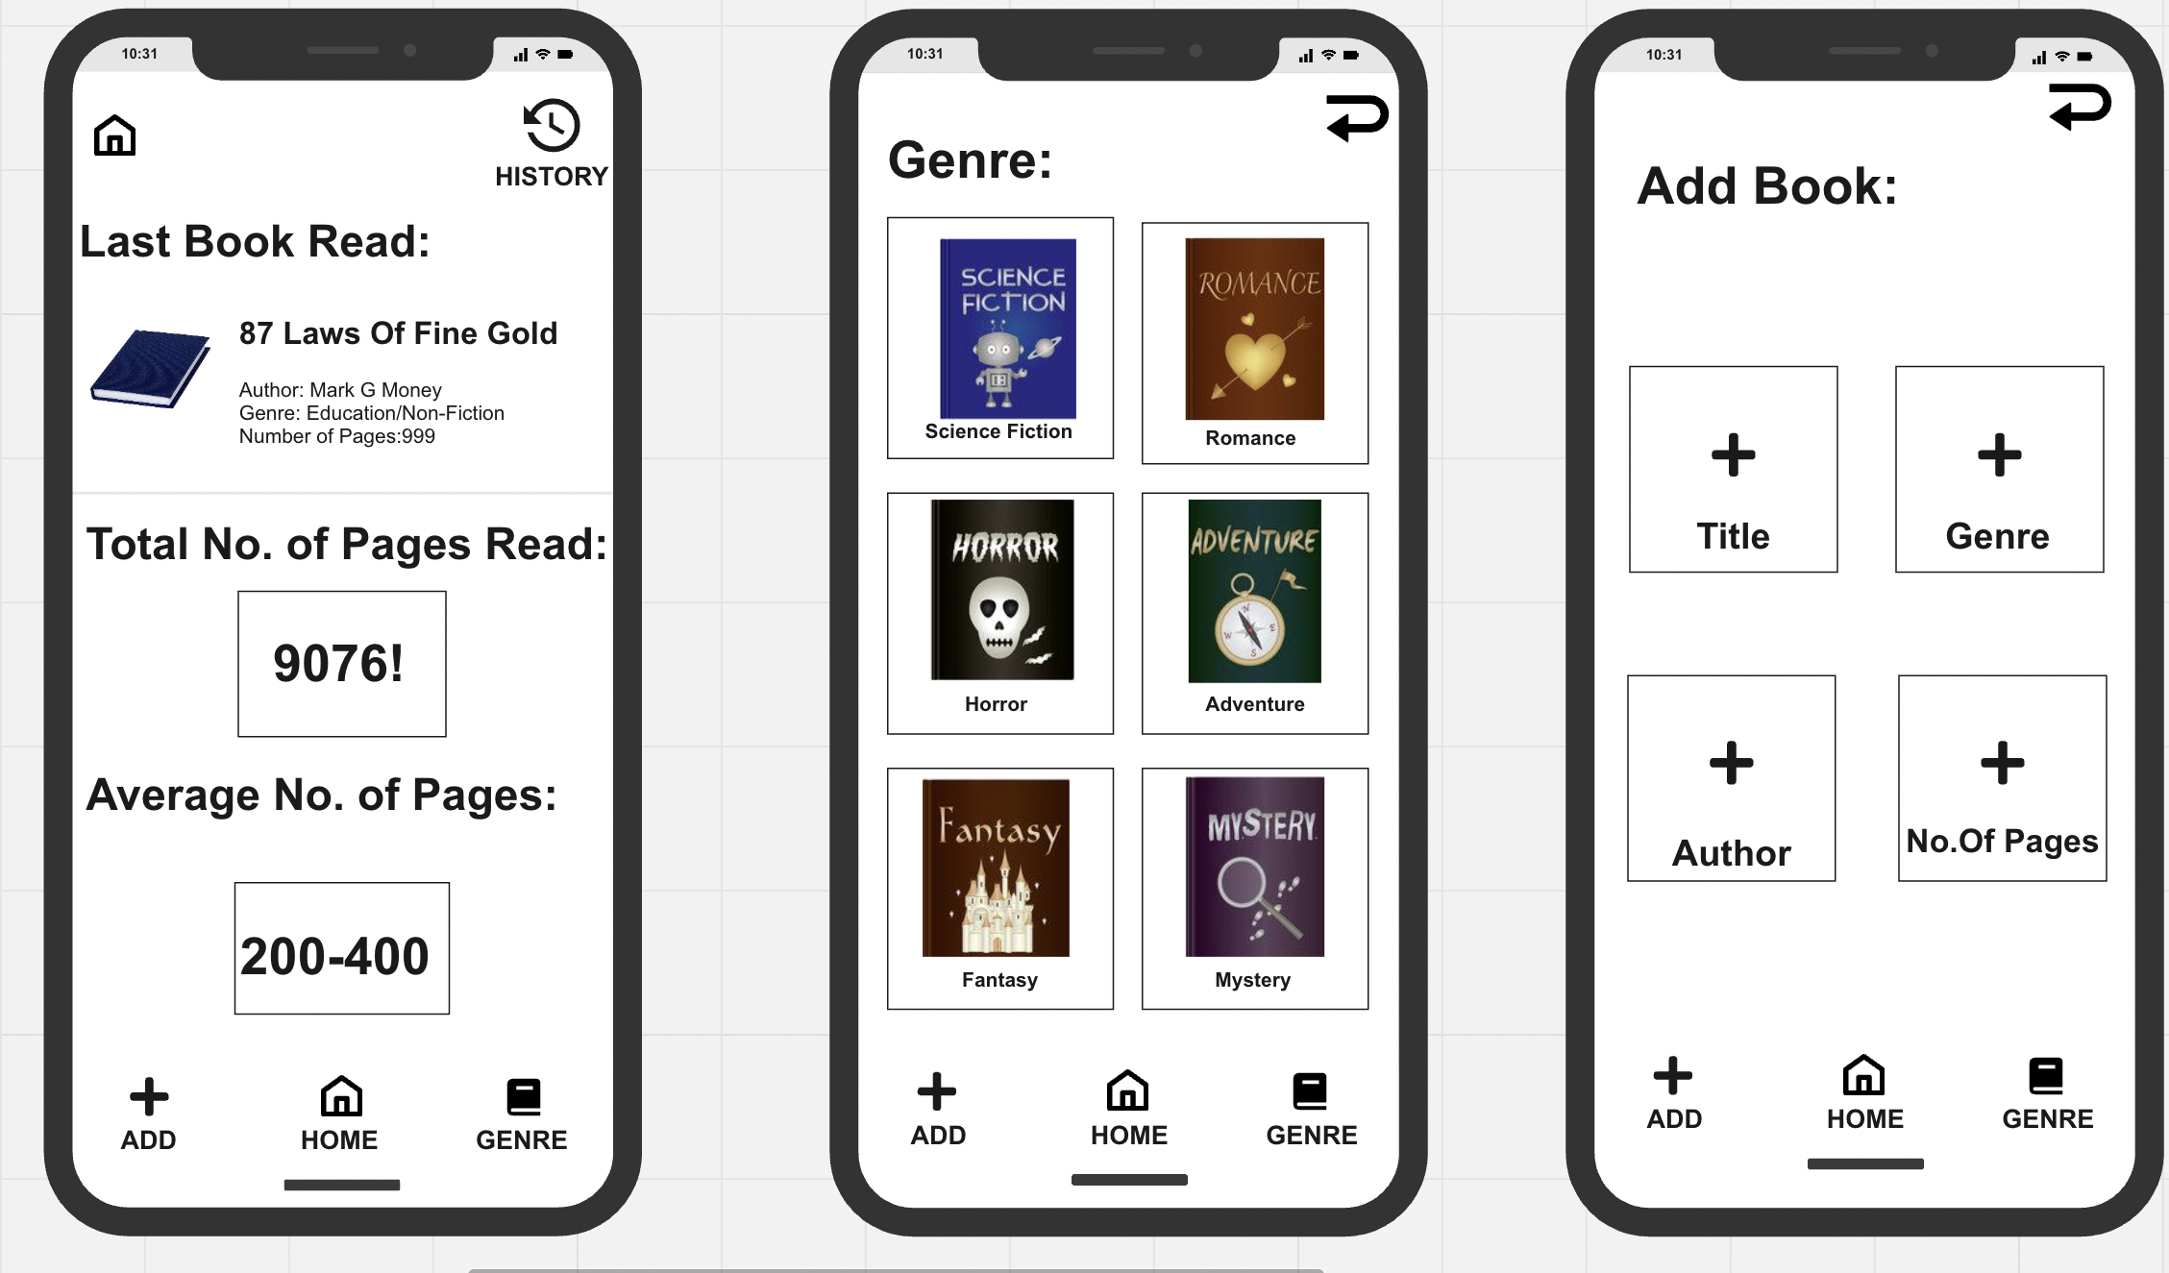

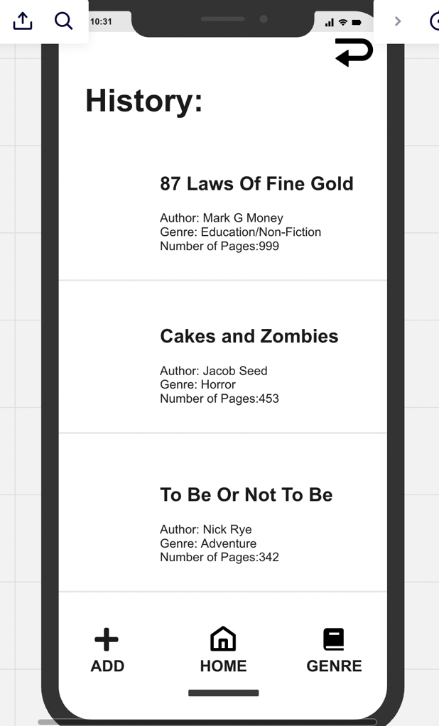

My Book app is easy to navigate and use, making use of the minimal button designs and layout. I have carefully placed each icon and button in easy to find areas. On the home screen you will find a bottom navigation bar with 3 buttons to help you navigate the app with ease. If you turn your attention to the top right corner, you will find a return button, On the home screen at the top we have opted to add the history tab there as it the most accessible spot on the app.

-Easy bottom nav bar

-Simple design

-Use of black and white colors

-Easy font to read and understand

Reference:

React Native (2022). *React Native · A framework for building native apps using React*. [online] reactnative.dev. Available at: https://reactnative.dev/.

‌