**ST10116374 PROG7311 POE Readme**

The vidoe for the demo link is: <https://youtu.be/dj25vrSJQjA> sorry for no sound the virtual machine wouldn't use my mic and the quality is bad because my laptop and internet are not the best.

To open the program, you can use Visual Studio use the "Green arrow and start button" or open "ST10116374\_PROG7311\_POE.sln" can also be done using visual studio. Once open in visual studio you will need to make sure that your database is connected to a SQL server to do this go to the top left under view than server explorer this page will pop up:

All SQL scripts are in the same folder as this file

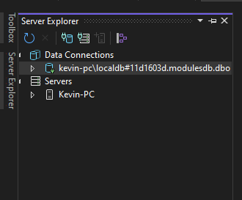

Hit the button that says “connect to databases” it looks like a cylinder with a power plug, then this page will pop up

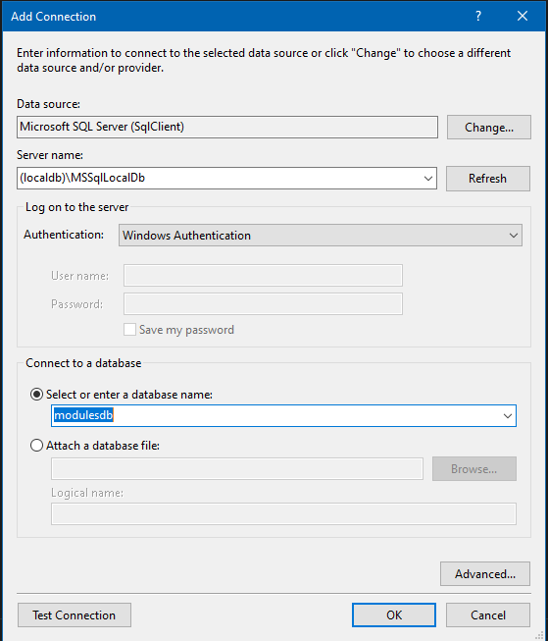

Fill server name with the server you connect to in SQL Server Management Studio and under “select or enter a database name” enter the databases that you will need mine was called ”FarmDB”

This is where you can find the server you're connecting to

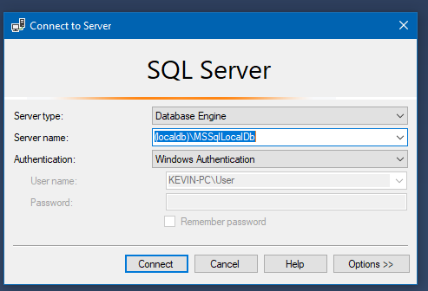

Once you have connected the server connection will appear under “Database Connections”

Then you will need the to change the connection string to your local database you find fin at the bottom right in visual studio if you click your database connection

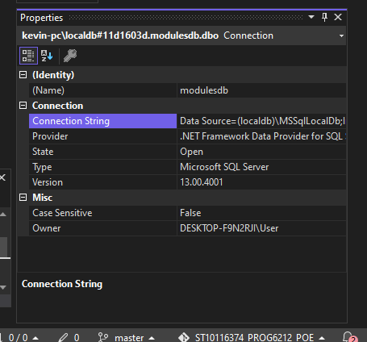

Copy the connection string and past it in the needed connectionString in the project file they look like this:

D:\Anime and Vidoes\College\PROG6212\ST10116374_PROG6212_POE\ST10116374_PROG6212_POE misc files\Images\ST10116374_PROG6212_POE Serverstringcode.PNG

There is one in Login\_Employee.cshtml, Login\_Farmer.cshtml, all index. Cshtml, Delete. Cshtml, create. Cshtml and NewFarmer. cshtml

Once you have done that and you used the same database name and tables the app should be able to read and write to the database. All that left is to press this button and the app will start how to use the app will be covered in the user manual.

D:\Anime and Vidoes\College\PROG6212\ST10116374_PROG6212_POE\ST10116374_PROG6212_POE misc files\Images\ST10116374_PROG6212_POE Button.PNG

**User manual**

This program demo was made so that famer could log in their product that they have made or have, this is just a demo so must feature will be working in progress.

Login

There are two login one for the employee who will create the login for the farmer, for the moment the employee will have to have a already existing profile on the SQL database because registering will create a data breach problem if anything would happen.

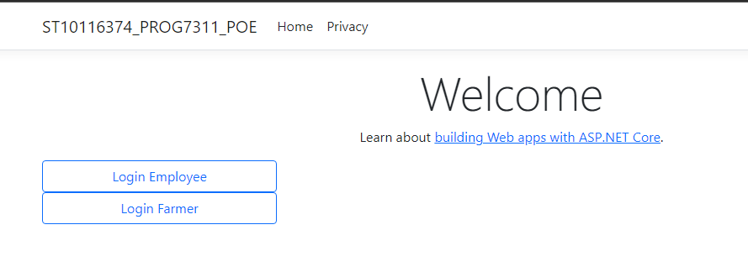

Login for employees is Name: Kevin Password: 2222

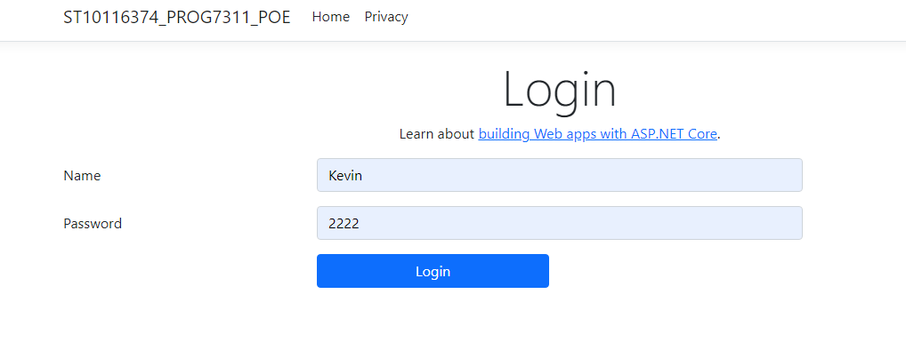

Then you will be on the farmer and product page here you can see all product that famers have uploaded and the famer profile with their passwords and ID if you click create new famer you can create a new famer profile that you can use to login with.

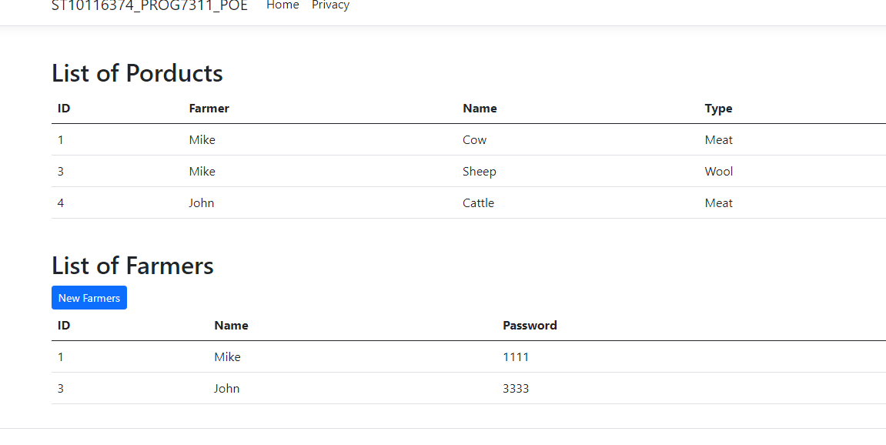

One the new famer page you can insert the passwords and username for famers ID is self-generated than click submit to create it than cancel to return to the Farmers and product page.

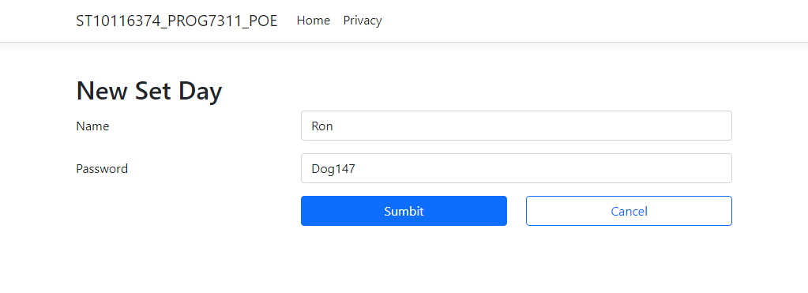

Succes message once done



Famer now on database

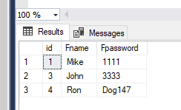

With the famer login use the newly generated Profile to login same as the Employee login

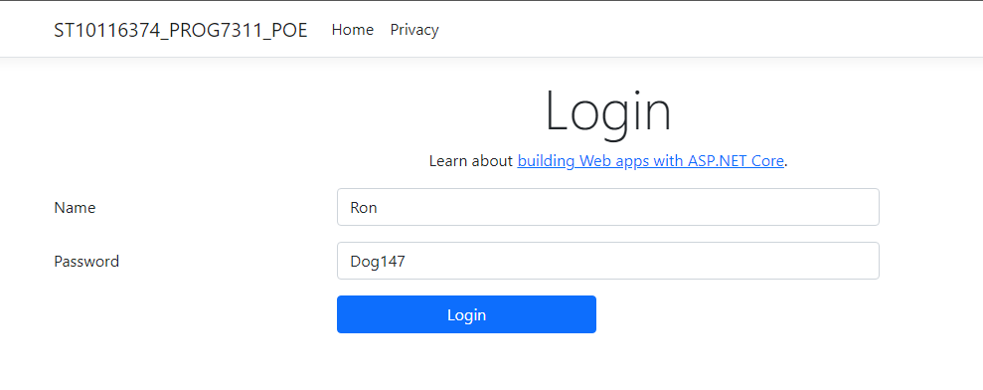

Now on the product page famer can only see product it's still in progress of being polished, so farmers can see all other farmers' product. The delete button will remove the product from the database and website and the new product button will let you create a new product.

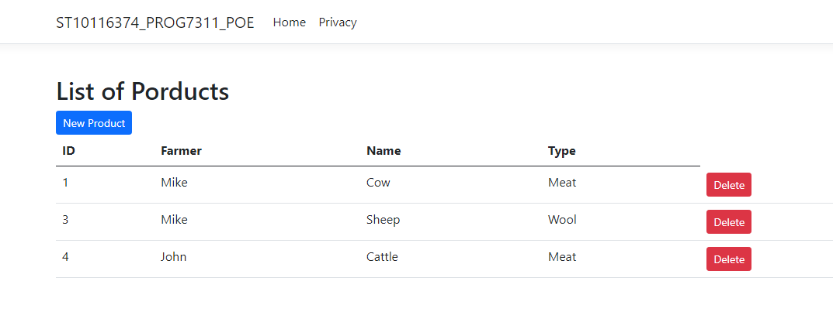

The create page will let farmer fill in their product first with their name, the product name and what type of product it is, click cancel to return to the product page.

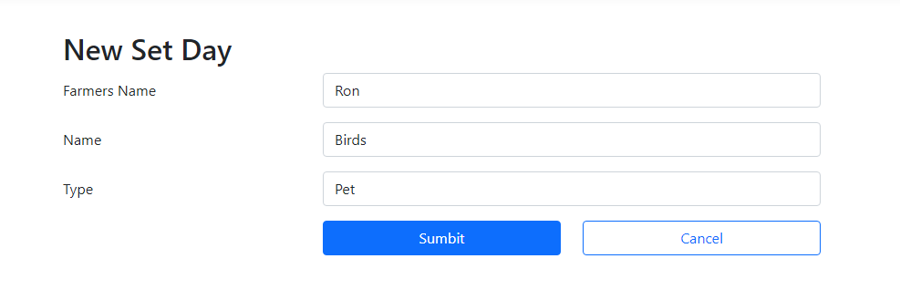

This is the success messages



The product now on the website and databases

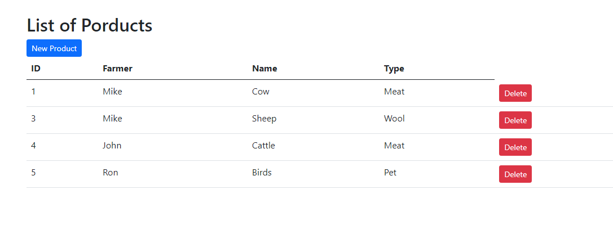

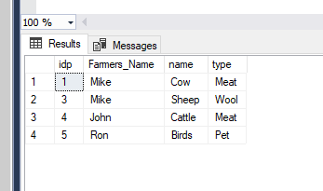

**Requirements**

**Software:** Visual studios and SQL Server Management Studio

**Operating Systems:**

Windows 7 SP1 and later

Windows 8.1

Windows 10 Version 1607 and later

Windows Server 2008 R2 SP1 (Full Server or Server Core)

Windows Server 2012 SP1 (Full Server or Server Core)

Windows Server 2012 R2 (Full Server or Server Core)

Windows Server 2016 (Full Server, Server Core, or Nano Server)

Mac OS X 10.11, 10.12\*

Red Hat Enterprise Linux 7

Ubuntu 14.04, 16.04, 17

**Hardware Environment**

Processor: x86 or x64

RAM : 512 MB (minimum), 1 GB (recommended)

Hard disc: up to 3 GB of free space may be required

**Development Environment**

Microsoft Visual Studio 2015 Update 3 (minimum) , 2017 version latest (15.6.4), 2019, 2022.

.NET Framework : Minimum .NET 4.5.1 upto .NET 4.7 .

Command Line (Optional. Necessary for command line deployment)

Visual Studio Code (optional text-editor)

SQL Server 2008 Express (optional)

.NET Core 3.1

**Browser support**

Chrome Firefox

Opera

Edge

IE

Safari

iOS

Chrome

Android

Windows Mobile

**Reference/Code attribution**

Create ASP.NET Core Web Application with SQL Server Database Connection and CRUD Operations, 2022. YouTube video, added by BoostMyTool. [Online]. Available at: https: <https://www.youtube.com/watch?v=T-e554Zt3n4&list=PLYq-lrm5Dl8956-oK_4s-5HVFrgQYf9k4&index=15&t=708s> [Accessed 28 November 2022]