

WEDE5020 POE PArt-1

Okuhle N-ST10317674



Contents

The South African Red Cross Society 2

Website Assets 3

Reference 4

# The South African Red Cross Society

Providing Humanitarian Services: The South African Red Cross provides humanitarian services to most people in need. These include health care, disaster relief, and social services.

Volunteering: The organization has a large network of volunteers who devote their time and effort to helping others in their communities. Working with Partners: The South African Red Cross works with other organizations and community groups to deliver its services.

This cooperation contributes to the efficient use of resources. Promotion of International Humanitarian Law: The South African Red Cross promotes the principles of international humanitarian law, which protect people in armed conflict and ensure that medical and humanitarian personnel can carry out their duties safely and unhindered.

The NMU branch of the South African Red Cross is a student-run organization dedicated to teaching students how to live the Red Cross mission by providing training on a wide variety of topics, from gender-based violence to childhood cancer through volunteering.

The reason chose this organization is because it is helping a lot of people who are struggling with their living situations, as well as their daily necessities which is incredible. It inspires people to look after each other to humility in the country.

Overall whether the South African Red Cross is good or not depends on your perspective, values ​​, and priorities.

# Website Assets

* [The South African Red Cross Society](https://redcross.org.za/home/)
* [SA Red Cross at war with itself (dailymaverick.co.za)](https://www.dailymaverick.co.za/article/2021-04-22-sa-red-cross-at-war-with-itself/)
* [South African Red Cross Society - Student Governance and Development (mandela.ac.za)](https://studev.mandela.ac.za/Student-Life-and-Events/Society-Categories/Developmental-Societies/South-African-Red-Cross-Society)

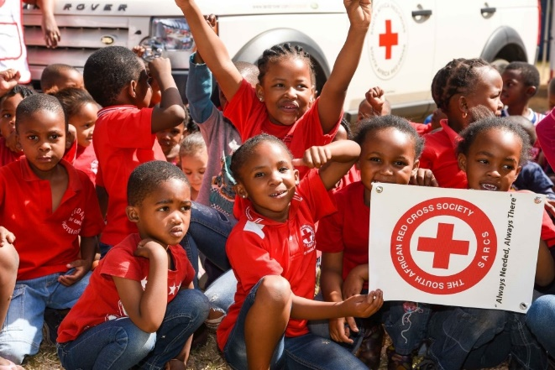

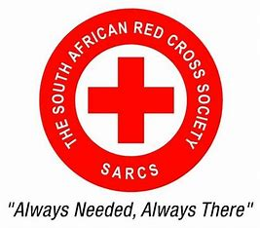

# Reference

* The South African Red Cross Society (2022). Available at: <https://redcross.org.za/home/>.
* Manoim, G.R. and I. (2021) SA Red Cross at war with itself. Available at: <https://www.dailymaverick.co.za/article/2021-04-22-sa-red-cross-at-war-with-itself/>.
* South African Red Cross Society  - Student Governance and Development (no date). Available at: <https://studev.mandela.ac.za/Student-Life-and-Events/Society-Categories/Developmental-Societies/South-African-Red-Cross-Society>.