Luthando Dlamini ST10447881

IMAD5112 Practical README File

# Links

<https://github.com/ST10447881/WeatherApp_Practical>

# Introduction

The app I have created is a Weather App, it collects user input and calculates the average temperature of seven days. The user inputs relevant data and the app calculates the average temperature and displays it to the user.

# Pseudocode

## First Screen

Start

1. Declarations

Textview

1. Find TextView with ID “tvDetails” and store it in tvDetails
2. Delay for 5 seconds

Create new intent to start MainActivity2

Start MainActivity2 using the intent

Stop

## Second Screen

Start

1. Declare and initialize variables

saveButton : Button

clearButton : Button

nextButton : Button

edDay : EditText

edMintemp : EditText

edMaxtemp : EditText

edWeather : EditText

tvMsg : TextView

1. Initialize lists to store weather data

Create empty lists :

dateArray, mintempArray, maxtempArray, weatherArray

1. Setup clearButton

When clearButton is CLICKED

CLEAR text in edDay, edMintemp, edMaxtemp, edWeather

End When

1. WHEN saveButton is CLICKED

READ values from edDay, edMintemp, edMaxtemp, edWeather

IF all values are NOT EMPTY

TRY

CONVERT mintemp and maxtemp to numbers

ADD values to lists(dateArray, mintempArray, maxtempArray, weatherArray)

CLEAR text in edDay, edMintemp, edMaxtemp, edWeather

CATCH NumberFormatException

Print(“Enter a valid number”) in tvMsg

End TRY

ELSE

Print(“Space cannot be left blank”) in tvMsg

End IF

End WHEN

1. WHEN nextButton is CLICKED

CREATE new Intent to start MainActivity3

PUT data arrays(dateArray, mintempArray, maxtempArray, weatherArray) as extras in

Intent

Start MainActivity3 using Intent

END WHEN

Stop

## Third Screen

Start

1. Declare

TextViews(tvDay, tvMintemp, etc.) and homeButton

1. GET dateArray, mintempArray, maxtempArray, weatherArray from Intent
2. //Calculate average temperature

sumTemp = 0

countTemp = 0

FOR EACH temp in mintempArray

sumTemp = sumTemp + temp

countTemp = countTemp + 1

END FOR

FOR EACH temp in maxtempArray

sumTemp = sumTemp + temp

countTemp = countTemp + 1

END FOR

IF countTemp > 0 THEN

avgTemp = sumTemp / countTemp

ELSE

avgTemp = 0

END IF

DISPLAY avgTemp in tvResult

1. //Build and display weather strings

CREATE strings for day, mintemp, maxtemp, weather, using data arrays

DISPLAY strings in TextViews

1. //Setup home button

WHEN homeButton is CLICKED

FINISH activity

END WHEN

Stop

## Screenshots of the App

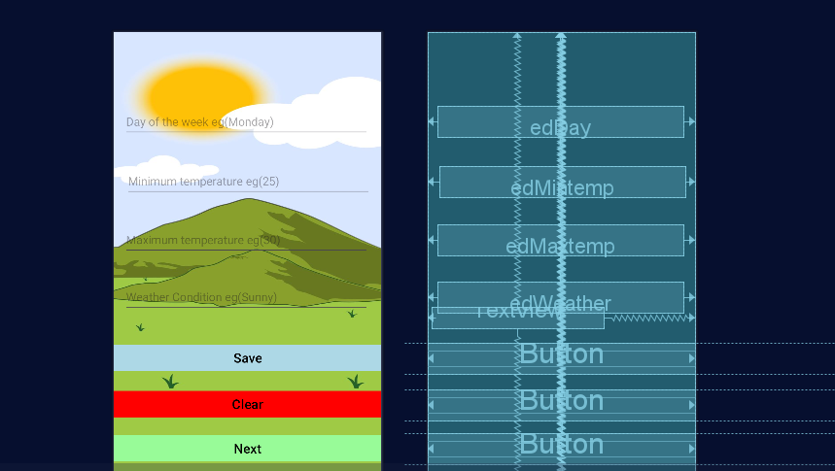

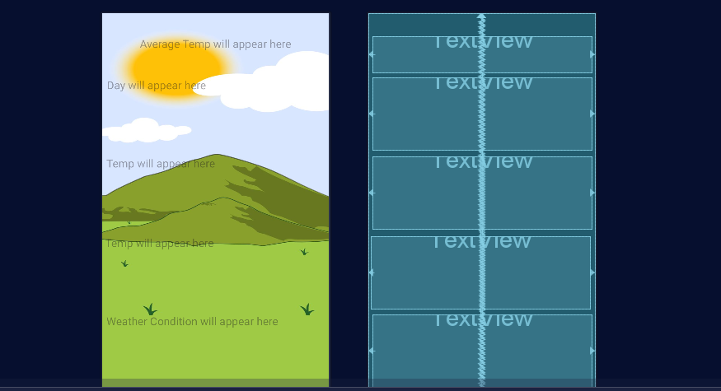

## Screenshot app working

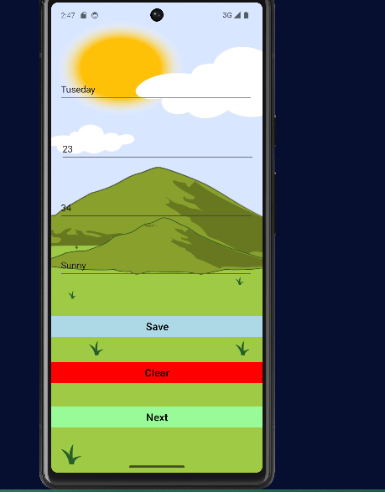

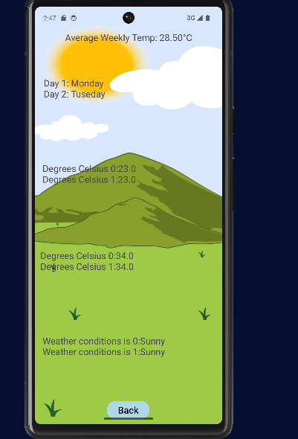

## Screenshot of error messages



