9/10/2024

Sashiel Moonsamy

ST10028058 prog6212 poe pART 1

Sashiel Moonsamy

ST10028058

PROG6212

POE Part 1

1. Documentation

* Github Link: <https://github.com/VCDN-2024/prog6212-poe-part-1-ST10028058-Sashiel.git>
* Uploaded on VC Learn as well

1. UML Class Diagram

* Github Link: <https://github.com/VCDN-2024/prog6212-poe-part-1-ST10028058-Sashiel.git>
* 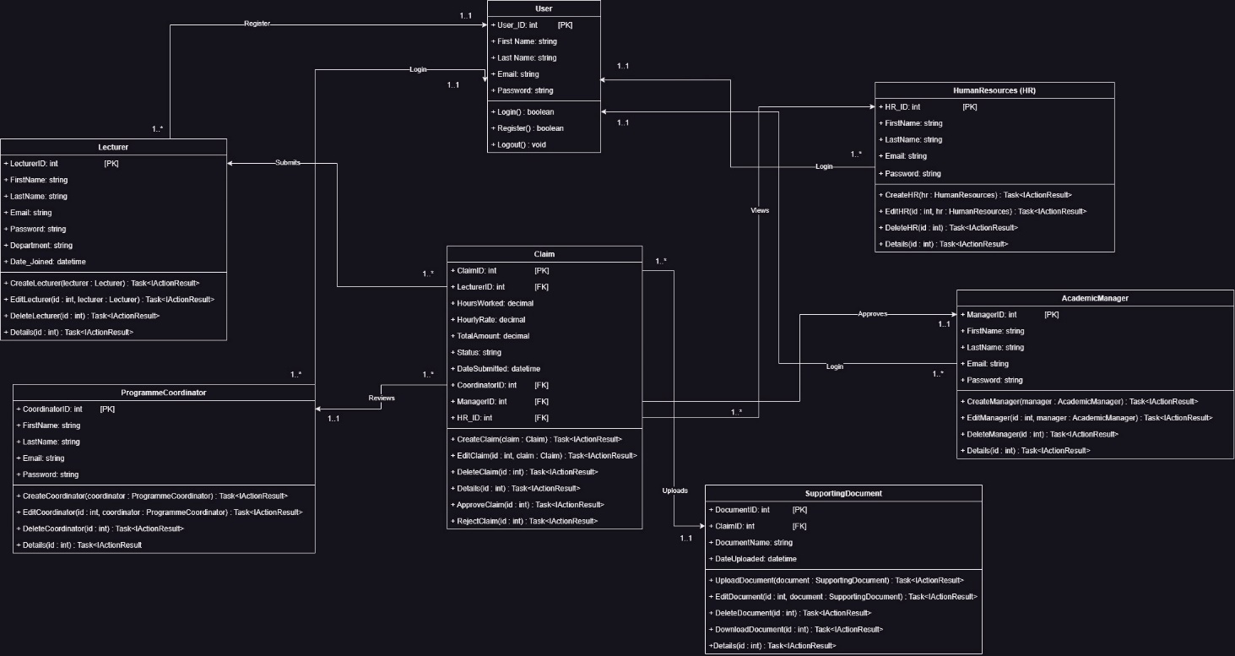

1. Project Plan

* Github Link: <https://github.com/VCDN-2024/prog6212-poe-part-1-ST10028058-Sashiel.git>
* Uploaded on VC Lean as Well

Project Plan

1.Project Phases

1. Phase 1: Planning and Requirements Gathering
2. Phase 2: System Design
3. Phase 3: Development
4. Phase 4: Testing
5. Phase 5: Deployment
6. Phase 6: Documentation and Handover

2. Tasks, Dependencies, and Timeline

Phase 1: Planning and Requirements Gathering

(“What Is a Project Plan? The Ultimate Guide to Project Planning,” n.d.)

-Task 1.1: Define Requirements (3 days)

- Identify user roles (Lecturers, Programme Coordinators, Academic Managers, HR).

- Gather functional requirements (claim submission, approval workflows, document uploads).

- Dependency: None.

- Task 1.2: Set Up Development Environment (2 days)

- Install necessary tools (e.g., Visual Studio, ASP.NET, SQL Server).

- Dependency: Completion of Task 1.1.

Total Time: 5 days

------------------------------------------------------------------------------------------------

Phase 2: System Design

- Task 2.1: Design Database Schema (3 days)

- Design tables and relationships for Lecturers, Claims, Coordinators, Managers, and HR.

- Dependency: Completion of Phase 1.

- Task 2.2: Design Application Architecture (4 days)

- Define MVC structure with models, views, and controllers for each user role.

- Dependency: Completion of Task 2.1.

- Task 2.3: Design User Interface Mock-ups (3 days)

- Create wireframes for Lecturer dashboard, claim submission forms, and review interfaces.

- Dependency: Completion of Task 2.2.

Total Time: 10 days

------------------------------------------------------------------------------------------------

Phase 3: Development

- Task 3.1: Implement Database (3 days)

- Create the database and implement schema for claims, users, and documents.

- Dependency: Completion of Phase 2.

- Task 3.2: Develop Models (4 days)

- Implement models for Lecturer, Claim, ProgrammeCoordinator, AcademicManager, and HR.

- Dependency: Completion of Task 3.1.

- Task 3.3: Develop Controllers (5 days)

- Implement controllers to handle interactions for claim submissions and approvals.

- Dependency: Completion of Task 3.2.

(“What Is a Project Plan? The Ultimate Guide to Project Planning,” n.d.)

- Task 3.4: Develop Views (5 days)

- Create views for Lecturer dashboards, claim submission, and review pages for Coordinators/Managers.

- Dependency: Completion of Task 3.3.

- Task 3.5: Implement File Upload for Supporting Documents (2 days)

- Allow users to upload PDFs as supporting documents for claims.

- Dependency: Completion of Task 3.4.

Total Time: 19 days

------------------------------------------------------------------------------------------------

Phase 4: Testing

- Task 4.1: Unit Testing (3 days)

- Test individual components (models, controllers) for each module.

- Dependency: Completion of Phase 3.

- Task 4.2: Integration Testing (3 days)

- Test workflows such as claim submission, review, approval, and HR processing.

- Dependency: Completion of Task 4.1.

- Task 4.3: Load Testing (2 days)

- Test system performance under increasing data loads.

- Dependency: Completion of Task 4.2.

Total Time: 8 days

------------------------------------------------------------------------------------------------

Phase 5: Deployment

- Task 5.1: Prepare Deployment Environment (2 days)

- Set up hosting and ensure proper configuration for deployment.

- Dependency: Completion of Phase 4.

- Task 5.2: Deploy the Application (1 day)

- Deploy the CMCS system and perform final checks.

- Dependency: Completion of Task 5.1.

Total Time: 3 days

------------------------------------------------------------------------------------------------

Phase 6: Documentation and Handover

- Task 6.1: Write User Documentation (3 days)

- Create user guides for lecturers, coordinators, managers, and HR staff.

- Dependency: Completion of Phase 5.

(“What Is a Project Plan? The Ultimate Guide to Project Planning,” n.d.)

- Task 6.2: Write Technical Documentation (3 days)

- Document the code structure, architecture, and setup instructions.

- Dependency: Completion of Task 6.1.

- Task 6.3: Handover and Training (2 days)

- Conduct training sessions for key users.

- Dependency: Completion of Task 6.2.

Total Time: 8 days

------------------------------------------------------------------------------------------------

3. Summary Timeline

- Phase 1: Planning and Requirements Gathering: 5 days

- Phase 2: System Design: 10 days

- Phase 3: Development: 19 days

- Phase 4: Testing: 8 days

- Phase 5: Deployment: 3 days

- Phase 6: Documentation and Handover: 8 days

Total Project Duration: 53 days (approximately 8 weeks)

1. GUI Design/UI Design

* Github Link: <https://github.com/VCDN-2024/prog6212-poe-part-1-ST10028058-Sashiel.git>
* Uploaded on VC Learn as well
* Login Page(Figma ,2016)
* 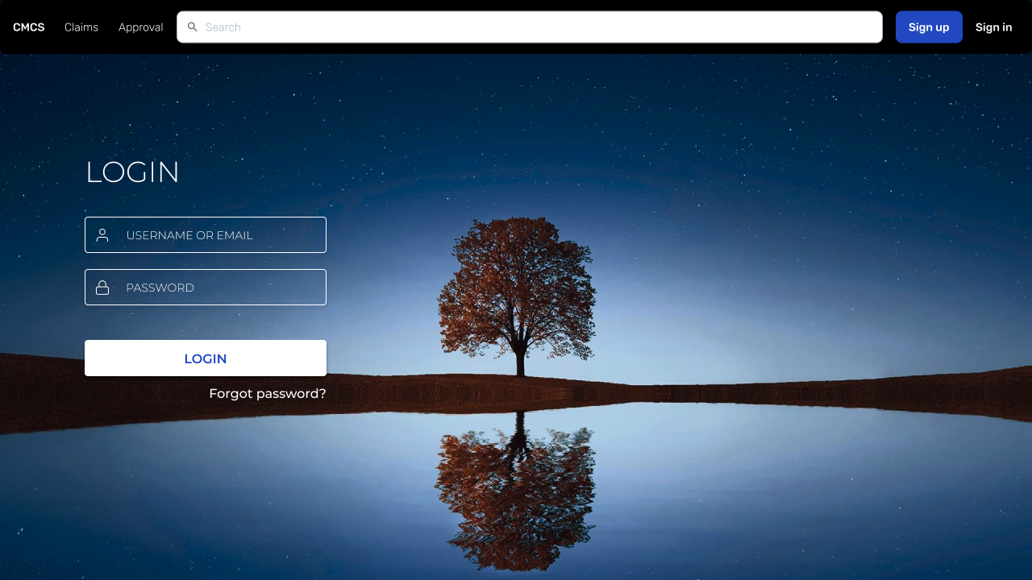
* Register Page(Figma ,2016)
* A tree reflected in water

  Description automatically generated
* Submit a Claim(Figma ,2016)
* A screenshot of a computer

  Description automatically generated
* Claim Progress(Figma ,2016)
* A screenshot of a computer

  Description automatically generated
* Claim Approval (Figma ,2016) A screenshot of a computer

  Description automatically generated

**Reference List**

Figma (2016) ‘Figma for UX design’. Figma.com.

(“What Is a Project Plan? The Ultimate Guide to Project Planning,” n.d.)

What Is a Project Plan? The Ultimate Guide to Project Planning [WWW Document], n.d. URL https://www.projectmanager.com/guides/project-planning (accessed 9.10.24).