JADIN NAICKER

ST10275486  1 October 2024

CLDV6212: POE Part 2

1. **Screenshots and deployment**

**Deployment**:

### **Web App creation**:

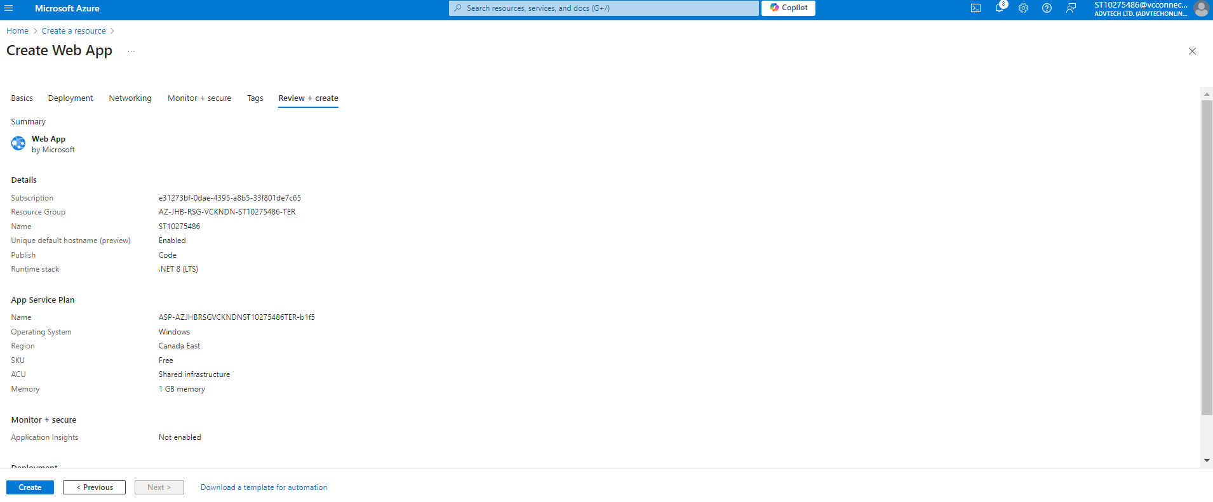

### **Web app published**:

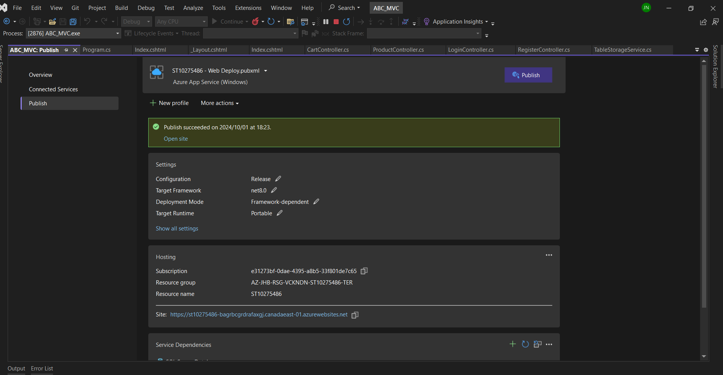

### Azure web app in use:

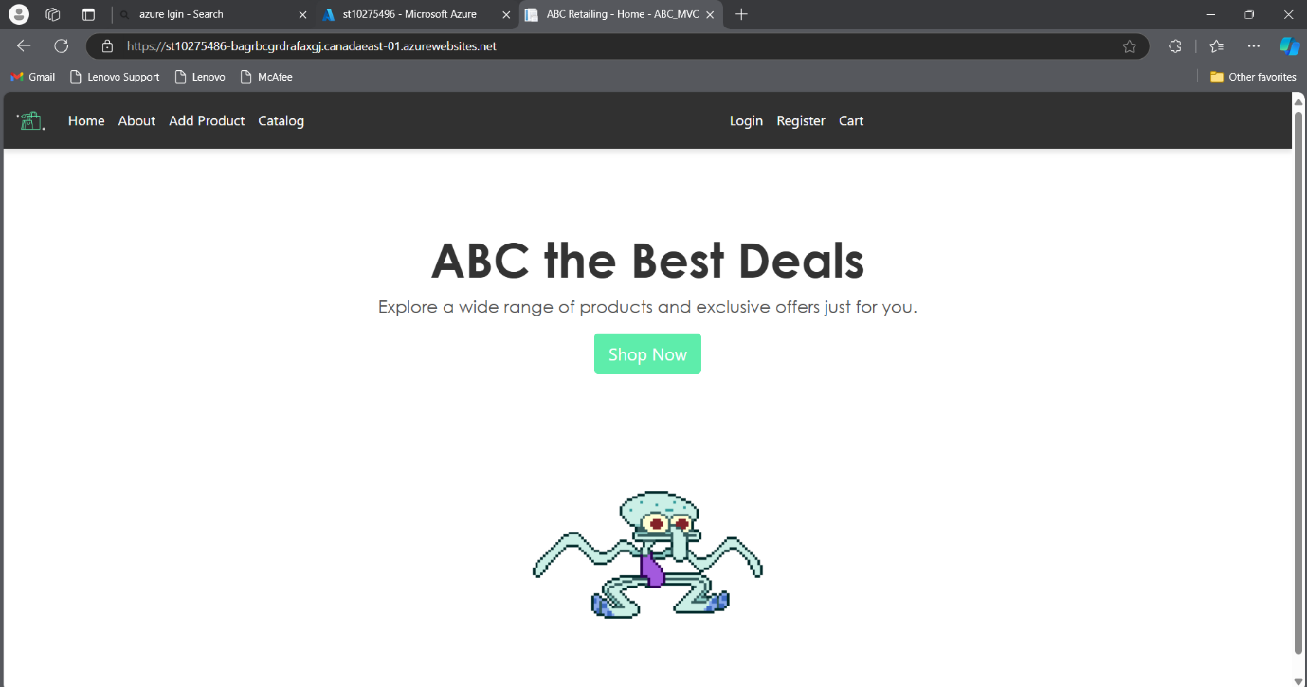**Function app in azure**:

## **Published functions:**

### Blob function:

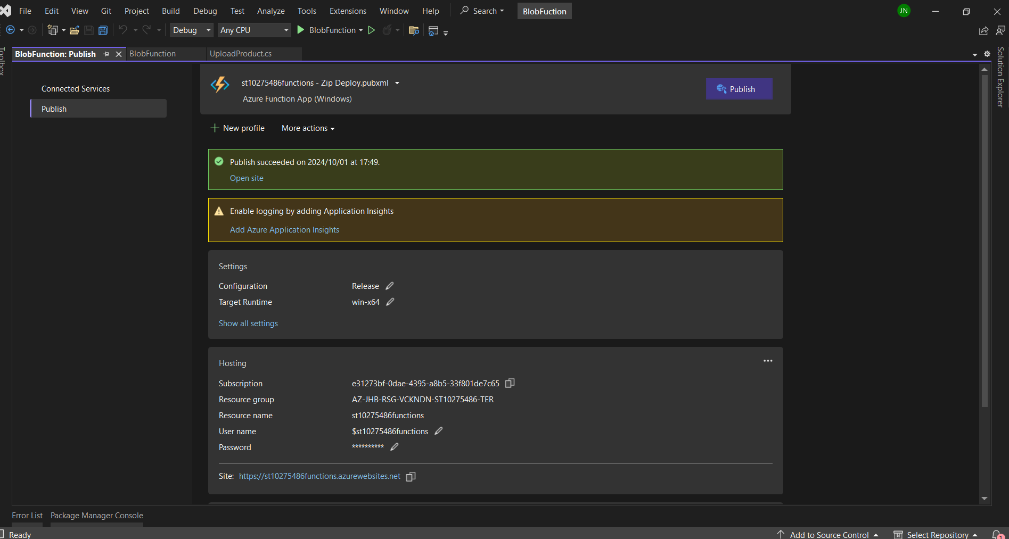

### Queue Trigger Function:

### File Share Trigger Function:

### Table function:

## **How each function Works:**

**B.** **Using Azure Event Hubs and Azure Event Grid Services for Improving Customer Experience**

## **Azure Event Hubs**

What are Azure Event Hubs

The Azure Event Hubs service is a fully managed solution for the collection of large quantities of data from various inputs such as applications, websites, and IOT devices. It is capable of effortless transmission of even millions of events per seconds making it high traffic and heavy data load suited. Event Hubs has unique features like geo-disaster recovery and geo-replication which means data processing can go on even in emergency situations. Event Hubs works with different Azure services to bring insights to customers and is compatible with existing Apache Kafka clients and applications without the need to alter any code, offering a fully managed Kappa infrastructure without the hassle of having to oversee your own clusters. Real-time data ingestion and micro-batching can be experienced by the users over the same stream, enabling agile and diverse data processing approaches to meet every altering business needs. (Microsoft, n.d.)

### Mechanism Of Azure Event Hubs

Azure Event Hubs is a key component of the architecture of business applications, enabling them to work with ease by transferring data across processes with the help of messages and events. It collects and handles enormous event streams and sends them to other systems such as Azure Stream Analytics or Azure Functions. Capable of supporting real time and in batch processing, Event Hubs maintains the consistency and scalability of the data presented using partitioned storage. Producers send events to the Event Hub, while consumers retrieve them in near real-time. In ABC Retail's order processing system, Azure Event Hubs efficiently manages large volumes of order events by automatically writing batches to Azure Blob Storage. This facilitates timely processing, enabling the company to handle peak shopping seasons seamlessly. With its strong event streaming capabilities, Event Hubs integrates smoothly with analytics services, providing real-time insights that enhance customer experience and optimise operational efficiency. (Turbo360, 2024)

### How Azure Event Hubs Adds Value to End Users

For ABC Retail, the use of Event Hubs will greatly enhance the processing of orders and customers in real-time even during the peak times that are associated with holidays. It deals with large flows of events, it guarantees timely and efficient processing of all client orders ensuring that there are minimal delays when customers are making payments for goods or updating their orders. This has a positive impact on the experiences of the customers therefore reducing chances of incidences where they abandon their shopping carts and ensuring that orders are fulfilled without any unnecessary hold ups. (spelluru, 2024b)

## **Azure Event Grid**

What are Azure Event Grids

Azure Event Grid is a cloud-based technology that manages the routing of events in a highly elastic manner to consider evented based systems. It ensures that events generated from different Azure services and IoT devices are sent to event consumers for example, Azure functions, Logic Apps or other external systems without fail. Since it supports a flexible pub-sub model and protocols such as MQTT and HTTP, Event Grid makes it easier to integrate applications and build reactive serverless applications. This is further emphasised by advanced capabilities such as event filtering, push and pull delivery modes, and support for CloudEvents 1.0 specification that are fit for any demanding real-time event processing developments. (spelluru, 2024)

### Mechanism Of Azure Event Grids

In Azure Event Grid, events are sent to topics by publishers, and events are responded to, almost instantaneously, by microservices and applications as subscribers. The service takes care of the propagation and scalability of events, so they are delivered to the appropriate subscribers efficiently. Supported delivery methods include acceptable push or pull deliveries that permit subscribers to get events through web addresses or by use of the service himself. This service also offers more sophisticated filtering, allowing events to be routed according not just to their type, but also certain attributes within the type. This is one of the many reasons Event Grid is helpful in applications that work with events rather than methods since it enables easy cooperation of various applications and services. (spelluru, 2024)

### How Azure Event Grids Adds Value to End Users

With Azure Event Grid, ABC Retail can create a more dynamic and personalised customer experience. For example, Event Grid could instantly notify customers of order status updates, product restocking alerts, or personalised promotions based on their shopping history. By improving event-driven communications, it ensures that customers receive timely information, which can lead to a more engaging and responsive shopping experience. Real-time responses to customer actions reduce latency and improve overall satisfaction. (spelluru, 2024a)

## **Conclusion**

Integrating Azure Event Hubs and Azure Event Grid into ABC Retail would support high capacities of real-time event processing and message dispatch, improving the current constraints. These services would decrease delays and mistakes as well as improve customer interaction by speeding up order processing and making it more tailored. This in turn would mean a better and more beneficial customer experience in all aspects, especially given peak shopping seasons.

## **Bibliography**