Prog6212

POE Part 2

ST10275486

Jadin Naicker  18 October 2024

# Feedback from Part 1:

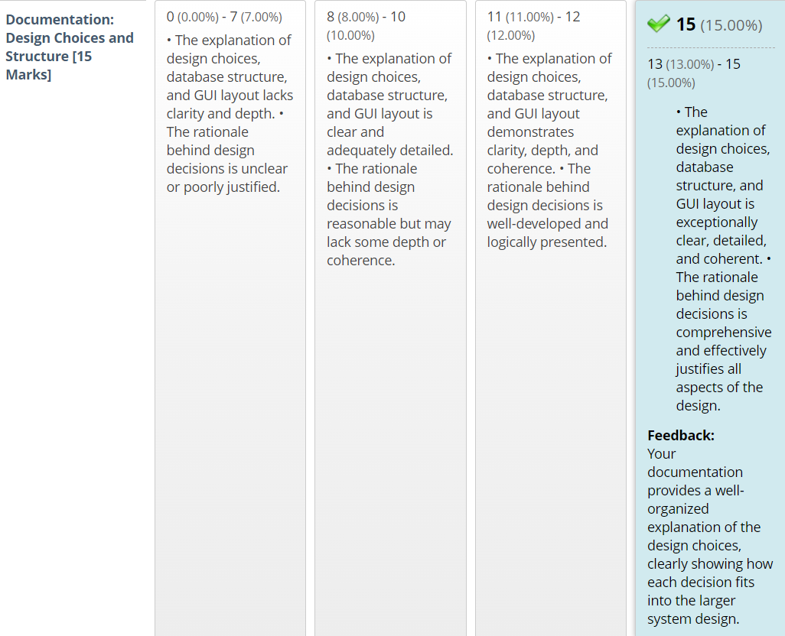

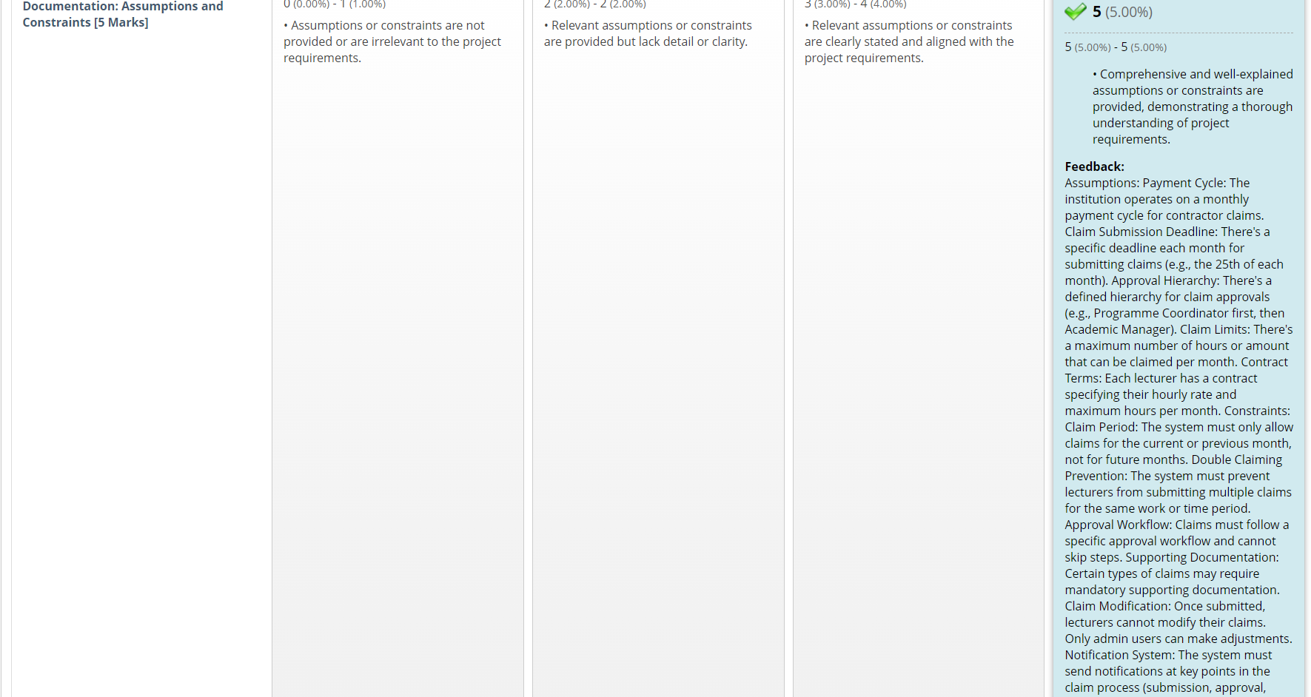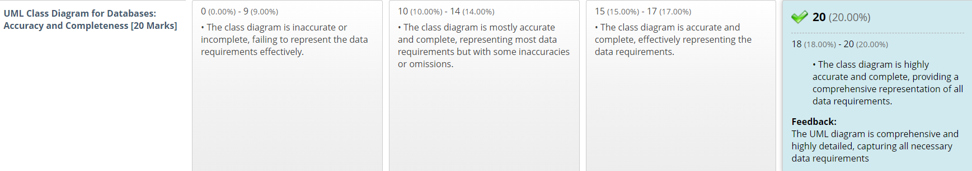

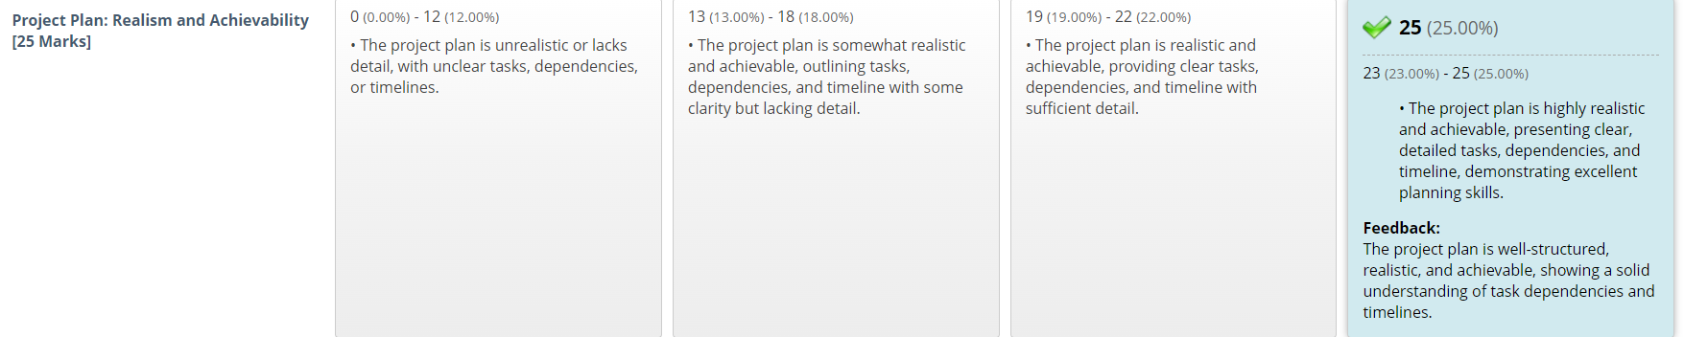

This is the feedback I received from my POE Part 1, I did not make any changes to my part 1 POE as I was rewarded full marks for it

# YouTube and GitHub link:

YouTube Link: <https://youtu.be/E0HKYIJH6D8>

In this YouTube video I show my project where I created my MVC called AfriclalimMVC it shows all the models, classes, controllers and views that I made and used as well as the unit tests I developed and ran. This video also shows the functionality of the web application as i run the code and show how it works, showing error handling as well

GitHub Link: <https://github.com/VCDN-2024/prog6212-poe-part-2-ST10275486.git>

# GitHub Commit History:

ReadME document:  
**Contract Monthly Claim System: Africlaim**

**Introduction** (Erikaheidi, 2022)

Africlaim is a website constructed to manage monthly claims from the lecturers, focused on improving user experience. The system allows educational institutions to administer the claims processes with ease, integrity and precision. The application enables the submission of claims by the lecturers while providing a structured process through which coordinators and managers can review and accept the submitted claims. Besides, Africlaim offers claim status tracking capabilities, claims notification capability, and extensive management functions for Human Resource officials in the organisation.

**Key Features** (Erikaheidi, 2022)

**Claim Submission**

* **Simple Interface**: It is feasible for lecturers to lodge claims inclusive of all relevant particulars like hours worked, their hourly pay, and any additional documents.
* **Document Upload**: Lecturers can attach supporting documents such as pdfs, word doc etc.

**Claim Verification and Approval**

* **Automated Workflow**: Claims are routed through verification and approval stages to minimize manual tasks.
* **Multi-Level Approval**: Programme Coordinators verify claims, and Academic Managers provide final approval.

**Status Monitoring**

* **Real-Time Updates**: Lecturers can track the status of their claims from submission to approval.
* **Notifications**: Automated email alerts inform users of claim status changes, approvals, or rejections.

**Technology Stack**

* **Framework**: ASP.NET Core MVC
* **Language**: C#
* **Front-End**: Razor Views
* **Version Control**: GitHub

**Software Requirements**

* **Operating System**: Windows 7 or later
* **IDE**: Visual Studio 2019 or later
* **.NET Core**: Version 4.7.2 or later

**Design and User Interface** (Erikaheidi, 2022)

**Colour Scheme**

* **Green**: Used for the layout for the views of the website
* **Teal**: Used for the layout for the views of the website
* **White**: Used for the layout for the views of the website
* **Black**: Used for the layout for the views of the website
* **Orange**: Draws attention to important actions like submissions.

**User Roles** (Erikaheidi, 2022)

**Lecturers**

* Submit claims, attach documents, and track the status of submissions.

**Admins (Program Coordinators & Academic Managers)**

* **Program Coordinators and Academic Managers**: Verify and approve submitted claims before sending them to managers for final approval.

**Conclusion** (Erikaheidi, 2022)

Africlaim provides a transparent, and efficient approach to managing monthly claims for lecturers. By automating claim submissions and approvals, it reduces administrative liability and provides a straightforward interface for all users.

# Bibliography

Bootstrap (n.d.). *Bootstrap Themes Built & Curated by the Bootstrap Team.* [online] Bootstrap Themes. Available at: https://themes.getbootstrap.com/.

Dhanuskodi, S. (2024). *asp.net core Button -Post method in Controller - Microsoft Q&A*. [online] Microsoft.com. Available at: https://learn.microsoft.com/en-au/answers/questions/1654918/asp-net-core-button-post-method-in-controller [Accessed 22 Sep. 2024].

Erikaheidi (2022). *Documentation 101: creating a good README for your software project*. [online] EHeidi.dev. Available at: https://eheidi.dev/tech-writing/20221212_documentation-101/ [Accessed 18 Oct. 2024].

McAllister, J. (n.d.). *Research Guides: Computer Science & Computer Engineering: Citing Programming Code*. [online] uark.libguides.com. Available at: https://uark.libguides.com/CSCE/CitingCode [Accessed 18 Oct. 2024].

MDN Web Docs (n.d.). *font-weight - CSS: Cascading Style Sheets | MDN*. [online] developer.mozilla.org. Available at: https://developer.mozilla.org/en-US/docs/Web/CSS/font-weight [Accessed 5 Oct. 2024].

Microsoft (2024a). *HtmlHelper.AntiForgeryToken Method (System.Web.Mvc)*. [online] Microsoft.com. Available at: https://learn.microsoft.com/en-us/dotnet/api/system.web.mvc.htmlhelper.antiforgerytoken?view=aspnet-mvc-5.2 [Accessed 22 Sep. 2024].

Microsoft (n.d.). *Path.combine Method (System.IO)*. [online] learn.microsoft.com. Available at: https://learn.microsoft.com/en-us/dotnet/api/system.io.path.combine?view=net-8.0 [Accessed 10 Sep. 2024].

Microsoft (2024b). *Path.GetFileName Method (System.IO)*. [online] Microsoft.com. Available at: https://learn.microsoft.com/en-us/dotnet/api/system.io.path.getfilename?view=net-8.0 [Accessed 9 Oct. 2024].

Stackoverflow (2018). *How to show and hide password when click on eye icon using jquery*. [online] Stack Overflow. Available at: https://stackoverflow.com/questions/51552661/how-to-show-and-hide-password-when-click-on-eye-icon-using-jquery [Accessed 10 Sep. 2024].

Stackoverflow (2020). *Pass UserID with HttpContext.Session to different Controller*. [online] Stack Overflow. Available at: https://stackoverflow.com/questions/62474963/pass-userid-with-httpcontext-session-to-different-controller [Accessed 10 Sep. 2024].

Troelsen, A. and Japikse, P. (2017). *Pro C 7 with .NET and .NET Core*. Berkeley: Apress, Cop.

.