PROG6212 POE PART 1

Varsity College
ST10445696

1.Detailed explanation of my design choices, the structure of my database and the layout of my GUI
Design Choices and Architecture
The Model-View-Controller (MVC) design pattern forms the basis of the CMCS's core architecture. This strategy was taken to ensure a unique separation of responsibilities, which improves the application's scalability, maintainability, and debugging capabilities. The data and business logic of the application are represented by the Model (for example, the Claim class manages computations). The View is the user interface, which was designed using Bootstrap and Razor views. As the go-between, the Controller responds to user inquiries and points them in the direction of the appropriate model and view. Future feature growth will be simpler, and concurrent development is made possible by this modularity.
The MVC design pattern forms the basis of the CMCS's core architecture. This strategy was taken to ensure a unique separation of responsibilities, which improves the application's scalability, maintainability, and debugging capabilities. The data and business logic of the application are represented by the Model. The View is the user interface, which was designed using Bootstrap and Razor views. As the go-between, the Controller responds to user inquiries and points them in the direction of the appropriate model and view. Future feature growth will be simpler and concurrent development is made possible by this modularity.
Database Structure
- Lecturer: Stores all personal and professional information for each independent contractor.
- Claim: The central table containing all claim-specific data, such as hoursWorked, totalAmount, submissionDate, and status. This table will link back to the Lecturer table, as each claim is submitted by one lecturer.
- SupportingDocument: Stores metadata for files uploaded to the system. It links to the Claim table, allowing a single claim to have multiple supporting documents.
- Approver: This table holds information for both Programme Coordinators and Academic Managers. A single field, role, will differentiate between the two, providing a flexible structure. This table links to the Claim table enabling the review process.
- hrAdmin: A table dedicated to managing system administrators and their credentials.
These tables are linked using one-to-many relationships ensuring data integrity and preventing redundancy.
GUI Layout
I used a bootstrap layout for a clean inviting UI and responsive grid layout system that adjusts the site for devices with different screen sizes so that the lectures can use this system in any device. On the navigation bar there are sections with separate functions. There is Claim Status, Lecture Info, Supporting Documents, Claim Status and Claim Approvals. They represent different functional areas that a user can access, serving clear entry points to the application main features.
The main navigation bar is a central element of the layout, providing clear and direct access to the four key functional areas of the application:
- Lecturer Info: This section presents a form that allows a lecturer to view and update their personal details, ensuring their information is always current.
- Supporting Documents: This page features a simple file upload form and a clean table for viewing previously submitted documents, simplifying the process of attaching files to claims.
- Claim Status: This is a dashboard where lecturers can see a transparent, real-time list of all their submitted claims in a sortable table. The use of color-coded badges for status (e.g., Pending, Approved) provides a quick visual cue.
- Claim Approvals: The layout for this section is a dashboard designed for the approvers. It primarily shows a list of claims with a "Pending" status, allowing managers to focus on tasks that require immediate attention. Each claim row includes an "Actions" button to either review, approve, or reject it.
This consistent and intuitive layout across all pages ensures a seamless and efficient user journey from start to finish.
Assumptions Considered
Assuming both the lectures and academic managers are going to use the same system I added a Claim Approval section where the academic managers or project coordinators can review claims and approve or reject claims submitted by the lectures. The system will be upgraded in future to include a login if the login is made by the academic managers or project coordinators, they will only be able to see Claims pending reviews while the lecturer only sees sections pertaining their claims not the review section seen by the academic managers or project coordinators.
Creating a separate view for Approvals will ensure that the Academic Manager and Project Coordinator see only what is relevant to their tasks. This view is distinct from the lecturer's view, which might just show a list of their own claims.

2. UML Class Diagram

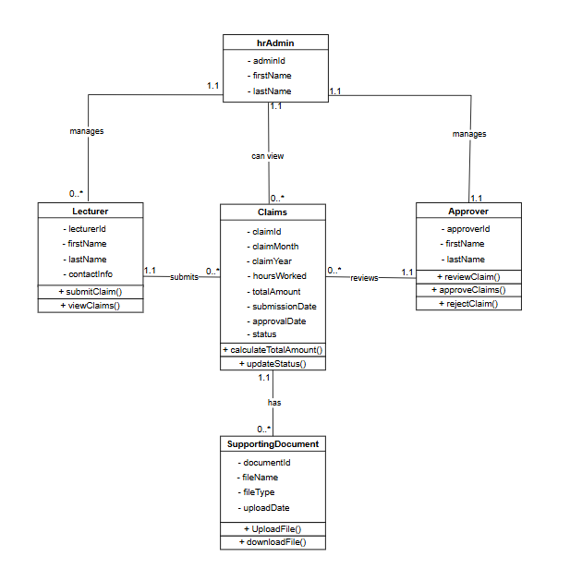 (JGraph Ltd, n.d.)

3.Project Plan
The project will be completed in logical phases, with each phase building on the last to ensure a solid foundation.
Tasks
The project is divided into four main phases, each containing a set of specific tasks.
Phase 1: Foundation and Data Modeling
- Project Setup: Create a new ASP.NET Core MVC project in Visual Studio.
- UML Diagram & Model Definition: Define the core classes (Lecturer, Claim, SupportingDocument, Approver) and their relationships as outlined in the UML diagram.
- Database Configuration: Set up the database and configure Entity Framework Core to connect to it.
- Database Migration: Create and run the initial database migration to build the tables from your models.
Phase 2: Core Functionality (CRUD)
- Develop Lecturer Pages: Create a LecturerInfoController and the corresponding Index, Create, Edit, and Delete views to manage lecturer data.
- Develop Claim Pages: Create a ClaimStatusController and its Index, Create, Edit, Details, and Delete views to manage claims from the lecturer's perspective.
- Develop Supporting Documents Pages: Create a SupportingDocumentsController and the views to handle uploading and viewing files.
Phase 3: User Roles and Approval Process
- Implement User Authentication: Add user login functionality and roles (e.g., Lecturer, Approver).
- Develop Approval Pages: Create an ApprovalsController and an Index view that lists all pending claims for review.
- Implement Approval Logic: Add methods to the ApprovalsController to allow an approver to change a claim's status to "Approved" or "Rejected".
- Conditional UI: Modify views to show or hide navigation links and buttons based on the user's role.
Phase 4: User Experience and Finalization
- Navigation and Home Page: Finalize the navigation bar in _Layout.cshtml and create a user-friendly home page with navigation buttons to the main sections.
- Connect Forms & Logic: Integrate the HTML forms in your Create and Edit views with the backend controller methods to process user input.
- End-to-End Testing: Test the entire system to ensure all features work correctly, including claim submission, document upload, and the approval process.
- Documentation: Write a final report or Portfolio of Evidence (POE) explaining the project's design and implementation.
Dependencies
The project tasks have both logical and technical dependencies.
Logical Dependencies
- Models before Views: You must define the data models (e.g., Claim) before you can create the views for them, as the views depend on the model's properties.
- Database before CRUD: You must set up the database and run migrations before you can implement the controller logic to interact with it.
- Backend before UI: The Index view for Approvals depends on the backend logic to filter and retrieve only pending claims.

Technical Dependencies
- ASP.NET Core MVC: The entire project depends on this framework for building the web application.
- Entity Framework Core: This is crucial for managing the database and translating your C# models into database tables.
- Bootstrap: The entire user interface is dependent on this framework for styling and layout.
- Database: A database management system (e.g., SQL Server) is required to store all the application's data.
Timeline
This is a conceptual timeline based on a typical academic project schedule.
Week 1: Foundations
- Tasks: 1, 2, 3, 4
- Focus: Getting the project structure and data model ready.
Week 2: Core Features
- Tasks: 5, 6, 7
- Focus: Building the main CRUD functionality for lecturers and claims.
Week 3: User Roles & Approval
- Tasks: 8, 9, 10, 11
- Focus: Implementing the user authentication, security, and the approval process.
Week 4: Finalization & Testing
- Tasks: 12, 13, 14, 15
- Focus: Polishing the user experience, ensuring all features are fully functional, and completing the documentation.

User Interface
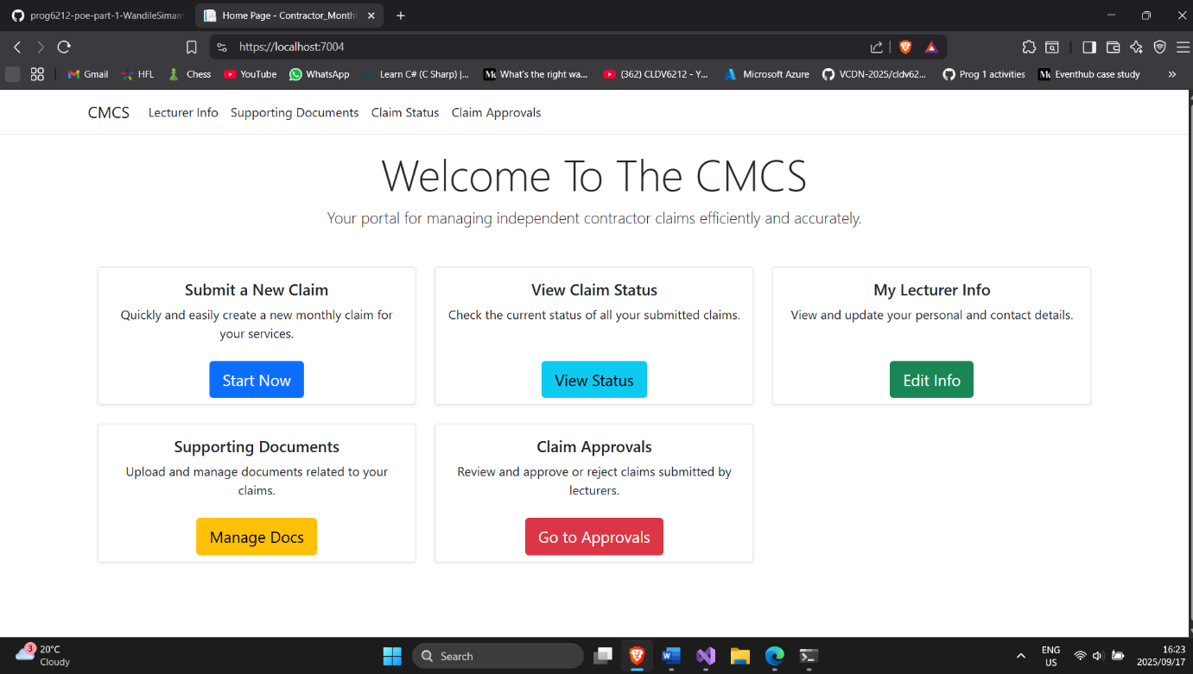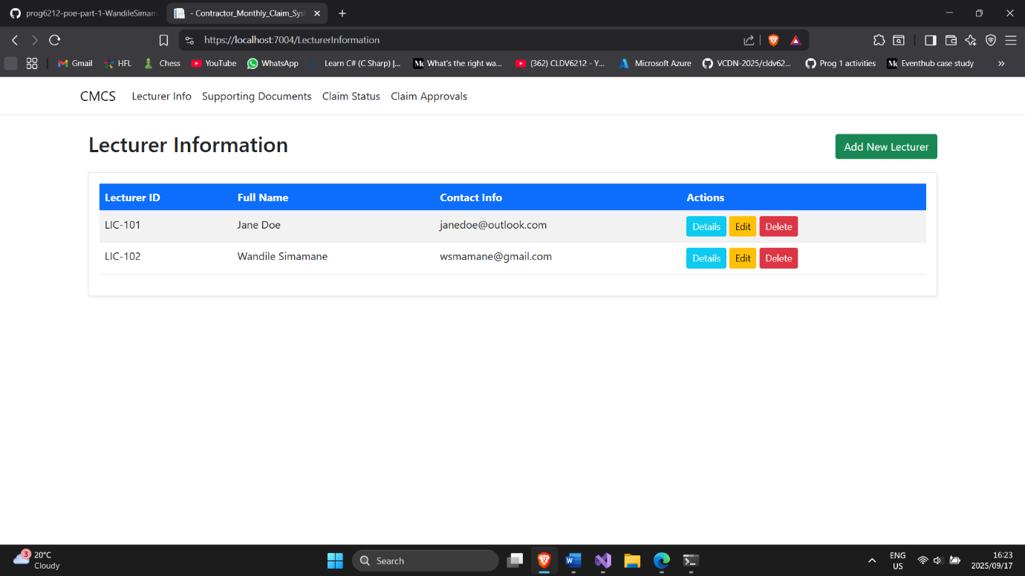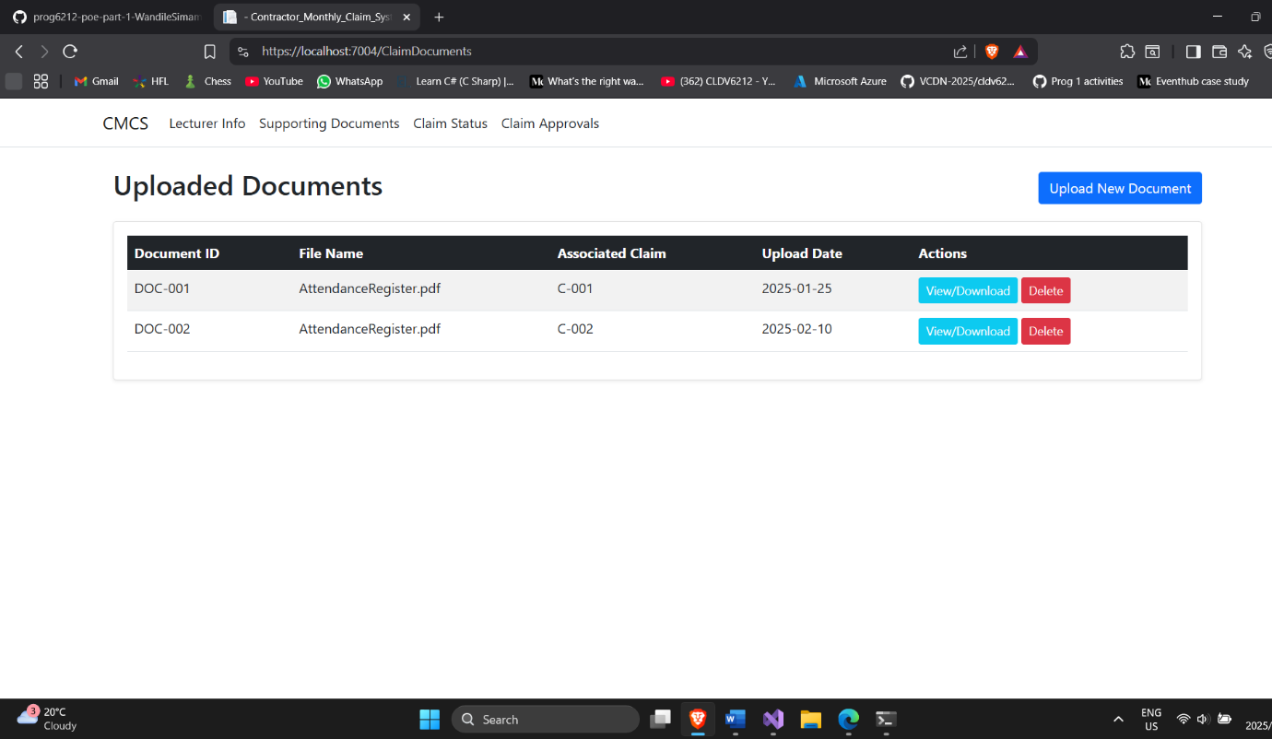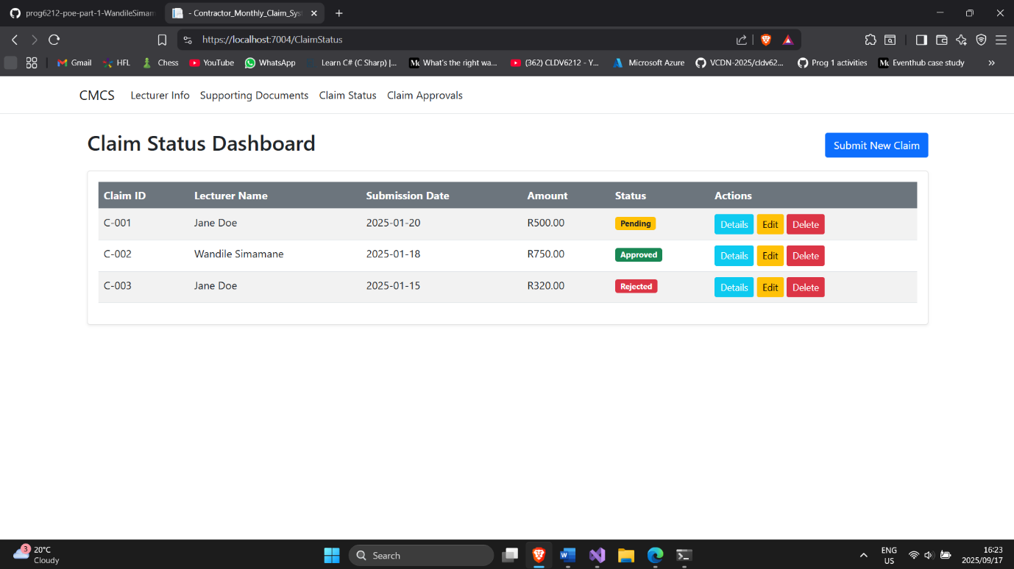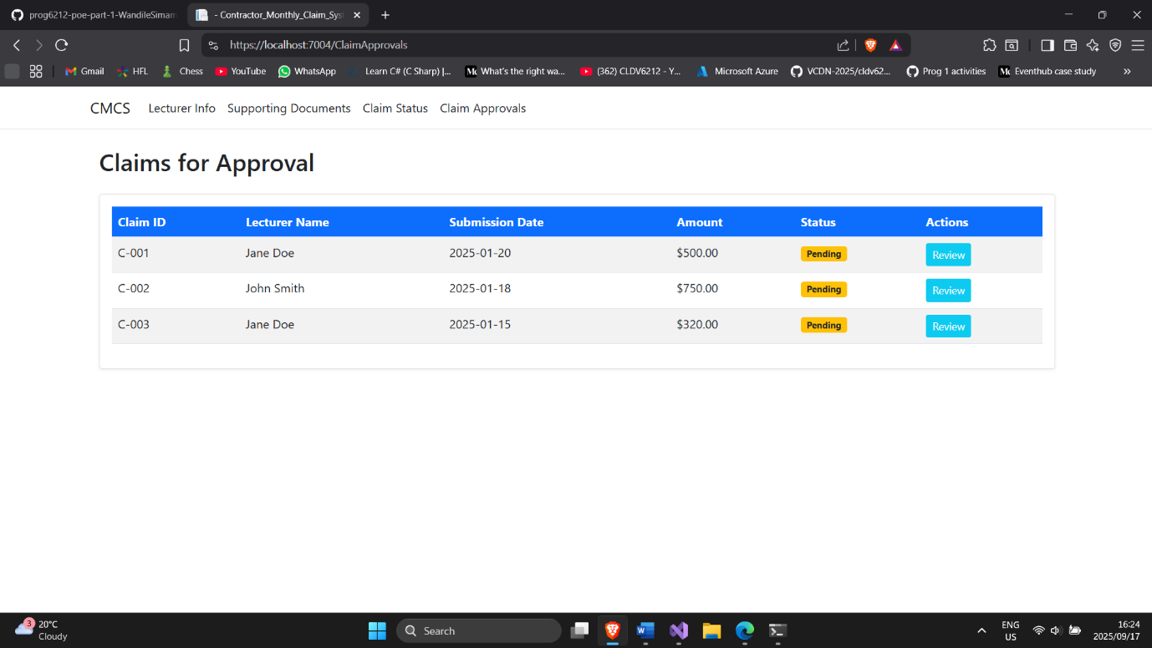

References
Bootstrap (2025) Bootstrap. Available at: https://getbootstrap.com/ (Accessed: 17 September 2025).
Github: https://github.com/VCDN-2025/prog6212-poe-part-1-WandileSimamane.git
JGraph Ltd (2025) Draw.io. Available at: https://www.draw.io/ (Accessed: 17 September 2025).

