ST10439133_CLDV6211_Part1

**ERD:**

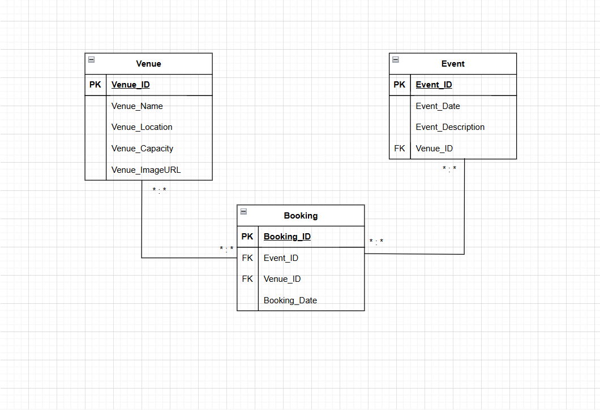

**Database Query:**

-- Create Venue Table

CREATE TABLE Venue (

VenueId INT PRIMARY KEY,

VenueName VARCHAR(255) NOT NULL,

Location VARCHAR(255) NOT NULL,

Capacity INT NOT NULL,

ImageUrl VARCHAR(500) NULL

);

-- Create Event Table

CREATE TABLE Event (

EventId INT PRIMARY KEY,

EventName VARCHAR(255) NOT NULL,

EventDate DATE NOT NULL,

Description TEXT NULL,

);

-- Create Booking Table (Associative Table)

CREATE TABLE Booking (

BookingId INT PRIMARY KEY,

EventId INT NOT NULL,

VenueId INT NOT NULL,

BookingDate DATE NOT NULL,

FOREIGN KEY (EventId) REFERENCES Event(EventId) ON DELETE CASCADE,

FOREIGN KEY (VenueId) REFERENCES Venue(VenueId) ON DELETE CASCADE

);

**Service Created in Azure Portal:**

**Query Editor:**

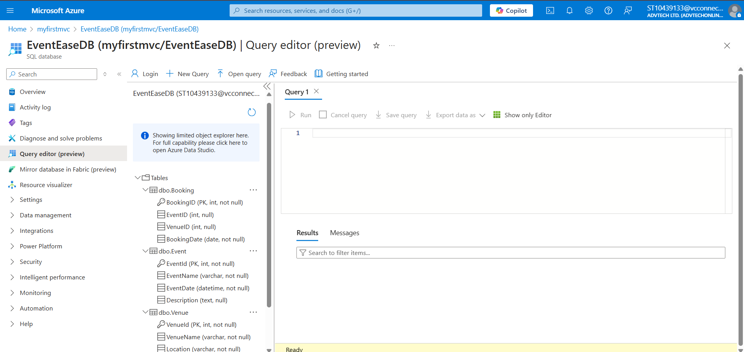

**Database migrated successfully:**

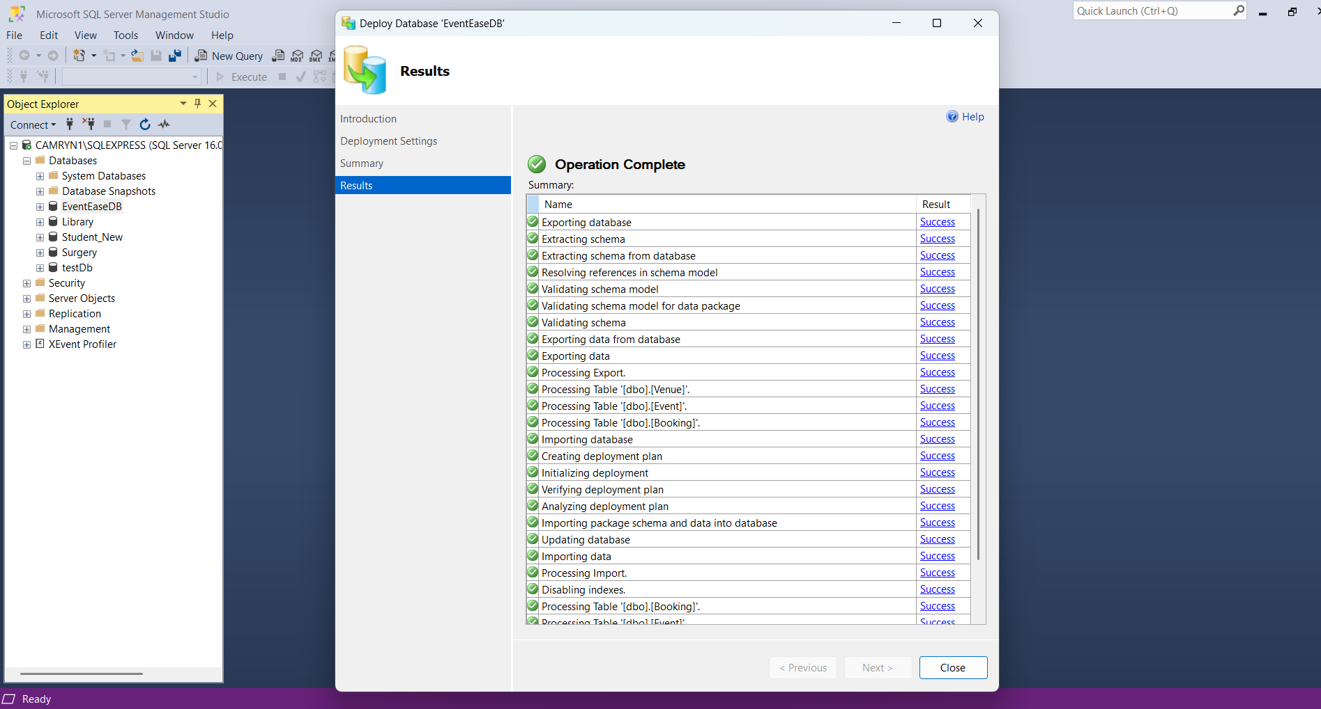

**Successful Deployment Message in Visual Studios:**

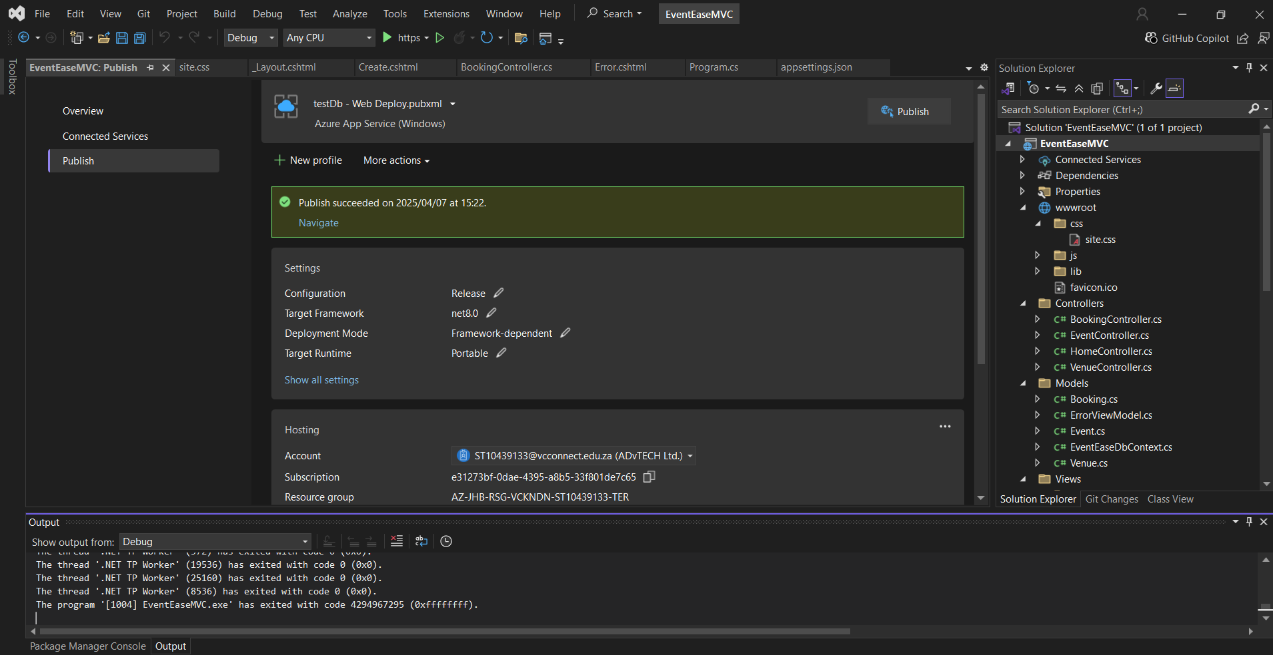

**Web App URL in correct format:**

<https://testdb-acd9dmcbf3a7dpev.southafricanorth-01.azurewebsites.net>

**Questions:**

**1.**

There are considerable differences between installing an application on-premises and in the cloud, particularly when it comes to resource management, deployment speed, and security. Organizations that use on-premises systems have total control over their security architecture, but they are also solely responsible for implementing security updates, maintaining firewalls, and controlling access. Cloud service providers like AWS, Azure, and Google Cloud, on the other hand, provide integrated security features such as encryption, DDoS protection, and compliance certifications like ISO and GDPR. For example, by deploying on Microsoft Azure, EventEase may use Azure Security Centre to automatically identify and address risks—capabilities that would be more difficult and expensive to implement in an on-premises setting (Microsoft Azure, n.d.-a).

Because pre-configured, scalable infrastructure is readily available, cloud-based deployments are usually faster. On-premises setup frequently necessitates hardware installation and purchase, followed by manual configuration, which can delay deployment by several weeks. In contrast, a developer can significantly reduce time-to-market by using automated CI/CD pipelines to deploy an application to platforms like Azure App Services or AWS Elastic Beanstalk within minutes (Amazon Web Services, n.d.).

In the cloud, resource management is also more efficient. Cloud systems enable the dynamic allocation and scalability of resources such as databases, processing power, and storage, depending on demand. Since on-premises setups are typically static, scaling up requires purchasing and setting up additional hardware. For instance, if EventEase experiences an unexpected spike in event bookings, a cloud-hosted application can automatically scale out to meet the increased demand, ensuring consistent performance without manual intervention or extra infrastructure planning (Microsoft Azure, n.d.-b).

2.

Infrastructure as a Service (IaaS) provides virtualized computing resources via the internet, where users manage the operating system, runtime, and applications while the service provider handles the hardware and virtualization (Amazon Web Services, n.d.). Examples of IaaS include Azure Virtual Machines (Microsoft Azure, n.d.-a) and AWS EC2 (BigCommerce, n.d.).

Platform as a Service (PaaS) offers a complete development and deployment environment, allowing developers to focus on application logic and coding, while the platform handles infrastructure, runtime, middleware, and the operating system (Microsoft Azure, n.d.-b). Google App Engine and Azure App Services are common examples of PaaS (TechTarget, n.d.; Microsoft Learn, n.d.-a). Software as a Service (SaaS) provides fully functional software applications managed entirely by the provider. Users simply access them through a web browser, without managing the underlying infrastructure (Microsoft Azure, n.d.-c). Common SaaS examples include Google Workspace and Microsoft 365 (Spanning, n.d.; Intranet.ai, n.d.).

PaaS is especially well-suited for EventEase because it simplifies development by eliminating the need to manage servers or infrastructure. It offers built-in features such as auto-scaling, performance monitoring, and continuous integration and deployment (CI/CD) pipelines, significantly reducing operational overhead (Medium, n.d.). This allows developers to focus on creating essential features like event booking, ticketing, and venue management. For instance, Azure App Services supports .NET Core and SQL integration while providing intelligent scaling during periods of high demand (Microsoft Learn, n.d.-b). Compared to IaaS, PaaS reduces time spent on configuration, and unlike SaaS, it allows full customization to suit EventEase’s unique requirements.

References:

1. Amazon Web Services (n.d.) Set Up a Continuous Deployment Pipeline Using AWS CodePipeline. Available at: <https://aws.amazon.com/getting-started/hands-on/continuous-deployment-pipeline/> (Accessed: 5 April 2025).
2. Microsoft Azure (n.d.-a) Azure DDoS Protection and Mitigation Services. Available at: <https://azure.microsoft.com/en-us/products/ddos-protection> (Accessed: 5 April 2025).
3. Microsoft Azure (n.d.-b) Scaling up vs. scaling out. Available at: <https://azure.microsoft.com/en-us/resources/cloud-computing-dictionary/scaling-out-vs-scaling-up> (Accessed: 5 April 2025).
4. Amazon Web Services (n.d.) *Types of Cloud Computing*. Available at: <https://aws.amazon.com/types-of-cloud-computing/> (Accessed: 5 April 2025).
5. BigCommerce (n.d.) *SaaS vs PaaS vs IaaS*. Available at: <https://www.bigcommerce.com/articles/ecommerce/saas-vs-paas-vs-iaas/> (Accessed: 5 April 2025).
6. Intranet.ai (n.d.) *Microsoft 365: SaaS vs On-Premise*. Available at: <https://intranet.ai/articles/microsoft-365/microsoft-365-saas-vs-on-premise/> (Accessed: 5 April 2025).
7. Medium (n.d.) *Automatic Scaling on Azure App Service*. Available at: <https://medium.com/microsoftazure/automatic-scaling-on-azure-app-service-166044224bb4> (Accessed: 5 April 2025).
8. Microsoft Azure (n.d.-a) *What is a Virtual Machine?*. Available at: <https://azure.microsoft.com/en-us/resources/cloud-computing-dictionary/what-is-a-virtual-machine> (Accessed: 5 April 2025).
9. Microsoft Azure (n.d.-b) *What is PaaS?*. Available at: <https://azure.microsoft.com/en-us/resources/cloud-computing-dictionary/what-is-paas> (Accessed: 5 April 2025).
10. Microsoft Azure (n.d.-c) *What is SaaS?*. Available at: <https://azure.microsoft.com/en-us/resources/cloud-computing-dictionary/what-is-saas> (Accessed: 5 April 2025).
11. Microsoft Learn (n.d.-a) *Overview of App Service*. Available at: <https://learn.microsoft.com/en-us/azure/app-service/overview> (Accessed: 5 April 2025).
12. Microsoft Learn (n.d.-b) *Manage Automatic Scaling in Azure App Service*. Available at: <https://learn.microsoft.com/en-us/azure/app-service/manage-automatic-scaling> (Accessed: 5 April 2025).
13. Spanning (n.d.) *Google Workspace vs G Suite*. Available at: <https://www.spanning.com/blog/google-workspace-vs-g-suite/> (Accessed: 5 April 2025).
14. TechTarget (n.d.) *Google App Engine*. Available at: <https://www.techtarget.com/searchcloudcomputing/definition/Google-App-Engine> (Accessed: 5 April 2025).