**Cloud Report**

**Cloud computing basics**

Cloud computing in this day and age is essential for most people to use at it provides tones of services that can make your computing experience better and smoother. These services come with servers that are online so you can access on the go so long as you have internet access, storage databases that allow you to have an extension of storage so you can store even more data but online where it is safe and can be easy access for the user, networking allows the user to be able to communicate online using computers at any given time and anywhere with internet access and are able they are able to share resources through application on the infrastructure. These services are a great way to change business and economies infrastructure from a physical one to an online infrastructure providing faster innovation and flexibility.

**Differences in Deploying Applications in the Cloud vs. On-Premises**

**Security**

**On-premises:** When it comes to on-premises security it very much differs from that of cloud security, as on-premises security, you are able to fully customize it according to the companies needs not only that but you are in full control over the infrastructure, data and the physical access, with the cost of security it requires a full upfront investment in hardware, software and personal. (IBM, 2021), however in the long run it will be cost-effective as the business will need this security if they are holding onto very sensitive data. However, the security on, on-premises can be susceptible to physical threats or attacks, so that means that the security would need constant maintenance.

**Cloud:** In order for the cloud to have the best possible defence or security they must invest a lot in the infrastructure as well as in an expertise that will hopefully offer you a more robust and better type of security so that it can be better than most organizations that implement security by themselves. (IBM, 2021)The providers are also given the job of giving the organization the security it needs to be safe and keep their data secure, but it is the job of the organization to install and configure the security according to the needs if the business, with data privacy cloud may be not fully in control of their own data as they are stored and processed by a third party thus making their data not in their full control. The vulnerability of the cloud security is that it is prone to cyber-attacks, data breaches, thus needing constant attention and proactive measures.

**Example**: The more private and sensitive information businesses such as financial business or government organizations would prefer more on-premises security as they would be in full control of their sensitive data, (OpenAI,2024)however companies or organizations such as a start-up organisation would prefer the cloud as the cloud can have providers suggest what type of security measures would be implemented and it is more cost effective for them as they are just starting up and can be provided security by AWS and they will suggest encryption as an option to protect the cloud hosted data.

**Deployment Speed**

**On-premises:** The Speed of the time it takes for the deployments to be active or deploy would take a substantial amount of time and would require a lot more man-hours as the process can take up to weeks or months as they would need to take in account t the setup of the hardware, software as well as the network. (IBM, 2021)The cost of the On-premises would require a decent sum of equity to be able to start the preparations and the build the physical infrastructure as well as configure it too, but overall, the deployment speed is slow and complex.

**Cloud:** The overall cloud deployment process is quick and easy to setup and use in an instant as the time it takes to set up the deployment process could just takes up a few hours or days at most, the cloud services are easy and ready to access almost in an instant as they would do this without having to set up any physical infrastructure, the applications can also be deployed within minutes by using the automation systems and using the CI/CD pipelines. (IBM, 2021)

**Example:** An example of the On-premises deployment speed would be for a car retailer, or any type of retailers can deploy their application for customers almost in an instant using the AWS rather than going the route of using the physical servers which would take exponentially longer to setup and deploy their application for the users to use. (OpenAI,2024)

**Resource Management**

**On-premises:** With their resources, On-premises or organizations are able to have full control over their resources that would include their hardware, software and their security settings. (IBM, 2021)With having full control they would need to implement an IT team that would be able to monitor, upgrade and replace the hardware components if need be, there is also the cost that is involved as the use of servers that hold all the data and resources they would need extended power supply that would keep the servers running as well as more space to allow more servers to be put into place, thus increasing the cost of added expenses an issue with the on-premises resource management would be underutilizing or over-provisioning as in peak business demands the organization would need to added or buy extra resources in order to meet these demands, however there could be low demands and then the extra purchased resources would have then gone to waste.

**Cloud:** There are features that can be used in cloud about resource management, and that would be auto-scaling, this feature allows the resources to be allocated to the correct amount of resources or adjust the number of computing instances based of the demand it askes for in real time, cloud also has a way of allowing different path ways for network resources or data to travel so there is not clutter or bottlenecks within the servers this is called load balancing, (IBM, 2021), in cloud there are also tools that help with monitoring the resources and keep track of the wastage and how they are used in the network and provide the best optimal performance when using the resources.

**Example:** An example of cloud would be Netflix as the cloud servers can easily deal with the spikes in all the latest movies being streamed all at the same time, thus making it smoother and easier to handle using cloud as it is used to the network traffic being cluttered so it finds a different way to redirect the data and resources through different server paths to avoid clutter and congestion. (OpenAI,2024) An example on On-premises would be a retailer that sells Christmas ornaments and since it would be Christmas on that day there will be a spike in demand and the system they use would be the POS system the point of sales system and the IT department needs to keep up with all the demand and spikes in the business.

**Question 2**

**Iaas**

The use of Iaas is that it is useful on providing virtualized computing resources and those computing resources could be servers, storage and not only that but it also allows the user to make their own operating systems as well as data and applications. (Toan, 2024). The term Iaas stands for infrastructure as a service and what that means is that is provides on-demand access to cloud services and cloud hosted physical and virtual servers as well as networking. Examples of the use of Iaas would include hosting websites and databases and that would include AWS EC2.

**Paas**

Pass provides a platform for cloud that will allow the suer to be able to perform developing, running and managing the applications. The service providers with the cloud using Paas would assist or help with the managing of the software and hardware that is included in the servers within the platform examples of the different hardware and software that will be maintained would be things like, storage, databases networking, the operating systems and help perform daily backups. (Toan, 2024) Another key feature of using Paas is that it allows users or application developers the ability to test, deploy and build their applications without managing the infrastructure an example of Web application development would be Microsoft azure app service.

**Saas**

The Term Saas is also called software as a service, but it is sometimes called cloud application services. It is known to users as a ready to use software application, however in order to be able to use the cloud application services, the user would need to pay a monthly rate or annual fee in order to use the complete application from the web browser or mobile application. (Toan, 2024) In the Saas vendor the infrastructure that is manged and hosted within the vendor would be the servers, storage and networking, but the overall use of the Saas is to allow a fully functional application via the internet. An example of a Saas vendor would be Email services such as Gmail or Microsoft office 365.

**Why PaaS is the Best Choice for EventEase**

Well in general the Benefits of using Paas is that it allows users for an On-premises organization it allows customization, the ability to test, build, run applications more efficiently and quickly allowing for conservative time management, it is also cost effective as it will benefit the on-premises as they can manage and maintain their own platforms. (Toan, 2024)The benefits are faster time to market, Paas allows developers to speed up the process it takes to deploy the application, by making the build time process, the debugging and testing and executing time, it takes all of these steps and processes and cuts it in half taking only minutes and not days or even months, this can allow developers to focus more on coding instead of configuration an example of this would be that eventease developers can also set up their own or deploy their booking system within a couple of minutes. (Toan, 2024) Another benefit of using Paas would be the scalability aspect as Paas can provide the most scalability due to organizations can purchase extra space or capacity for building, testing and running the applications when they need it to as well as increasing the space depending on the demand of it, and furthermore when EventEase starts to grow Paas can be able to handle the network traffic without requiring the additional hardware to improve the network, thus cost effective. (Toan, 2024)The last benefit of using the Paas is due to it providing or should I say preventing real-time updates from having double bookings and keeping everything in order and not having any overlaps, as what Paas does in this case is look at the booking systems and see what is overlapping and then it would access the schedule of both the overlapping booking dates or double bookings and then it would reschedule the dates so then there is no conflicts. An example of this would be that EventEase would be that the booking system in EventEase uses a new managing system that overlooks the event bookings, however without real-time updates and then only using two specialist that manage the event bookings, they could potentially make a human error and book the venue fir two different users on the same day, thus leading to customer conflicts and the distrust of the organization, that is why with the use of Paas it would benefit the organization by keeping things in an organized state.

Reference List:

IBM ,2021. *IaaS, PaaS and SaaS*. [online] Available at: <<https://www.ibm.com/think/topics/iaas-paas-saas>> [Accessed 1 April 2025]

Duc ,Taon.,2024. Cloud vs On Premise Deployment: Similarities and Differences | Relia Software. [online] Available at:< <https://reliasoftware.com/blog/cloud-vs-on-premise-deployment>>[Accessed 1 April 2025]

OpenAI.2024.Chat-GPT(Version 3.5).[Large language Model].Available at: <<https://chatgpt.com/c/67e94d57-d0a4-8008-b60f-edd512f7424c>> [Accessed: 1 April 2025].

Images

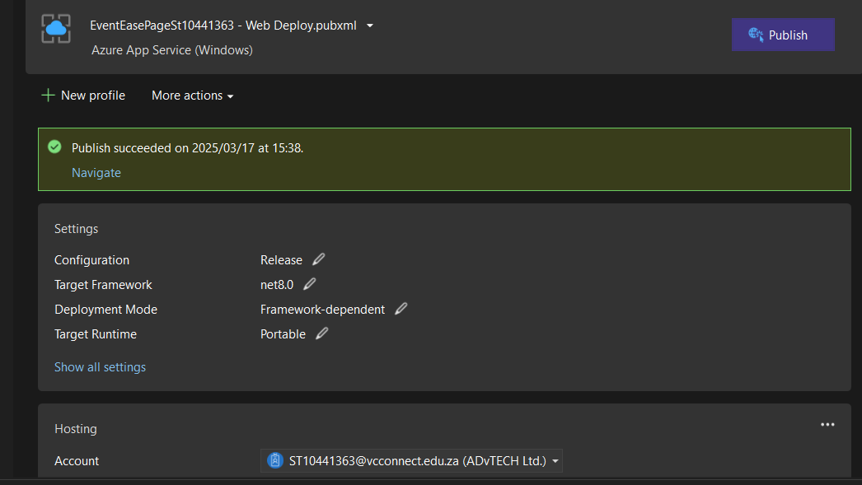

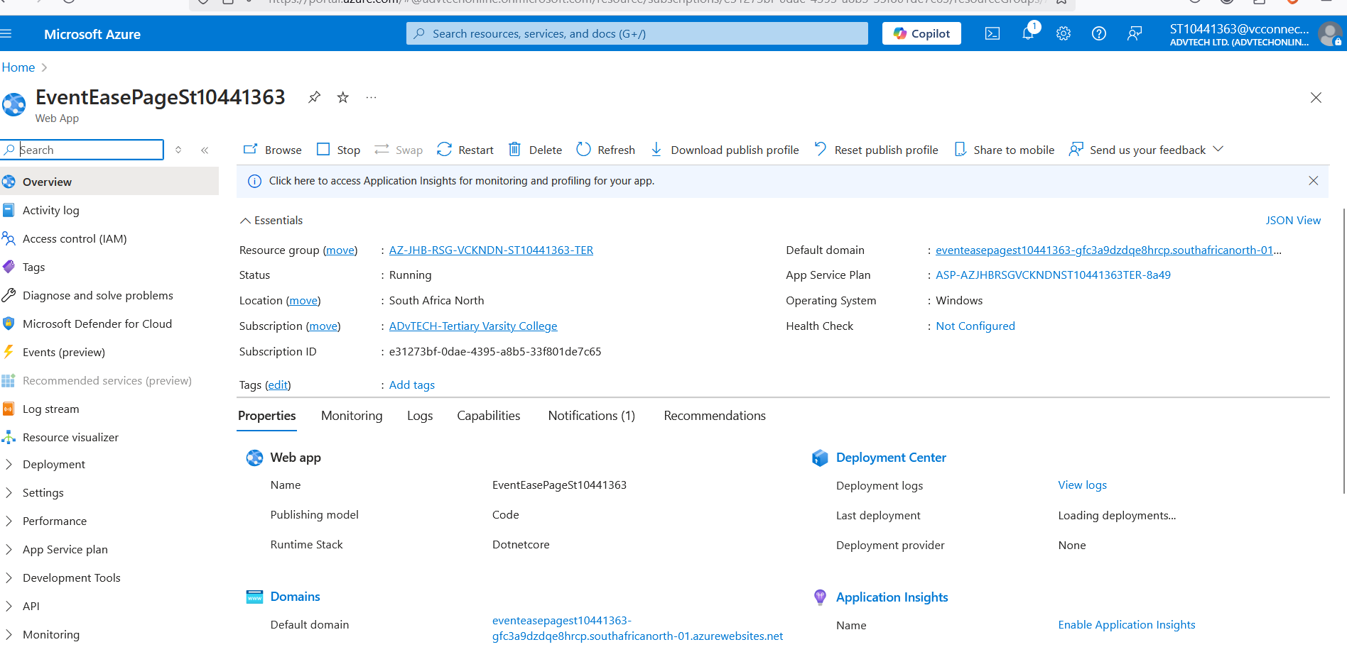

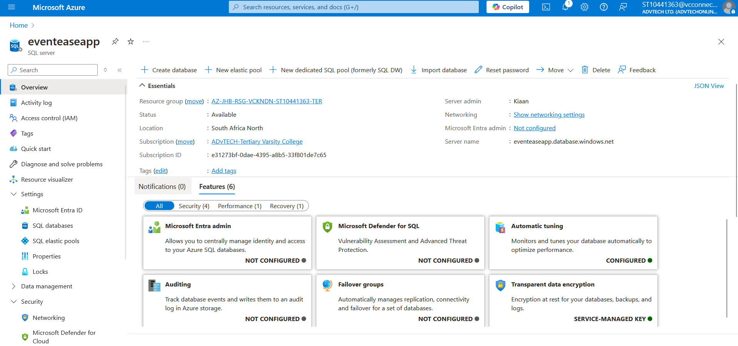

VISIO ERD

SQL Database Code

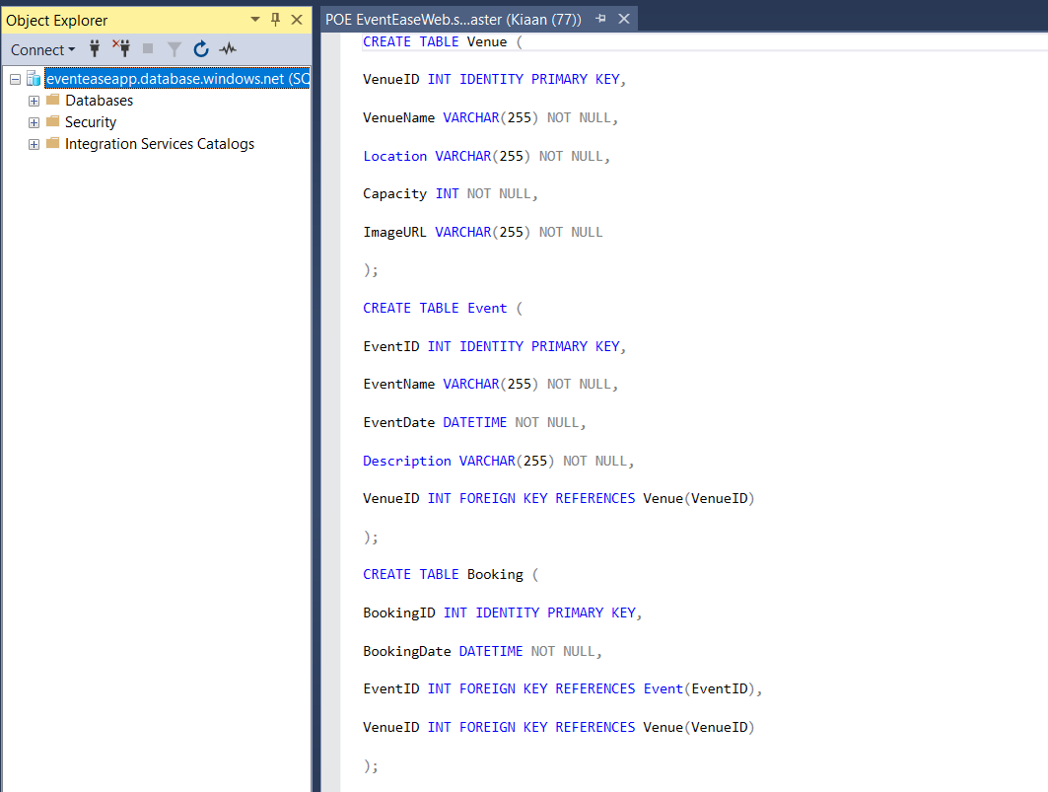

Website link EventEase

<https://eventeasepagest10441363-gfc3a9dzdqe8hrcp.southafricanorth-01.azurewebsites.net>