CLOUD PoE PArt 2

ST10434082

1. **Integrate Azure Storage**
2. **Implement Error Handling and Validation**
3. **Enhanced Display and Search**

Please see the following GitHub and Web app Link:

Web app link: <https://localhost:7168/>

GitHub link: <https://github.com/VCDN-2025/cldv6211-poe-part-2-Stephgamer2k.git>

1. **Azure Deployment and Updates**

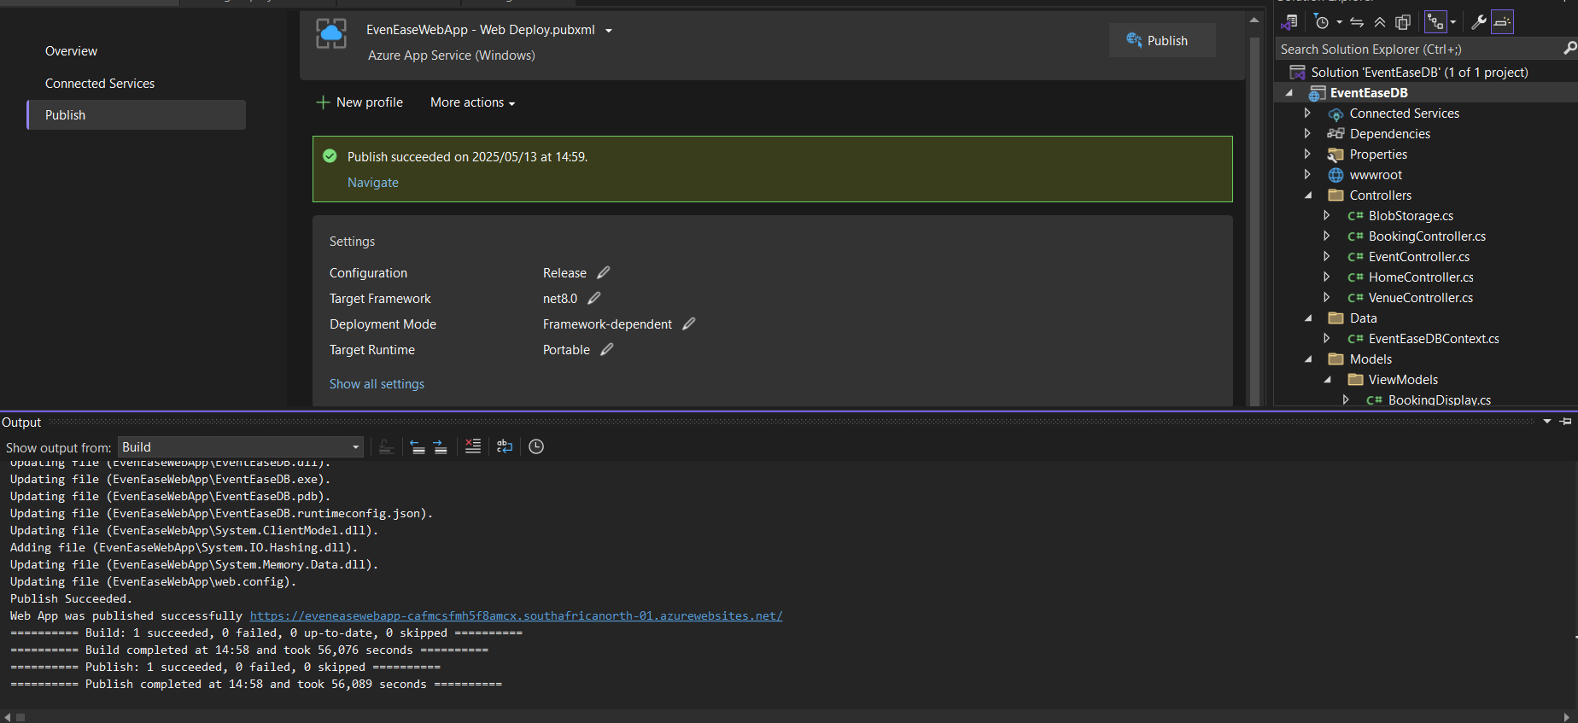

1. **Database Design, Cognitive Search**

**Question 1:**

**Azure Cognitive Search and Its Difference from Traditional Search Engines**

Azure Cognitive Search goes beyond what traditional search engines offer by bringing artificial intelligence and machine learning into the mix. While conventional engines mainly depend on simple keyword matching, Cognitive Search takes things further with natural language processing (NLP), semantic search, and customizable AI models. This means it can better understand the context behind a query, figure out user intent, and identify relationships in data(Microsoft, 2023). These smart capabilities enable Azure Cognitive Search to deliver a more accurate and relevant result when dealing with complex or unstructured content like PDFs, images, and audio files. It also works smoothly with other Azure services, allowing it to perform tasks like recognizing entities, analysing sentiment, and translating languages, features that aren’t typically found in standard search tools (Microsoft, 2023).

**Advantages in Use Cases**

Cognitive Search is especially powerful in fields that handle large amounts of complicated data. Take healthcare, for example: it can pull information from medical records so doctors can quickly find what they need. In e-commerce, it improves product searches by understanding synonyms and what the customer really wants(Ghodsi et al., 2021). Legal professionals also benefit from its ability to scan through massive volumes of documents and highlight important terms or clauses. This makes it a great fit for industries that rely on complex, often unstructured information (Ghodsi et al., 2021).

**Limitations and Mitigation Strategies**

That said, Azure Cognitive Search isn’t without its limitations. One major drawback is that it’s closely tied to the Azure ecosystem, which can be restrictive for organizations using multiple cloud providers or on-premises systems(Chappell, 2022). Also, while AI improves search quality, it can sometimes slow things down—especially when working with large datasets. Costs can also climb quickly if many AI features are in use. To manage these issues, companies can fine-tune how they index data, use caching to speed things up, and plan resources carefully to keep expenses under control. In some cases, using Cognitive Search alongside other search tools in a hybrid setup can offer a nice balance of power and flexibility (Chappell, 2022).

**Question 2**

**Importance of Database Normalisation in Cloud-Based Design**

Database normalisation is a crucial part of designing databases for the cloud. It helps ensure data accuracy, reduces duplication, and improves overall efficiency, especially in distributed systems like those running on Azure. By organising data into clearly defined tables and relationships (such as 1NF, 2NF, and 3NF), normalisation limits the chance of redundant entries and avoids problems when inserting, updating, or deleting data (Microsoft 2023). In cloud environments where you often pay for what you use, such as in Azure SQL Database, a normalised design helps optimise storage, which can directly lower costs (Redgate Software 2024).

**Performance Impact of Normalised Structures in Cloud Environments**

That said, normalised database structures can sometimes impact performance in cloud setups. Because data is split across multiple related tables, queries often require complex joins, which can slow things down, especially when the data is spread across regions (IBM 2023). This is particularly problematic for applications that frequently read large amounts of data, as the increased processing time can lead to slower response times and higher compute costs on platforms like Azure.

**Advantages of Denormalized Structures for Scalability**

To address these performance issues, denormalization is often used. This approach flattens the database structure by duplicating some data, which reduces the need for joins and speeds up read-heavy operations like analytics and reporting. For example, Azure Cosmos DB uses a denormalized, NoSQL-based structure to provide low-latency access for globally distributed applications (Microsoft 2024). In such cloud environments, denormalization is useful when horizontal scalability and fast data access are more important than conserving storage.

**Challenges of Denormalization in Cloud Databases**

However, denormalization isn’t without its drawbacks. Duplicating data increases the risk of inconsistencies, especially if there’s no solid strategy for keeping everything in sync. This can lead to update anomalies and make maintenance more complicated in a distributed system. Plus, because more data is stored, your storage costs may go up, which is an important consideration in metered cloud environments (Google Cloud 2023).

**Hybrid Strategies for Optimal Cloud Database Design**

To balance the trade-offs between normalisation and denormalization, many cloud architectures use hybrid approaches. These might include techniques like materialised views (used in Azure Synapse) or table partitioning (in Azure SQL Database), which blend normalised data storage with denormalized performance improvements (Google Cloud 2023). These strategies allow systems to scale while staying fast and cost-effective, taking full advantage of the cloud’s flexibility to meet varying workload demands.

# Reference List:

Chappell, D. 2022. *Azure Cognitive Search: A Deep Dive*. Microsoft Whitepapers, [Online] June 2022. Available at:<<https://azure.microsoft.com/en-us/resources/azure-cognitive-search-deep-dive/>> [Accessed 10 May 2025].

Ghodsi, A., Zaharia, M. and Xin, R. 2021. *AI-Powered Search: Transforming Enterprise Data Retrieval*. O’Reilly Media, [Online] 12 October 2021. Available at:<<https://www.oreilly.com/library/view/ai-powered-search/9781492090018/> >[Accessed 10 May 2025].

Google Cloud. 2023. *Database Normalization vs. Denormalization*, [Online] 10 November 2023. Available at:<<https://cloud.google.com/learn/database-normalization-vs-denormalization> >[Accessed 10 May 2025].

IBM. 2023. *Normalized vs. Denormalized Databases: What’s the Difference?*, [Online] 22 August 2023. Available at:<<https://www.ibm.com/topics/database-normalization> >[Accessed 12 May 2025].

Microsoft. 2023. *Designing Efficient Cloud Databases with Normalization*, [Online] 5 March 2023. Available at:<<https://learn.microsoft.com/en-us/azure/architecture/data-guide/relational-data/normalization>> [Accessed 12 May 2025].

Microsoft. 2023. *What is Azure Cognitive Search?* Microsoft Docs, [Online] 15 March 2023. Available at:<<https://docs.microsoft.com/en-us/azure/search/search-what-is-azure-search>>[Accessed 12 May 2025].

Microsoft. 2024. *Azure Cosmos DB: Modeling Data for NoSQL*, [Online] 18 January 2024. Available at: <<https://learn.microsoft.com/en-us/azure/cosmos-db/nosql/modeling-data>> [Accessed 12 May 2025].

Redgate Software. 2024. *Database Normalization in the Cloud Era*, [blog] 14 February 2024. Available at: <https://www.red-gate.com/blog/database-normalization-cloud> [Accessed 12 May 2025].