IARTV 2006 | Unit 3 Chemistry | Trial Examination Solutions

Section A – Multiple choice questions

- A
- B
- D
- C
- C
- B
- D
- B
- A
- D
- C
- C
- B
- D
- D
- A
- A
- A
- B
- A

Section B – Short Answer Questions

Question 1 (10 marks)
- Any two of readily obtainable, known formula, pure, can be stored, solid that does not react with air, soluble and have high molar mass. (1 mark)
- Anhydrous sodium carbonate or sodium oxalate (1 mark)
- Na₂CO₃ (aq) + 2 HCl (aq)  2 NaCl (aq) + H₂O (l) + CO₂ (g) (1 mark)
- Methyl orange or bromothymol blue (1 mark)
- n(Na₂CO₃) = c × V for anhydrous sodium carbonate chosen as the primary standard
= 0.117 × 0.02110
= 2.47 × 10^{–3} mol (1 mark)
- n(HCl) = c × V
= 2.47 × 10^{–3} × 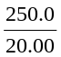
= 0.0309 mol (1 mark)
- n(NaOH) in 20.00 mL = n(HCl)
- m(NaOH) = 0.0309 × 40.0 = 1.23 g
%(w/w) of NaOH = 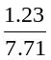 × 100 = 16.0 %(w/w) (1 mark)

Question 2 (10 marks)
- Ethanol first and 2-methylbutan-1-ol last (1 mark)
- Ethanol 2-methyl butan-1-ol
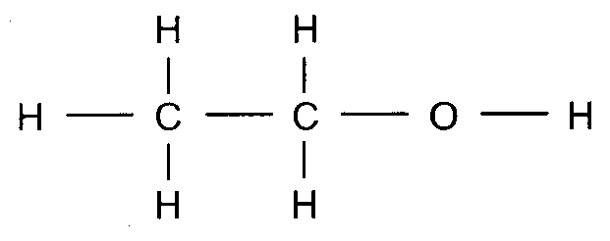 | 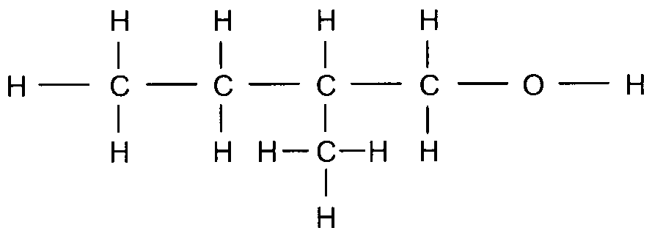 | (2 marks)
- Prepare a set of solutions of ethanol of different known concentrations, including a blank. For each solution obtain a reading from the GC and plot a calibration curve of reading versus concentration. (2 marks)
- To vaporise the sample. (1 mark)
- An inert carrier gas. (1 mark)
- Hexan-1-ol is volatile and stable but glucose is unstable at elevated temperatures and will decompose. (2 marks)
- By comparison of retention times with a known sample of hexan-1-ol. (1 mark)

Question 3 (8 marks)
- Fe²⁺ (aq)  Fe³⁺ (aq) + e–
Cr₂O₇^{2–} (aq) + 14 H⁺ (aq) + 6 e–  2 Cr³⁺ (aq) + 7 H₂O (l)
Cr₂O₇^{2–} (aq) + 6 Fe²⁺ (aq) + 14 H⁺ (aq)  2 Cr³⁺ (aq) + 6 Fe³⁺ (aq) + 7 H₂O (l) (3 marks)
- n(Cr₂O₇^{2–}) = c × V
= 0.150 × 0.01355
= 2.03 × 10^{–3} mol (1 mark)
- n(Fe²⁺) = 6 × n(Cr₂O₇^{2–})
= 1.22 × 10^{–2} mol in 25.00 mL of the aliquot (1 mark)
- mFe²⁺) = 1.22 × 10^{–2} × 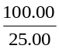 × 55.9 g
= 2.73 g (1 mark)
- Percentage by mass of Fe²⁺ = 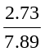 × 100% Percentage composition of Fe²⁺ = 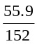 × 100%
= 34.6% = 36.8 % (2 marks)

Question 4 (7 marks)
- K = 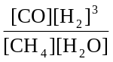 M² (1 mark)
- K = 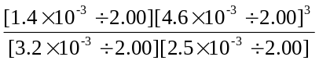 = 4.3 × 10^{–6} M²
This is not equal to the give value of 8.6 so the system is not at equilibrium. (3 marks)
- The equilibrium must shift to the product side so that the concentration fraction can reach the value of K. (2 marks)
- Because the reaction is endothermic the equilibrium constant will increase as the temperature increases. (1 mark)

Question 5 (5 marks)

Change | Concentration of N₂ |  |  | Forward Reaction Rate
Change | Increased | Decreased | Unchanged | Increased | Decreased | Unchanged
Hydrogen chloride gas was added to the system |  |  |  |  | 
Volume of the container is doubled |  |  |  |  | 
Water vapour is added to the system |  |  |  |  |  | 
Helium gas is added to the system |  |  |  |  |  | 
A catalyst is added to the system |  |  |  | 

Question 6 (5 marks)
- HF (aq) + H₂O (l)  H₃O⁺ (aq) + F (aq) (1 mark)
- K_{a} = 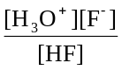 (1 mark)
- K_{a} = 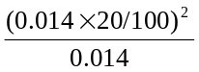 = 5.6 × 10^{–4} M (2 marks)
- pH = –log(0.014 × 20/100) = 2.6 (1 mark)

Question 7 (7 marks)

 | Contact Process | Production of Ethene
Key reaction | SO₂ (g) + O₂ (g)  SO₃ (g) | C₂H₆ (g)  C₂H₄ (g) + H₂ (g)
Name of vessel in which reaction occurs | converter | cracking furnace
Type of reaction:  Endothermic or Exothermic? | exothermic | endothermic
Name of the type of chemical reaction | redox or combustion | cracking or redox or dehydrogenation
Major source of the reactant | by-product of smelting or air and elemental sulfur deposits | natural gas
Pressure conditions that would improve the rate | high pressure | high pressure
Pressure conditions that would improve the yield | high pressure | low pressure
Major use of the final product of the process | production of fertiliser or sulfuric acid | monomer in polymer industry

