IARTV
2006
UNIT 4 CHEMISTRY

SECTION A – Multiple-choice questions

Question 1
The least efficient energy conversion process occurs when
- chemical energy is converted to electrical energy in a fuel cell
- chemical energy is converted to mechanical energy in a car engine
- light energy is converted to chemical energy in a leaf
- electrical energy is converted to mechanical energy in a blender

Question 2
For technological reasons, fuel cells have had limited use as a supply of electrical energy. The hydrogen-oxygen fuel cell
- converts thermal energy into electrical energy
- stores electrical energy
- functions only with an acidic electrolyte
- utilises an overall exothermic combustion reaction

Question 3
An athlete weighing 75.5 kg runs up the stairs of the Empire State Building in New York. The efficiency of cellular respiration is 20% and the energy required to do the climb is 95 kJ. How much glucose would the athlete consume in the climb?
C₆H₁₂O₆ (aq) + 6 O₂ (g) → 6 CO₂ (g) + H₂O (l) ΔH = –2803 kJ mol^{–1}
- 0.40 g
- 6.1 g
- 24 g
- 31 g

Question 4
Which of the following would result in a spontaneous reaction?
- A pellet of cobalt is added to aluminium sulfate solution.
- Hydrogen sulphide gas is bubbled into a solution of acidified hydrogen peroxide.
- A piece of copper wire is added to nickel sulfate solution.
- Iron(II) nitrate solution is added to zinc chloride solution.

Question 5
The reactions in a particular button cell are:
Anode: Zn (s) + 2 OH– (aq) → ZnO (s) + H₂O (l) + 2 e–
Cathode: HgO (s) + H₂O (l) + 2 e– → Hg (l) + 2 OH– (aq)
The cell could be described as a
- primary alkaline cell
- secondary alkaline cell
- primary cell in which the pH decreases as the cell discharges
- secondary cell in which the pH increases as the cell discharges

Question 6
Electrolysis of molten potassium bromide is carried out. The products at the cathode and the anode will be in turn
- potassium and bromine
- bromine and potassium
- hydrogen and oxygen
- oxygen and hydrogen

Question 7
Consider the following apparatus used in electrolysis. The electrodes are graphite and the solutions are all 1.0 M.
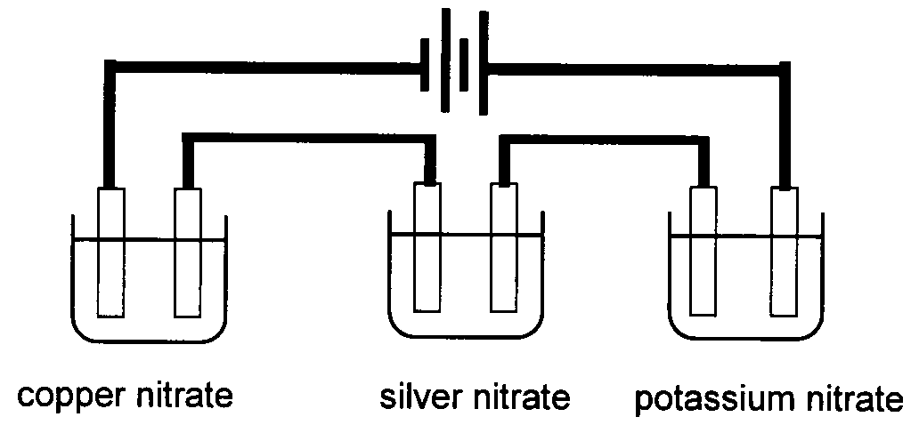
The beakers contain 1.0 M solutions of copper nitrate, silver nitrate and potassium nitrate respectively. The mass ratio of metals deposited on the cathodes from left to right are
- 1 : 2 : 0
- 2 : 1 : 1
- 1 : 3.4 : 1.2
- 1 : 3.4 : 0

Question 8
Which of the following statements is not true?
For the production of chlorine and sodium hydroxide a membrane cell
- has a steel mesh cathode
- has asbestos fibres in the membrane
- produces pure sodium hydroxide solution
- has a graphite anode

Question 9
Some ice packs contain a capsule of solid sodium thiosulfate in a bag of water. When the capsule is crushed the sodium thiosulfate dissolves in the surrounding water. The process can be represented by the following equation.
Na₂S₂O₃ (s) 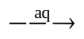 Na₂S₂O₃ (aq) ΔH = +7.2 kJ mol^{–1}
If 0.100 mol of sodium thiosulfate were dissolved in 250 mL water then the energy needed to return the solution to the original water temperature would be
- 7.2 kJ
- 1.8 kJ
- 0.72 kJ
- 0.18 kJ

Question 10
Stearic acid C₁₇H₃₆O₂ and glycerol C₃H₈O₃ react to produce the fat, tristearin. What is the molar mass of tristearin?
- 908 g mol^{–1}
- 854 g mol^{–1}
- 566 g mol^{–1}
- 307 g mol^{–1}

Question 11
Which of the following molecules is a mono-unsaturated fatty acid?
- C₂₀H_{.34}O₂
- C₂₀H₃₆O₂
- C₂₀H₃₈O₂
- C₂₀H₄₀O₂

Question 12
Citric acid is used as an antioxidant additive in foods. Citric acid reacts with
- oxygen preferentially before oxygen can react with the food
- the double bonds in unsaturated fats to protect them
- oxygen, bonding it to the double bonds in unsaturated fats
- saturated fats to produce double bonds

Question 13
The structure of alanine in aqueous conditions is dependent on the pH of the solution. Alanine is most likely to exist as
A. | 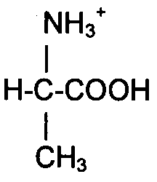 | at pH 10 | C. | 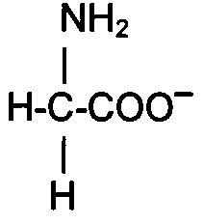 | at pH 10
B. | 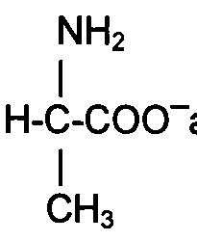 | at pH 10 | D. | 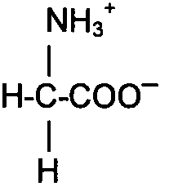 | at pH 2

Question 14
An example of a sequence of nitrogen compounds formed by a nitrogen-fixing plant is
- NH₄⁺, NO₂–, NO₃–, CH₂(NH₂)COOH
- NH₄⁺, NO₂–, NO₃–, CH₂(NH₂)₂
- NO₃–, NO₂–, NH₄⁺, CH₂(NH₂)₂
- CH₂(NH₂)COOH, NH₄⁺, NO₂–, NO₃–

Question 15
Aluminium oxide, Al₂O₃, reacts with aqueous sodium hydroxide to form
- Al³⁺
- Al(H₂O)₆³⁺
- Al(OH)₃
- Al(OH)₄–

Question 16
In 1919, Rutherford bombarded nitrogen-14 with alpha particles
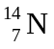 + 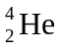 → 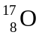 + X
X was most likely to be a
- proton
- neutron
- electron
- positron

Question 17
The following diagram shows relative size of either two atoms or ions.
 | 
X | Y

X and Y are most likely to be, in this order
- P and Al
- Cl and Cl–
- Li and Na
- Na and Na⁺

Question 18
Our Sun produces helium by hydrogen fusion and releases energy. Over time
- the mass of our Sun is increasing and the number of particles is increasing
- the mass of our Sun is decreasing and the number of particles is decreasing
- the mass of our Sun and the number of particles remains constant
- the mass of our Sun and the number of particles varies according to temperature

Question 19
Which of the following excited state atoms will release the most energy when it returns to the ground state?
- 1s² 2s¹ 2p⁶
- 1s² 2s² 2p⁶ 3s² 3p⁶ 3d⁹ 4s¹
- 1s² 2s² 2p⁵ 3s¹ 3p⁶ 3d¹⁰ 4s²
- 1s² 2s² 2p⁶ 3s² 3p⁶ 3d⁸ 4s¹

Question 20
There are two naturally occurring isotopes of the element chlorine. How many peaks corresponding to a singly charged molecule of chlorine would be observed in a mass spectrum of chlorine?
- 1
- 2
- 3
- 4

SECTION B – Short-answer questions

Question 1
- Recently the debate about whether Australia should sell its uranium resources to other countries for power generation has resurfaced. Support for this debate has come from some eminent scientists.
i. What is the main argument in favour of nuclear power stations?
__________________________________________________________________________________
__________________________________________________________________________________
1 mark
ii. State two disadvantages of nuclear power stations.
__________________________________________________________________________________
__________________________________________________________________________________
__________________________________________________________________________________
1 mark
iii. Is uranium considered a renewable or non-renewable resource? Justify your answer.
__________________________________________________________________________________
__________________________________________________________________________________
__________________________________________________________________________________
1 mark
iv. Is the nuclear process in a power station one of fission or fusion? Justify your answer.
__________________________________________________________________________________
1 mark
- Electric eels generate an electric charge by means of a series of electrochemical cells. Each cell produces about 0.14 volts and the potential difference produced can be around 700 volts. The eel’s head has a positive polarity while its tail has a negative polarity. Which part of the eel is the cathode?
______________________________________________________________________________________
1 mark
- In the lead-acid battery name the
i. reductant _________________________________________________________________________
ii. electrolyte _________________________________________________________________________
2 marks
iii. If the overall equation for the lead-acid battery during discharge is given as
Pb (s) + PbO₂ (s) + 2 SO₄^{2–} (aq) + 4 H⁺ (aq) → 2 PbSO₄ (s) + 2 H₂O (l)
write the half-equation for the reaction occurring at the cathode.
__________________________________________________________________________________
1 mark
iv. In the recharging process write the equation for the reaction that takes place at the anode.
__________________________________________________________________________________
1 mark
Total 9 marks

Question 2
A galvanic cell is made from the two half-cells MnO₄– (aq), H⁺ (aq) / Mn²⁺ (aq) and Fe²⁺ (aq) / Fe (s). The E⁰ value for the reduction of the acidified permanganate half-cell reaction is +1.51 volts. The permanganate ion has a distinctive purple colour.

- Write the half-reaction that is occurring at the
i. anode _________________________________________________________________________
ii. cathode _________________________________________________________________________
2 marks
- Calculate the overall voltage for the cell.
______________________________________________________________________________________
______________________________________________________________________________________
1 mark
- On the diagram below
i. suggest a suitable material for each electrode
2 marks
ii. show which way the electrons flow.
1 mark
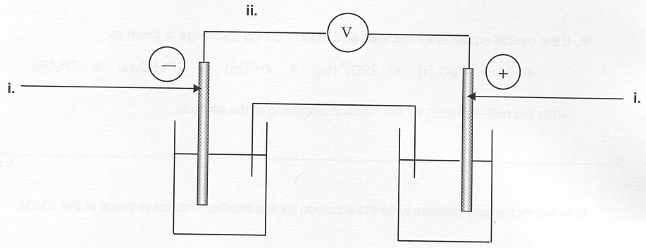
iii. suggest a suitable solution for the iron half-cell.
__________________________________________________________________________________
1 mark
- Describe the changes you would see in each half-cell as the cell discharged.
Anode ________________________________________________________________________________
______________________________________________________________________________________
Cathode _______________________________________________________________________________
______________________________________________________________________________________
2 marks
Total 9 marks

Question 3
A metal chloride has the formula XCl₃. Electrolysis of the molten salt with a current of 0.850 A for 6 hours 35 minutes produced 3.62 g of the metal. Calculate the molar mass of the metal.
__________________________________________________________________________________________
__________________________________________________________________________________________
__________________________________________________________________________________________
__________________________________________________________________________________________
__________________________________________________________________________________________
__________________________________________________________________________________________
Total 3 marks

Question 4
The following information was recorded for two soft drinks, Zone and Zilch. One drink contains sugar, the other contains no sugar.

Zilch | per 100 mL
energy content | 1.4 kJ
total carbohydrate | 0.1 g
sugars | 0 g
sodium | 11 mg

Zone | per 100 mL
energy content | 205.2 kJ
total carbohydrate | 11.84 g
sugars | 11.4 g
sodium | 0.98 mg

- How many 250 mL glasses of Zilch would you need to drink to consume the same energy content as a 100 mL glass of Zone?
______________________________________________________________________________________
______________________________________________________________________________________
1 mark
- The sugar added to Zone is sucrose. Fructose and glucose are structural isomers. Sucrose is formed from the reaction between a glucose molecule and a fructose molecule.
i. What type of biochemical reaction occurred between fructose and glucose?
__________________________________________________________________________________
1 mark
ii. What is the molecular formula of sucrose?
__________________________________________________________________________________
1 mark
- Zone is sold in 250 mL aluminium cans. Sucrose has an energy content of approximately 18 kJ g^{–1}. Calculate the energy content of the sugar contained in a can of Zone.
______________________________________________________________________________________
______________________________________________________________________________________
______________________________________________________________________________________
______________________________________________________________________________________
2 marks
- The energy content on the label was obtained by calorimetry. Give two reasons why the net energy available to a person is less than the value given.
______________________________________________________________________________________
______________________________________________________________________________________
______________________________________________________________________________________
______________________________________________________________________________________
2 marks
Total 7 marks

Question 5
A gluten-free biscuit is tested to see if it contained any protein in the form of gluten. The following information was recorded from the biscuit’s packaging.

 | per 100 g
total carbohydrate | 78.8 g
dietary fibre | 1.4 g
total fat | 3.0 g

The biscuit was prepared for testing in a bomb calorimeter. A current of 5.10 amperes at a voltage of 7.22 V was passed through the calorimeter for 5.00 minutes. Subsequently the biscuit was ignited in the bomb.
The following results were obtained.

First temperature reading 19.45°C
Second temperature 21.15°C
Final temperature 24.69°C

Mass of sample 1.50 g

- Calculate the calibration factor for this bomb calorimeter.
______________________________________________________________________________________
______________________________________________________________________________________
______________________________________________________________________________________
______________________________________________________________________________________
2 marks
- Calculate the energy produced by burning the biscuit in the bomb calorimeter.
______________________________________________________________________________________
______________________________________________________________________________________
1 mark
- If the energy content of carbohydrates is 18 kJ g^{–1} and the energy content of fat is 39 kJ g^{–1}, calculate the energy content of a 1.50 g sample of the biscuit from the information provided on the packaging.
______________________________________________________________________________________
______________________________________________________________________________________
2 marks
- Do you think that the biscuit contained any protein in the form of gluten? Give an explanation.
______________________________________________________________________________________
______________________________________________________________________________________
1 mark
Total 6 marks

Question 6
In 1870, the German scientist Lothar Meyer published a periodic table, part of which is shown below.

I | II | III | IV | V | VI | VII | VIII | XI
 | B | Al |  |  |  | In |  | Tl
 | C | Si |  |  |  | Sn |  | Pb
 | N | P |  | As |  | Sb |  | Bi
 | O | S |  | Se |  | Te

- How did Meyer show what we now call ‘groups’?
______________________________________________________________________________________
______________________________________________________________________________________
1 mark
- Meyer arranged elements in order of increasing atomic weights. How is this different from the modern Periodic Table?
______________________________________________________________________________________
______________________________________________________________________________________
1 mark
- Meyer grouped elements with similar physical properties. How was this different from Mendeleev?
______________________________________________________________________________________
______________________________________________________________________________________
1 mark
- Meyer calculated the relative volumes of atoms for the known elements from their atomic weight and density. We can not determine the atomic volumes accurately. Explain why these decrease across a period of the modern Periodic Table.
______________________________________________________________________________________
______________________________________________________________________________________
1 mark
- Why does the atomic volume for each element increase down a group in the modern Periodic Table?
______________________________________________________________________________________
______________________________________________________________________________________
1 mark
- The noble gases helium, neon, argon, krypton and xenon were not yet discovered in 1870. Why was this?
______________________________________________________________________________________
______________________________________________________________________________________
______________________________________________________________________________________
2 marks
Total 7 marks

Question 7
Copper is a transition element with important industrial applications.

- The electron structure of copper is unusual in that it contains only one electron in the 4s subshell. Write the electron configuration for copper.
______________________________________________________________________________________
1 mark
- Copper is found in a variety of compounds. One example is Cu(NH₃)₂NO₃.
What is the oxidation number of Cu in Cu(NH₃)₂NO₃?
______________________________________________________________________________________
1 mark
- Another copper compound is Cu(NH₃)₄(H₂O)₂(NO₃)₂
i. What is the name given to the water and ammonia molecules in Cu(NH₃)₄(H₂O)₂²⁺
__________________________________________________________________________________
1 mark
ii. Draw and fully label the complex ion Cu(NH₃)₄(H₂O)₂²⁺, showing the correct orientation of the water and ammonia molecules.

3 marks
- Many transition elements such as copper from complex ions. Name another chemical property shown by most transition metals that are not found in main group metals.
______________________________________________________________________________________
______________________________________________________________________________________
1 mark
Total 7 marks

Question 8
Explain the following:

- The first period contains only two elements.
______________________________________________________________________________________
______________________________________________________________________________________
______________________________________________________________________________________
______________________________________________________________________________________
1 mark
- The first ionisation energy of an element (energy needed to remove the first electron from an atom) is lower than the second ionisation energy (energy needed to remove the second electron).
______________________________________________________________________________________
______________________________________________________________________________________
______________________________________________________________________________________
______________________________________________________________________________________
1 mark
- Elements become less metallic across a period.
______________________________________________________________________________________
______________________________________________________________________________________
2 marks
- Write balanced chemical equations for the following:
i. solid sodium oxide reacts with dilute nitric acid.
__________________________________________________________________________________
1 mark
ii. reaction of sulphur trioxide gas with dilute potassium hydroxide solution.
__________________________________________________________________________________
1 mark
Total 6 marks

