STAV 2006 | Unit 3 Chemistry | Trial Examination Solutions

Section A – Multiple choice questions

- B
- D
- B
- D
- C
- C
- B
- A
- C
- C
- A
- B
- C
- A
- A
- D
- B
- D
- B
- D
- A
- A

Guidelines for Section A solutions

Question 1
n(Fe₂(SO₄)₃) = cV = 0.0100 × 0.200 = 0.00200 mol
n(SO₄^{2–}) = 3 × n(Fe₂(SO₄)₃) = 3 × 0.00200 = 0.00600 mol
(Answer B)

Question 2
The equation for the reaction is: Ba(OH)₂ + 2 HCl → BaCl₂ + 2 H₂O
n(HCl) = 2 × n(Ba(OH)₂) = 2 × c × V = 2 × 0.0250 × 0.350 = 0.0175 mol
V(HCl) = = 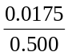 = 00350 L = 35.0 mL
(Answer D)

Question 3
Balanced equation is: 3 Cu (s) + 2 NO₃– (aq) + 8 H⁺ (aq) → 3 Cu²⁺ (aq) + 2 NO (g)+ 4 H₂O (l)
n(NO₃–) = × n(Cu) = × 1 = 0.67 mol
(Answer B)

Question 4
Volumetric analysis is the process used for the accurate determination of the amounts of substances in solutions. A standard solution used in this technique is made by dissolving an accurately weighed mass of a suitable reactant. This is dissolved and made up to a specific volume using a volumetric flask.
(Answer D)

Question 5
- Molar mass of ZnO = 65.4 + 16.0 = 81.4. Therefore % Zinc = 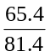 × 100 = 80.3%
- Molar mass of Zn₂S = 65.4 × 2 + 32.1 = 162.9. Therefore % Zinc = 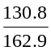 × 100 = 80.3%
- Molar mass of ZnS = 65.4 + 32.1 = 97.5. Therefore % Zinc = 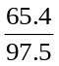 × 100 = 67.1%
- Molar mass of FeZnS = 55.8 + 65.4 + 32.1 = 153.2. Therefore % Zinc = 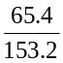 × 100 = 42.7%
(Answer C)

Question 6
Atomic absorption spectrometry is used to determine the type and amount of metallic elements present in a sample. It is capable of detecting over 70 metallic elements. It is extremely sensitive, routinely determining part per million (ppm) levels and in some cases part per billion (ppb) levels of elements.
(Answer C)

Question 7
Gravimetric analysis is the process in which the mass of an element (or component) in a compound is determined by using another reagent to extract some part of the original compound. Typically a precipitate is formed which can be collected, dried and weighed. Using knowledge of the chemical formula of the precipitate, the amount of the element (or component) that was present in the original compound can then be calculated.

Question 8
The R_{f} value can be calculated using the relationship:
R_{f} = 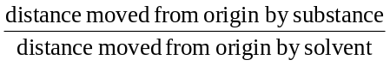
Hence, R_{f} = 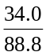 = 0.383
(Answer A)

Question 9
GC is used for gases and volatile liquids that are easily vaporised. The compounds analysed must be stable to high temperatures. That is they must have strong intra-particle forces and weak inter-particle forces. Typically suitable compounds have a molar mass of less than 300 g/mol. eg. alcohols, alkane mixtures, fatty acids, and stable gases.
(Answer C)

Question 10
Rate of reaction can be defined as the decrease in the concentration of reactants per unit time or the increase in the concentration of product per unit time. The factors that increase the rat of reaction are: 1) an increase in reactant concentration; 2) an increase in temperature; 3) an increase in surface area; and 4) the presence of a catalyst (at a given temperature).
(Answer C)

Question 11
pH = –log₁₀[H⁺] = 2.0
Therefore [H⁺] = 10^{–2} = 0.010 M
(Answer A)

Question 12
In the titration of a weak acid, HZ, with a strong base the reaction will react all of the acid.
n(HA) = cV = 0.10 × 0.100 = 0.010 mol
n(KOH) = n(HA)
V(KOH) = 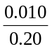 = 0.050 L = 50 mL
(Answer B)

Question 13
It is usually assumed in calculations that the concentration of H₃O⁺ and the anion are equal. However, due to the slight self-ionisation of water {2 H₂O → H₃O⁺ + OH–} the [H₃O⁺] will be slightly greater than the [HC₂O₄–]. In addition, H₂C₂O₄ is diprotic and the HC₂O₄– ion will further ionise reducing the [HC₂O₄–] more. HC₂O₄– + H₂O → C₂O₄^{2–} + H₃O⁺.
(Answer C)

Question 14
The substance with the highest boiling temperature will have the strongest bonding between its molecules. Ethane is the smallest molecule (lowest molar mass) and will, therefore, have the weakest dispersion forces. In addition, due to the general symmetry of ethane it will have no molecular dipole. Therefore, ethane will have the lowest boiling temperature. The other three molecules are polar: however, ethanol and ethanoic acid are both capable of hydrogen bonding and will have higher boiling temperatures than chloroethane. In addition, ethanoic acid has the greater molar mass and will have the higher boiling temperature compared to ethanol. [Ethane: boiling temperature is –88.6°C; chloroethane 12.3°C; ethanol 78.3°C; and ethanoic acid 117.9°C]
(Answer A)

Question 15
In the Contact Process the reaction producing SO₃ does not have sufficient time to reach equilibrium. The temperature is increased to ensure adequate rate of reaction even though the reaction is exothermic and a catalyst – vanadium(V) oxide, V₂O₅ – is used. The boiling temperature of SO₃ is 45°C.
(Answer A)

Question 16
As the volume is 2L;
[SO₃] = ½ × 0.040 = 0.020 M; [SO₂] = ½ × 0.020 = 0.010 M; and [O₂] = ½ × 0.010 = 0.0050 M
The equilibrium constant, K_{c} = 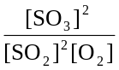 = 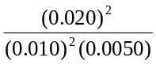 = 80 M⁻¹.
(Answer D)

Question 17
The easiest way to tackle this type of problem is to look at the alternatives and determine the copolymers formed from the pairs of monomers given. Alternatives A, C and D each form a polymer with at least one methyl side chain. Only but-1-ene allows the formation of an ethyl side chain.
(Answer B)

Question 18
Polyesters are condensation polymers made from monomers with at least two reactive functional groups. Only alternative D gives the chemical formula of a molecule with only one functional group which prevents the chain from growing at the end to which the molecule becomes attached.
(Answer D)

Question 19
An element undergoes oxidation when its oxidation number increases and it undergoes reduction when its oxidation number decreases. An oxidant is reduced in the process. Therefore you are looking for a reduction I the oxidation number of the element involved. In this case the element is sulfur. A change in the oxidation number of sulfur only occurs in alterative B; SO₄^{2–} has an oxidation number of +6 for sulfur and SO₂ has an oxidation number of +4 for sulfur.
(Answer B)

Question 20
When the temperature is increased the particles will have more energy and will move at a greater speed, and, hence will collide more frequently. Both an increase in energy and more collisions will result in more ‘successful’ reactions and a greater rate of reaction. An increases in activation energy will lead to a slower rate of reaction. In addition, an increase in activation energy will not occur with an increase in temperature.
(Answer D)

Question 21
The bond formed between the alcohol and carboxylic acid is indicated on the semi-structural formula. This is the point from which a water molecule may be considered to be lost during formation of the ester (during the condensation reaction).
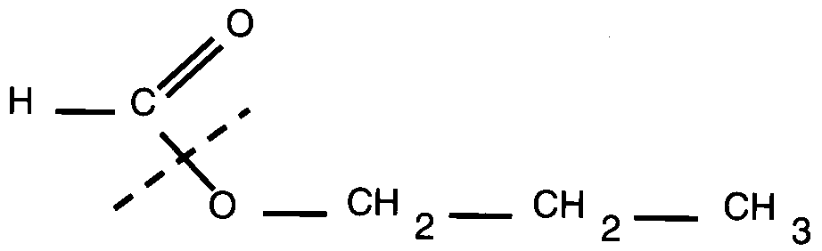
The fragment containing the C=O group originates from the carboxylic acid. The formula of the acid can be determined by adding –OH at this point giving HCOOH {methanoic acid}. The remaining fragment can be used to determine the formula of the alcohol by adding –H at this point. This forms the formula HOCH₂CH₂CH₃. This is the semi-structural formula of propan-1-ol.
(Answer A)

Question 22
For but-2-ene the carbon-carbon double bond is between carbon atoms 2 and 3. During the addition reaction involving bromine, Br₂, a bromine atom will be added to each of the carbon atoms initially involved in the double bond. This will form 2,3-dibromombutane in this case.
Answer (A)

Section B – Short Answer Questions

Question 1 (Total = 11 marks)
- K = 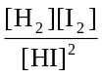 (1 mark)
 |  | Change to system | Direction of  reaction | Change to the intensity  of the purple colour |  | Change to rate of  forward reaction
 | (i) | temperature is decreased | forward | increased |  | decreased
 | (ii) | volume is decreased | neither | increased |  | increased
 | (iii) | hydrogen gas is added | backward | decreased |  |  | (3+3+2 = 8 marks)
 | 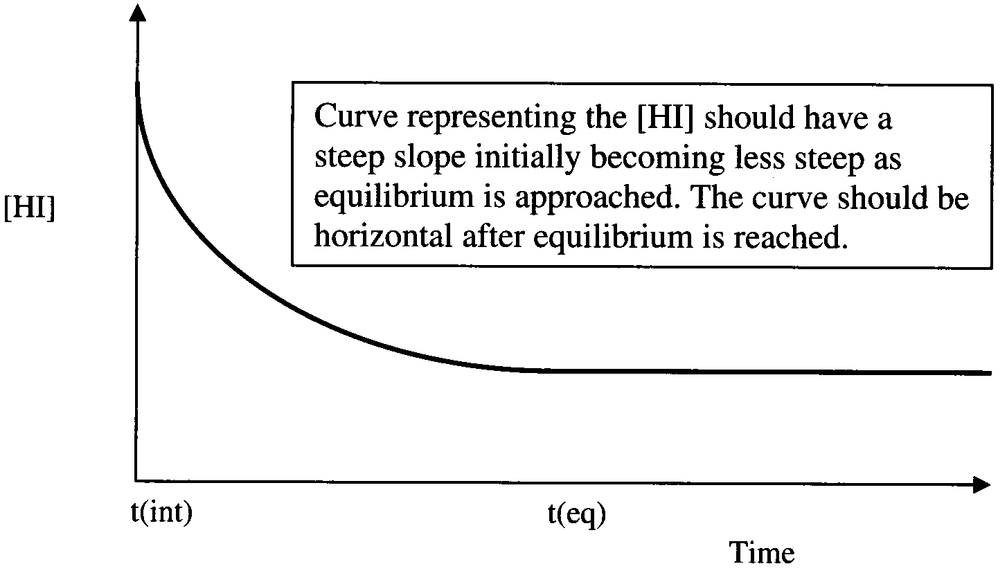 |  |  |  | (2 marks)

Question 2 (Total = 8 marks)
- Steam is added to the thermal cracker to reduce carbon build-up during thermal cracking. (1 mark)
[The chemical equation for the process is: H₂O (g) + C (s) → CO (g) + H₂ (g)]
- (i) Any 3 of the following alkenes.
H₂C=CH₂ ethene
H₃C–CH=cH₂ propene
H₃C–CH=CH–CH₃ but-2-ene
H₃C–CH₂–CH₂=CH₂ but-1-ene (1+1+1=3 marks)
 | (ii) | 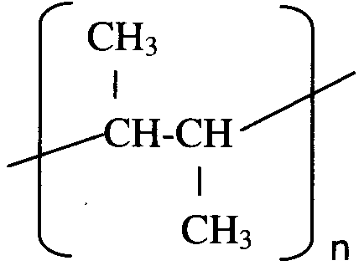 | or | 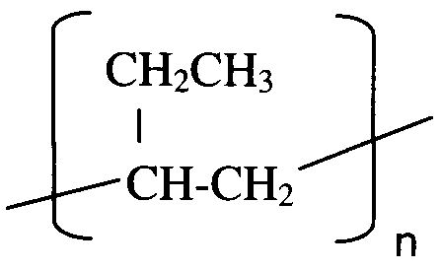
 |  | polybut-2-ene | or | polybut-1-ene | (1+1 = 2 marks)
- (i) zeolite or alumina (Al₂O₃) (1 mark)
(ii) C₁₀ H₂₂ (g)  C₅H₁₀ (g) + C₅H₁₀ (g) (1mark)

Question 3 (Total = 8 marks)
- (i) positive or + (1 mark)
(ii) The data in the table indicates that K_{W} increases with an increase in temperature. This is typical of an endothermic reaction which has a positive ΔH. (1 mark)
(iii) K_{W} = [H⁺] [OH–] = [H⁺]² = 5.48 × 10⁻¹⁴
[H⁺] = 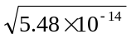 = 2.34 × 10^{–7} M (1 mark)
Therefore pH = –log₁₀[H⁺] = –(–6.63) = 6.6 (1 mark)
(iv) The water is (still) neutral as the [H⁺] = [OH–] (1 mark)
(Note: pH does not have to be 7 to be neutral if the temperature is not 25°C.)
- (i) HSO₄– (aq) + H₂O (l)  SO₄^{2–} (aq) + H₃O⁺ (aq) (1 mark)
(ii) pH = –log₁₀[H₃O⁺] = 1.18
Therefore [H₃O⁺] = 0.06607 M (1 mark)
K_{a} = 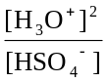 = 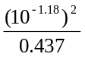 = 0.00999 M (1 mark)

Question 4 (Total = 8 marks)
 | 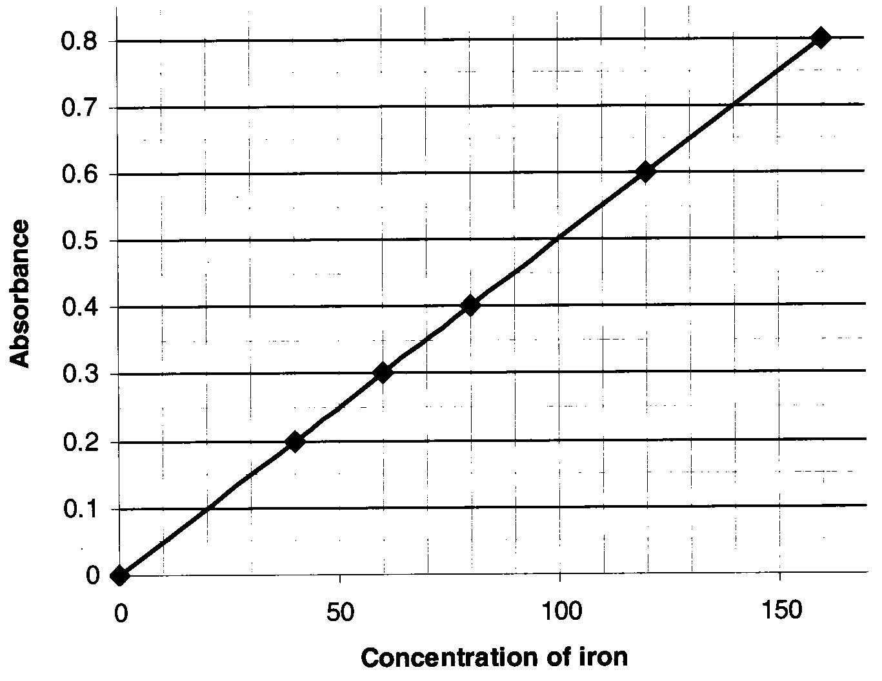 | 1 mark for selection of scales and 1 mark for accuracy  (1+1 = 2 marks)
- Absorbance = 0.35 (range of ±0.01 acceptable) (1 mark)
This corresponds to 70 μg L⁻¹ (range of ±2 acceptable) (1 mark)
The original sample of blood serum was diluted by a factor of 10 Hence, concentration of iron in the original sample of blood serum: 700 μg L⁻¹ (range of ±20 acceptable) (1 mark)
- n(Fe) = 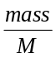 = 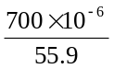 = 12.5 × 10^{–6} mol (1 mark)
n(Fe) = 12.5 μmol
Hence, [Fe] = 12.5 μmol L⁻¹, which is in the range for normal adult blood. (Range of 12.2 to 12.9 μmol L⁻¹ acceptable) (1 mark)
- The wavelength of 562 nm is selected because this corresponds to the maximum absorbance of the purple iron complex (and it will reduce the percentage error associated with the measurements). (1 mark)

Question 5 (Total 8 marks)
- 17050 mg = 17.05 g per 100 g
Therefore mass (in 3 g) = 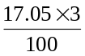 = 0.5115 g (1 mark)
n(Na) = = 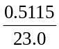 = 0.022239 = 0.022 mol (1 mark)
- Precipitation reaction is shown by the equation: Ag⁺ + Cl– → AgCl (s)
[Assuming that n(Cl–) = n(Na⁺)]
n(Cl–) = 0.022239 mol = n(AgCl) (1 mark)
Mass AgCl = n × M and Molar mass Ag Cl = 107.9 + 35.5 = 143.4 g mol⁻¹
Mass AgCl = 0.022239 × 143.4 = 3.18909 g in the 250 mL of ‘soup’ solution. (1 mark)
Mass AgCl (in 20 mL sample) = 3.18909 × = 0.255125808 g
Mass AgCl (in 20 mL sample) = 0.26 g (or 0.25 g if rounded figures used) (1 mark)
- Gravimetric analysis (1 mark)
- Not all of the chloride ions were bonded with the sodium ions as sodium chloride (for example the soup may also have contained potassium chloride). That is n(Cl–) does not equal n(Na⁺). (1 mark)
- This would result in a smaller mass of Ag Cl and the amount of NaCl content determined by the student would be lower. (1 mark)

Question 6 (Total = 10 marks)
 | 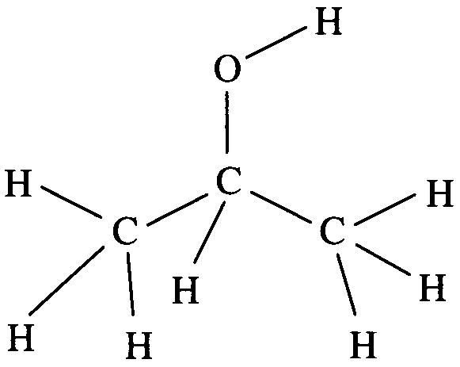 | (1 mark)
- (i) nonan-4-ol (1 mark)
(ii) 2-chloropentane (1 mark)
(iii) propanoic acid (1 mark)
- (i) addition reaction (1 mark)
(ii) HCl (1 mark)
(iii) substitution reaction (1 mark)
(iv) OH– (strong base such as NaOH) (1 mark)
(v) oxidation reaction (oxidation of ethanol occurs) (1 mark)
(vi) (A) H⁺ (source of H⁺ could be concentrated H₂SO₄)
(B) Cr₂O₇²⁻ or MnO₄– (Both required for 1 mark)

Question 7 (Total = 6 marks)
- VOC concentration increase will cause the [NO] t lower. This, in turn, will cause the reaction to go in the forward direction (towards the right or products) and the [O₃] will increase. (1 mark)
- (i) The result from experiment 1 was not used in the calculation of the average as it was (considered) not to be concordant with the other two results. (1 mark)
(ii) n(S₂O₃²⁻) = cV = 0.010 × 22.45 × 10^{–3} mol per 10⁵ L of air
n(S₂O₃^{2–}) = 2.245 × 10^{–4} mol per 10⁵ L of air
n(S₂O₃^{2–}) = 2.245 × 10⁻⁹ mol per 1 L of air (1 mark)
n(O₃) = n(I₂) = ½ n(S₂O₃^{2–}) (1 mark)
Therefore n(O₃) = ½ × 2.245 × 10^{–9} mole per 1 L of air
n(O₃ = 1.1225 × 10^{–9} mol per 1 L of air (1 mark)
Number of molecules of ozone = n(O₃) × N_{A} = 1.1225 × 10^{–9} × 6.02 × 10²³
Number of molecules of ozone = 6.8 × 10¹⁴ (1 mark)

